<https://github.com/gto76/python-cheatsheet>

**Debugging Server Side Application Using Python In Pycharm**

<https://www.youtube.com/watch?v=89PZ7faYTgA>

**Pycharm**

<https://docs.google.com/document/d/1Fnwj4aRMKEWbEecJpddOmaDEvV746cug_yHHZ1TDGN4/edit>

<https://www.makeuseof.com/python-built-in-functions-methods-you-should-know/>

<https://towardsdatascience.com/10-killer-ways-to-speed-up-python-9c23d932da33>

<https://www.geeksforgeeks.org/python-programming-language/>

Python Certifications

<https://insights.dice.com/2020/05/18/python-certifications-4-big-questions-answered/>

**Python IDE**

<https://towardsdatascience.com/best-python-ides-and-code-editors-you-must-use-in-2020-2303a53db24>

<https://analyticsindiamag.com/pycharm-ide-for-dummies-beginners-guide/>

**Python List techniques**

<https://towardsdatascience.com/advanced-python-list-techniques-c6195fa699a3>

**India AI**

<https://indiaai.in/>

**Contrastive Learning**

<https://analyticsindiamag.com/contrastive-learning-self-supervised-ml/>

<https://towardsdatascience.com/excel-functions-in-python-17d35defebdd>

**Edureka Tutorial**

<https://www.youtube.com/watch?v=vaysJAMDaZw>

Python is a general purpose high level programming language

Python can be used for developing Data Science applications, Machine Learning, Web applications, Artificial Intelligence, Robotics etc.

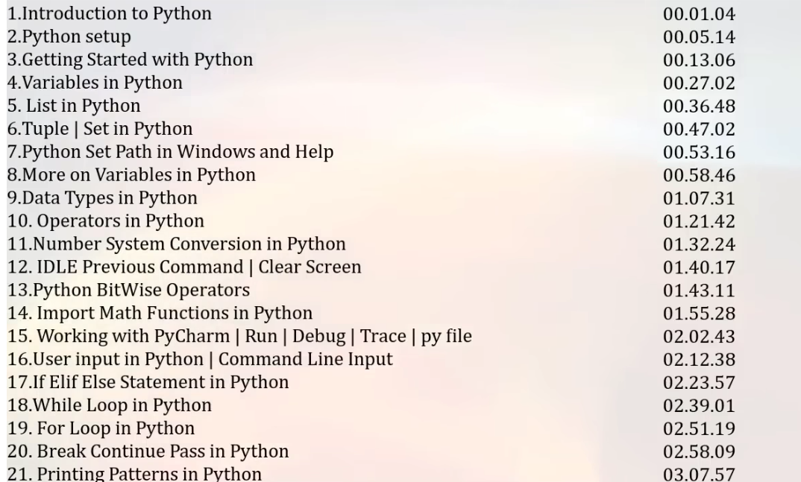

Python is an interpreted, object oriented and High level programming language.

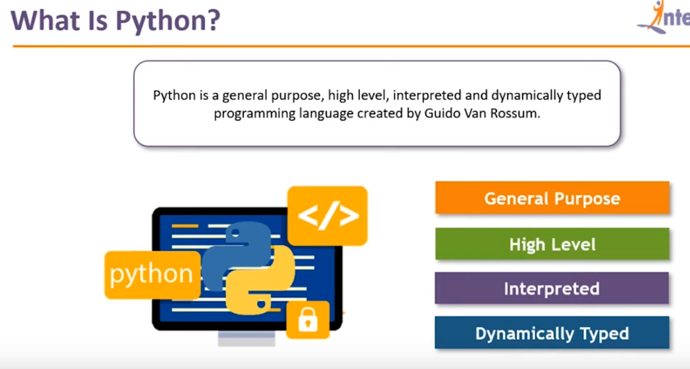

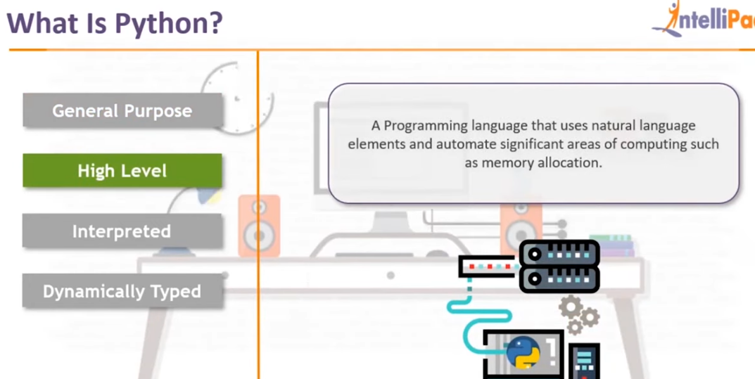

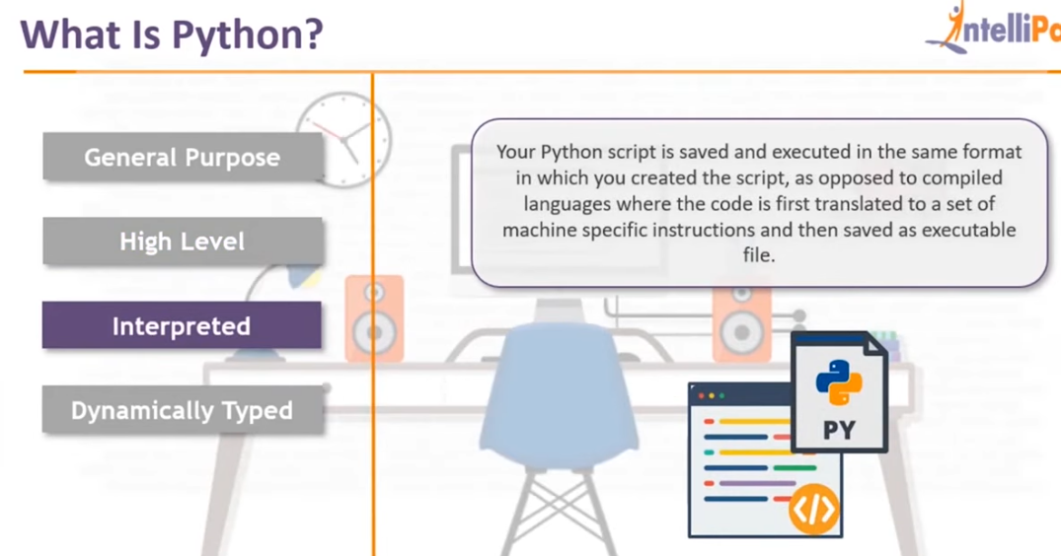

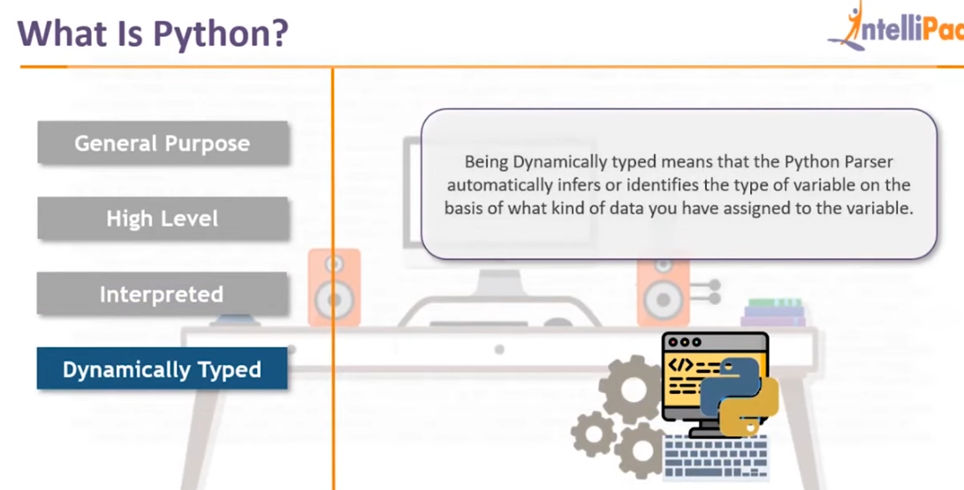

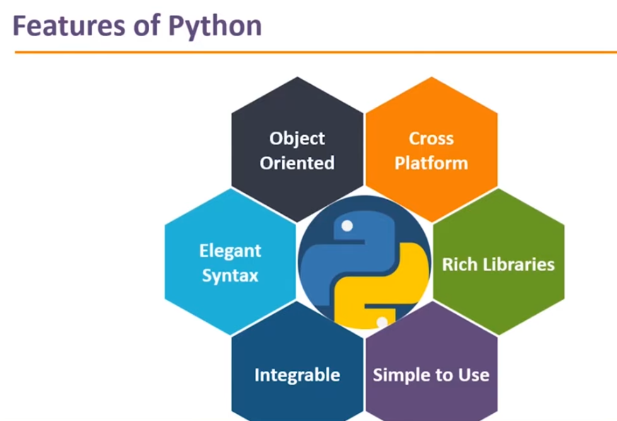

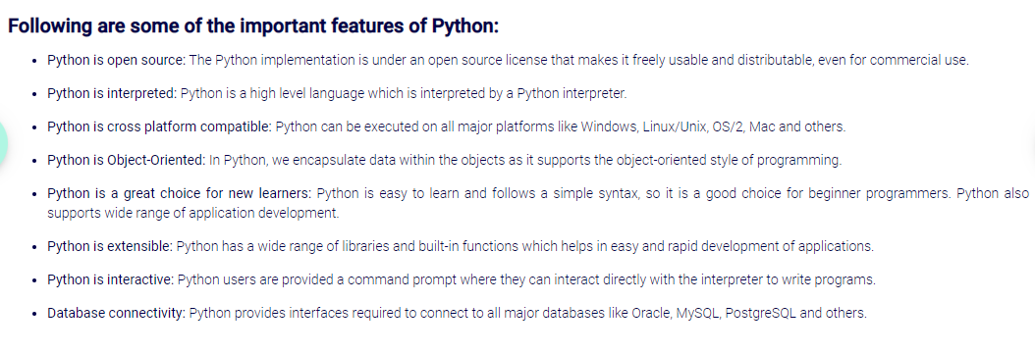

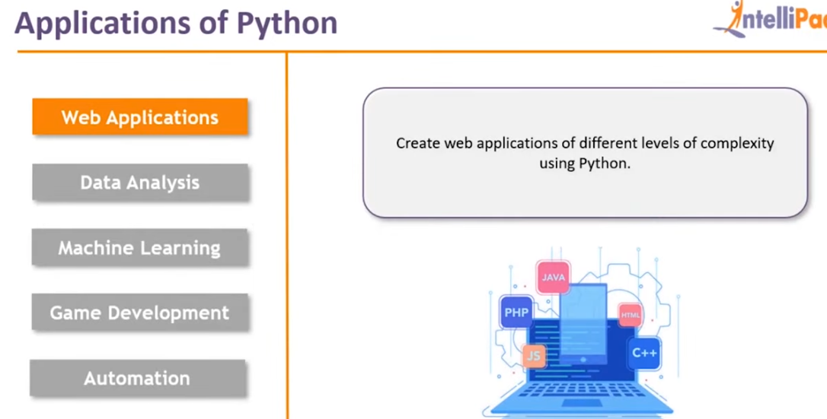

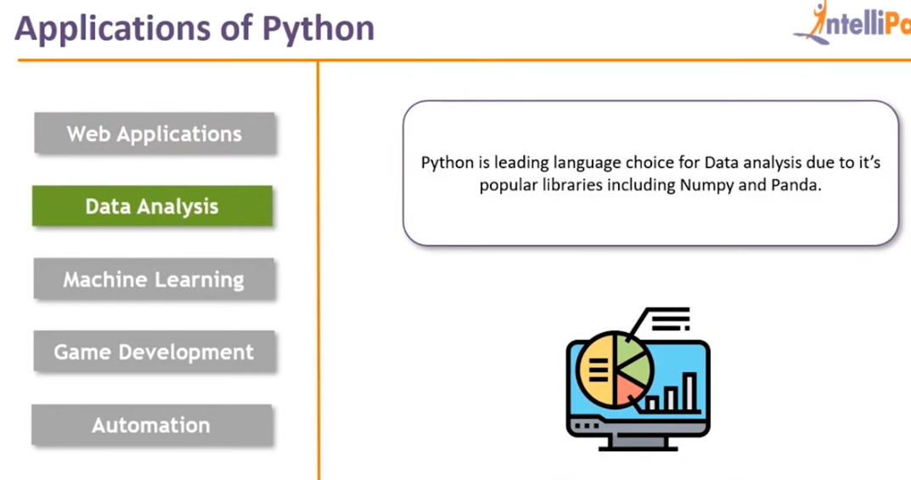

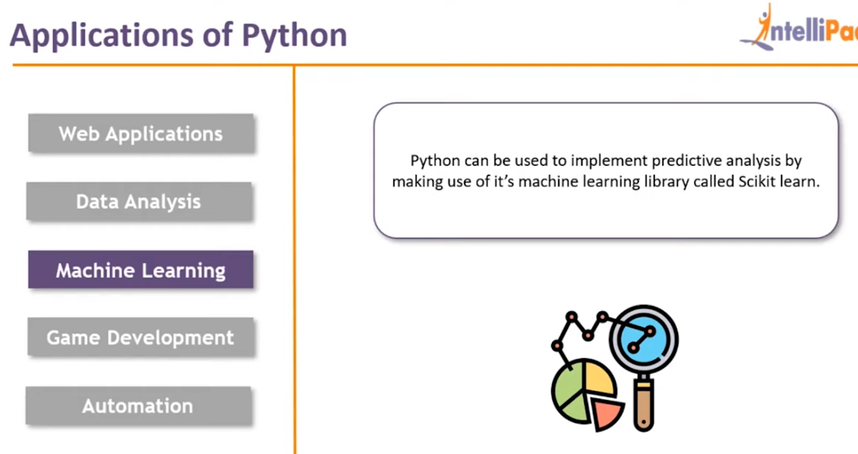

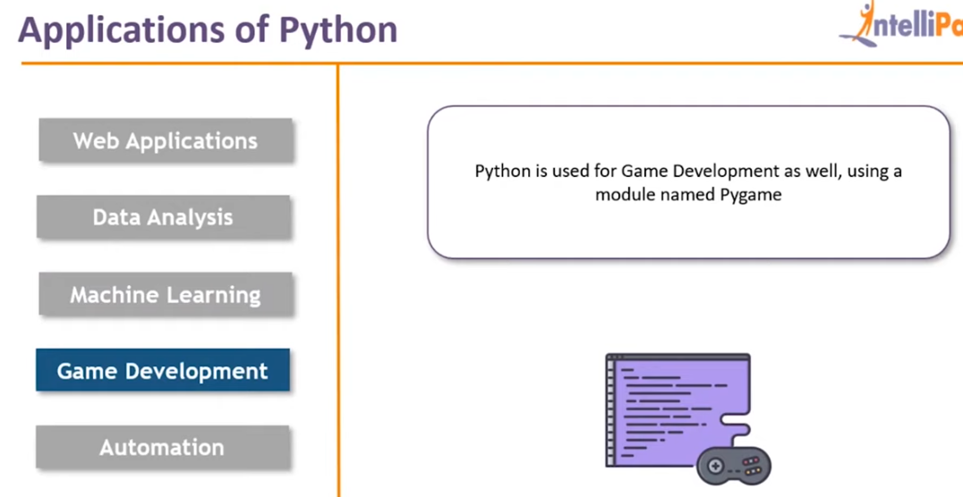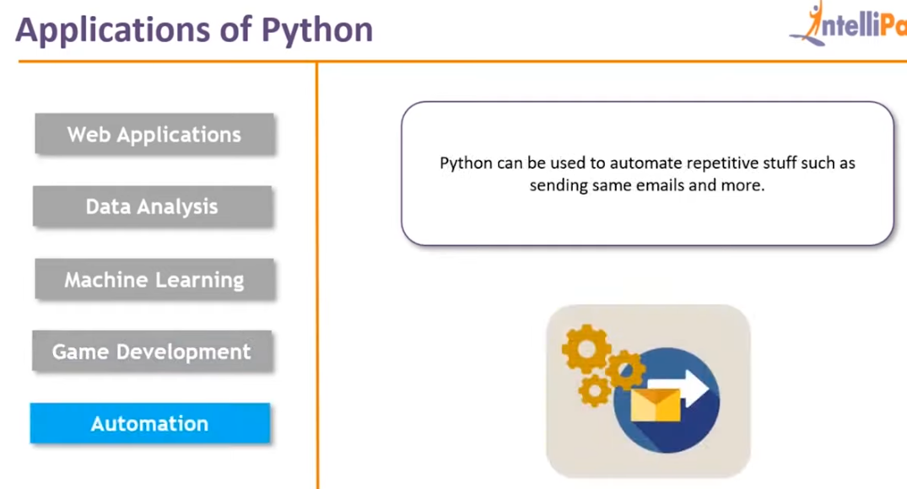

<https://medium.com/geekculture/if-you-ask-these-4-python-questions-you-might-still-be-a-nooby-7e4c503aa1c3>

Version of Python

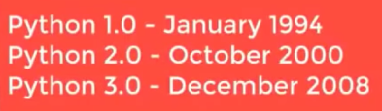

NOTE : Most companies have migrated from Python 2 to Python 3 in the year 2019. So it is better to learn Python 3 now.

In Python 3, the string data type supports unicode by default. But in Python 2, the string data type does not support unicode.

In Python 2, print was a statement whereas in Python 3, print is a function.

Installing Python and setting up environment

<https://youtu.be/pJ3IPRqiD2M?t=523>

(Watch upto 14:05)

Python setup (Watch upto 12:59)

<https://youtu.be/YfO28Ihehbk?t=312>

Python download and installation and Pycharm IDE (Watch upto 6:06)

<https://youtu.be/_uQrJ0TkZlc?t=112>

Creating project and Python file in Pycharm IDE and printing(11:23)

<https://youtu.be/_uQrJ0TkZlc?t=373>

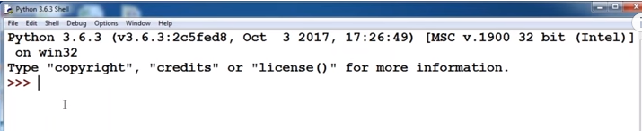

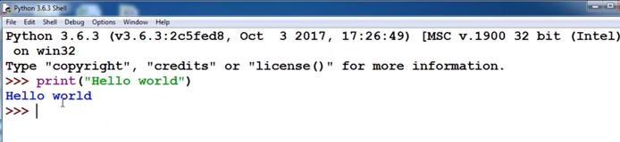

Biggest advantage of Python is that we can write lengthy codes in a small number of lines

In C and Java, we have to declare the type of variables i.e. C and Java are statically typed programming languages. But in Python, there is no need to declare the type of variables. If we use the keywords **int**, **float**, **boolean** etc in Python, the compiler will give an error.

Based on the value that is provided to a variable, Python compiler will internally decide the type of the variable

Semicolon is not required in Python.

Suppose we want to print the sum of 2 numbers

In Java, we will have to write the following code :

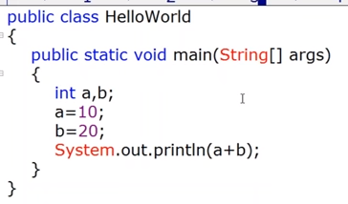

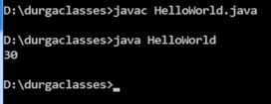

In C language, we will have to write this code :

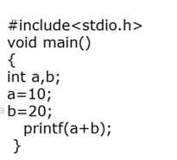

But in Python we can just write :

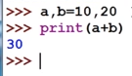

10 will be assigned to a and 20 will be assigned to b

In Java and C language, if we want to use any variable, then mandatorily we have to declare data type. So, Java and C language are statically typed languages

But in Python, we need not specify data type when declaring a variable.

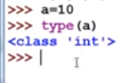

In Java, if we try to assign a value of different type to another type :

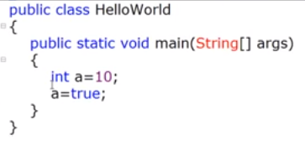

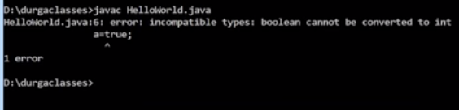

But if we give a value of different type to another type in Python

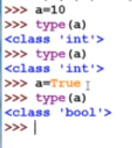

When we assign int type value to variable **a**, **a** is treated as int type. But as soon as we assign a value of boolean type to the variable **a**, **a** is treated as boolean type.

Python is dynamically typed programming language

Python is a strongly typed programming language. A strongly typed programming language is one where the data types do not get converted implicitly. Javascript is a weakly typed programming language.

Guido Van Rossam was the person who developed Python on Feb 20th 1991.

Python is an Object Oriented Programming language because Object language features are borrowed from the Java language.

Python is a Functional programming language as well because Functional programming features are borrowed from C++ language.

Python is also a Scripting language.

Few companies that are using Python language are Google, YouTube, IBM, Stock Market etc.

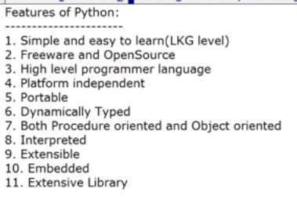

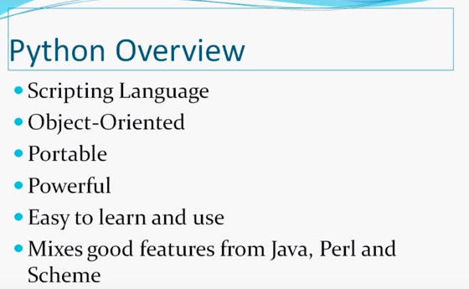

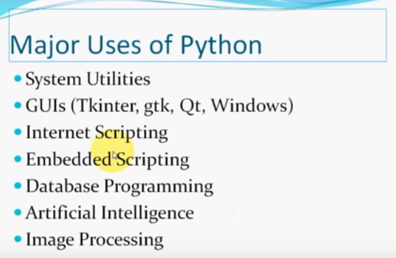

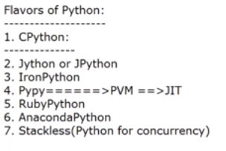

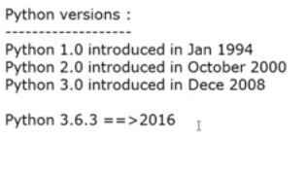

Current version of Python is 3.6

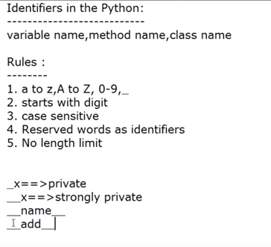

<https://youtu.be/VqSNhdCyZUc?list=PLd3UqWTnYXOnkicyzePnIg8rc2qEXgjiF&t=672>

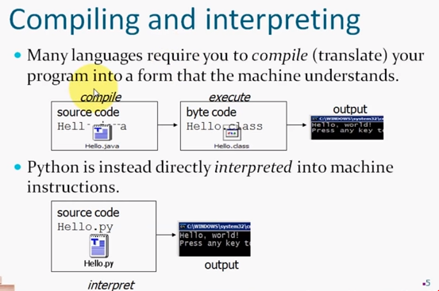

C, C++ and Java language require us to compile the source code file and then after compilation, an executable file is generated which can be run

But Python is an interpreted language. This means there is no need to compile the Python program. Because it is an interpreted language, we will directly be able to run the program. If there are any errors, we will be able to see them only during runtime.

When we run/execute a Python code, then the python interpreter( example: CPython interpreter) reads all the Python code and implicitly compiles it down to Python bytecode. Once it does that, it executes the Python code from top to bottom. So there is no difference in the compilation step and the runtime step.

In Java, the code is compiled explicitly by the compiler.

Cpython, Cython, Pypy, Jython, IronPython etc are different python interpreters.

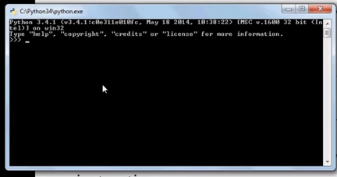

This is a command line tool that can be used to execute Python programs

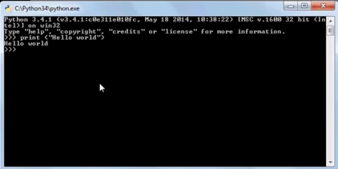

print is a built-in function to print

Python : Interpreted or compiled (Imp for interview/understanding) (Watch upto 5:53:12)

<https://youtu.be/YfO28Ihehbk?t=20797>

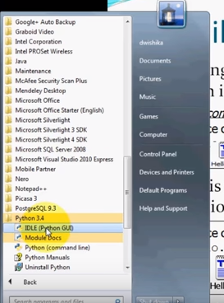

Opening IDLE ( Python GUI )

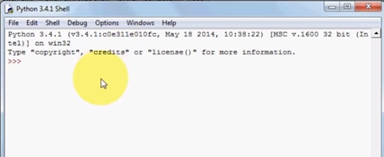

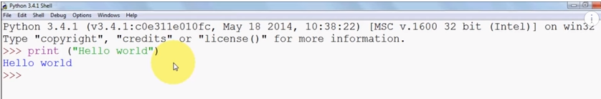

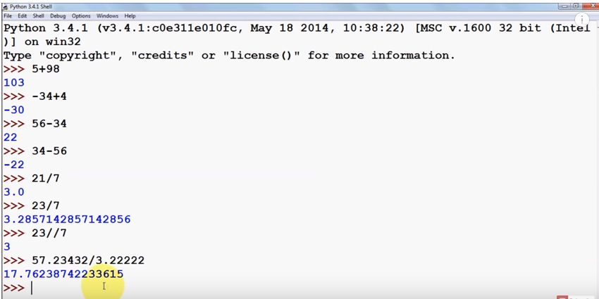

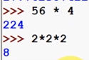

To write exponent :

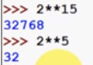

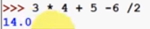

Declaring variable and assigning it a value

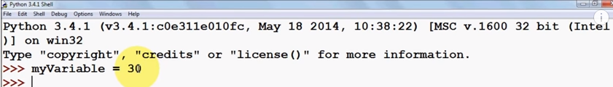

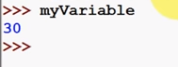

Python is a case sensitive language

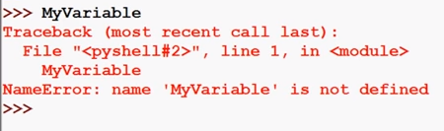

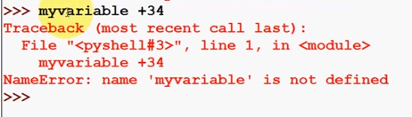

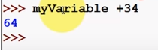

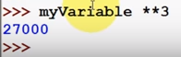

To take input from the user, we use an inbuilt function **input()**



<https://youtu.be/YtX-Rmoea0M?list=PLS1QulWo1RIaJECMeUT4LFwJ-ghgoSH6n&t=362>

Whatever the user enters as input, it will be taken as String

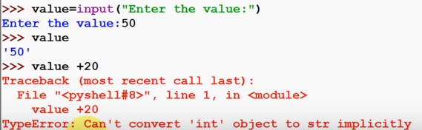

If we want to convert the type of the input entered by the user into another type :



<https://youtu.be/YtX-Rmoea0M?list=PLS1QulWo1RIaJECMeUT4LFwJ-ghgoSH6n&t=492>



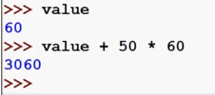



<https://youtu.be/YtX-Rmoea0M?list=PLS1QulWo1RIaJECMeUT4LFwJ-ghgoSH6n&t=573>

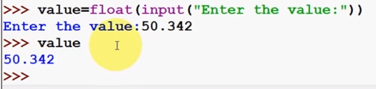

Suppose we want to calculate 2 to the power of 3

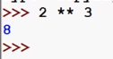

Variables(Watch upto 18:21)

<https://youtu.be/_uQrJ0TkZlc?t=785>

Variables are needed to temporarily store data in computer’s memory

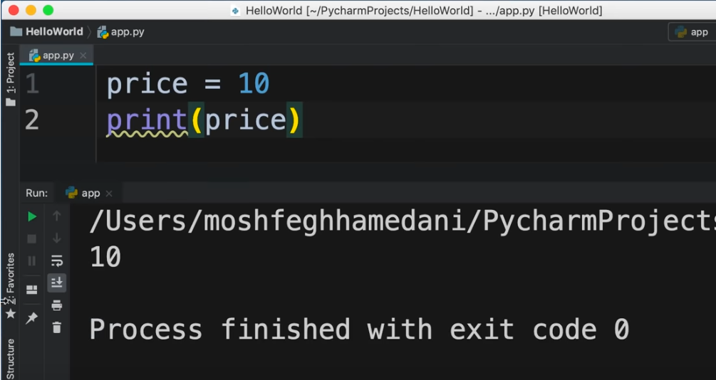

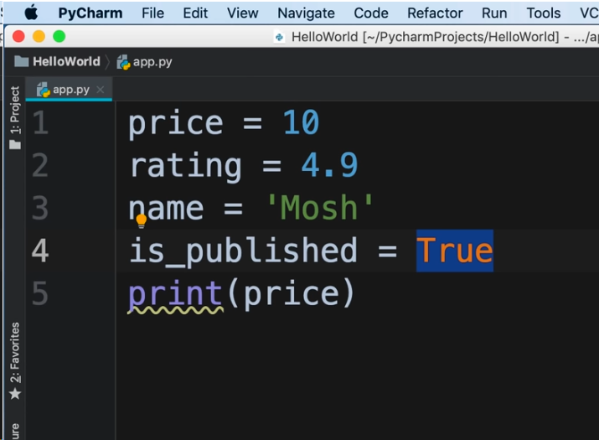

Getting input from user(Watch upto 22:15)

<https://youtu.be/_uQrJ0TkZlc?t=1103>

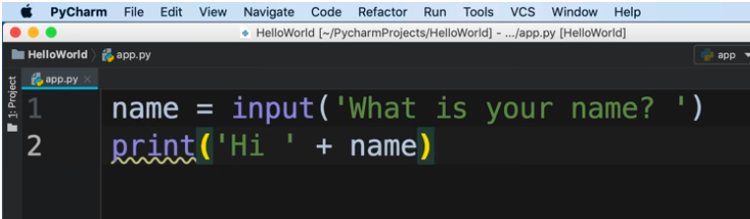

Execution

<https://youtu.be/_uQrJ0TkZlc?t=1238>

Type conversion(29:31)

<https://youtu.be/_uQrJ0TkZlc?t=1370>

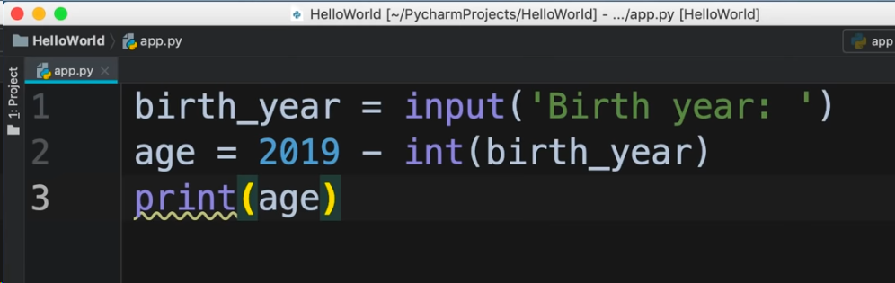

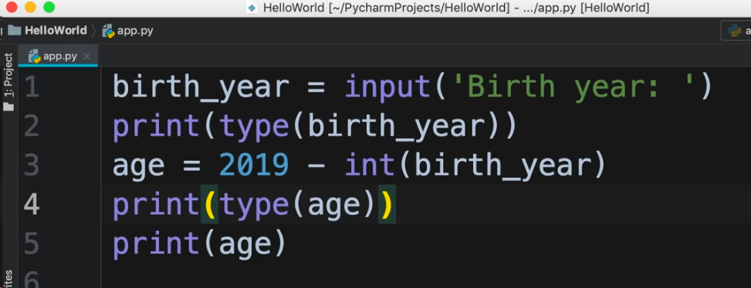

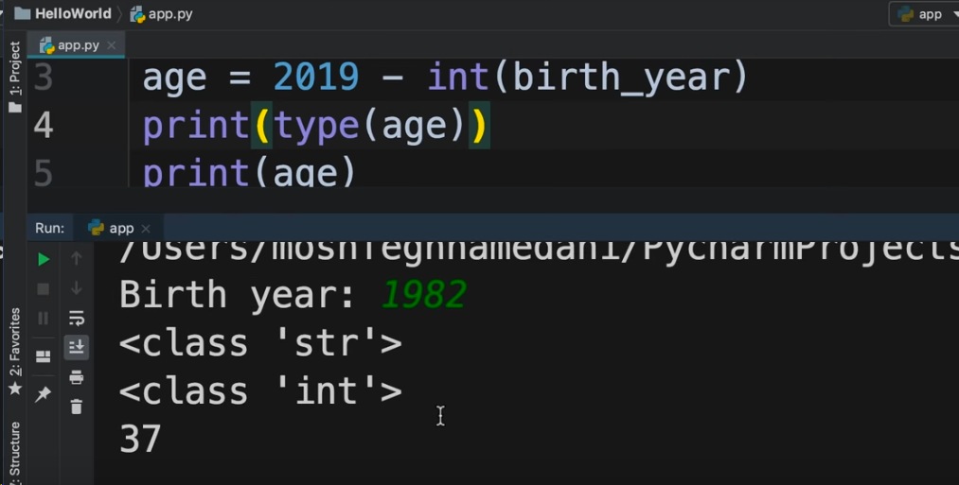

To make this easier, we can use built in function of Python

A function is a piece of code that executes some logic

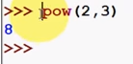

To see the list of built in functions in Python, we can use the command :

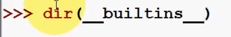

<https://youtu.be/GTpl5yq3bvk?list=PLS1QulWo1RIaJECMeUT4LFwJ-ghgoSH6n&t=155>

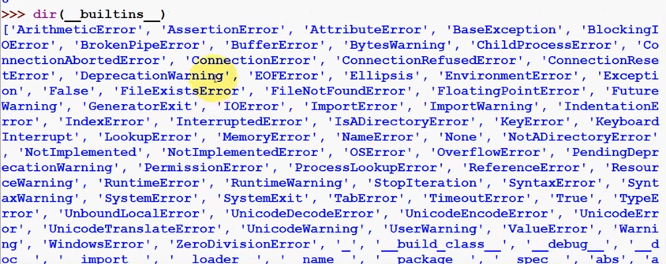

Using some built in functions :

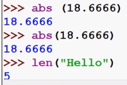

If we want to know what a function performs, then we can use the function “help”

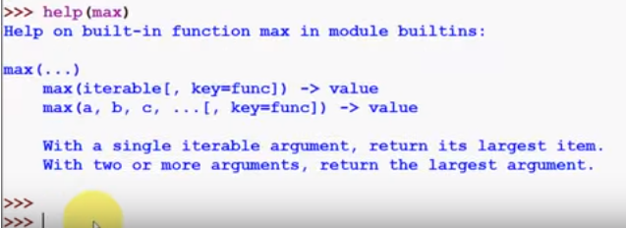

There is something called as Built-in module that contains extra functionalities

If we want to find the square root of a number, then we can use the module “math”. First we need to import this module

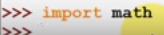

Module is a separate file consisting of reusable code.

These are the built-in functions inside math module

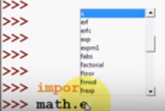

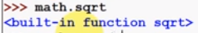

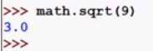

Importing functions(58:19)

<https://youtu.be/_uQrJ0TkZlc?t=3309>

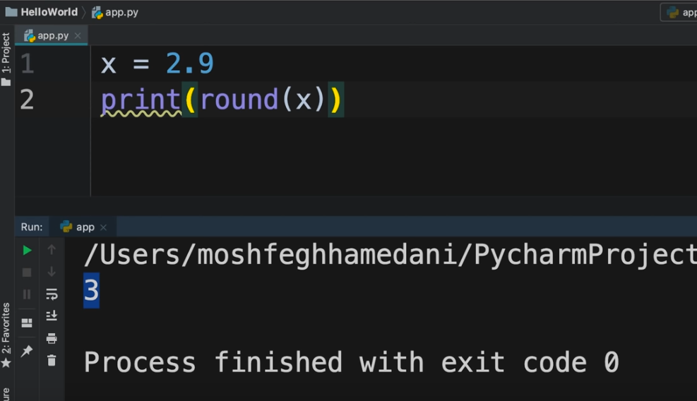

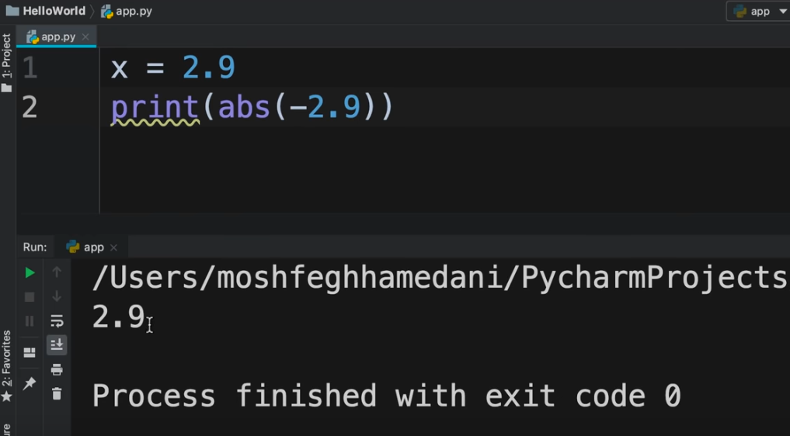

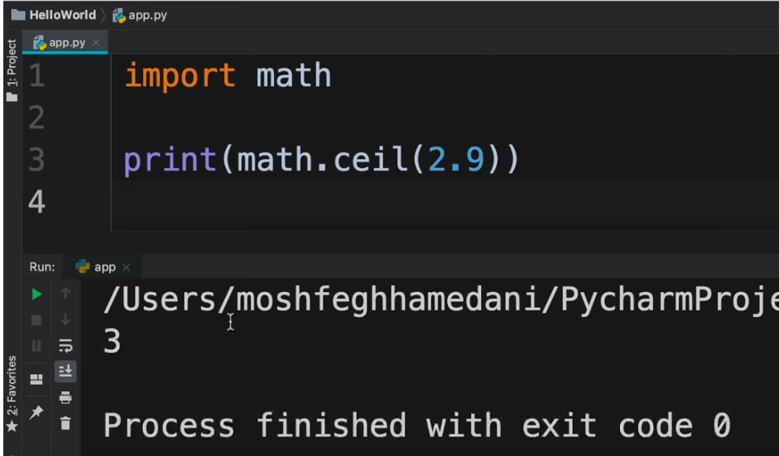

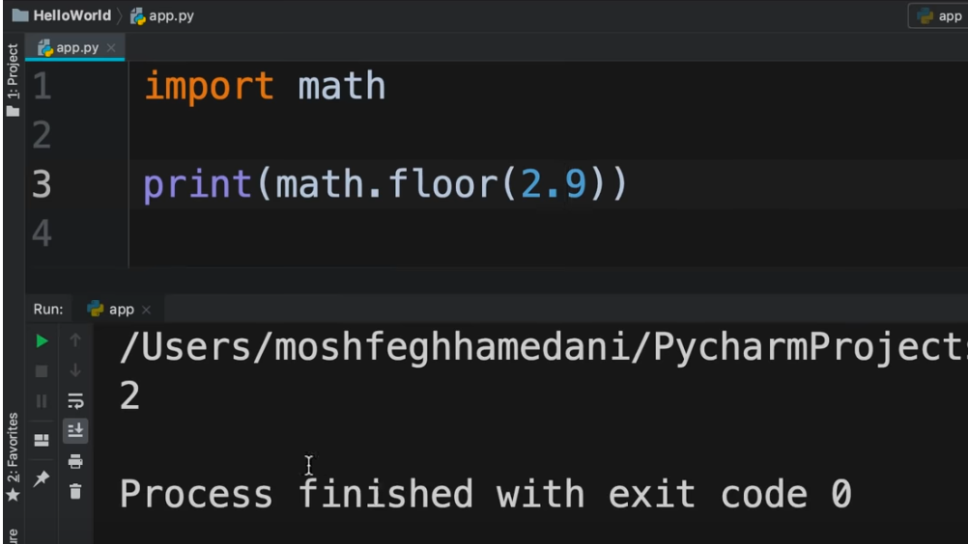

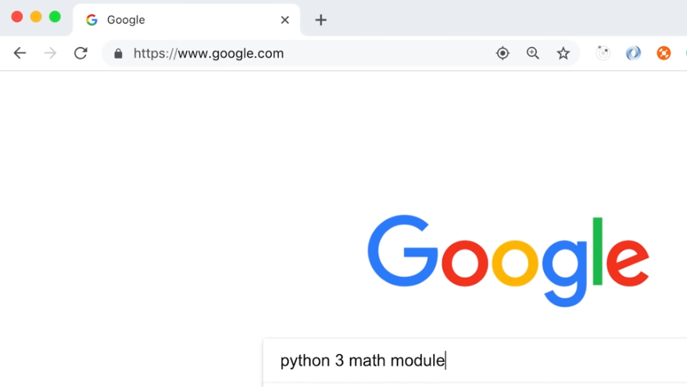

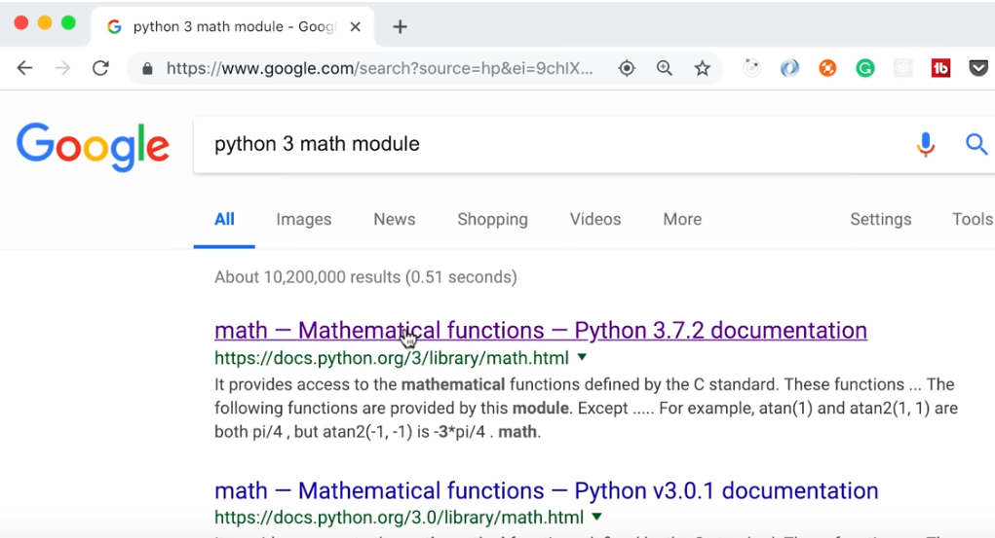

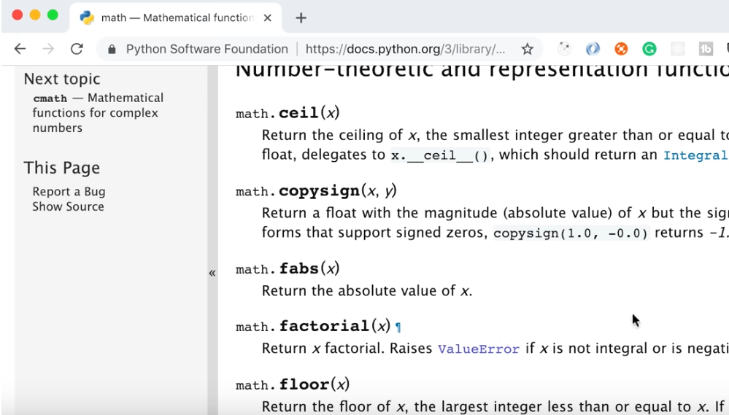

**Save and run Python files .py**

If we want to save python code and run it whenever needed, we will write code in a Python shell file instead of Python shell editor

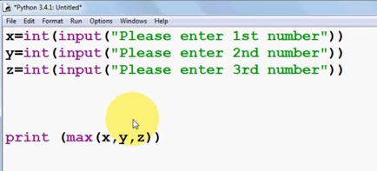

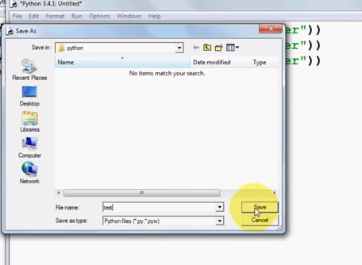

Click on Save

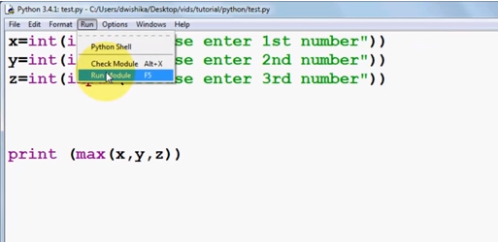

<https://youtu.be/dw3jaIj1ylw?list=PLS1QulWo1RIaJECMeUT4LFwJ-ghgoSH6n&t=217>

Another Example :

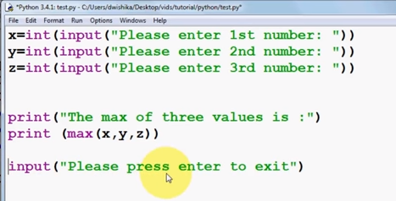

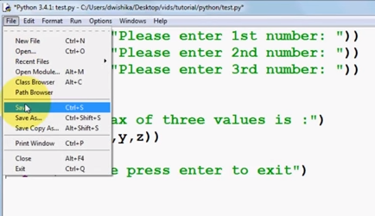

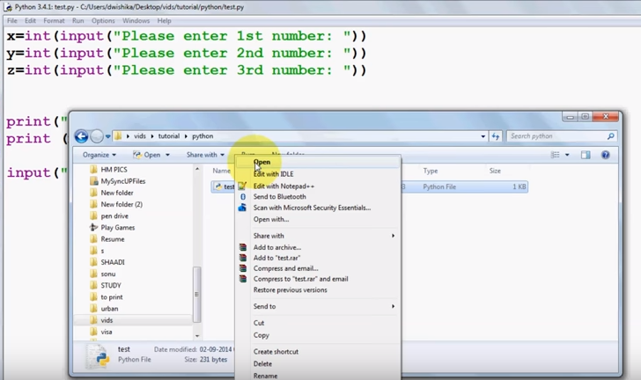

<https://youtu.be/dw3jaIj1ylw?list=PLS1QulWo1RIaJECMeUT4LFwJ-ghgoSH6n&t=396>

This is the python file where we will write the code

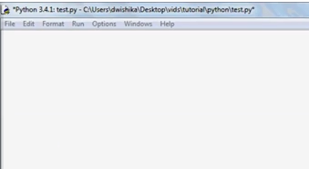

This is the Python shell where we will see the result

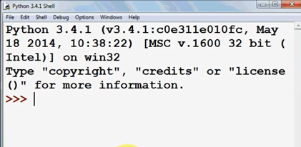

There are 3 ways to use Strings in python :

* Using single quotes
* Using double quotes
* Using triple quotes

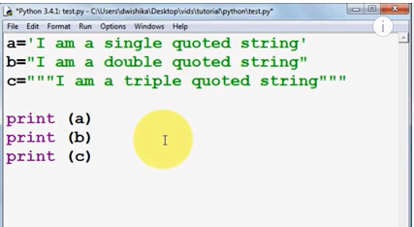

First we will save the program

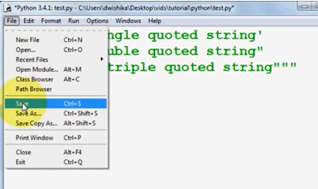

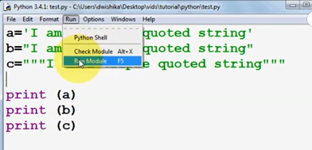

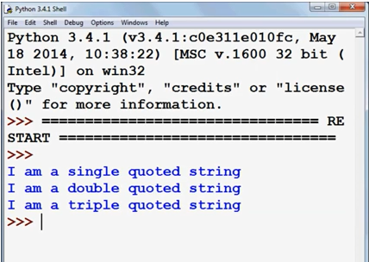

If we write like this :

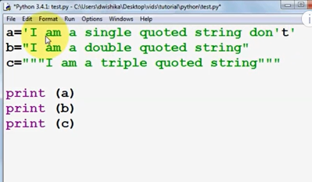

In the above scenario, we will need to use an escape character i.e. \

This backlash tells the compiler that we want to print the single quote defined inside single quotes. The escape character does not get printed in the output

If we write like this :

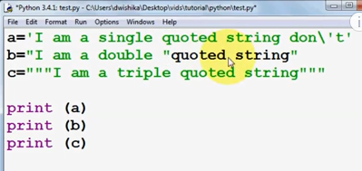

Again we will use backslash character

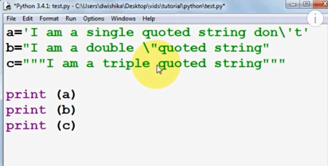

Similarly for the triple quotes string

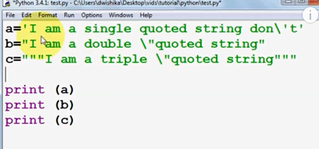

We will save the program and run it

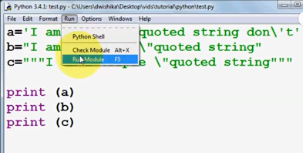

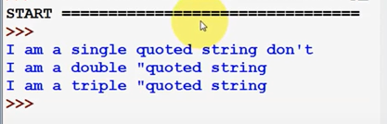

Suppose we want to print the escape character

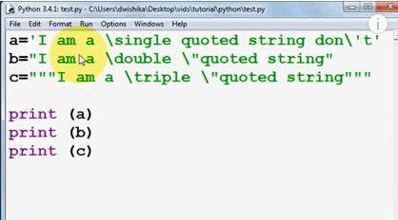

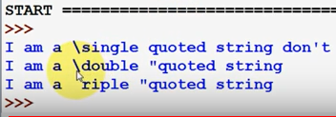

If we write like this :

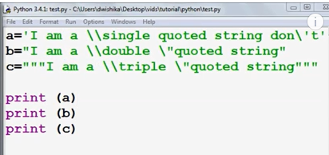

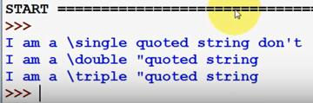

If we want to find the length of a string

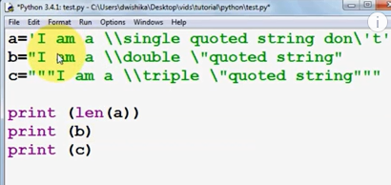

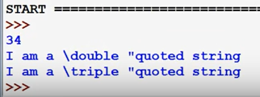

Suppose we want to join 2 strings :

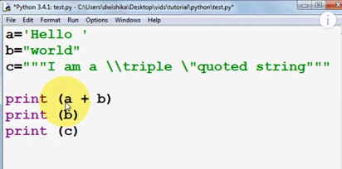

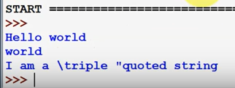

Suppose we have a variable and we want to print n number of times :

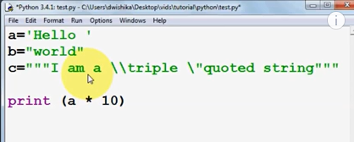

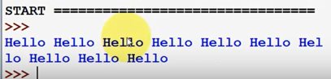

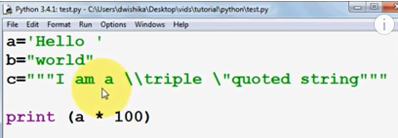

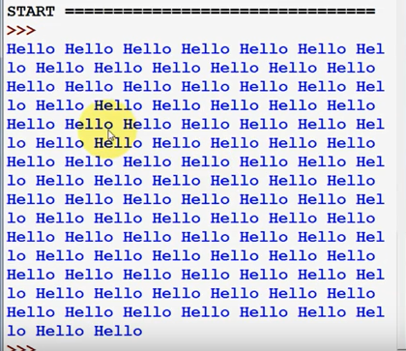

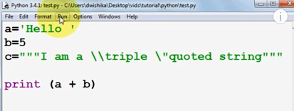

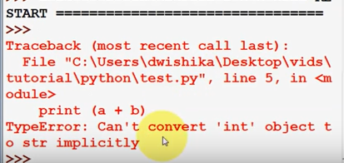

This gives error because a is of type String and b is of type int

To solve this problem, we can do type casting

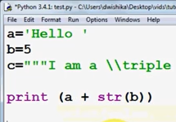

Basics by Naveen Reddy (Watch upto 26:56)

<https://youtu.be/YfO28Ihehbk?t=782>

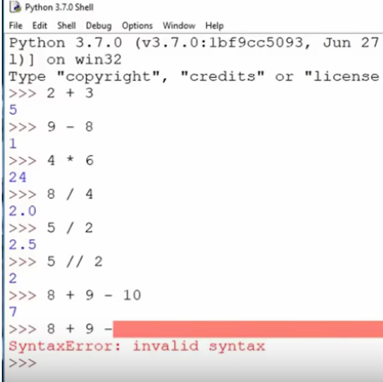

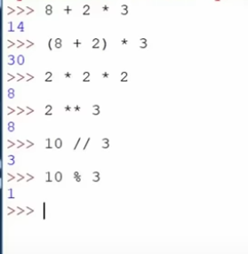

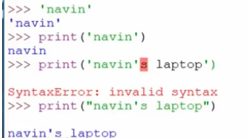

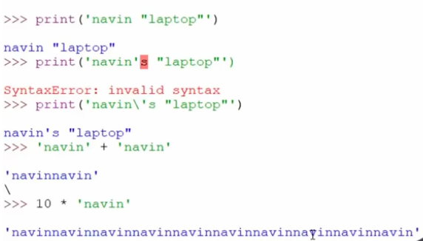

**\n** means new line in Python. To nullify the effect of \n, we need to print the string as it is, which means raw string. For this, we can use **r** which means raw string.

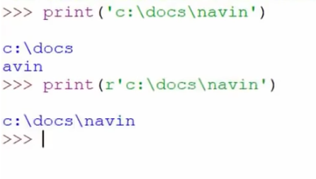

Variables and Strings by Naveen Reddy (Watch upto 36:42)

<https://youtu.be/YfO28Ihehbk?t=1617>

Variable is like a container inside which we can store a value

**_** (underscore) represents the output of the previous operation

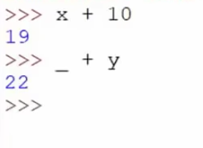

Once we assign a value to a string, we cannot change it. String is immutable

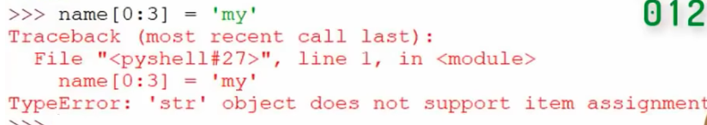

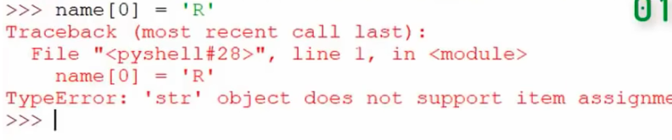

Assignment of a value to a variable by Intellipaat

<https://youtu.be/pJ3IPRqiD2M?t=869>

(Watch upto 19:00)

Python Tokens by Intellipaat

<https://youtu.be/pJ3IPRqiD2M?t=1154>

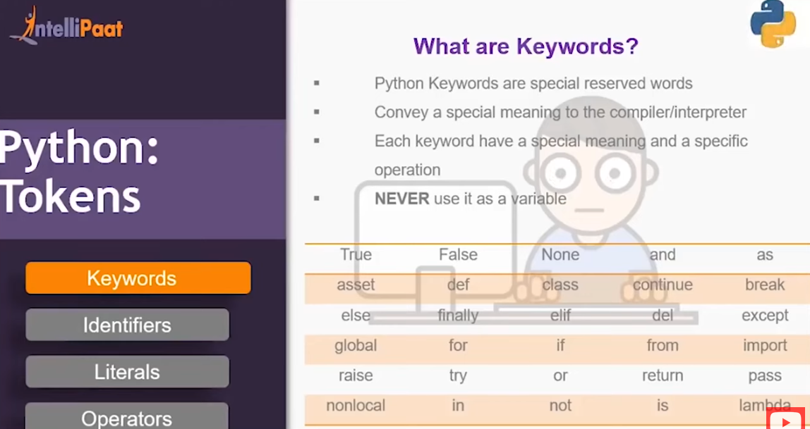

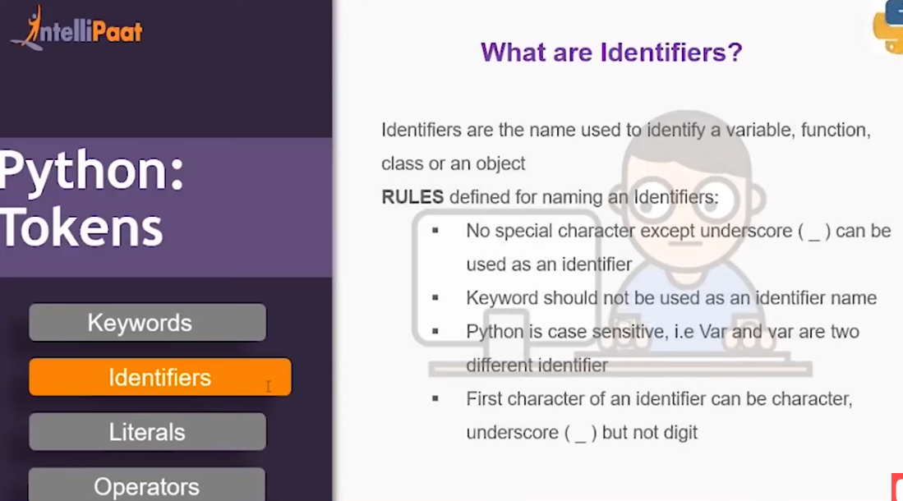

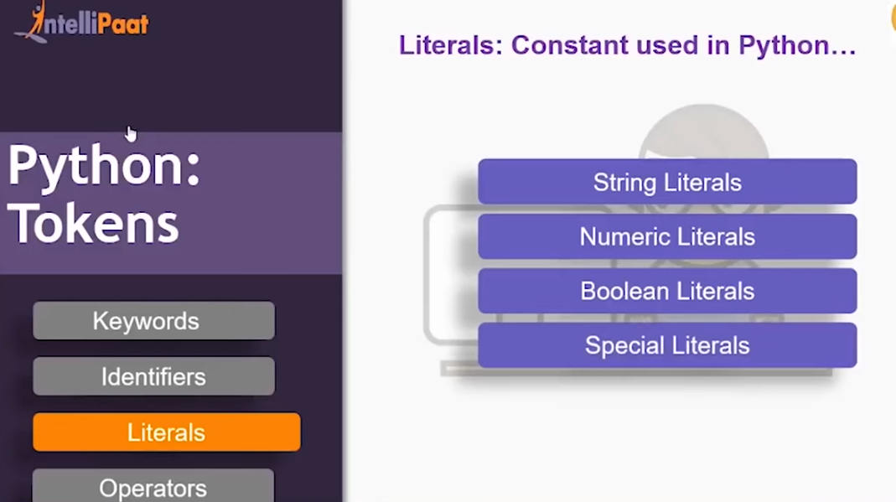

Address of Variables by Naveen Reddy (Watch upto 1:07:26)

<https://youtu.be/YfO28Ihehbk?t=3523>

Every variable has an address in the memory. To fetch the address of the variable, we can use a function called id()

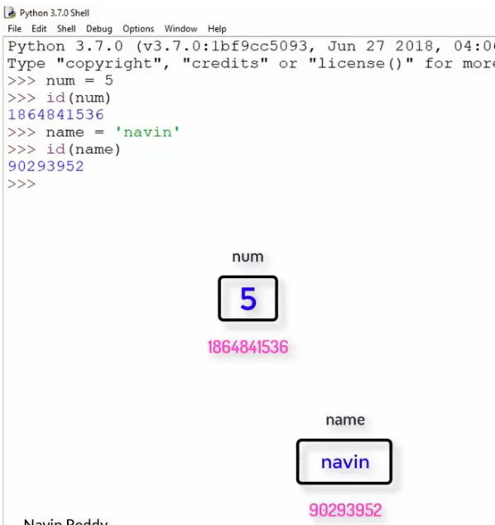

If 2 variables have the same value, they both will have the same address

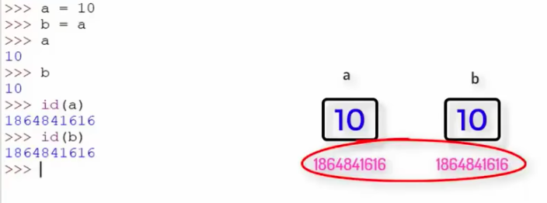

Data types in Python by Naveen Reddy (Watch upto 1:13:59)

<https://youtu.be/YfO28Ihehbk?t=4048>

The various data types in Python are :

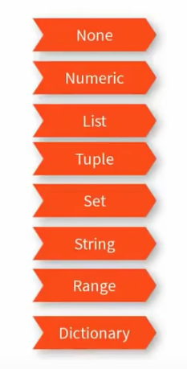

**NONE** means no value

**NUMERIC** are of the following kinds :

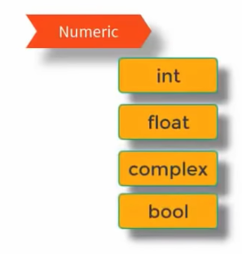

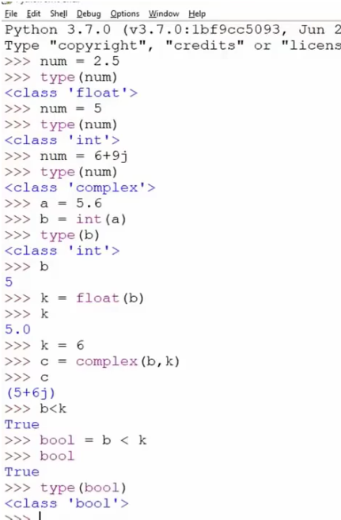

In Python, True is considered as 1 whereas False is considered as 0

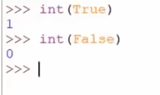

Data types by Durga

<https://www.youtube.com/watch?v=Y3ASaSgOQNo&list=PLd3UqWTnYXOnkicyzePnIg8rc2qEXgjiF&index=6>

Strings(37:37)

<https://youtu.be/_uQrJ0TkZlc?t=1774>

If we write like this, we will get error because Python interpreter does not understand this

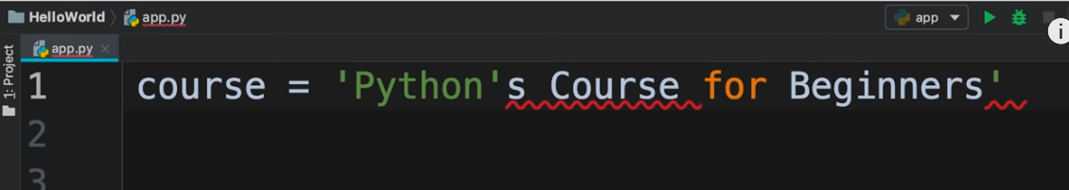

We can write like this

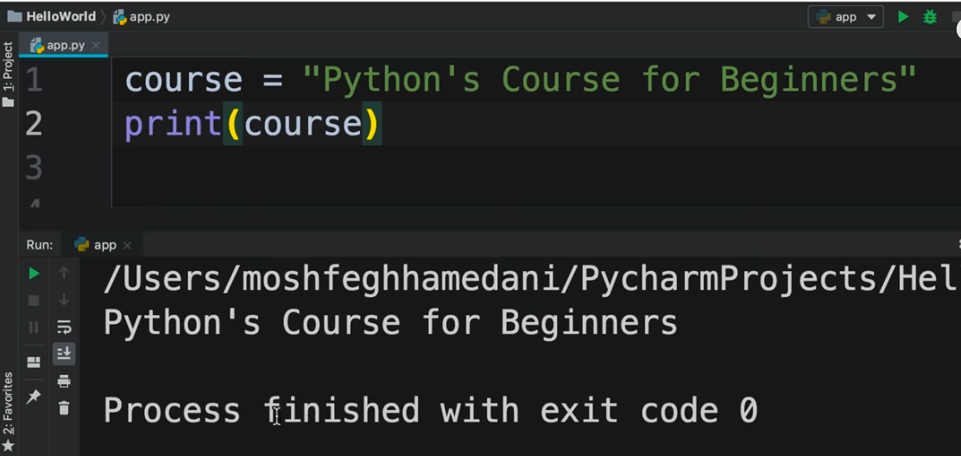

If we write like this, we will get error because Python interpreter does not understand this

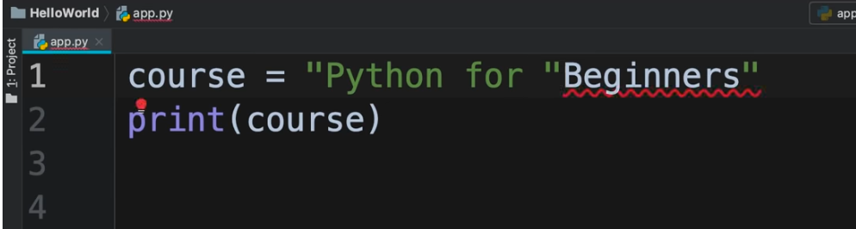

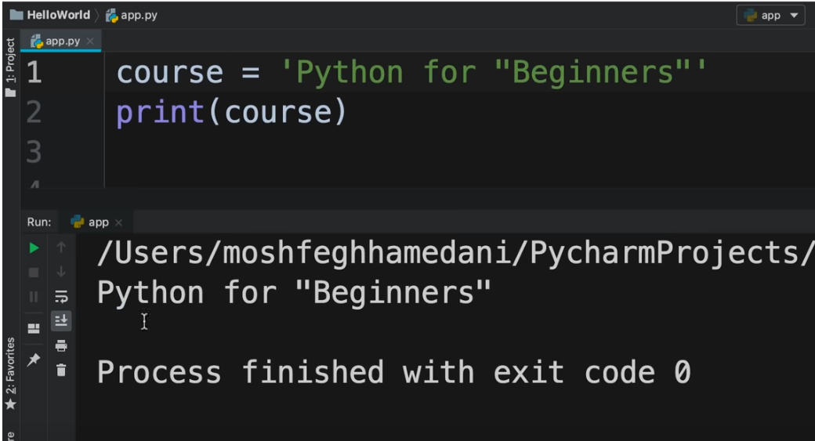

Suppose we want to define a string which is to be used for messaging i.e. a lengthy string spanning over multiple lines. For this, we can use triple quotes

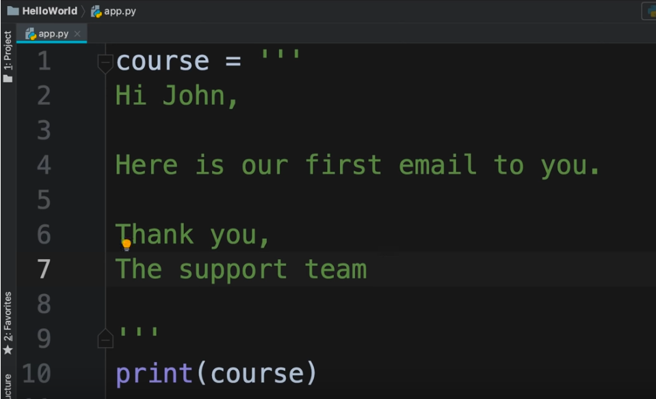

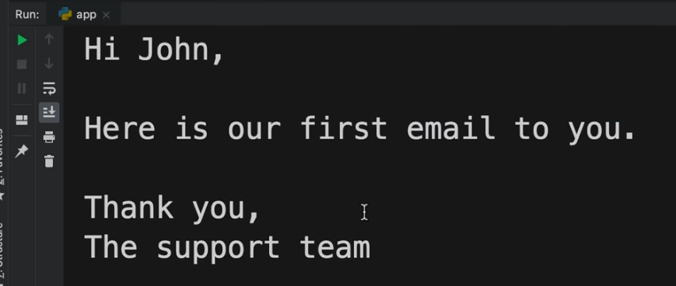

To find a character of a string

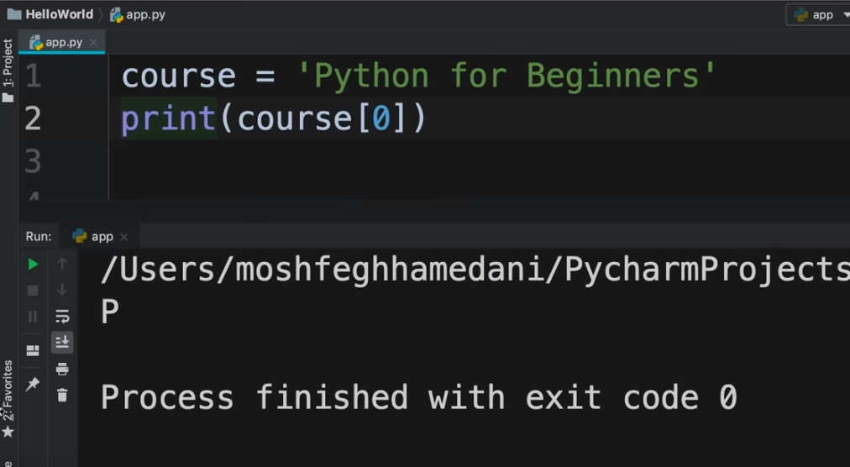

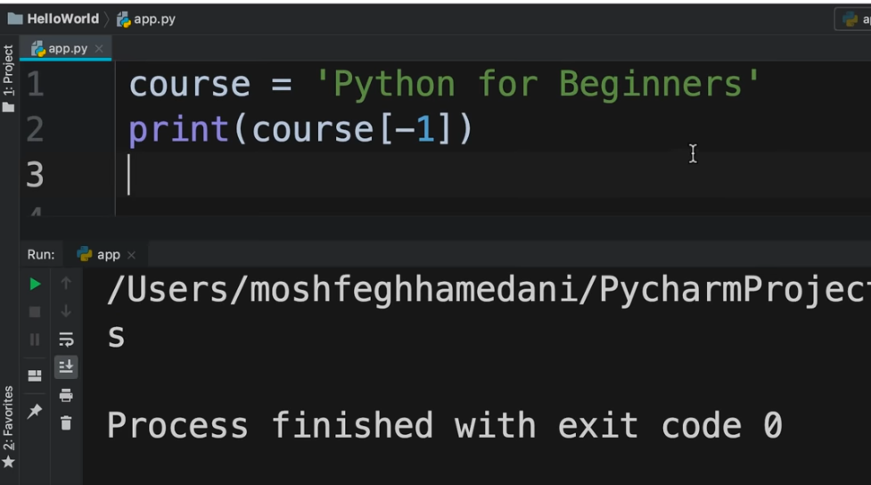

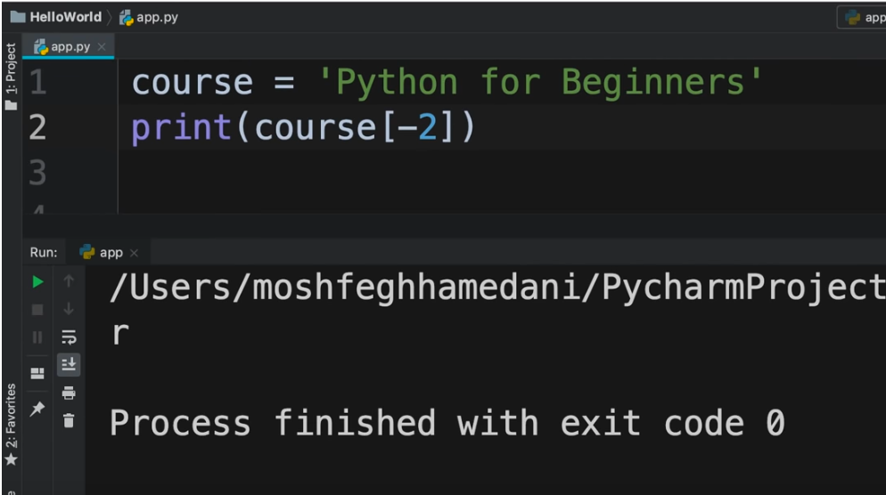

If we want characters for a range of index :

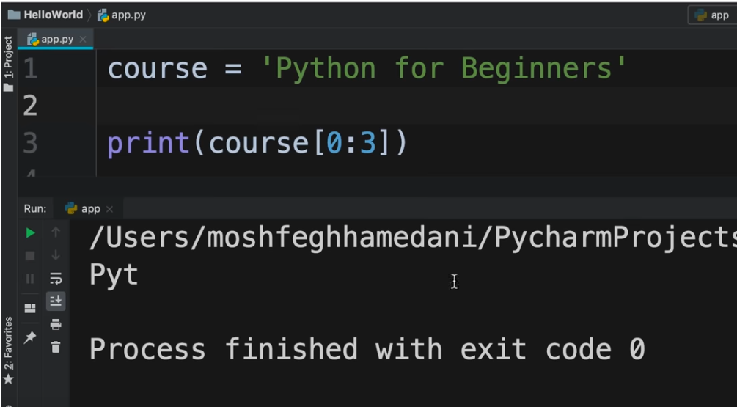

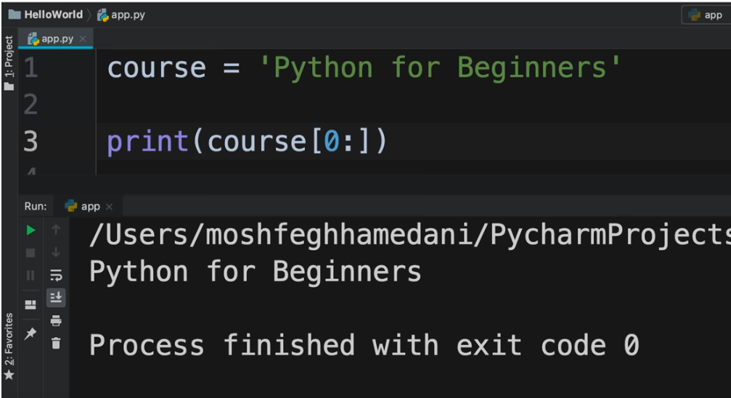

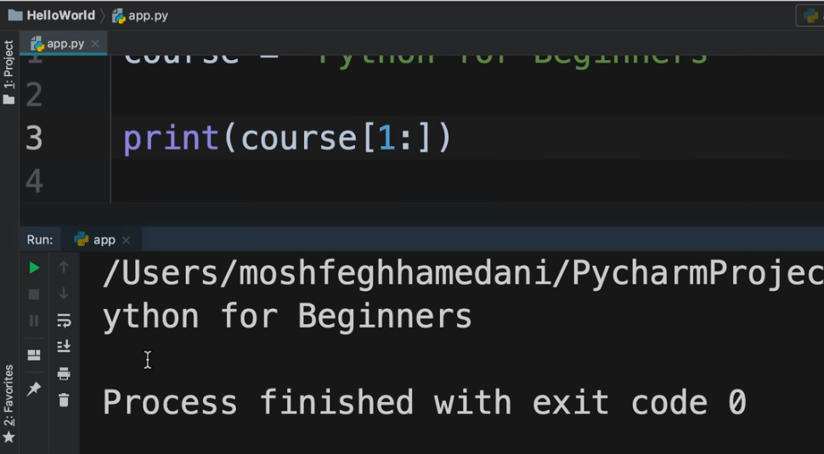

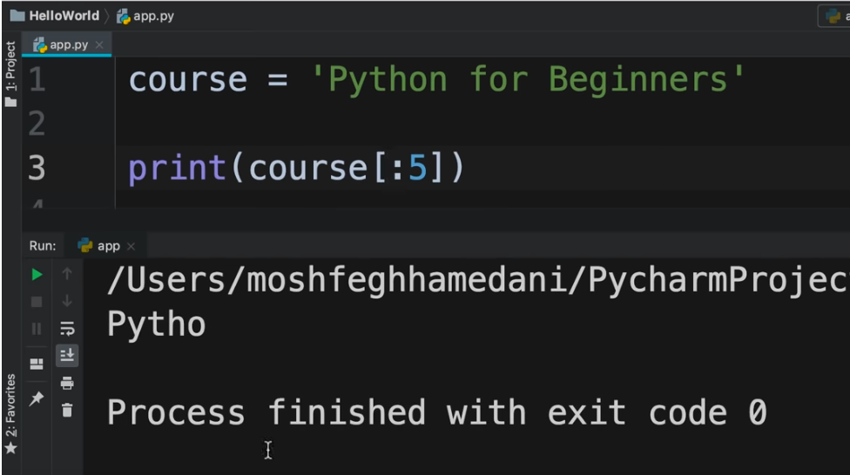

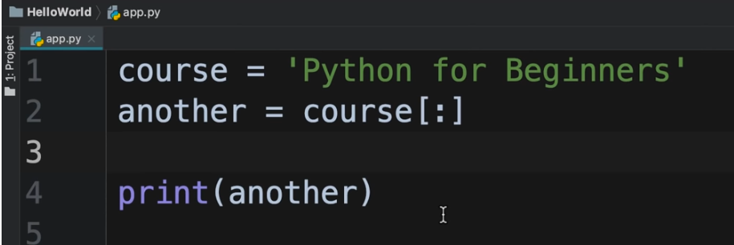

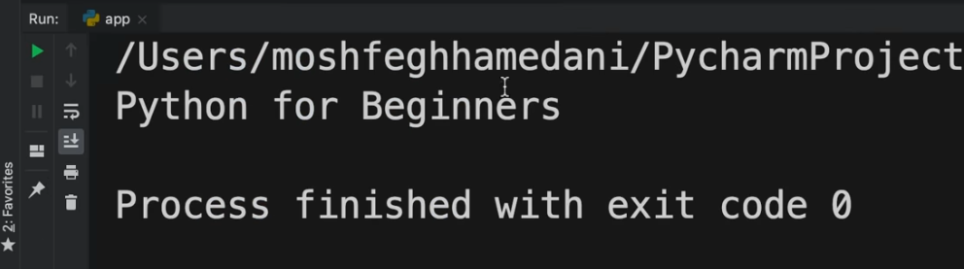

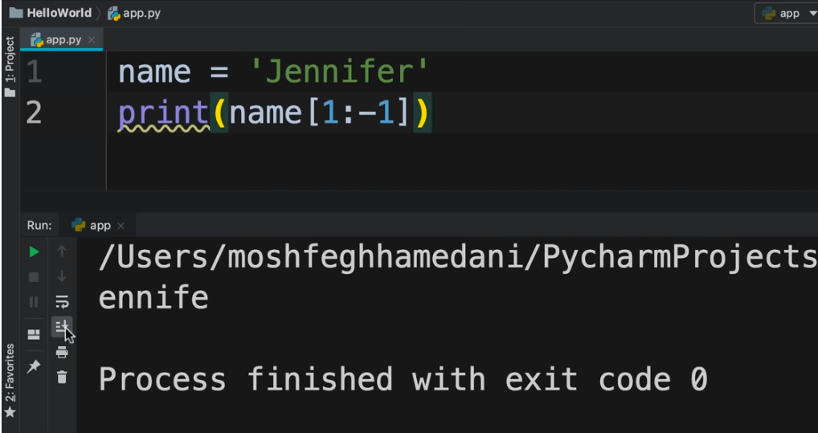

Formatted strings(40:51)

<https://youtu.be/_uQrJ0TkZlc?t=2259>

Formatted strings are useful where we want to generate some text dynamically

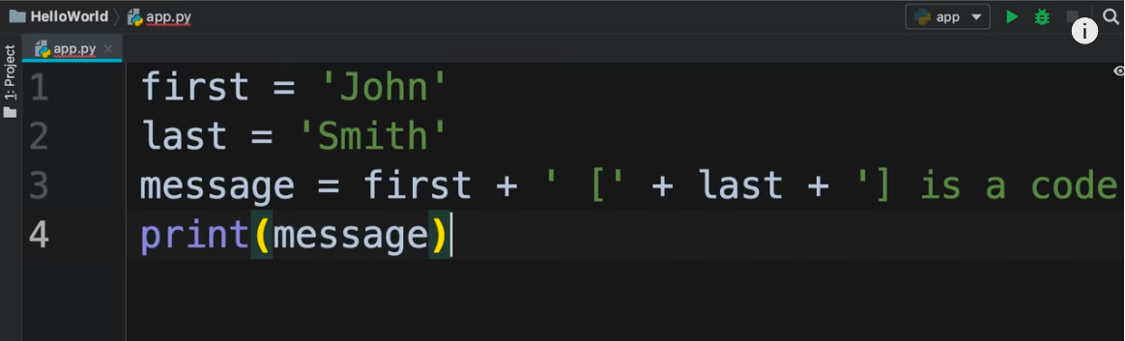

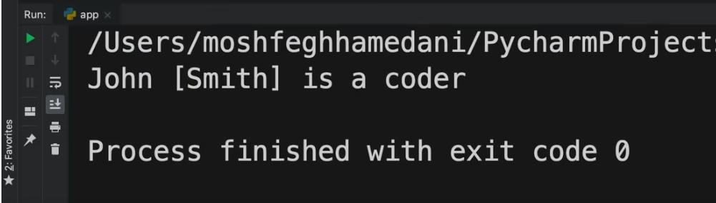

The above approach is not ideal when the text becomes lengthy. In such a case, we can use formatted string

Formatted string is prefixed with **f** and enclosed between single quotes. { } are placeholders

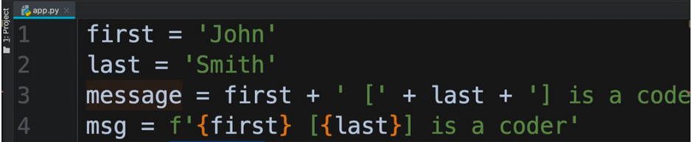

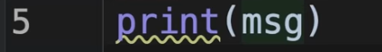

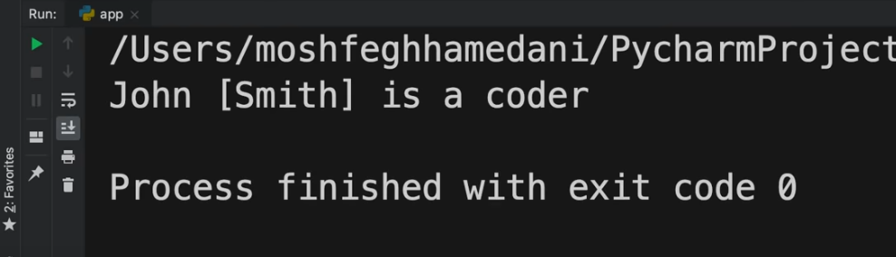

String methods(48:35)

<https://youtu.be/_uQrJ0TkZlc?t=2453>

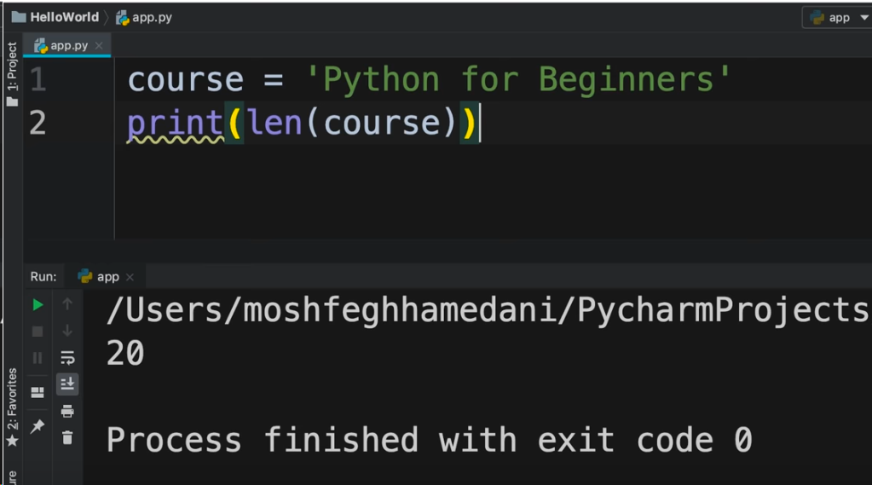

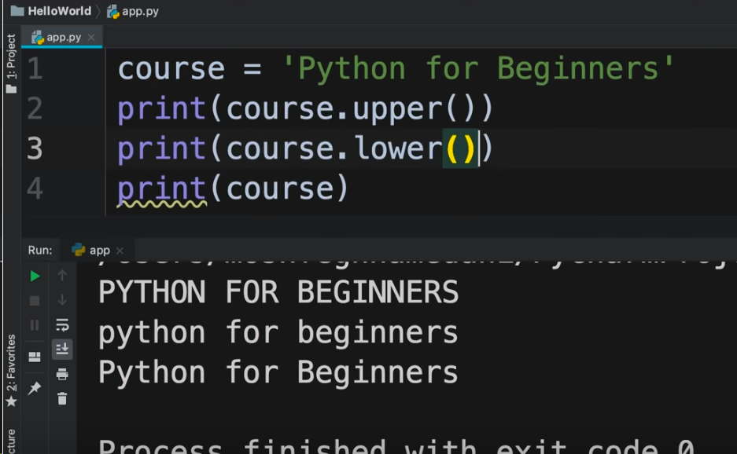

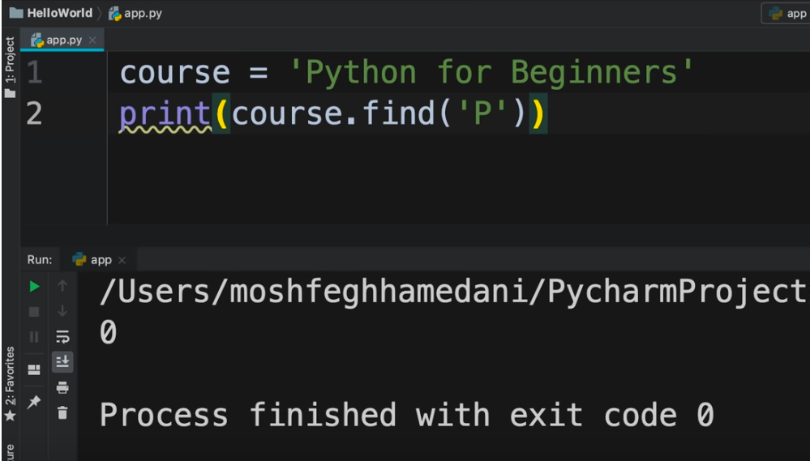

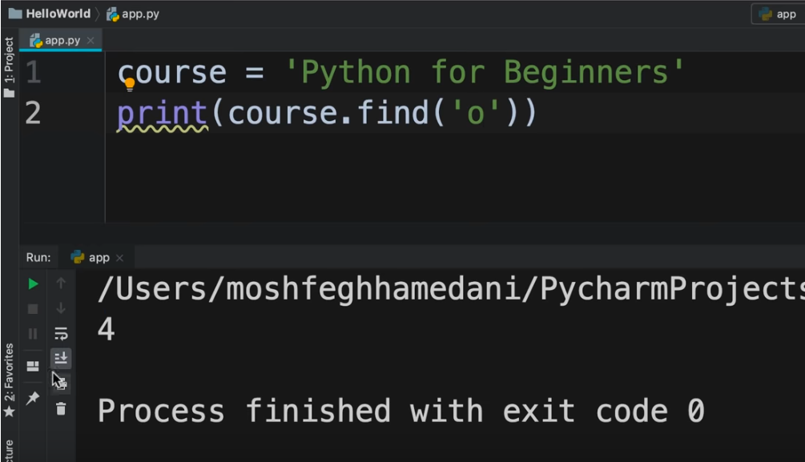

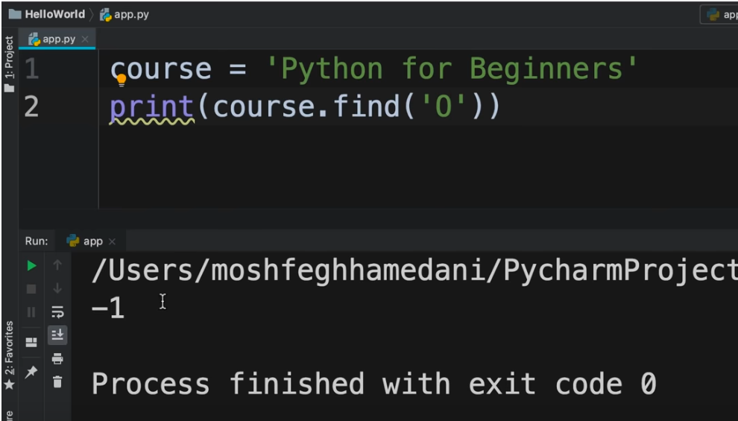

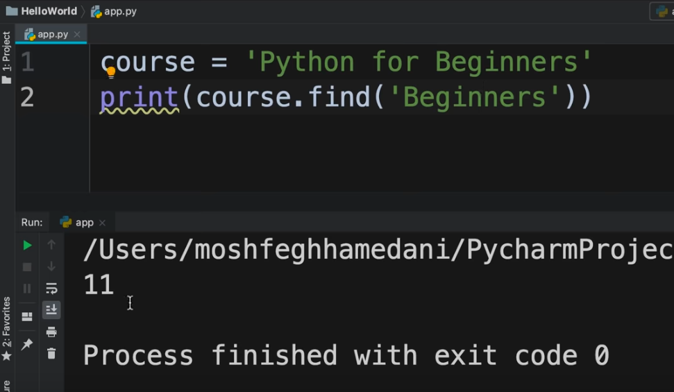

To replace a character or sequence of characters, we can use **replace()** method

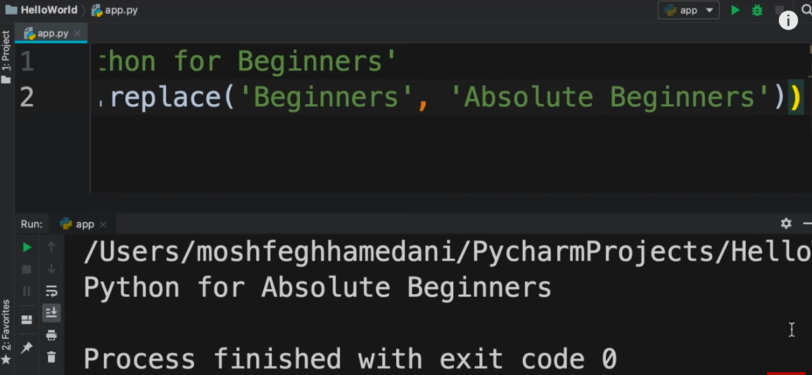

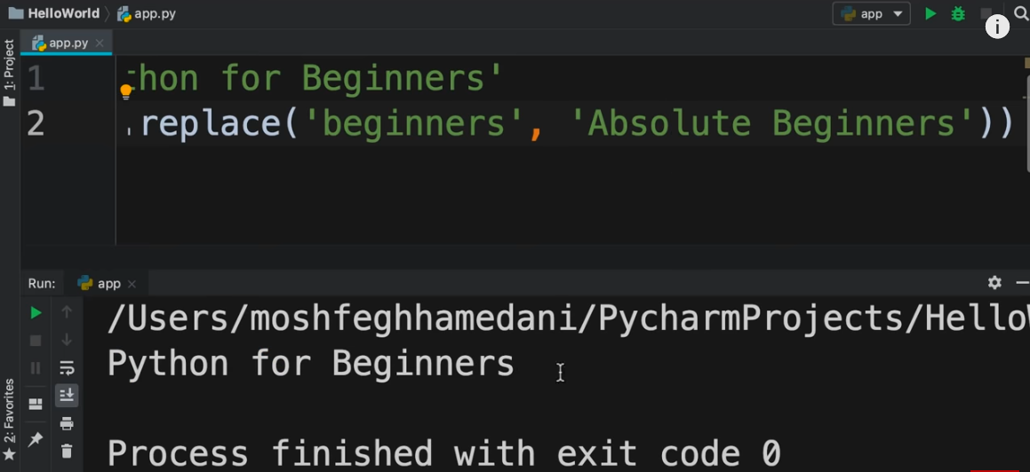

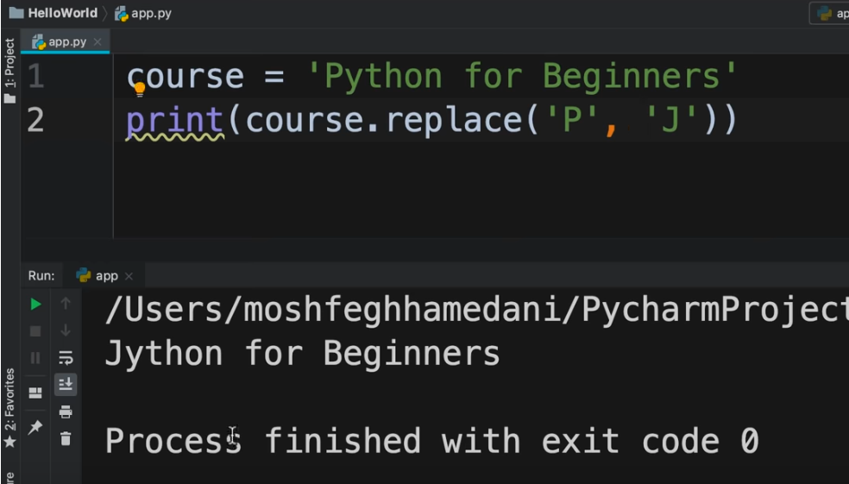

Suppose we want to check the existence of a character or sequence of characters in a string. For this, we can use **in**

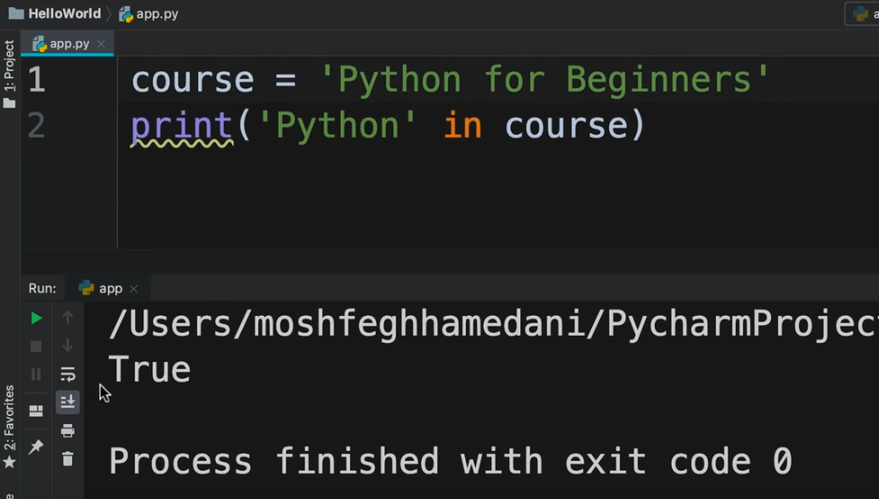

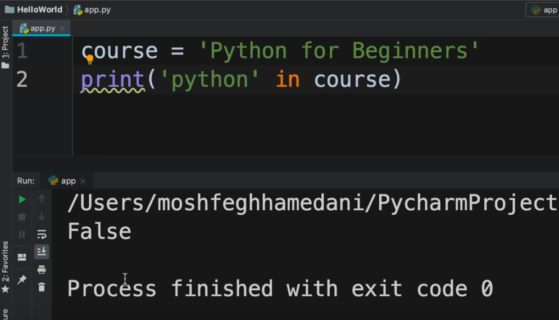

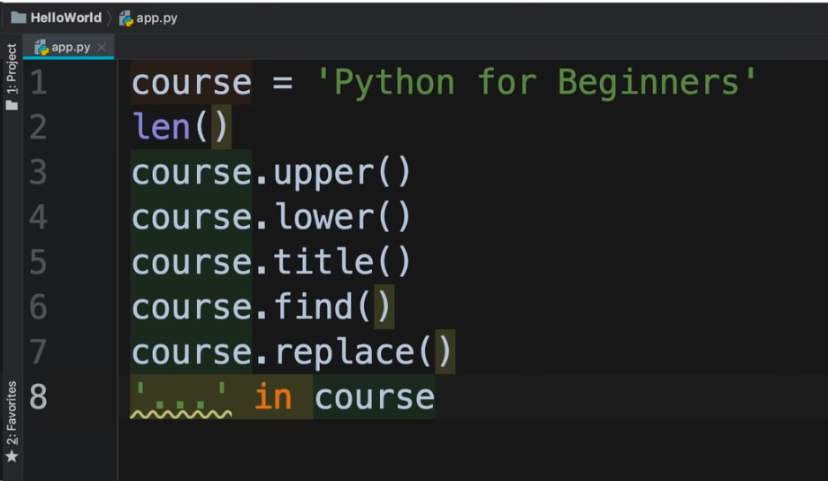

Arithmetic Operations(51:33)

<https://youtu.be/_uQrJ0TkZlc?t=2917>

Operator precedence(55:06)

<https://youtu.be/_uQrJ0TkZlc?t=3097>

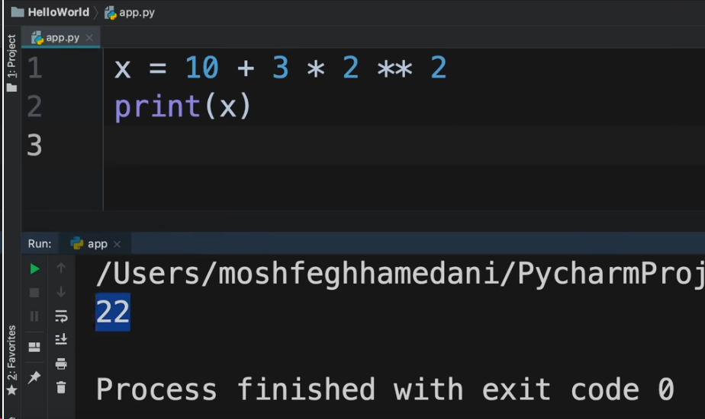

To declare list in Python :

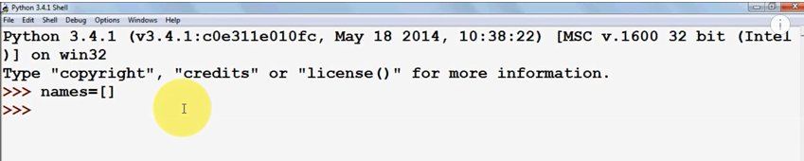

This is an empty list

A list can have any number of values ie. from 0 to any number

If we execute the list :

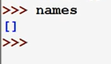

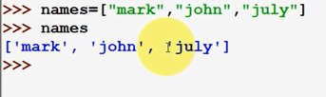

The index denotes the position of a value in the list

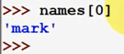

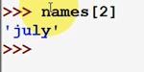

We also have the index starting in reverse direction i.e. -1, -2, -3 etc

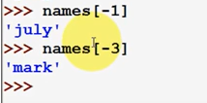

To add more values to the list

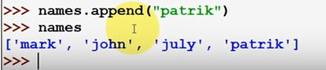

To add 2 lists

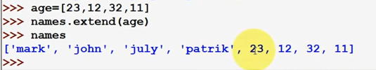

NOTE : List in python can contain values of different types

To remove items from a list :

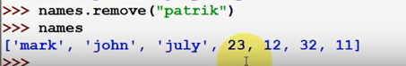

To print a list :

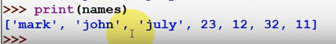

To print multiple lists :



To find the length of list :

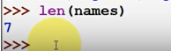

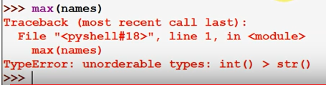

This gives an error because the “names” list contains values of both string type and int type

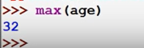

In Python, there is a concept called Slicing used to separate a slice/portion from a list

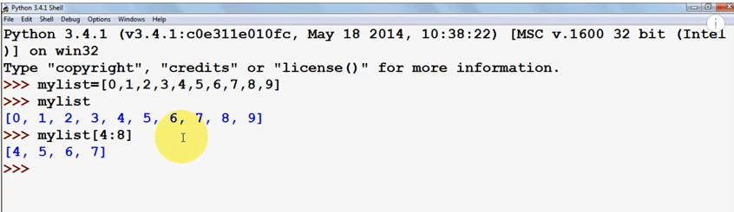

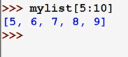

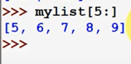

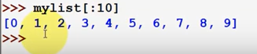

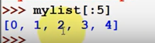

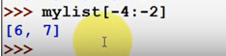

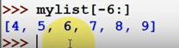

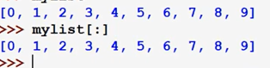

If we want to skip some values in the list :

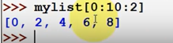

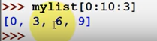

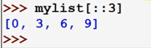

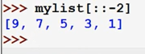

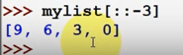

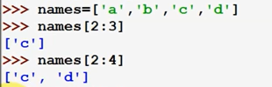

List (2:01:51)

<https://youtu.be/_uQrJ0TkZlc?t=6959>

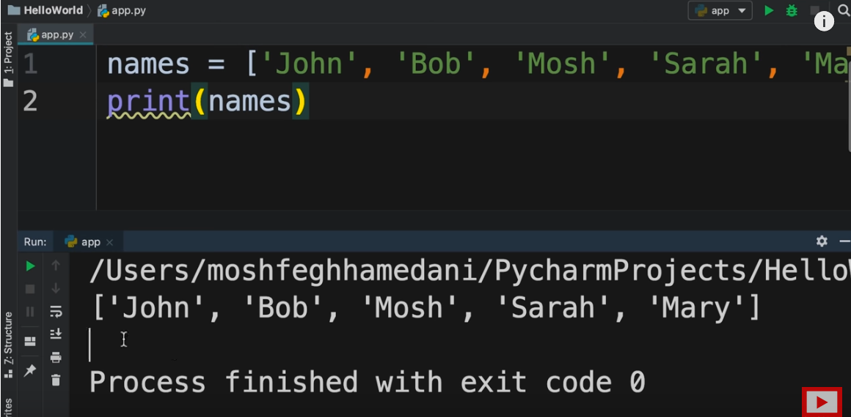

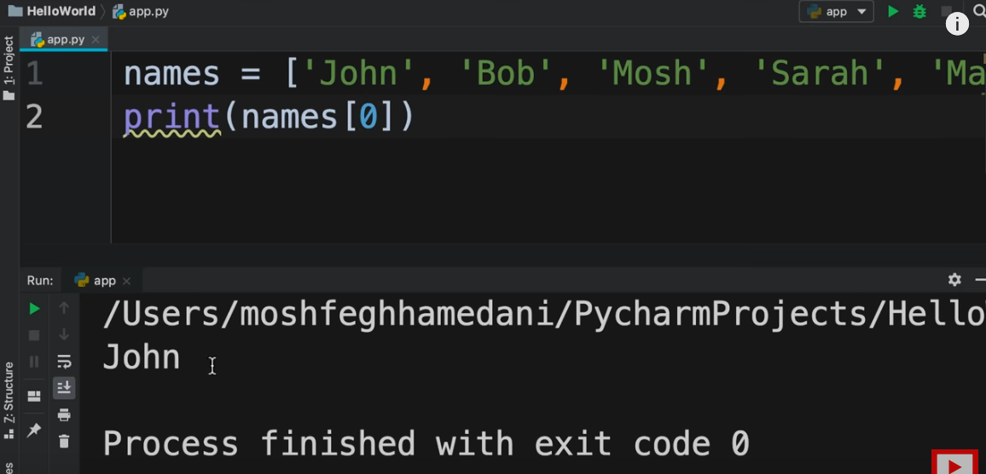

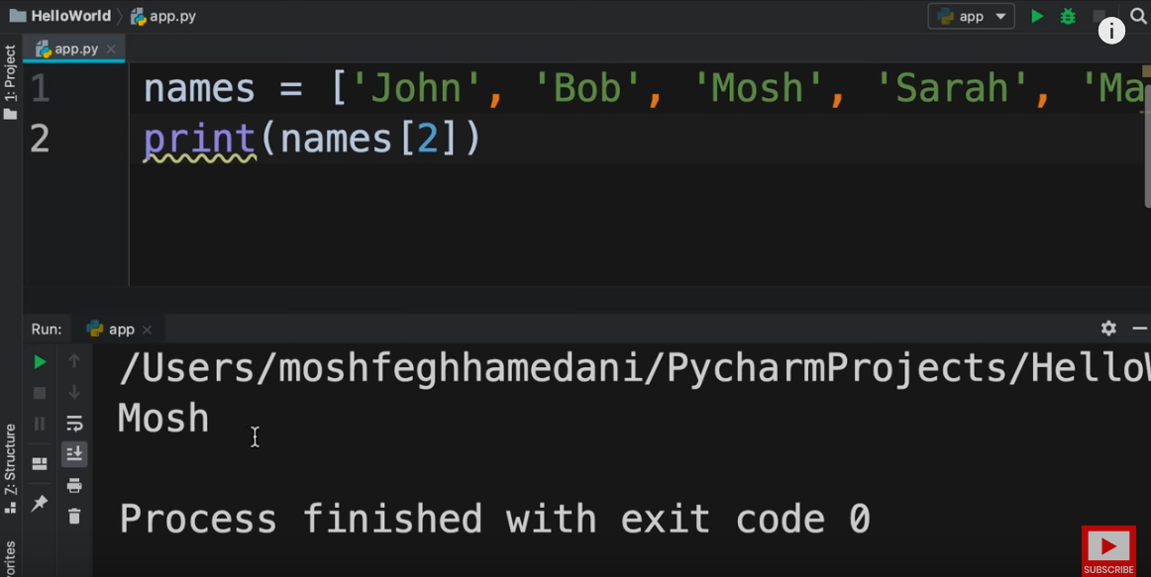

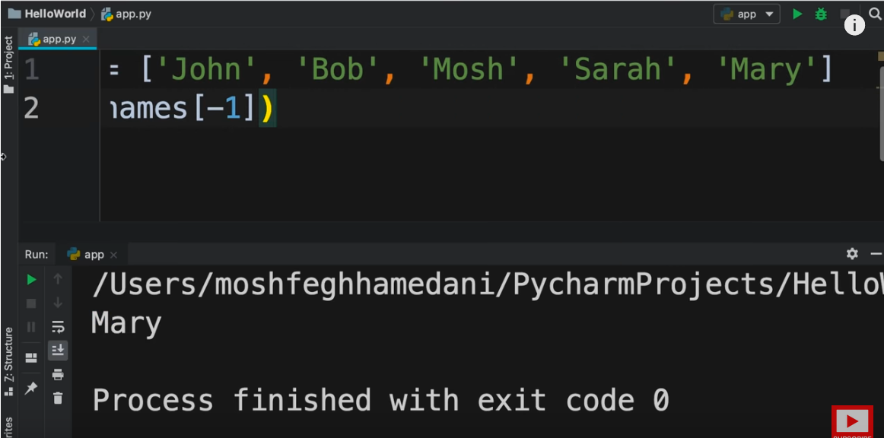

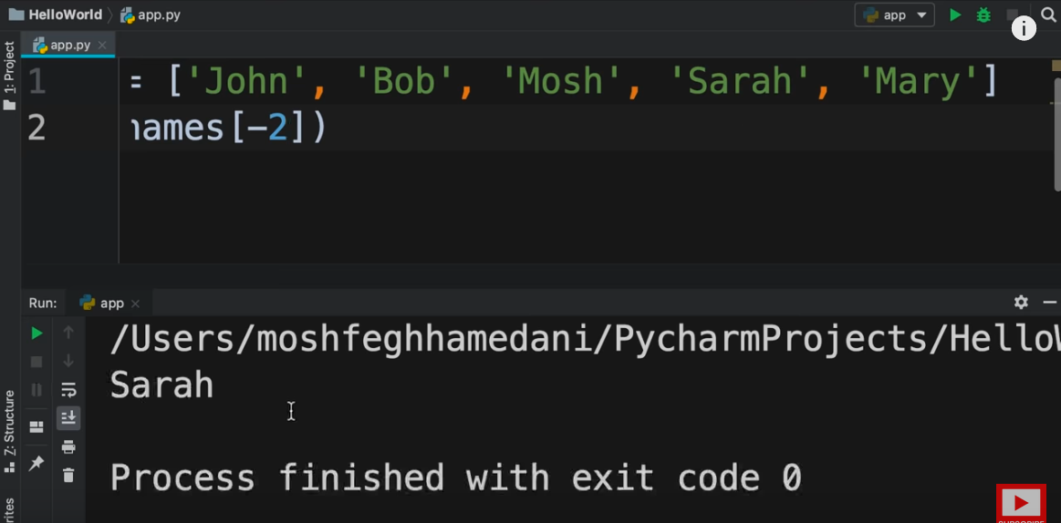

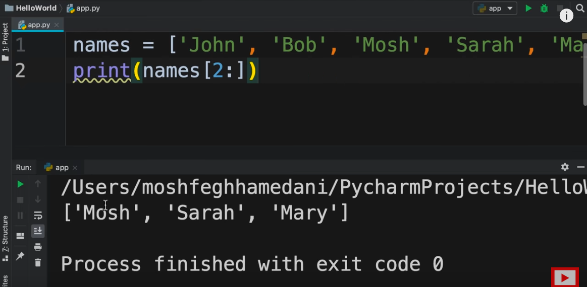

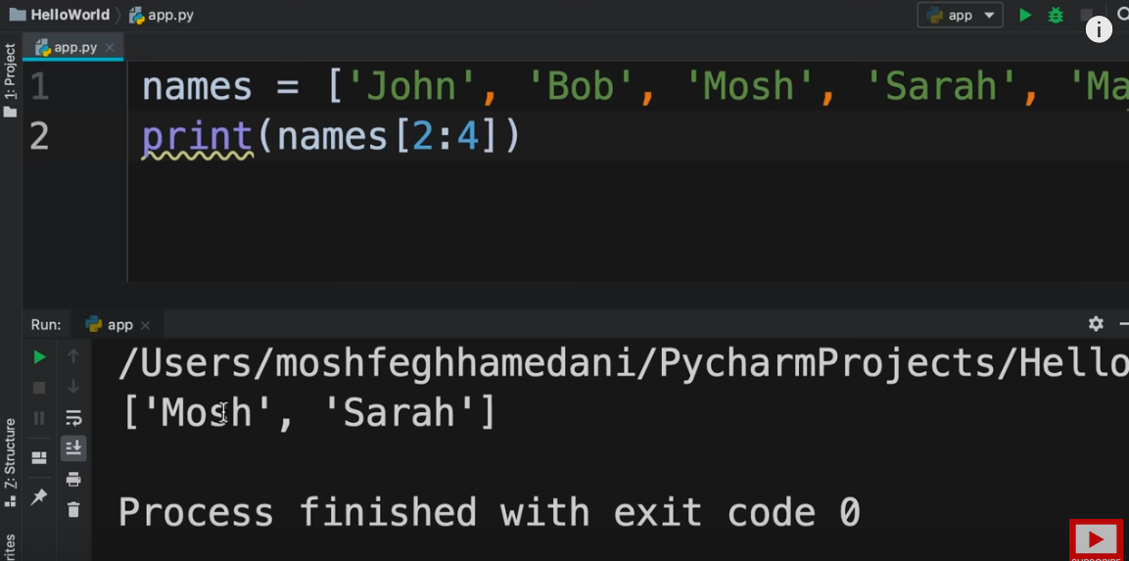

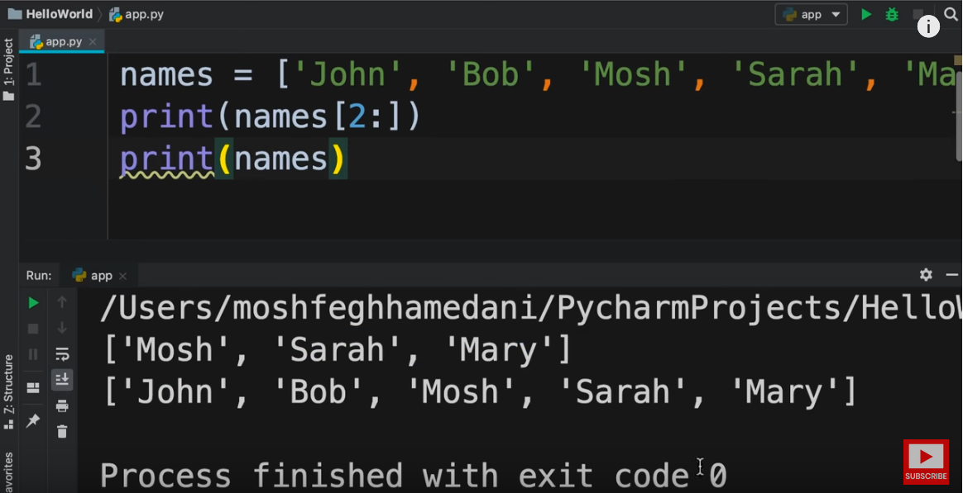

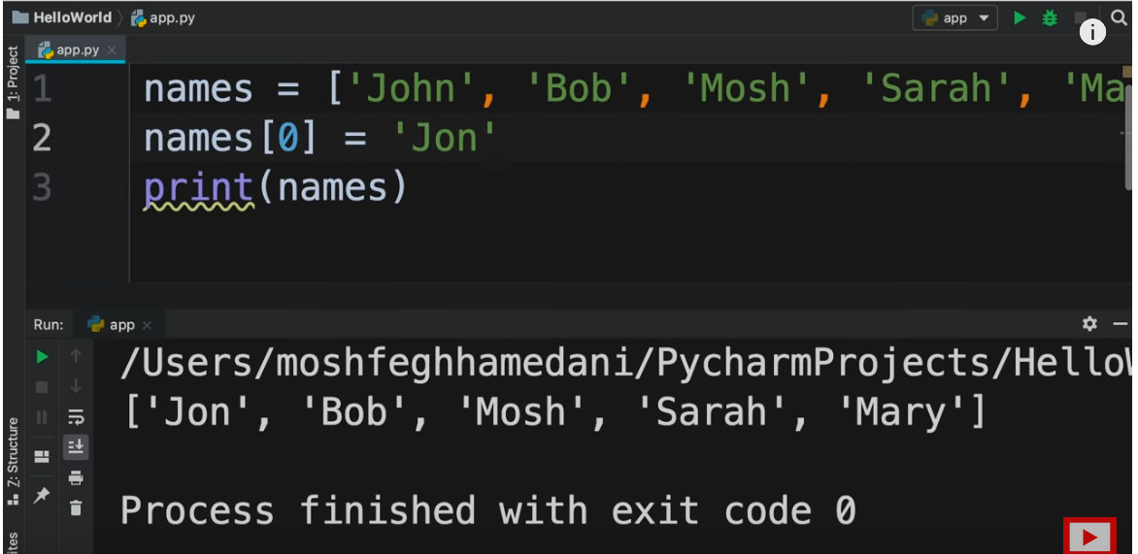

2D List

<https://youtu.be/_uQrJ0TkZlc?t=7314>

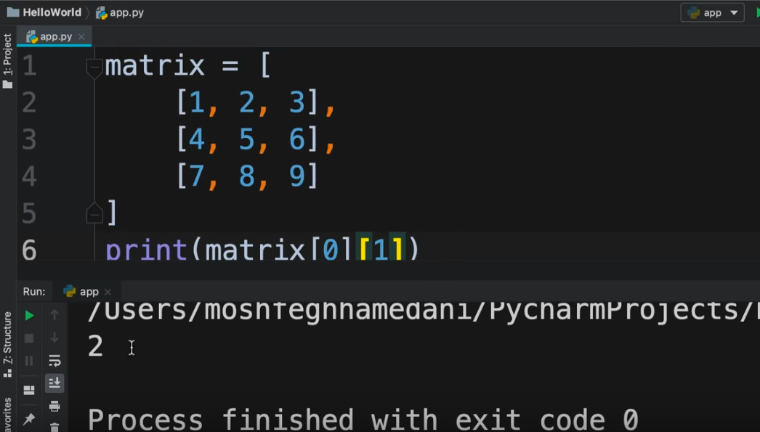

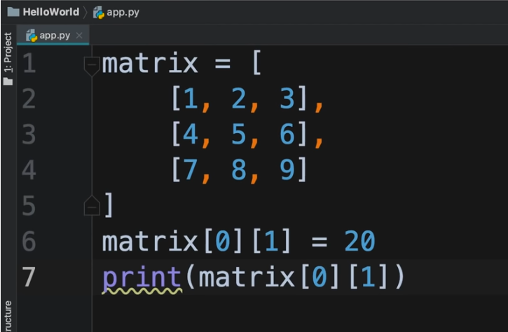

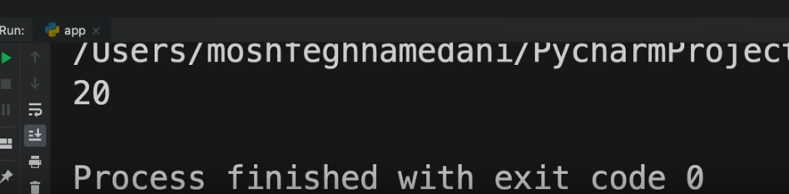

List Methods

<https://youtu.be/_uQrJ0TkZlc?t=7569>

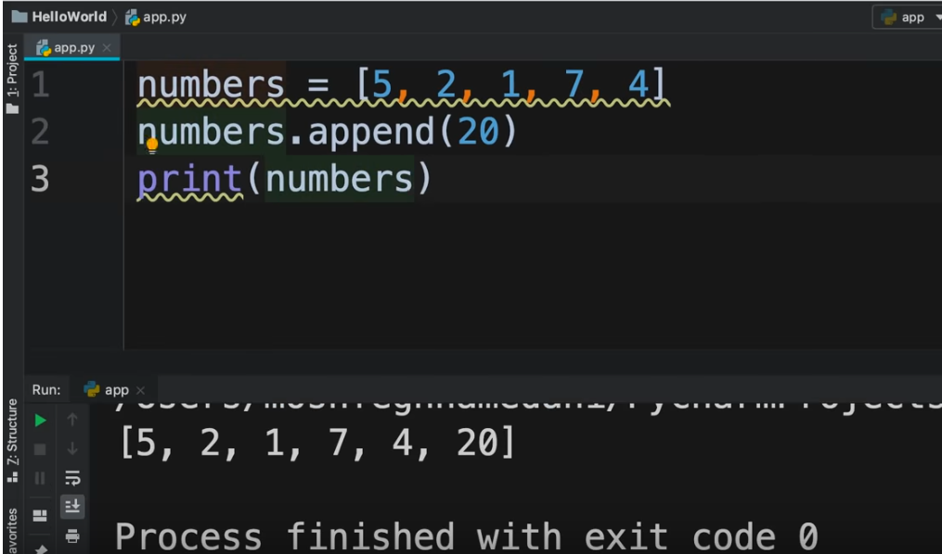

To insert element in a list at a particular index

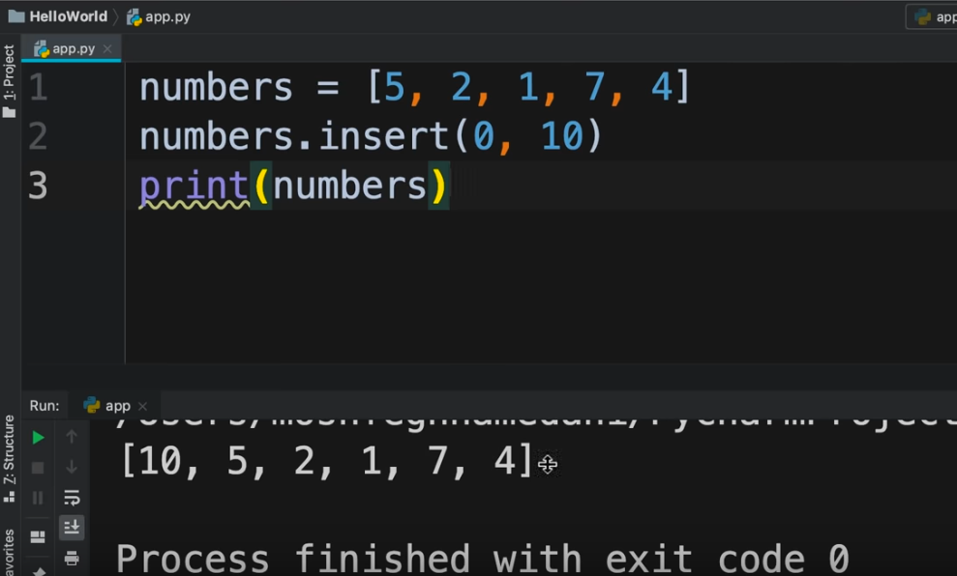

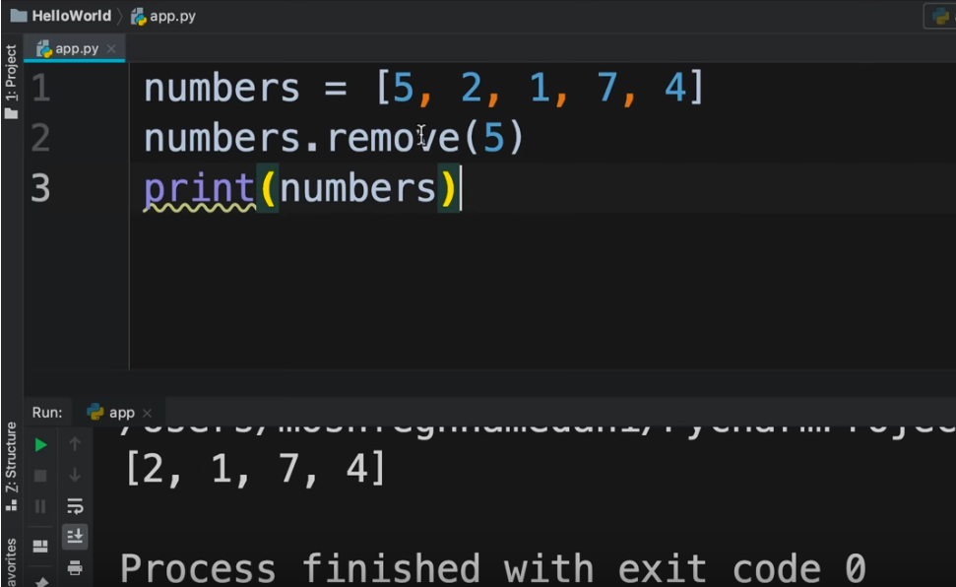

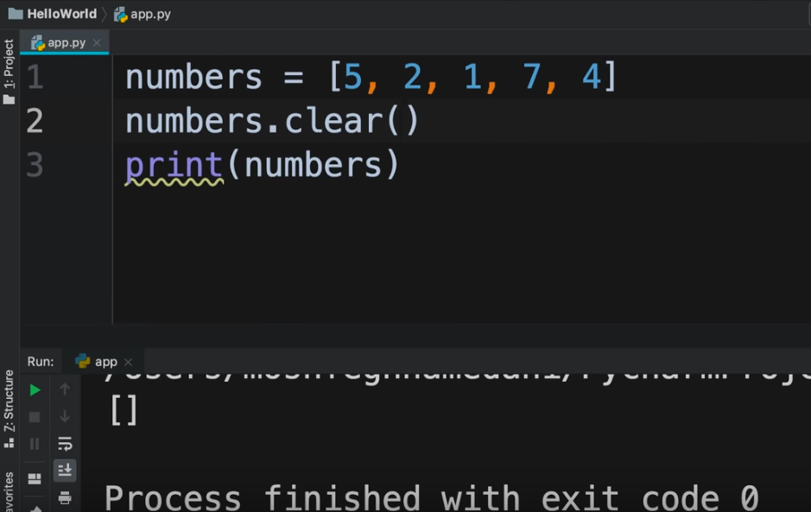

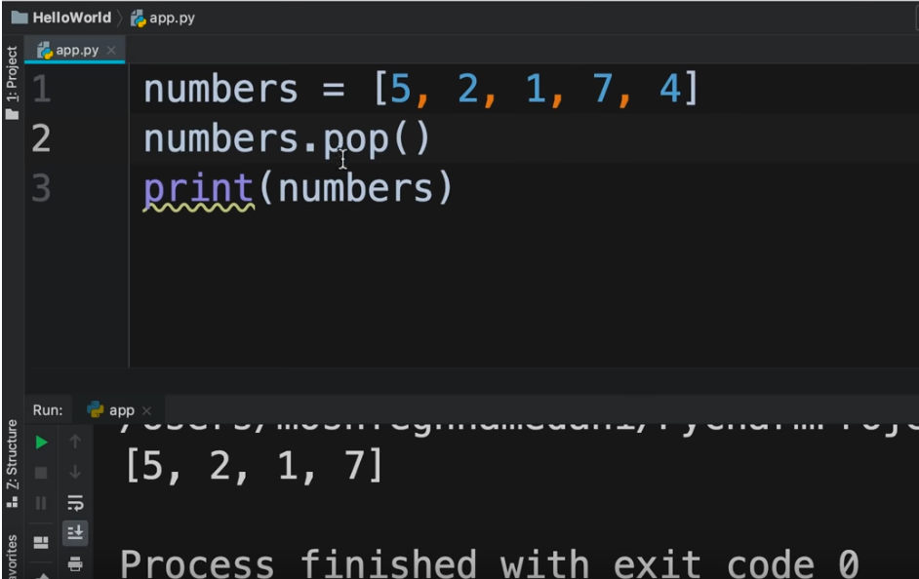

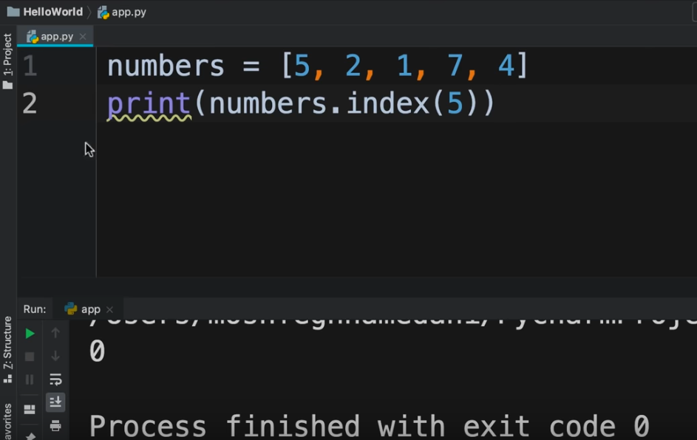

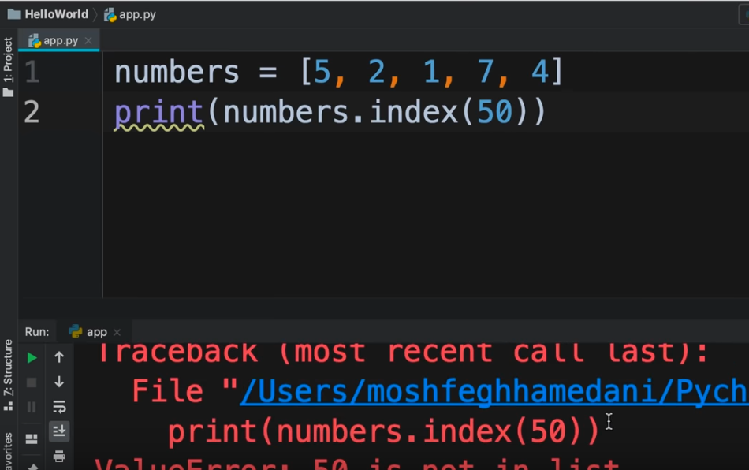

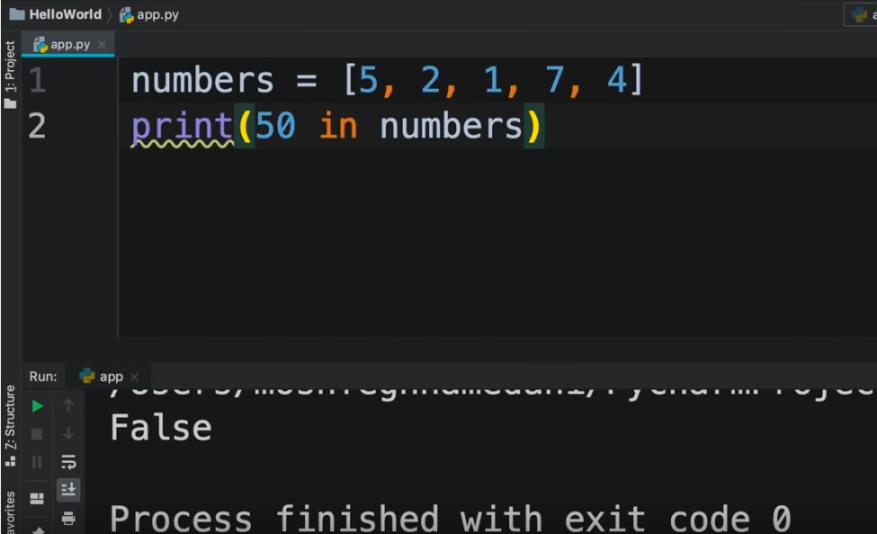

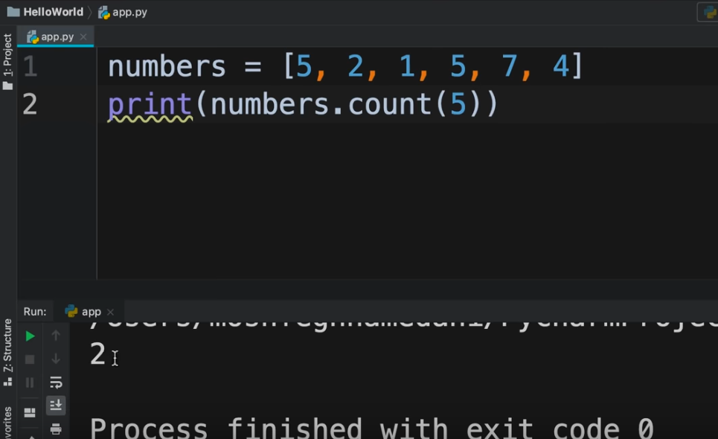

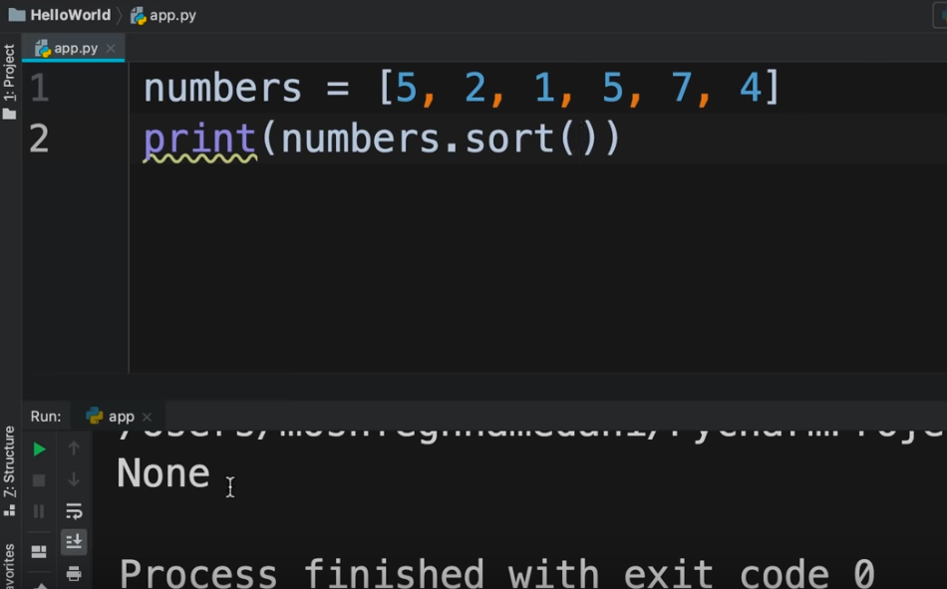

**None** is an object in Python that represents the absence of value

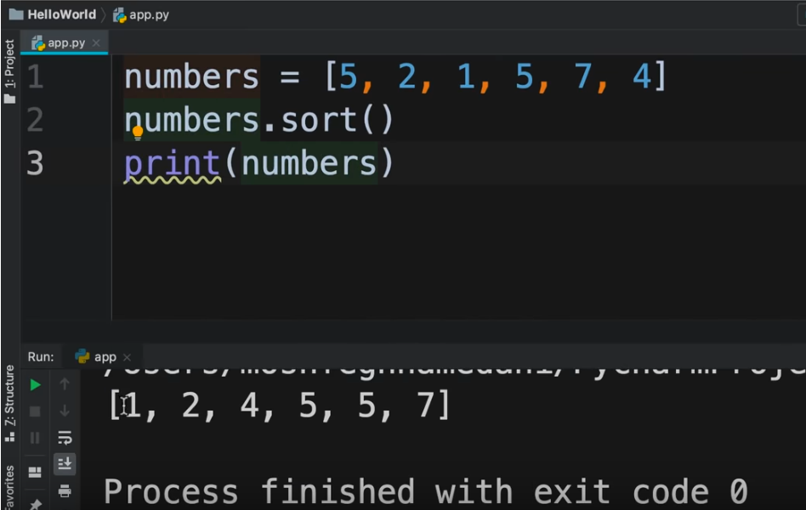

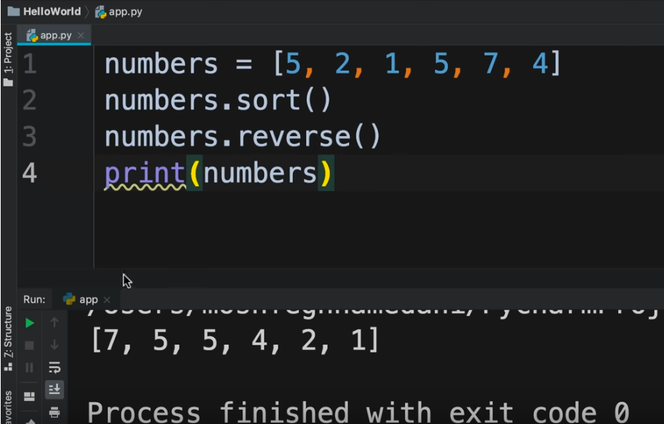

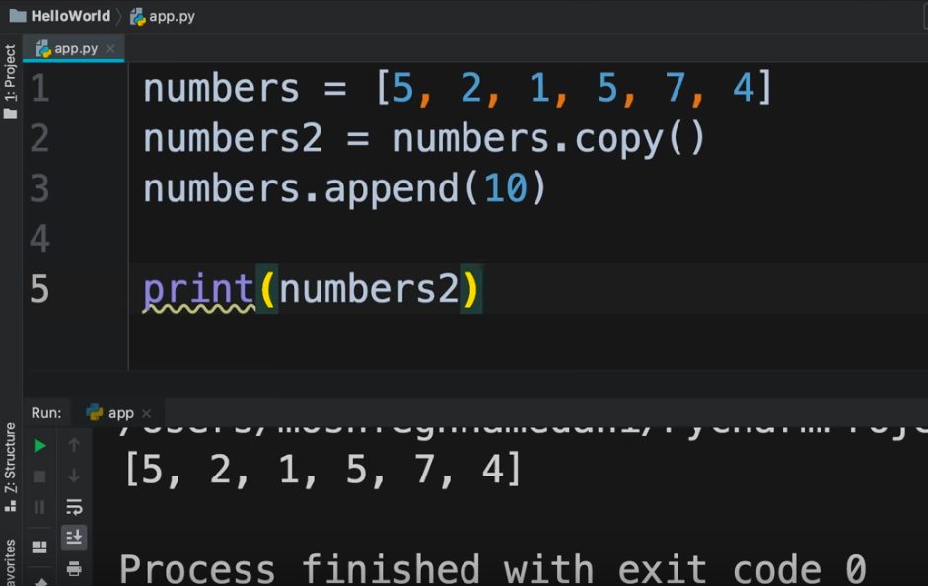

List by Naveen Reddy (Watch upto 46:57)

<https://youtu.be/YfO28Ihehbk?t=2205>

List is mutable

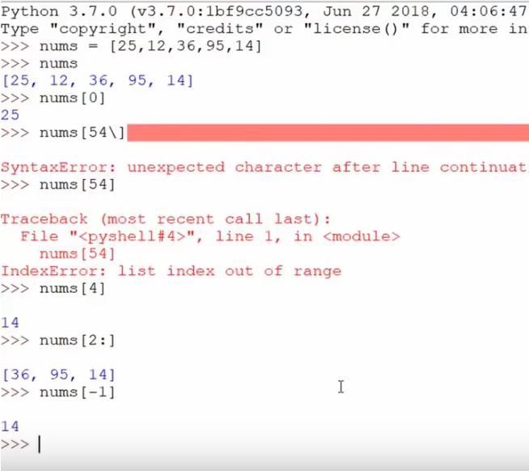

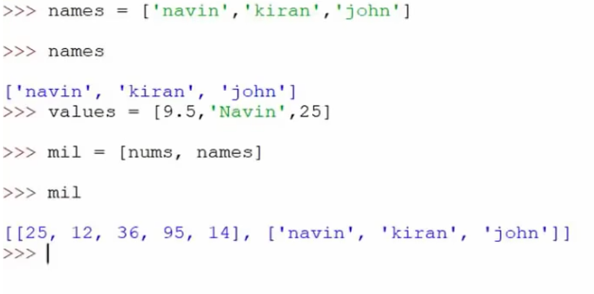

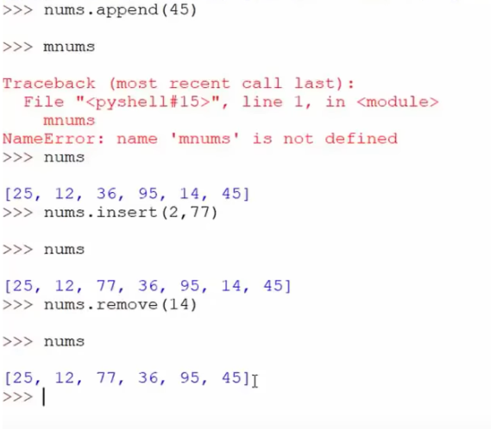

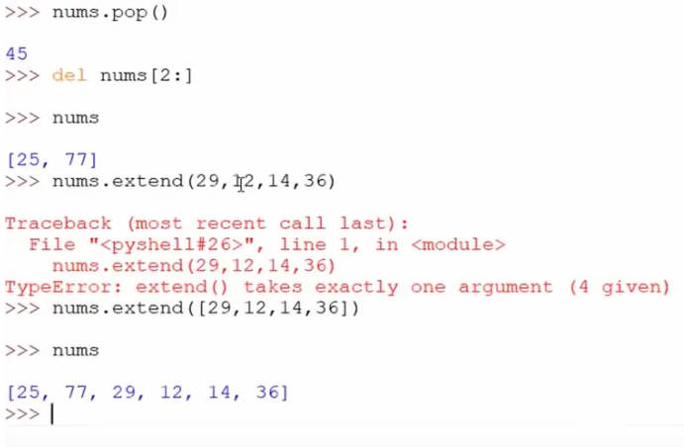

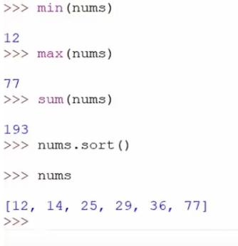

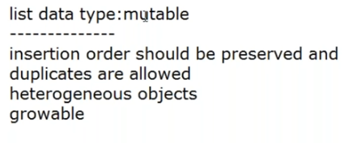

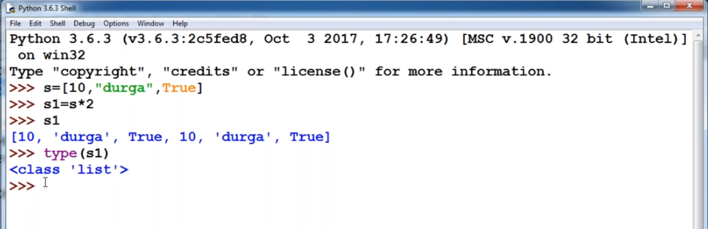

**IF ELSE**

Suppose we want to find the absolute value of a number

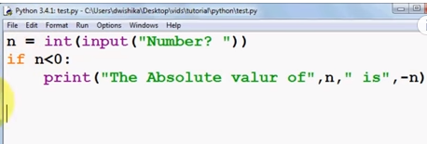

On execution :

<https://youtu.be/-nJvt_7l-sk?list=PLS1QulWo1RIaJECMeUT4LFwJ-ghgoSH6n&t=284>

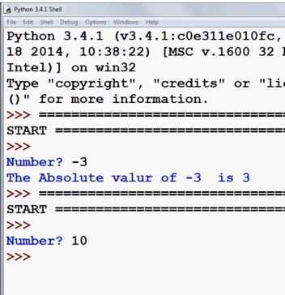

If we write like this

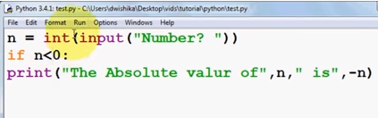

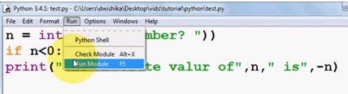

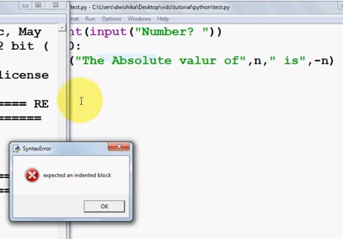

**indentation** means a space or tab

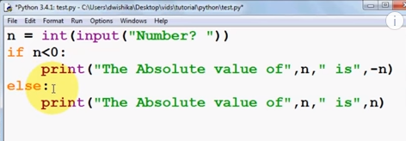

On execution :

<https://youtu.be/-nJvt_7l-sk?list=PLS1QulWo1RIaJECMeUT4LFwJ-ghgoSH6n&t=508>

Suppose we write like this

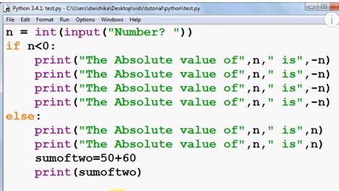

On execution :

<https://youtu.be/-nJvt_7l-sk?list=PLS1QulWo1RIaJECMeUT4LFwJ-ghgoSH6n&t=683>

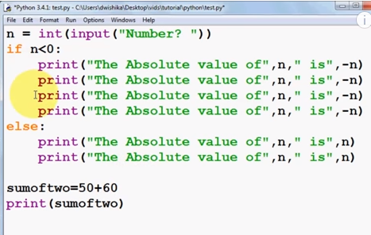

On execution :

<https://youtu.be/-nJvt_7l-sk?list=PLS1QulWo1RIaJECMeUT4LFwJ-ghgoSH6n&t=742>

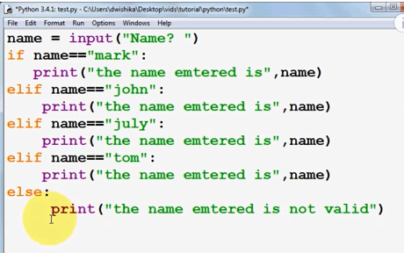

On execution :

<https://youtu.be/1QfPTboc1Pw?list=PLS1QulWo1RIaJECMeUT4LFwJ-ghgoSH6n&t=236>

**Nested if statement**

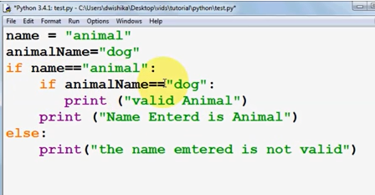

On execution :

<https://youtu.be/1QfPTboc1Pw?list=PLS1QulWo1RIaJECMeUT4LFwJ-ghgoSH6n&t=540>

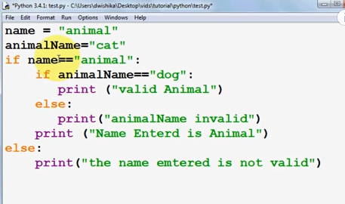

On execution :

<https://youtu.be/1QfPTboc1Pw?list=PLS1QulWo1RIaJECMeUT4LFwJ-ghgoSH6n&t=663>

If statements(Watch upto 1:06:34)

<https://youtu.be/_uQrJ0TkZlc?t=3502>

IF ELSE by Naveen Reddy (Watch upto 2:38:55)

<https://youtu.be/YfO28Ihehbk?t=8634>

**Comparison and Logical operators**

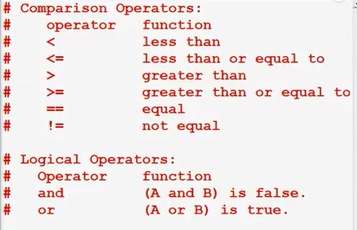

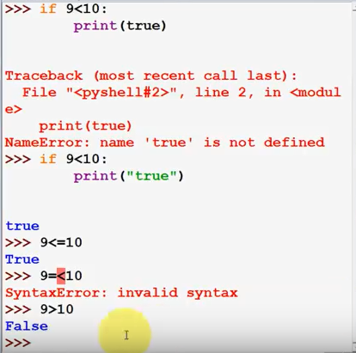

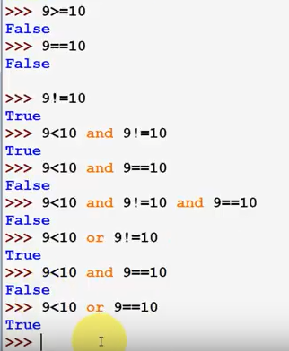

To check if a character/characters is present in a String or not

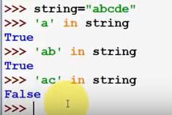

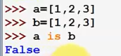

a and b are mathematically equal but they are not logically equal

Logical operators(Watch upto 1:11:28)

<https://youtu.be/_uQrJ0TkZlc?t=3997>

Comparison operators(1:16:20)

<https://youtu.be/_uQrJ0TkZlc?t=4291>

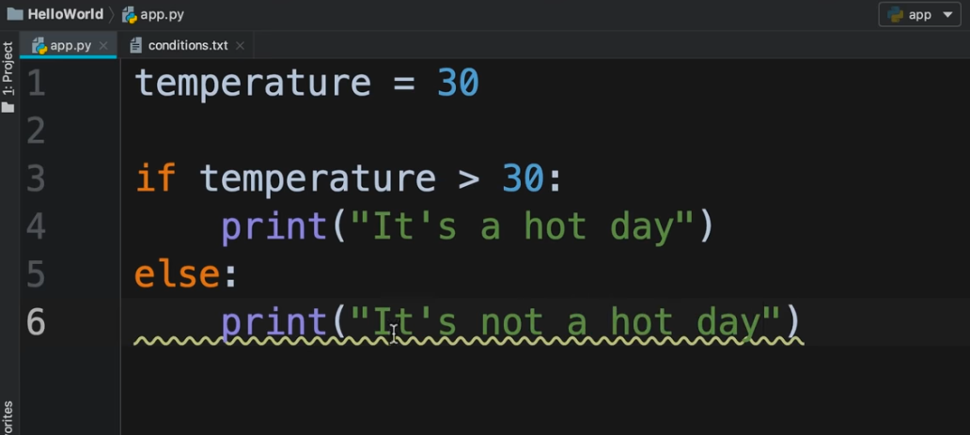

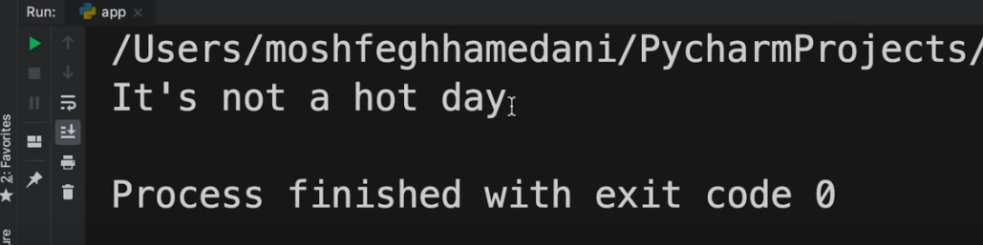

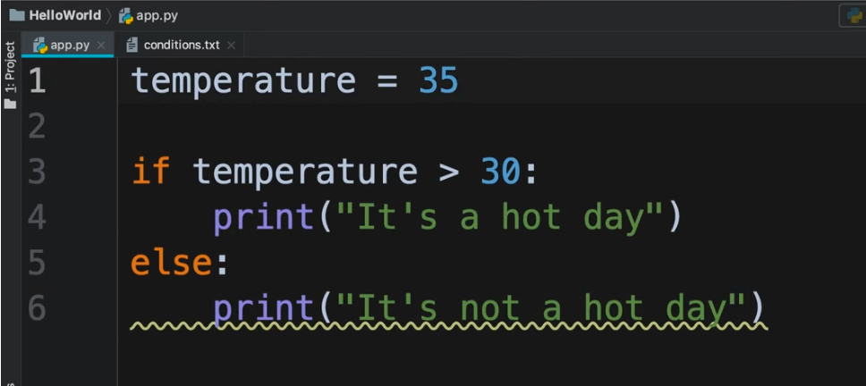

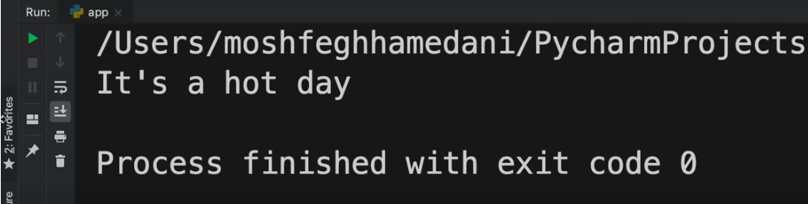

Weight converter Problem(1:20:46)

<https://youtu.be/_uQrJ0TkZlc?t=4583>

**WHILE and FOR Loop**

<https://youtu.be/YuVcBm_J2js?list=PLS1QulWo1RIaJECMeUT4LFwJ-ghgoSH6n&t=587>

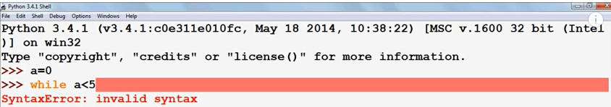

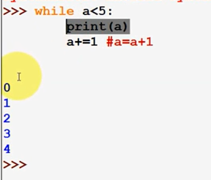

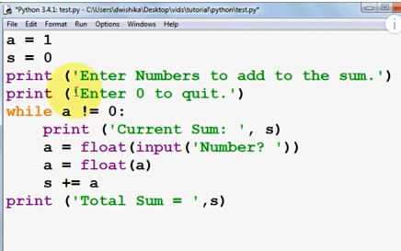

On execution :

<https://youtu.be/26VtIlzEcmU?list=PLS1QulWo1RIaJECMeUT4LFwJ-ghgoSH6n&t=332>

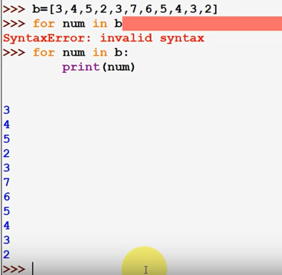

<https://youtu.be/TkBLZk_hV5Y?list=PLS1QulWo1RIaJECMeUT4LFwJ-ghgoSH6n&t=1>

WHILE Loop(1:24:11)

<https://youtu.be/_uQrJ0TkZlc?t=4850>

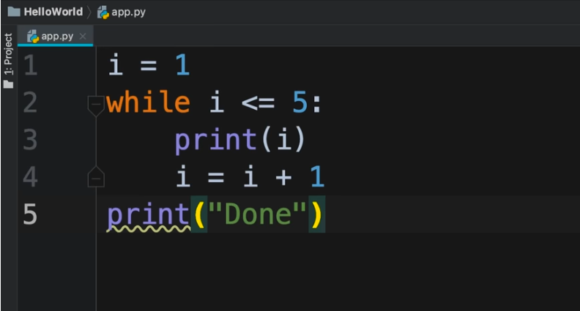

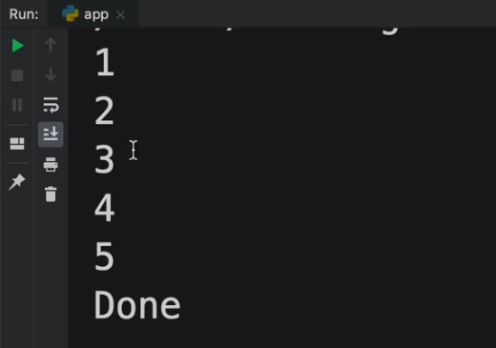

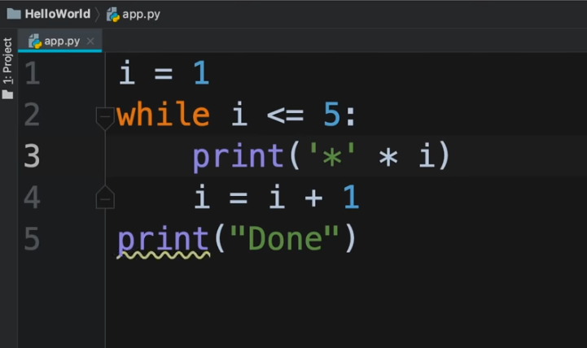

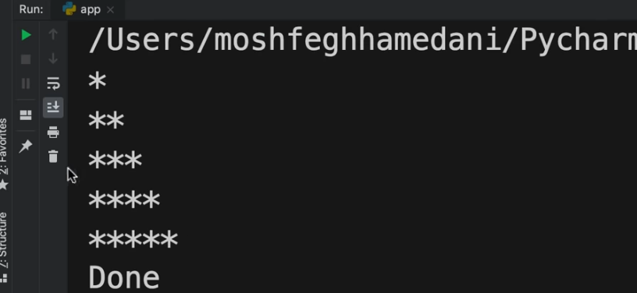

Guessing Game Problem(1:30:55)

<https://youtu.be/_uQrJ0TkZlc?t=5054>

Car Game Problem(1:41:52)

<https://youtu.be/_uQrJ0TkZlc?t=5458>

WHILE LOOP by Naveen Reddy (Watch upto 2:51:13)

<https://youtu.be/YfO28Ihehbk?t=9538>

For Loop(1:47:51)

<https://youtu.be/_uQrJ0TkZlc?t=6115>

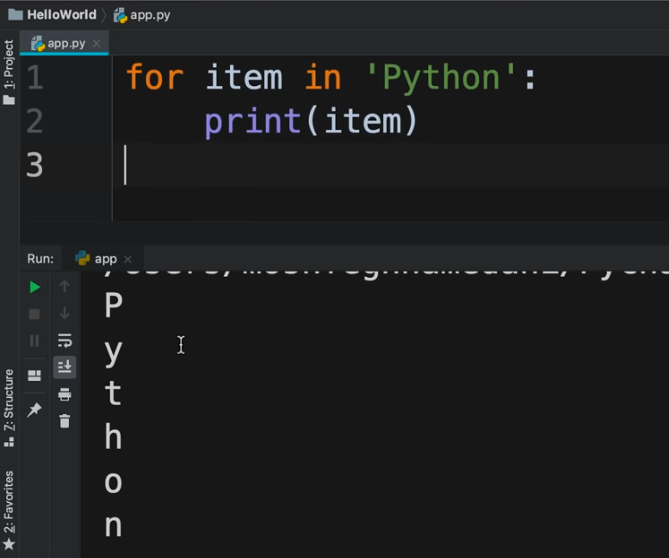

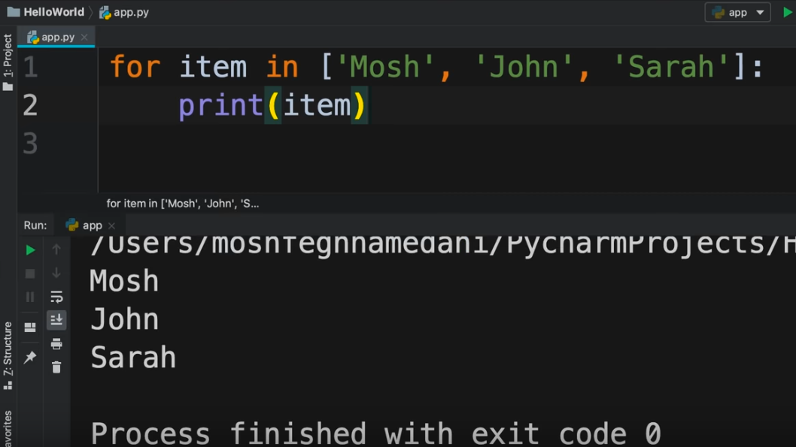

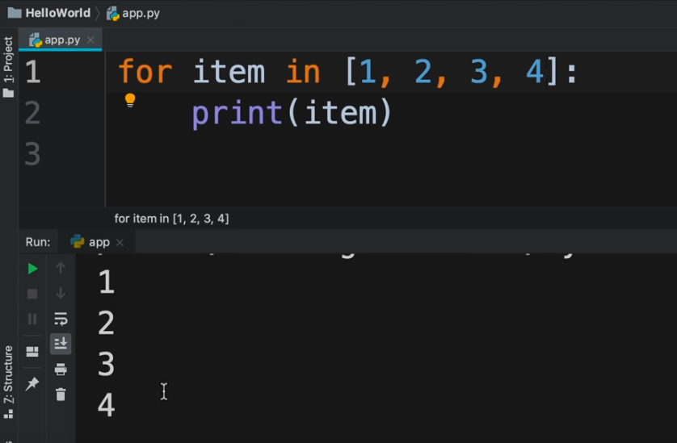

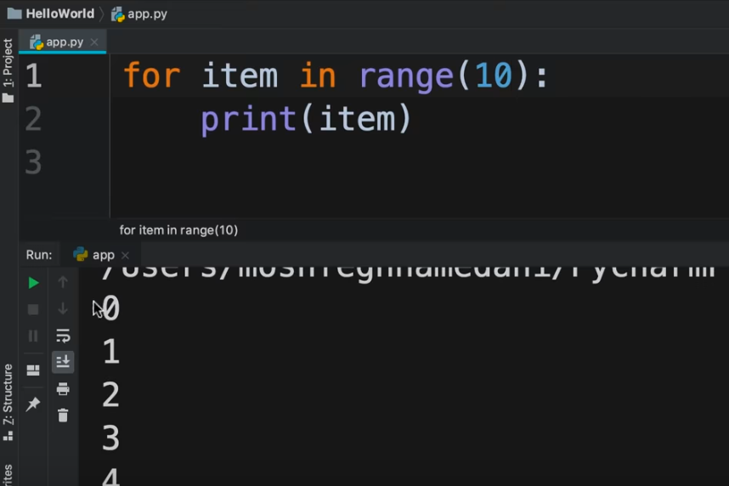

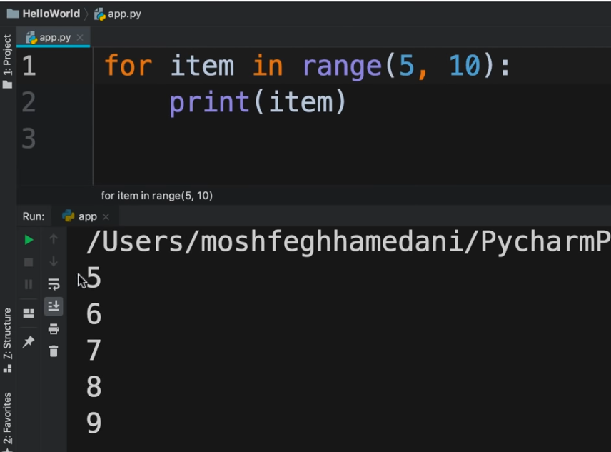

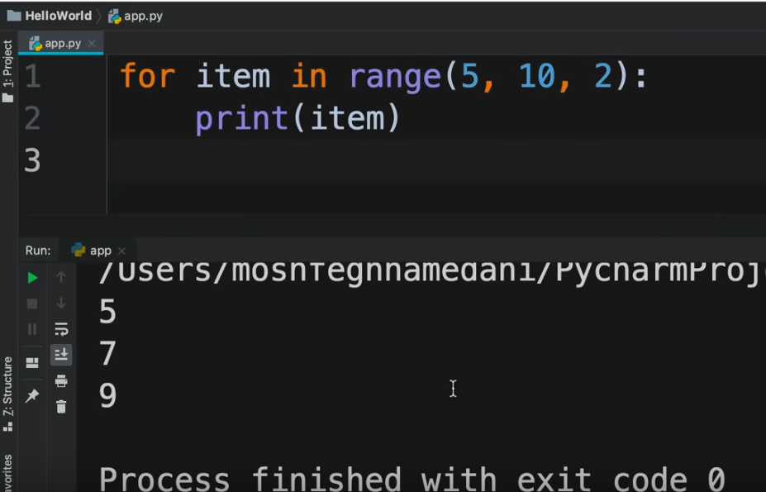

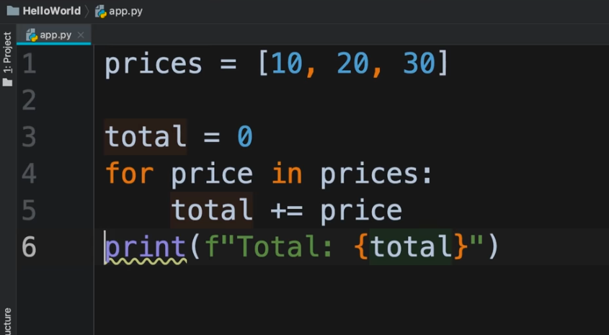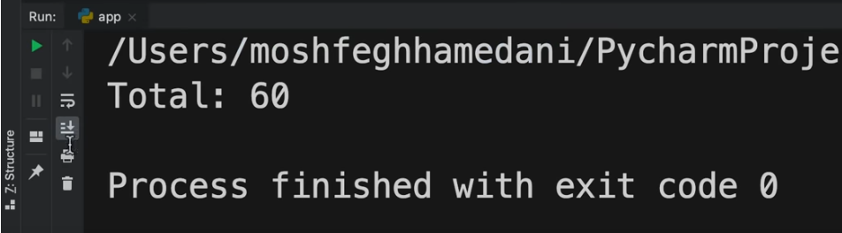

FOR LOOP by Naveen Reddy (Watch upto 2:58:03)

<https://youtu.be/YfO28Ihehbk?t=10276>

Nested Loop(1:55:55)

<https://youtu.be/_uQrJ0TkZlc?t=6474>

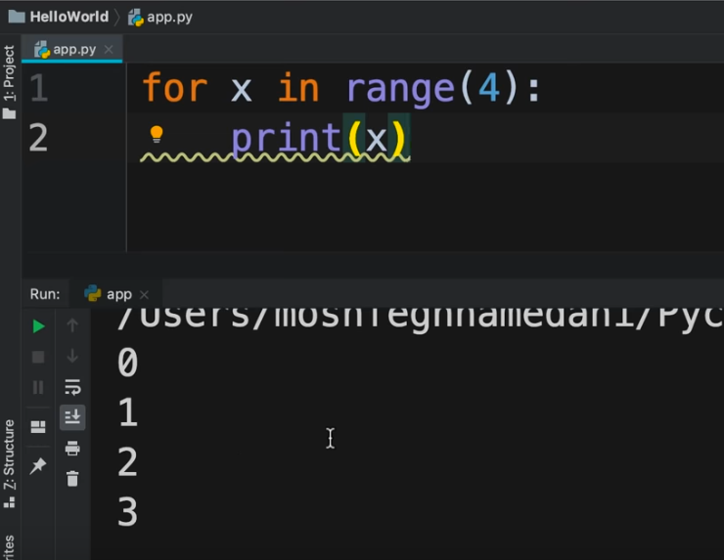

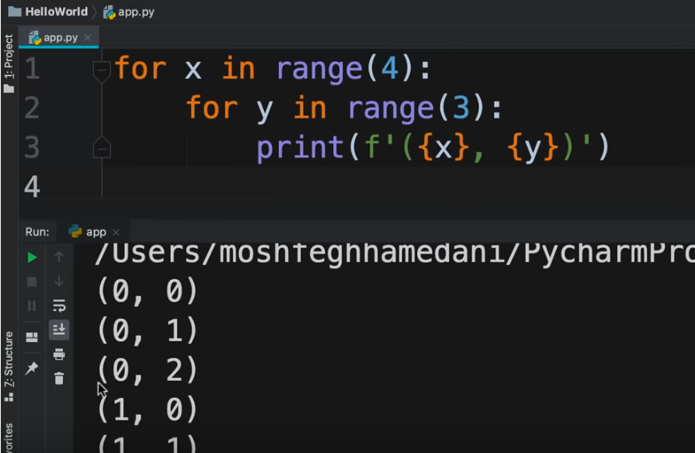

Break Continue Pass by Naveen Reddy (Watch upto 3:07:52)

<https://youtu.be/YfO28Ihehbk?t=10686>

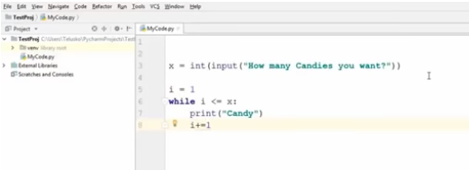

Execution

<https://youtu.be/YfO28Ihehbk?t=10792>



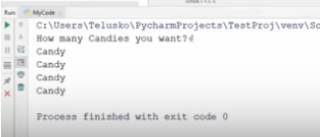

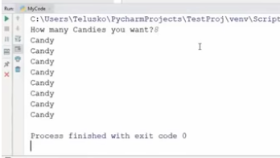

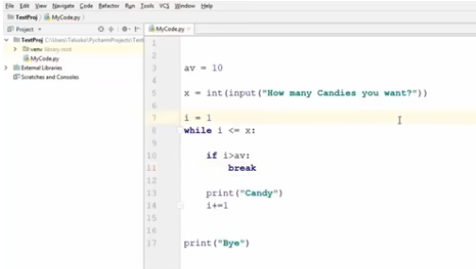

Execution

<https://youtu.be/YfO28Ihehbk?t=10907>

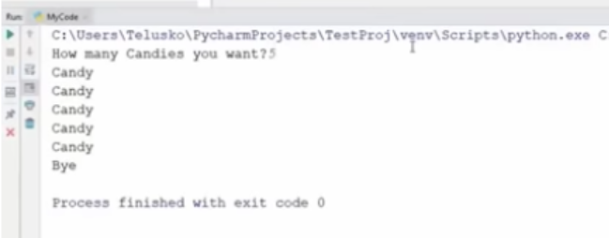

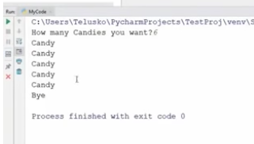

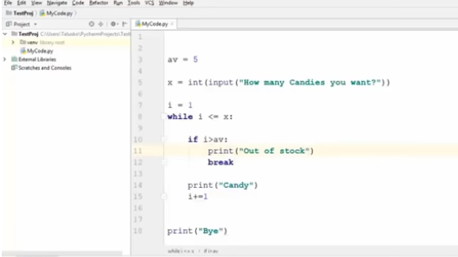

Execution

<https://youtu.be/YfO28Ihehbk?t=10958>

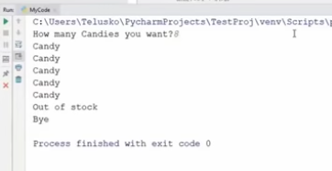

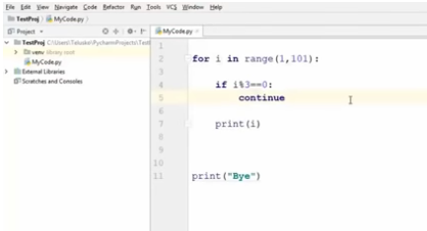

Execution

<https://youtu.be/YfO28Ihehbk?t=11108>

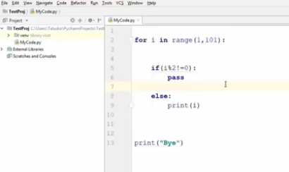

Execution

<https://youtu.be/YfO28Ihehbk?t=11261>

Printing Patterns by Naveen Reddy(Watch upto 3:15:27)

<https://youtu.be/YfO28Ihehbk?t=11275>

Tuples(2:15:40)

<https://youtu.be/_uQrJ0TkZlc?t=8014>

Tuple is similar to list. Tuples can be used to store items but we cannot modify Tuples i.e. we cannot add new items, we cannot remove existing items. Tuples are immutable.

We use [ ] to define list and () to define Tuples

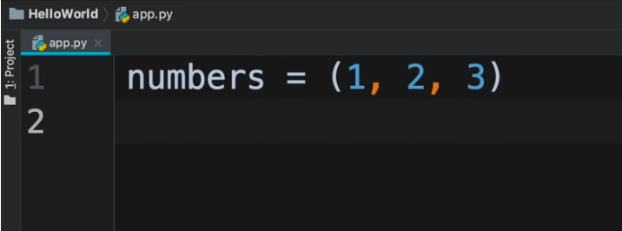

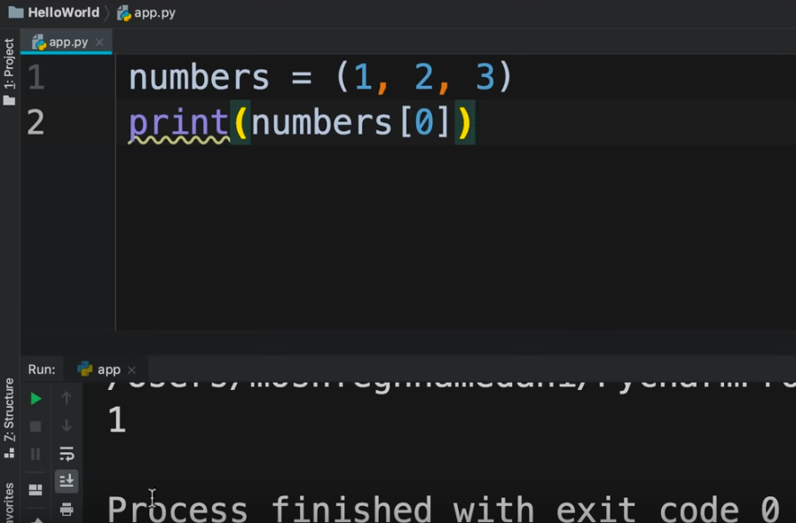

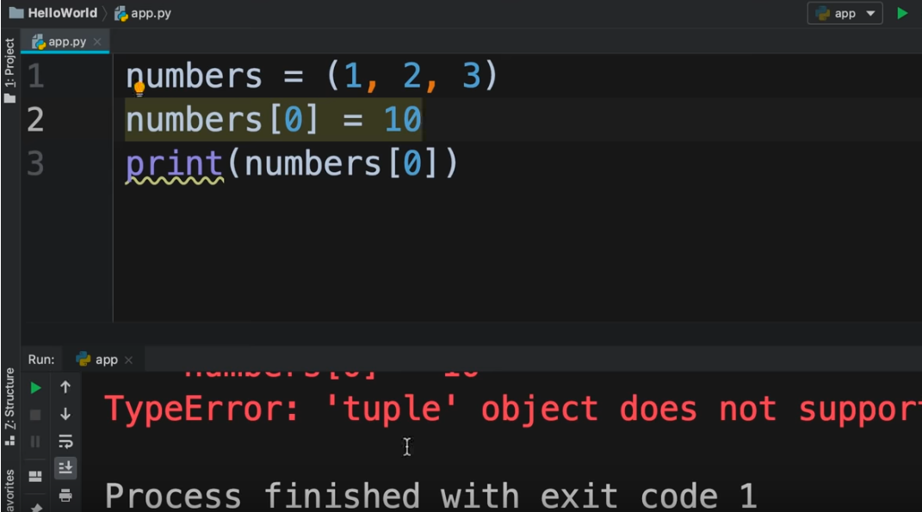

Unpacking(2:18:28)

<https://youtu.be/_uQrJ0TkZlc?t=8143>

If we have a tuple, we can store the individual values as below :

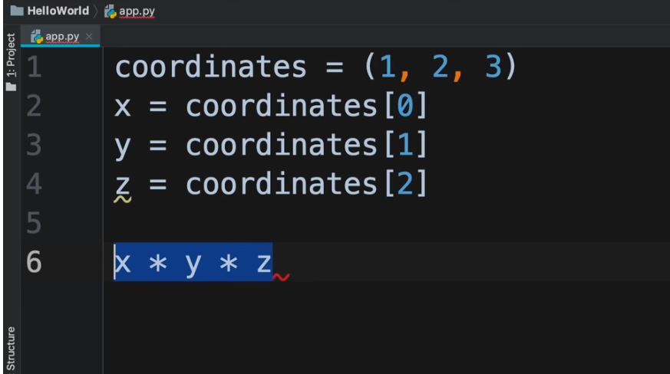

But in Python, there is a feature called **Unpacking**

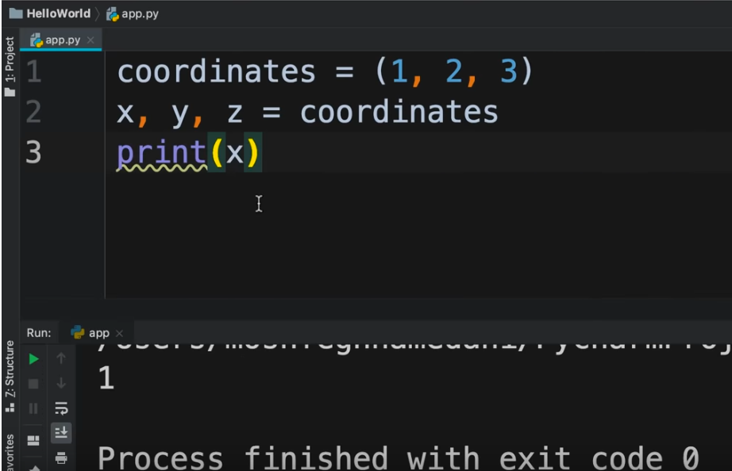

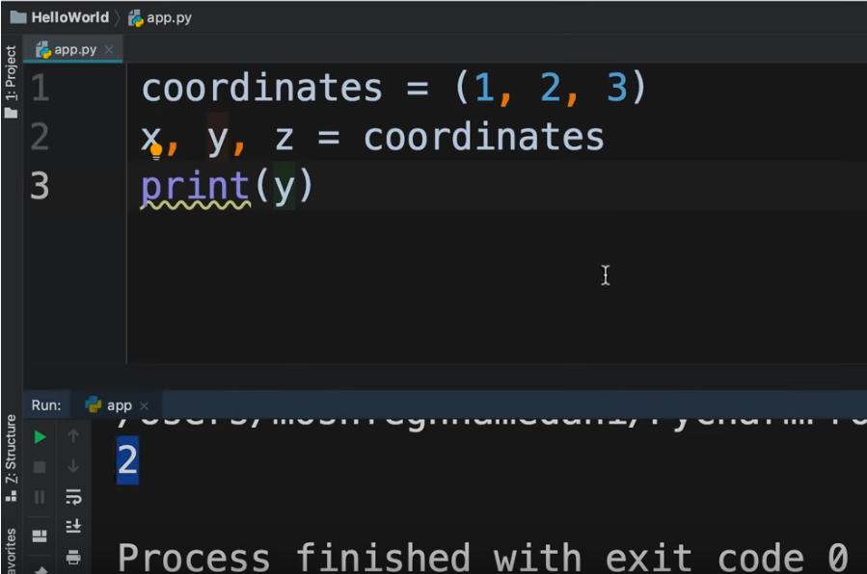

Unpacking works with list as well

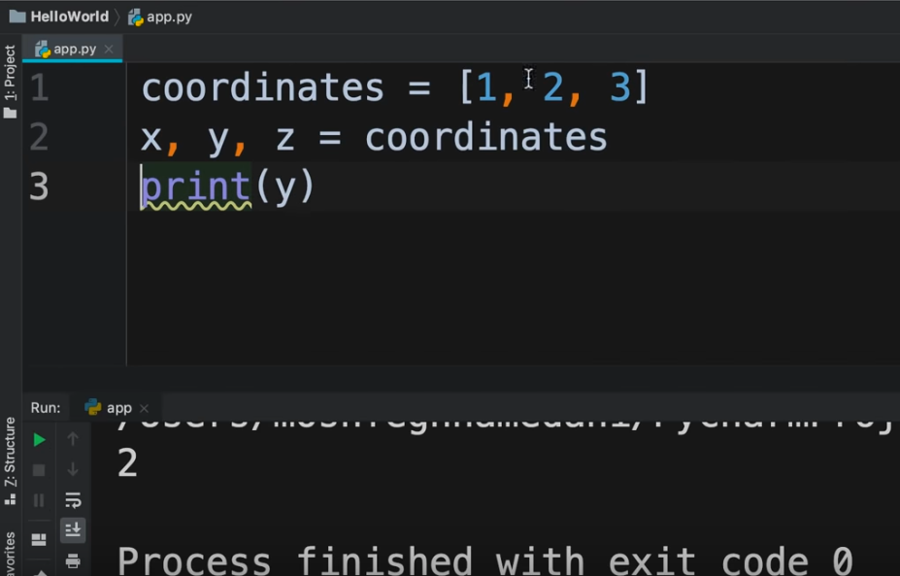

Tuple and sets by Naveen Reddy (Watch upto 53:11)

<https://youtu.be/YfO28Ihehbk?t=2819>

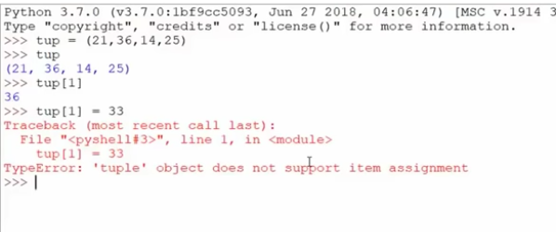

When we want a list for which we do not want to modify values, we can go for a Tuple. Iteration over Tuple is faster than on List

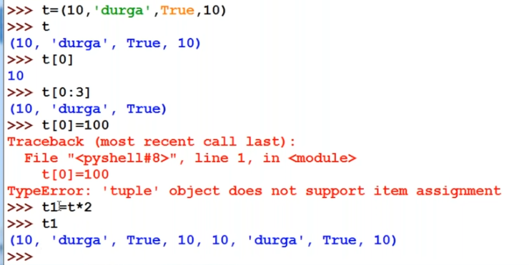

Set is a collection of unique elements.

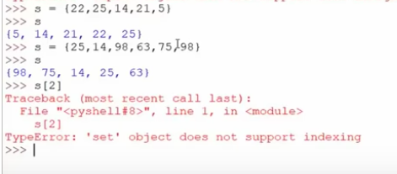

Minimum and maximum in sets

<https://www.geeksforgeeks.org/python-maximum-minimum-set/>

Sequence Data type by Naveen Reddy

<https://youtu.be/YfO28Ihehbk?t=4440>

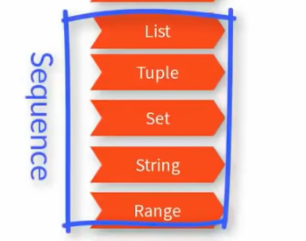

**range data type (Watch upto 39:19)**

<https://youtu.be/m6P5Xx4Y1n8?list=PLd3UqWTnYXOnkicyzePnIg8rc2qEXgjiF&t=1621>

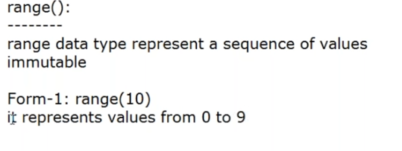

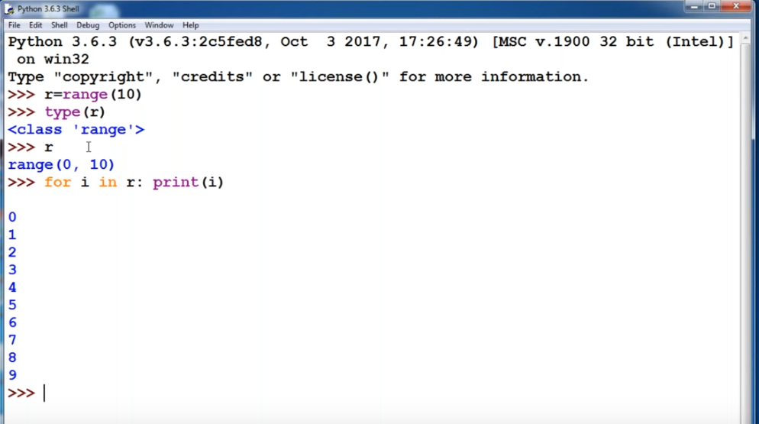

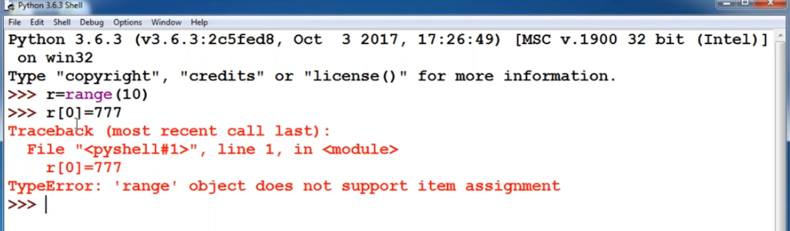

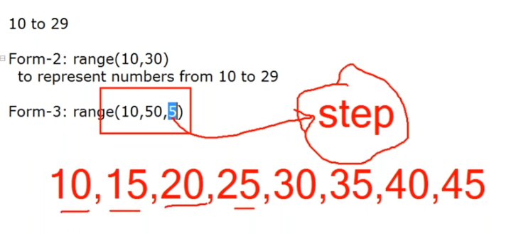

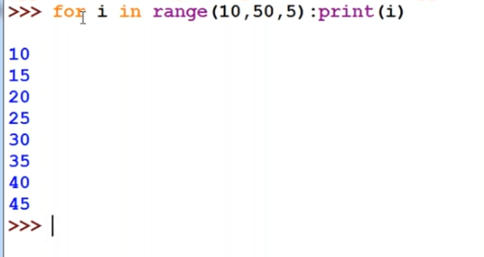

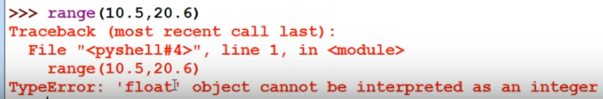

Object Oriented Programming by Naveen Reddy (Watch upto 3:33:18)

<https://youtu.be/YfO28Ihehbk?t=11742>

Dictionaries

<https://youtu.be/_uQrJ0TkZlc?t=8311>

We use Dictionaries when we want to store information as a key, value pair.

We use { } to create a Dictionary

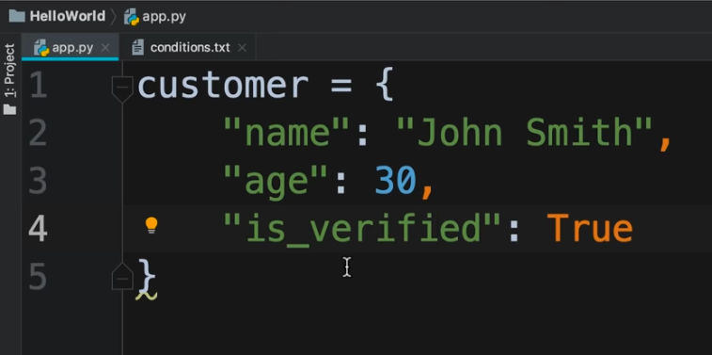

Key should be unique

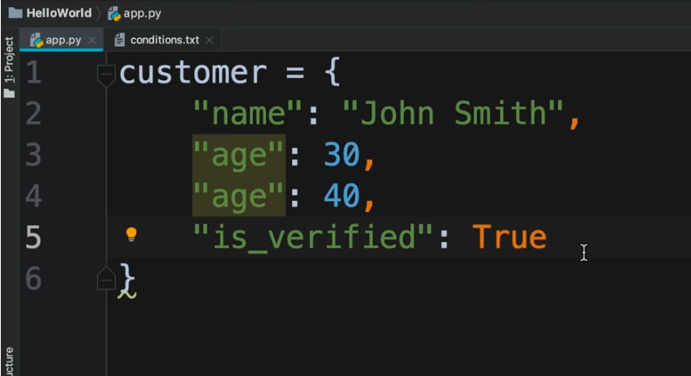

Here, **age** is a duplicate key and the editor has highlighted it

To access the items in the dictionary :

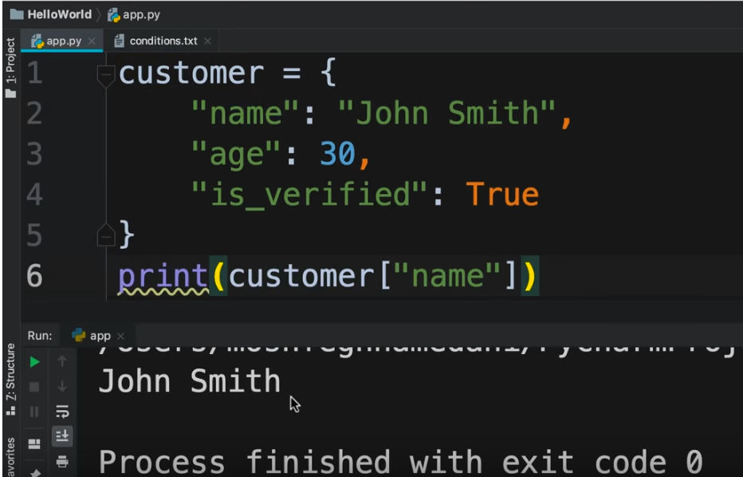

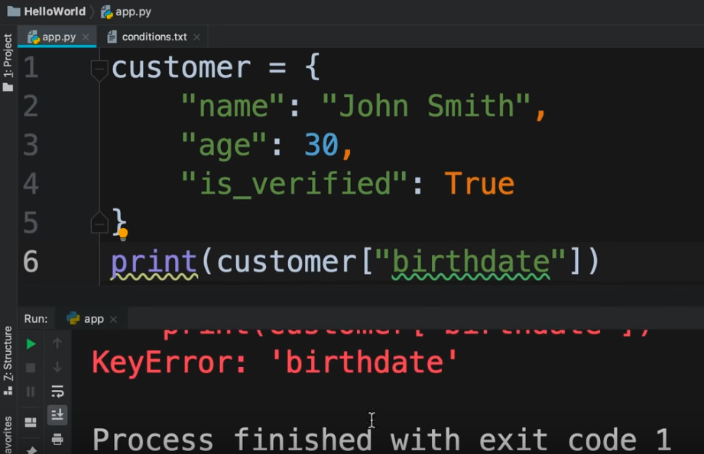

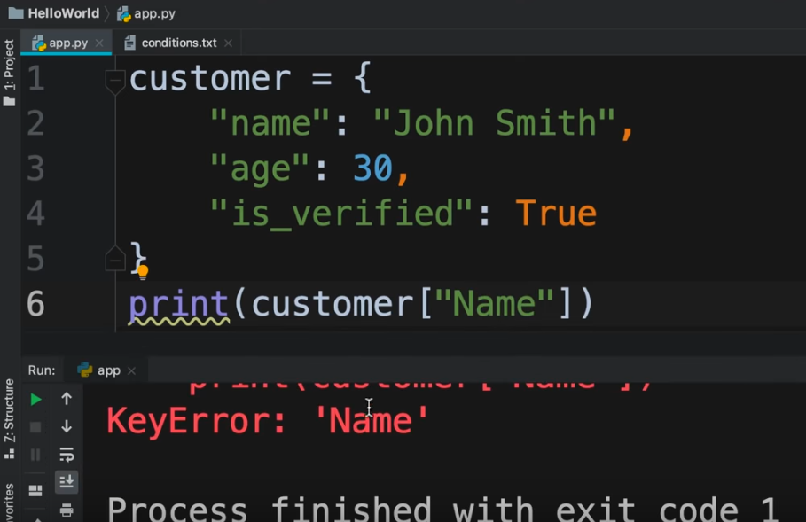

If we use **get()** method and pass a key that does not exist, it returns None

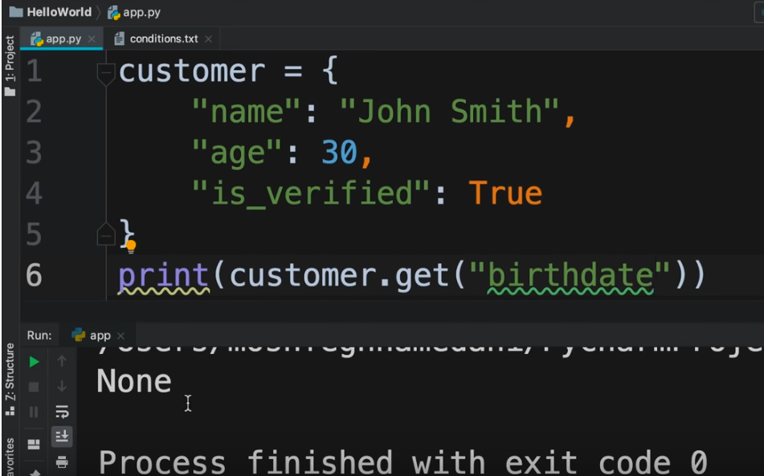

We can also pass a default value as below

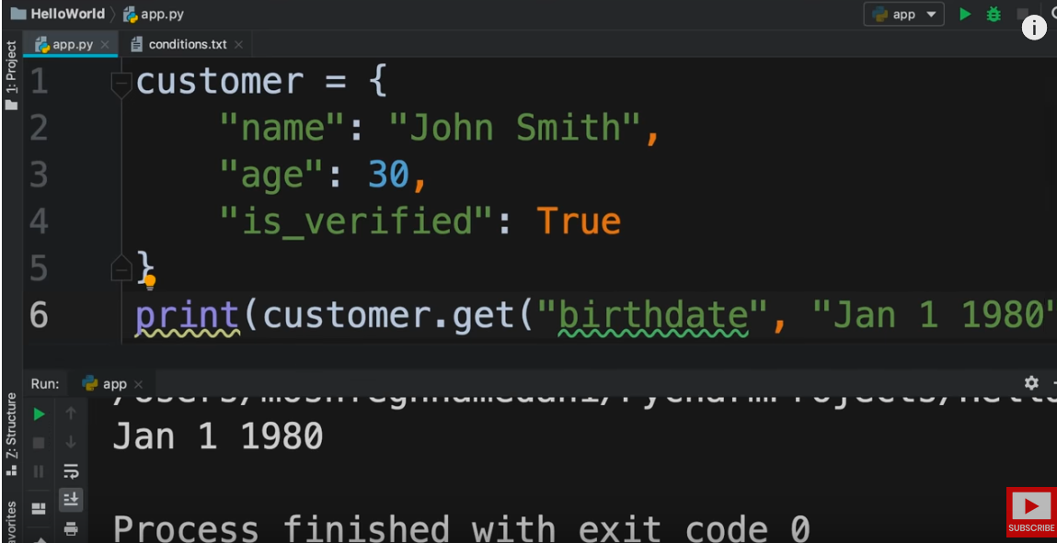

We can also update as below :

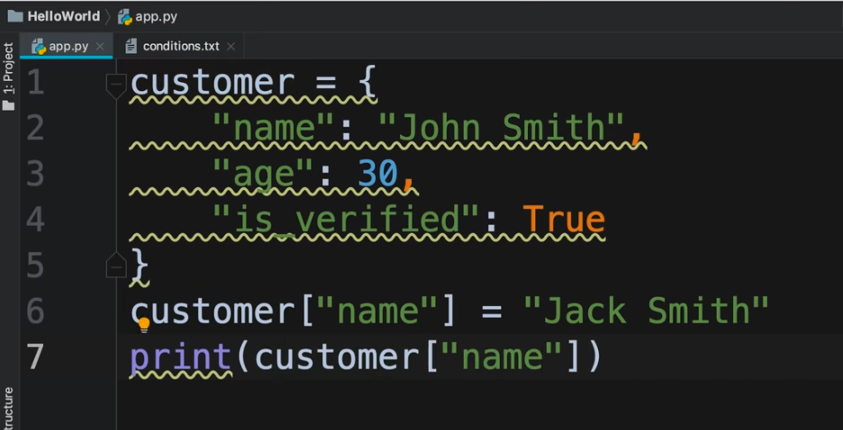

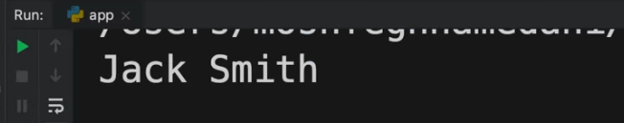

We can also add a new key, value pair

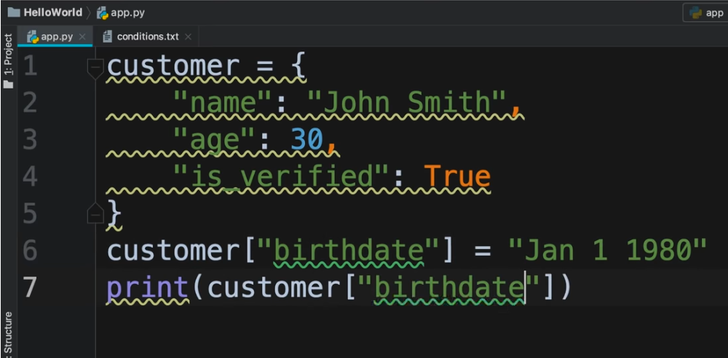

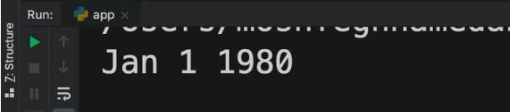

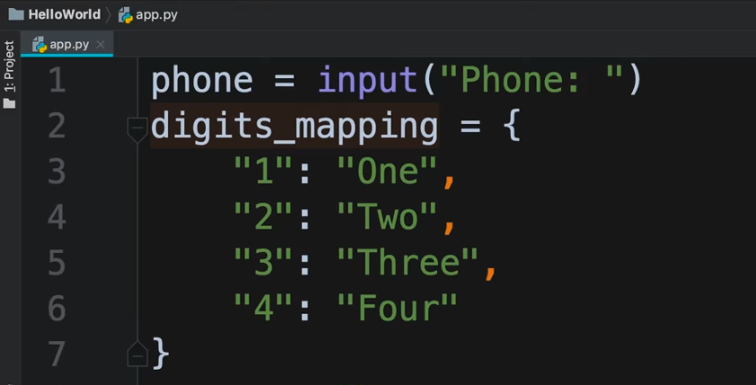

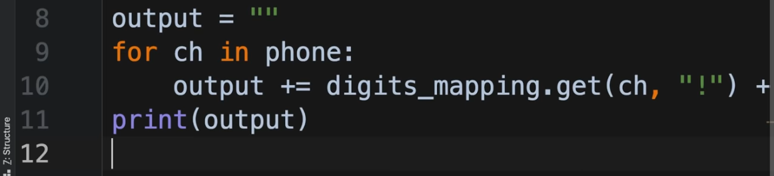

Execution

<https://youtu.be/_uQrJ0TkZlc?t=8777>

Emoji Converter (2:30:40)

<https://youtu.be/_uQrJ0TkZlc?t=8791>

The split() method of String is used to split the string as per the pattern passed as argument to split() method and it returns a list of the split items.

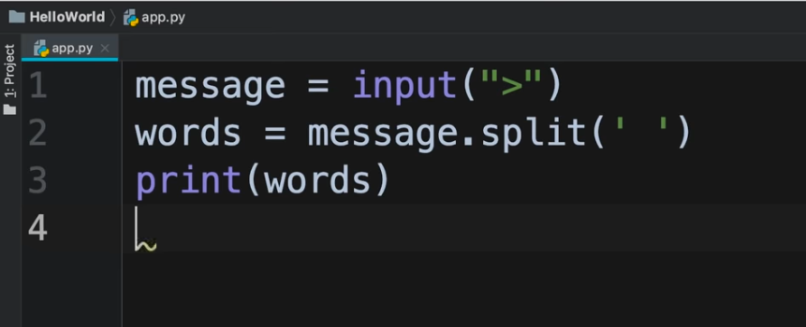

Execution

<https://youtu.be/_uQrJ0TkZlc?t=8884>

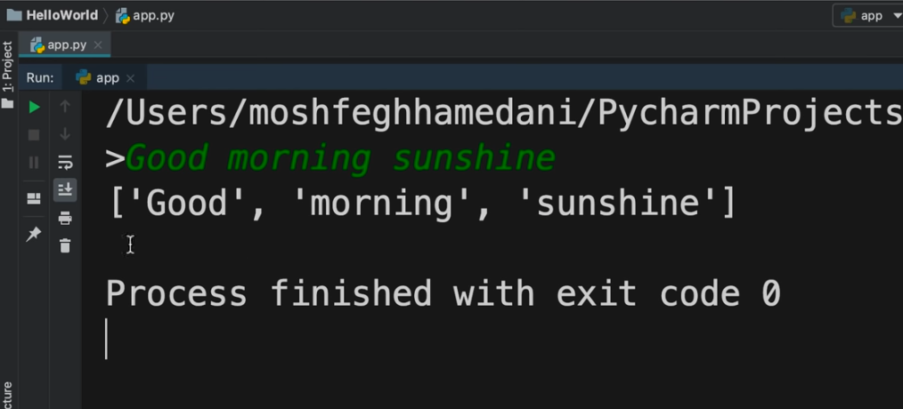

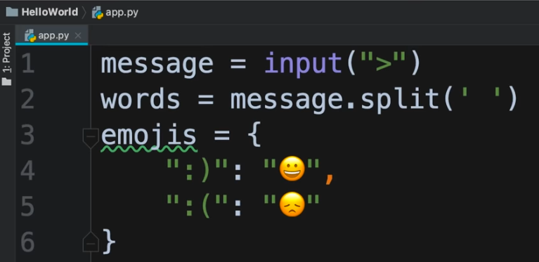

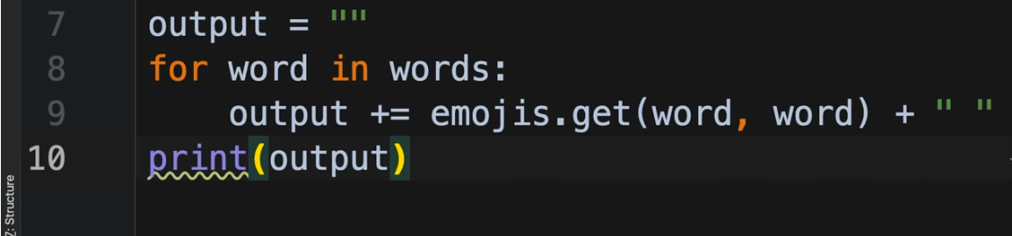

Execution

<https://youtu.be/_uQrJ0TkZlc?t=9020>

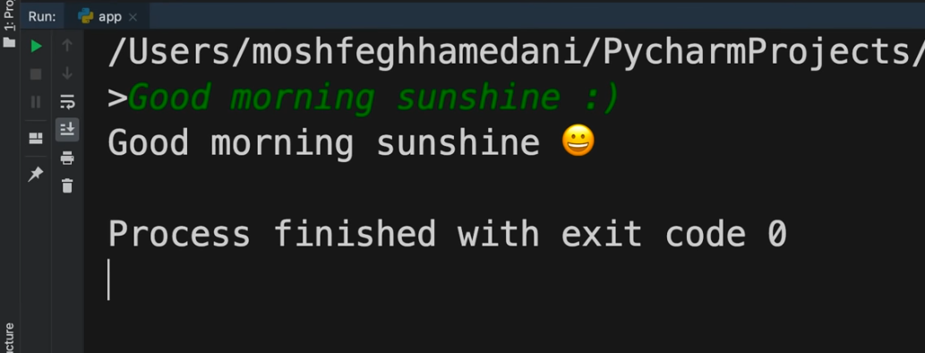

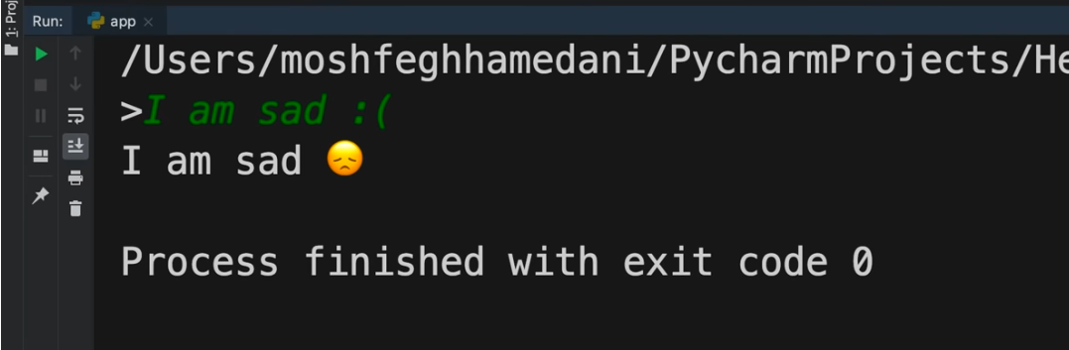

Dictionary by Durga

<https://youtu.be/m6P5Xx4Y1n8?list=PLd3UqWTnYXOnkicyzePnIg8rc2qEXgjiF&t=3642>

Curly braces are used for both sets and dictionaries.

To create an empty set

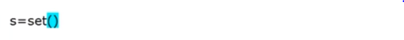

To create an empty dictionary

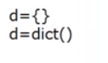

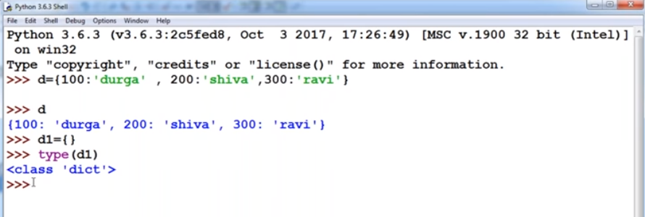

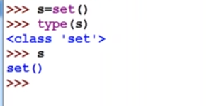

Dictionary is mutable

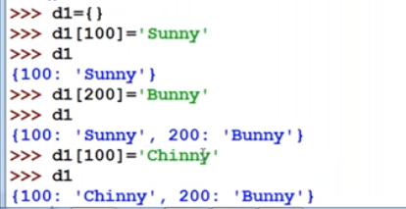

**Defining Functions**

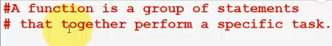

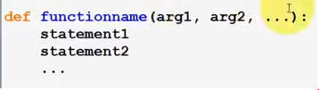

Defining Function

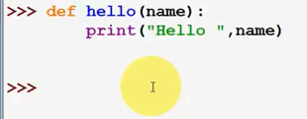

Invoking the function

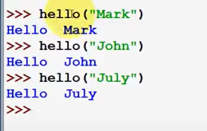

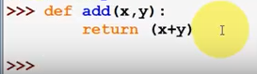

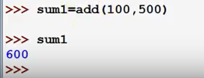

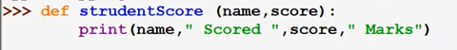

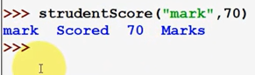

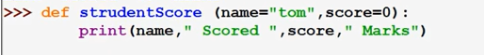

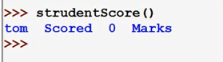

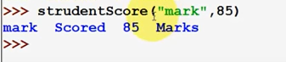

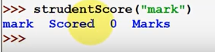

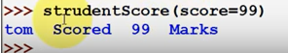

Passing multiple parameters to a function :

The * tells Python that the corresponding parameter will be passed once or multiple times

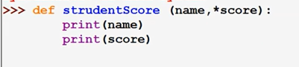

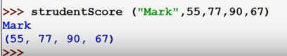

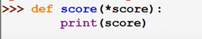

Functions

<https://youtu.be/_uQrJ0TkZlc?t=9041>

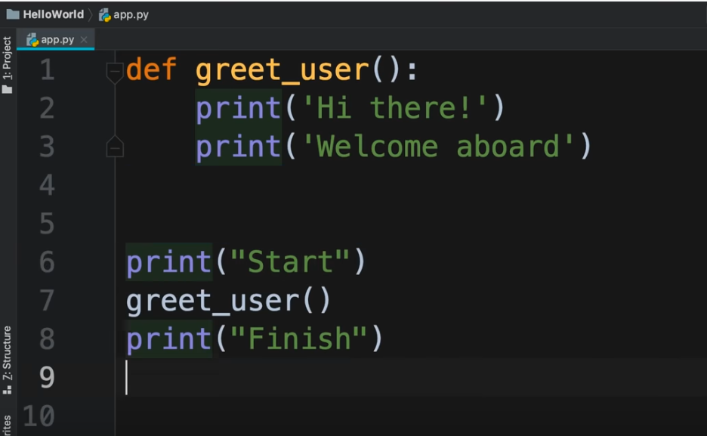

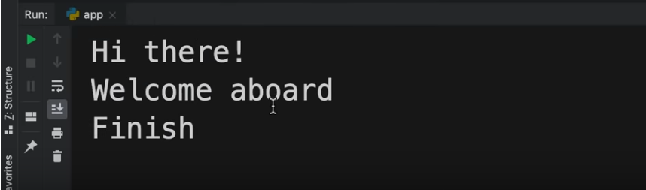

Parameters of function

<https://youtu.be/_uQrJ0TkZlc?t=9332>

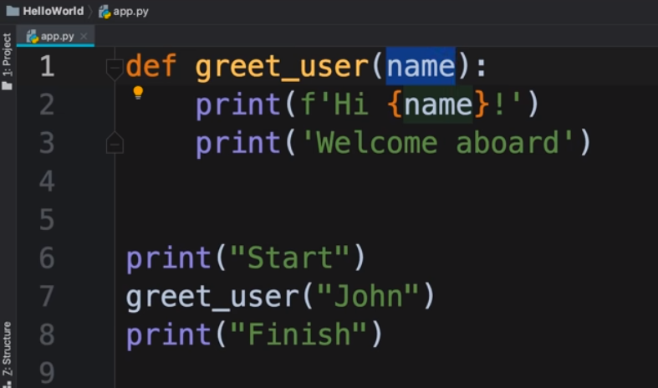

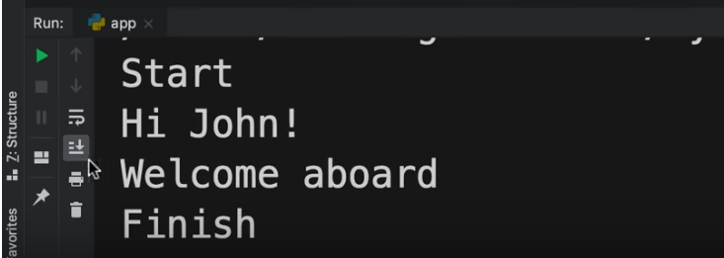

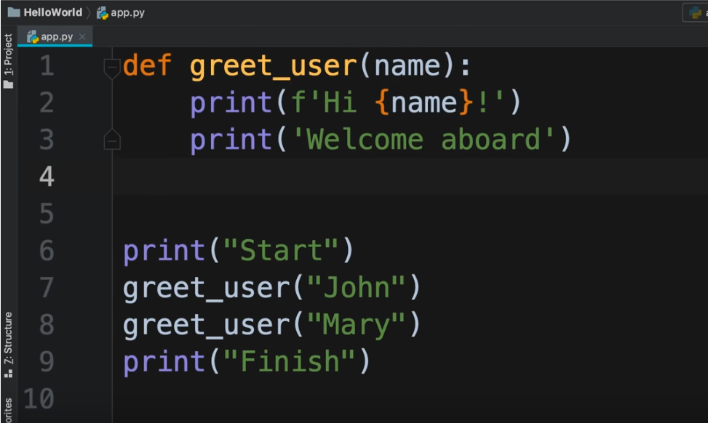

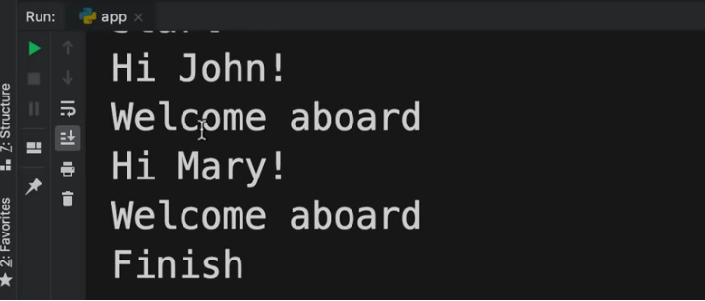

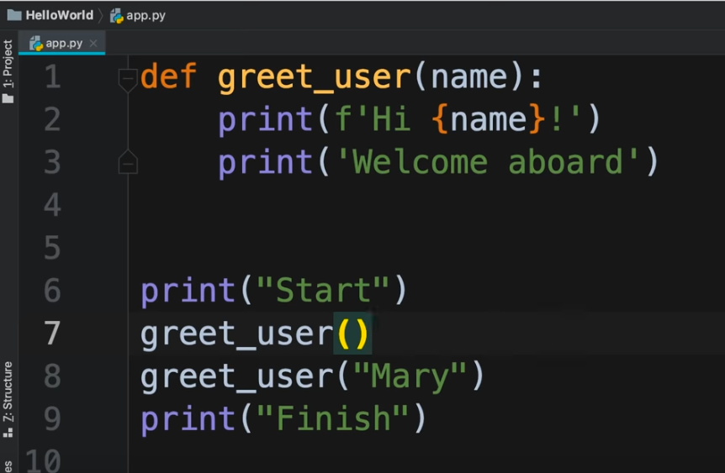

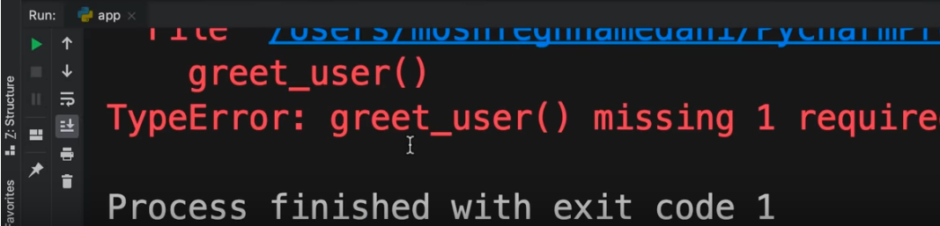

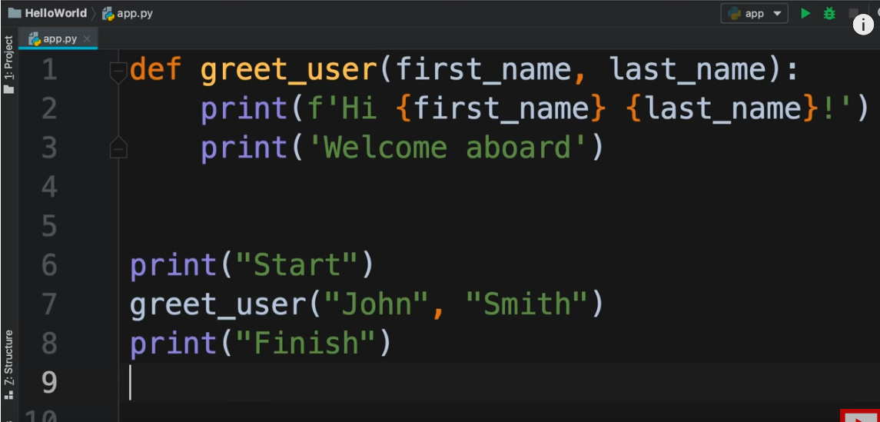

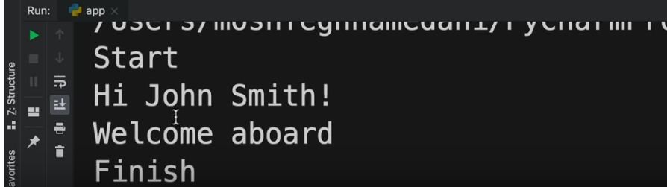

Keyword Arguments

<https://youtu.be/_uQrJ0TkZlc?t=9575>

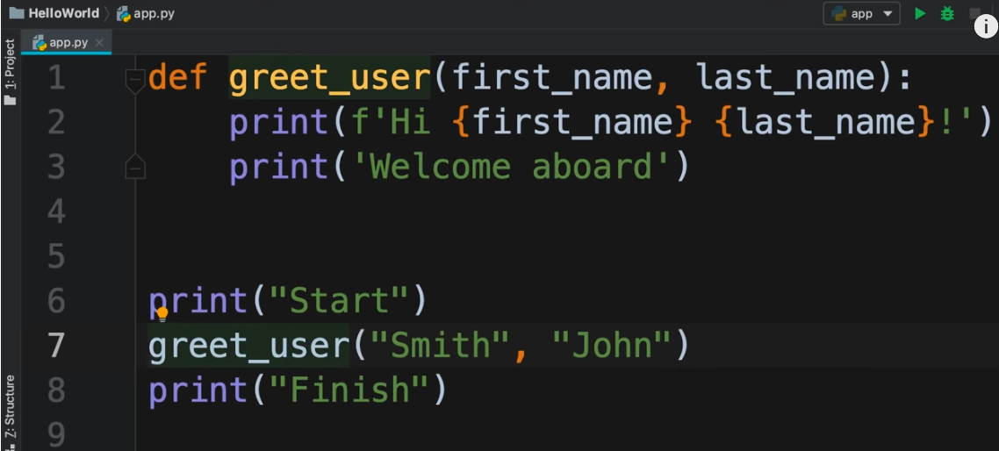

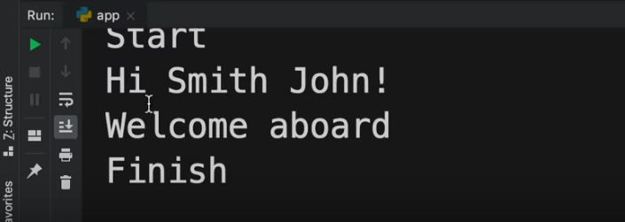

The position of the argument matters in a function and such arguments are called positional arguments. But in Python, there are keyword arguments whose position does not matter and such arguments are called keyword arguments

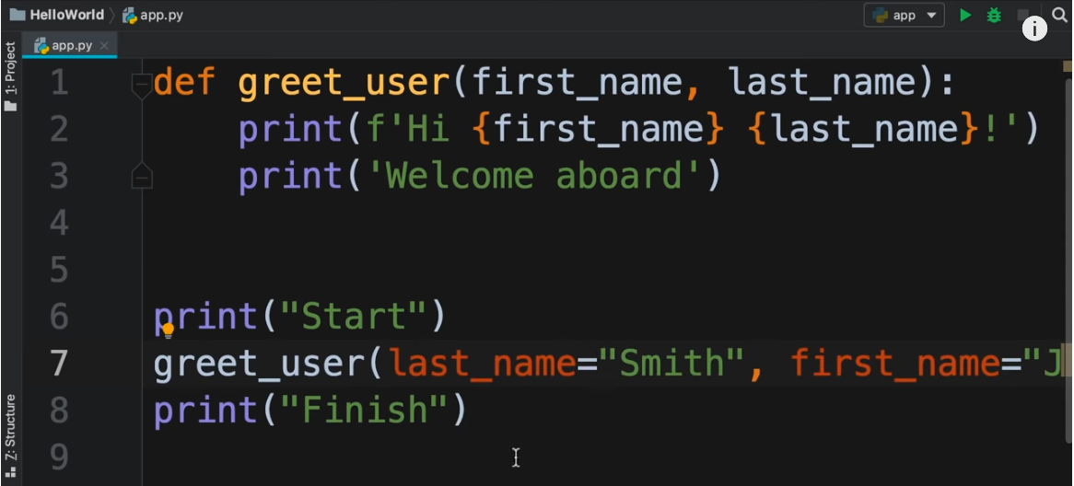

If we write positional arguments and keyword arguments in the same method call, then positional arguments should be written before the keyword arguments.

This is not valid

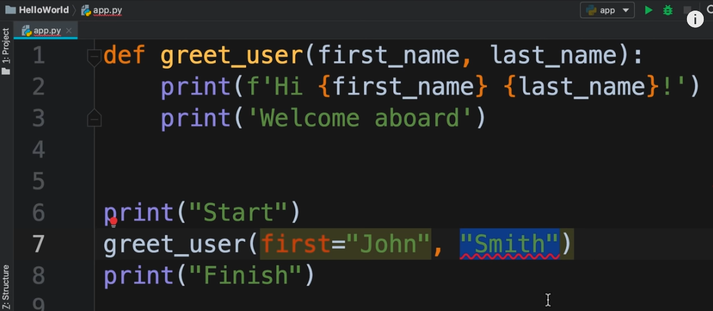

This is valid

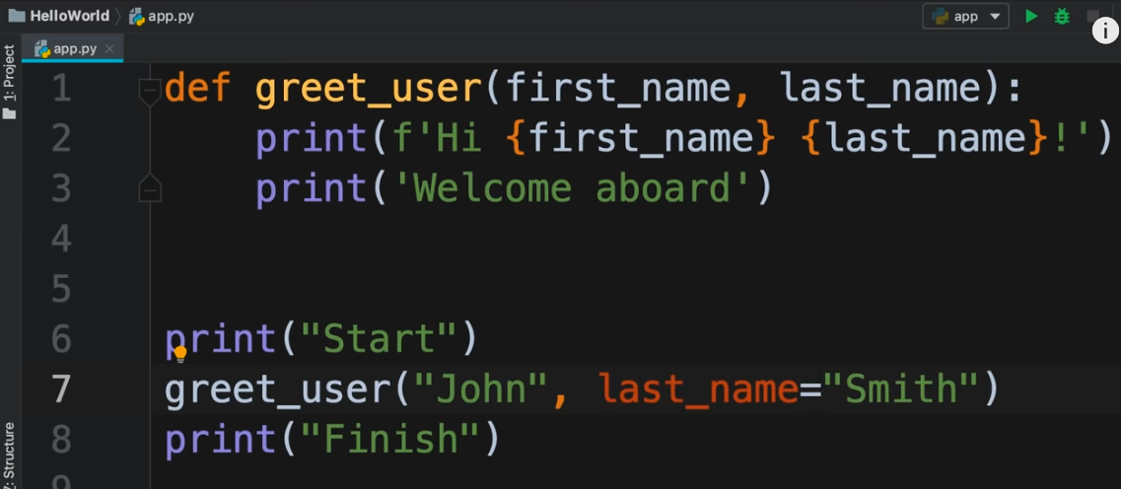

Return Statement

<https://youtu.be/_uQrJ0TkZlc?t=9905>

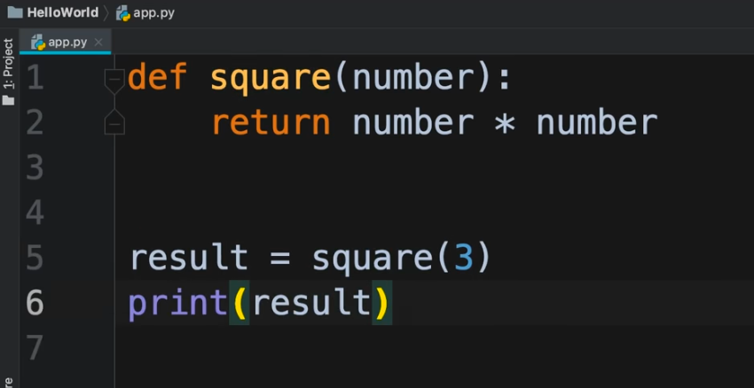

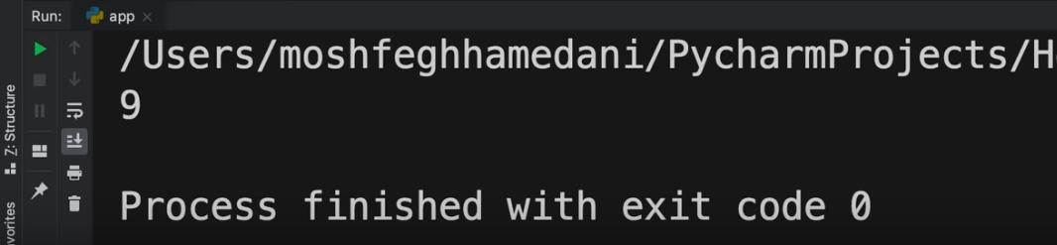

In the below code, the **square(3)** function is called first by the python interpreter. So it prints 9. But the function square() returns **none.** none is analogous to null in java. So after the function square(3) is executed, it passed none as an argument to print() function and thus none is printed on console

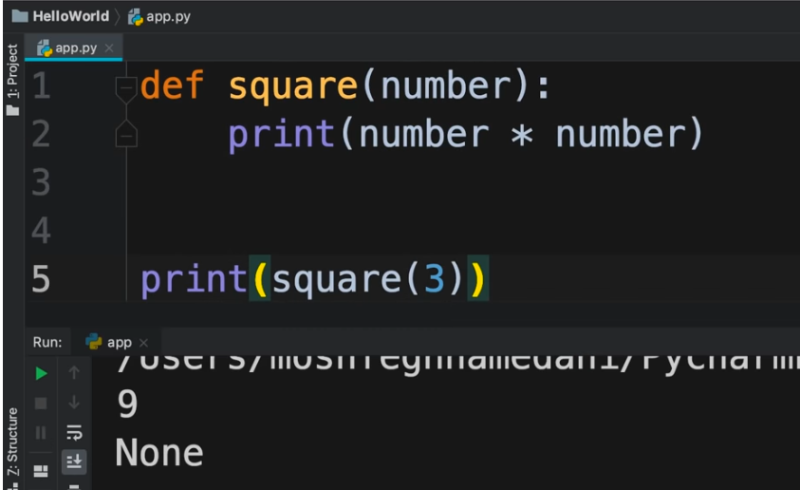

Creating a Reusable function

<https://youtu.be/_uQrJ0TkZlc?t=10146>

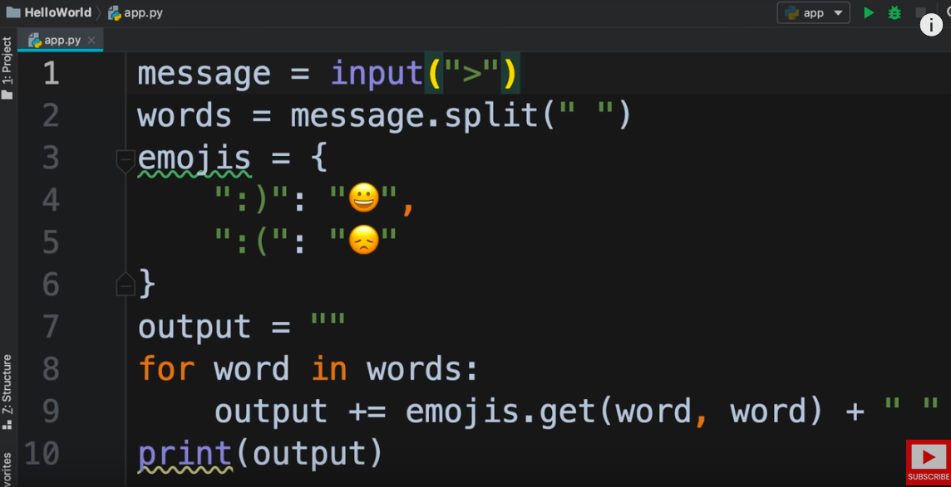

We need to reorganize the above code using a function. This is because the algorithm in the above function can be made reusable. The lines 2 to 9 implement the feature of this function. So we should put these lines in a separate function.

The input can come from different sources i.e. the input can come from terminal or GUI etc. So the first line will not be reusable.

Also the last line should not be reusable. This is because what we do with the output is different from one program to another.

So now we will move the reusable part of the above code to another function

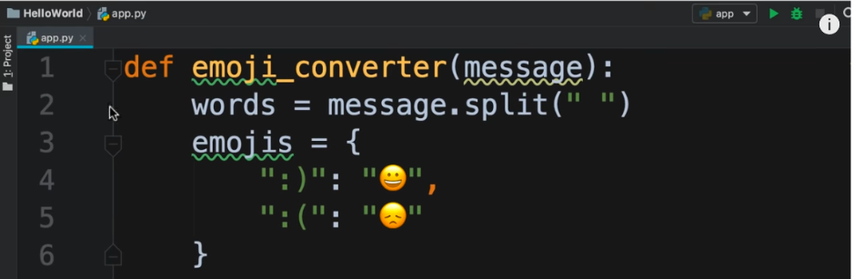

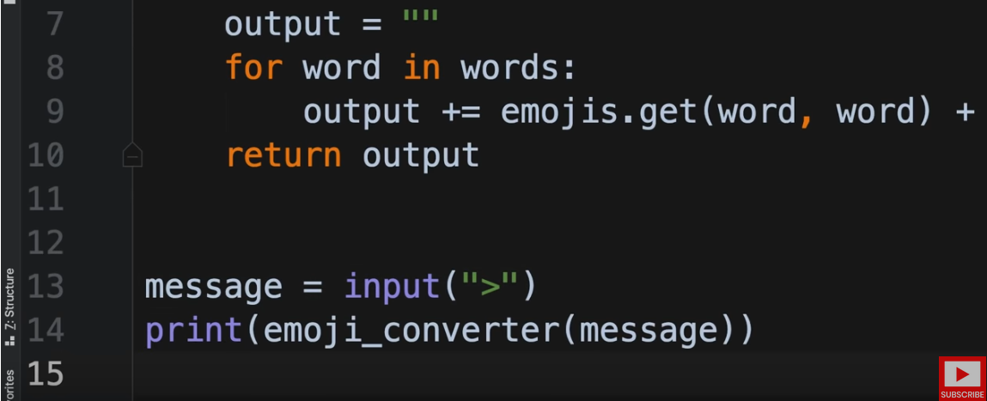

NOTE : There must always be 2 blank lines after the function definition ends.

Execution

<https://youtu.be/_uQrJ0TkZlc?t=10407>

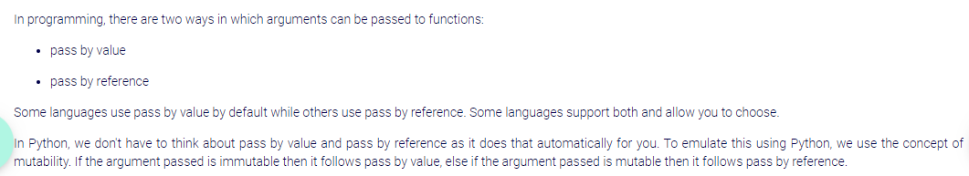

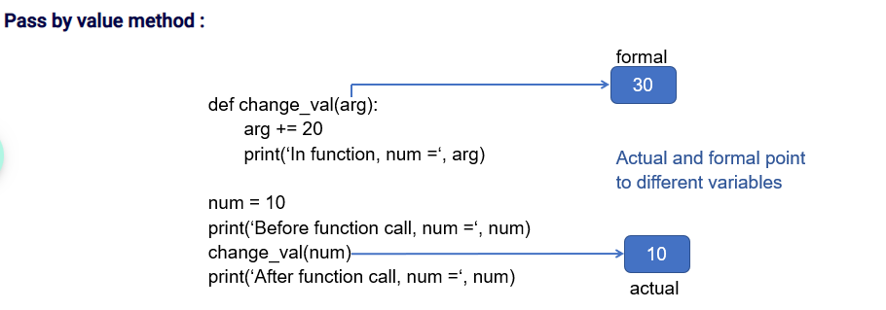



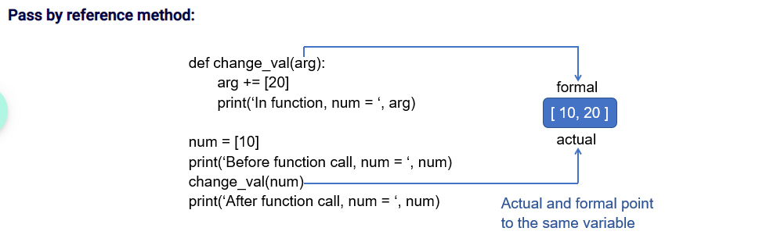



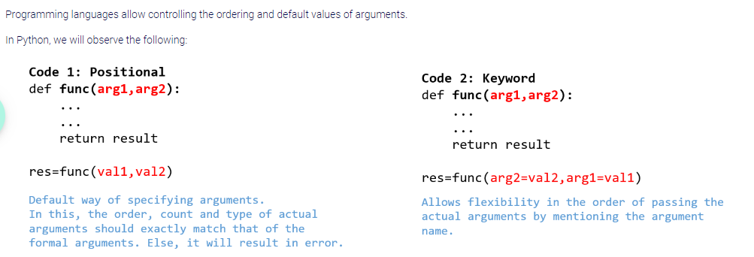

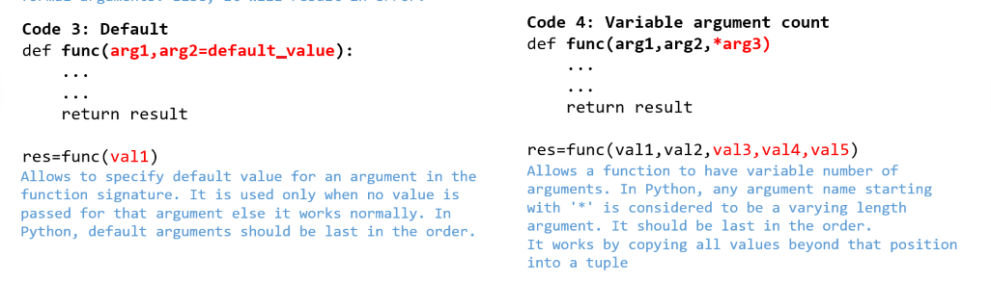

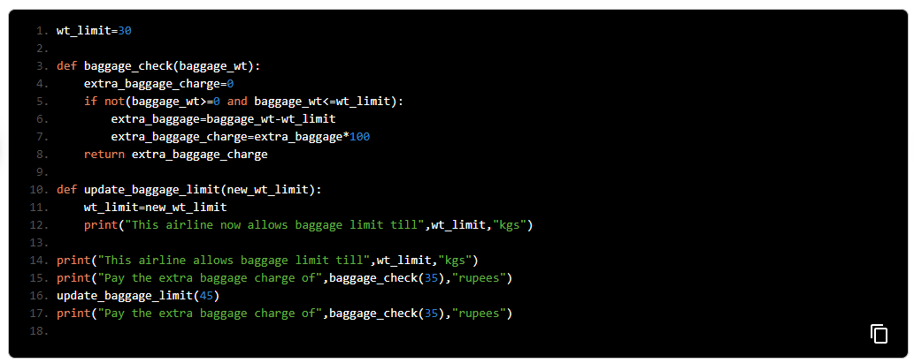

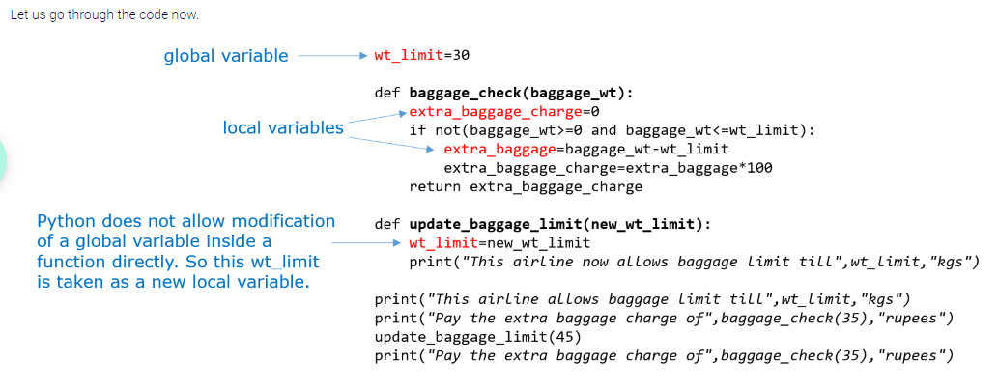

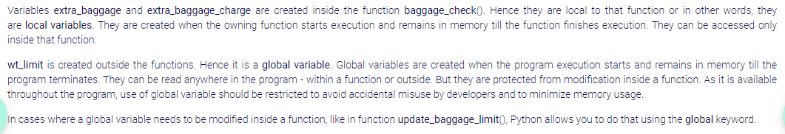

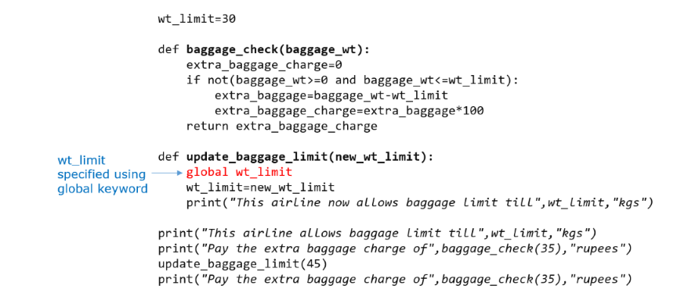

**Python Decorators​**

​[https://medium.com/swlh/python-decorators-explained-ddb82cc51fc5​](https://medium.com/swlh/python-decorators-explained-ddb82cc51fc5%E2%80%8B)

Exception Handling

<https://youtu.be/_uQrJ0TkZlc?t=10435>

Suppose we write a program to get user’s age from the terminal

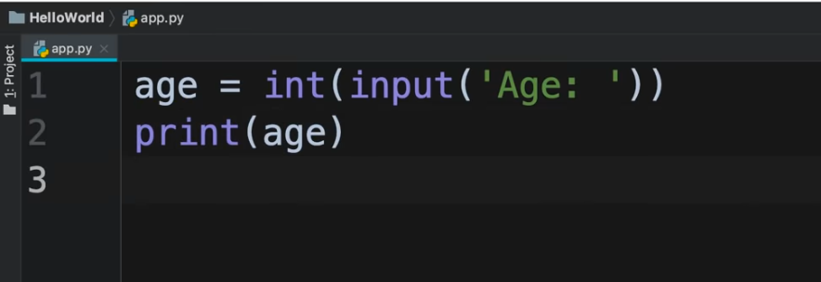

Execution

<https://youtu.be/_uQrJ0TkZlc?t=10465>

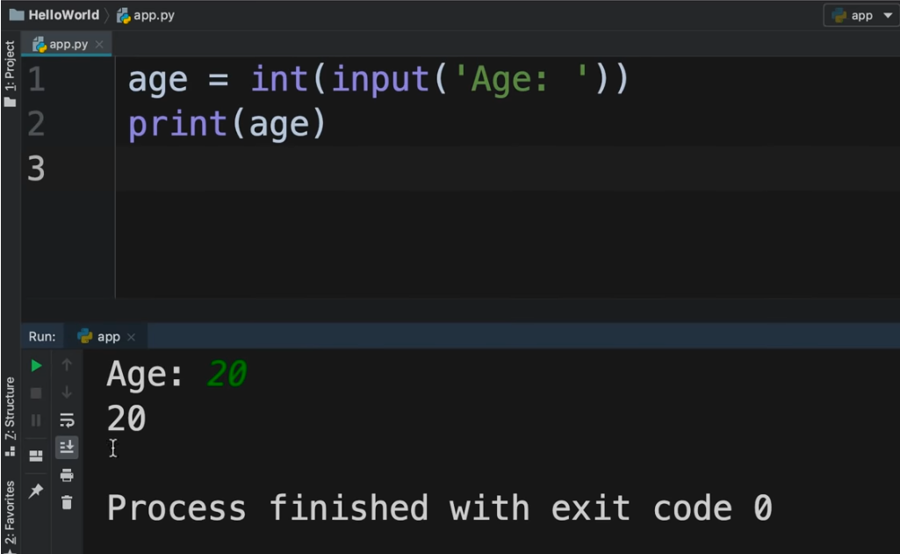

The exit code is 0. This means the program terminated successfully.

But if we enter a non numerical value, then we will get an exception

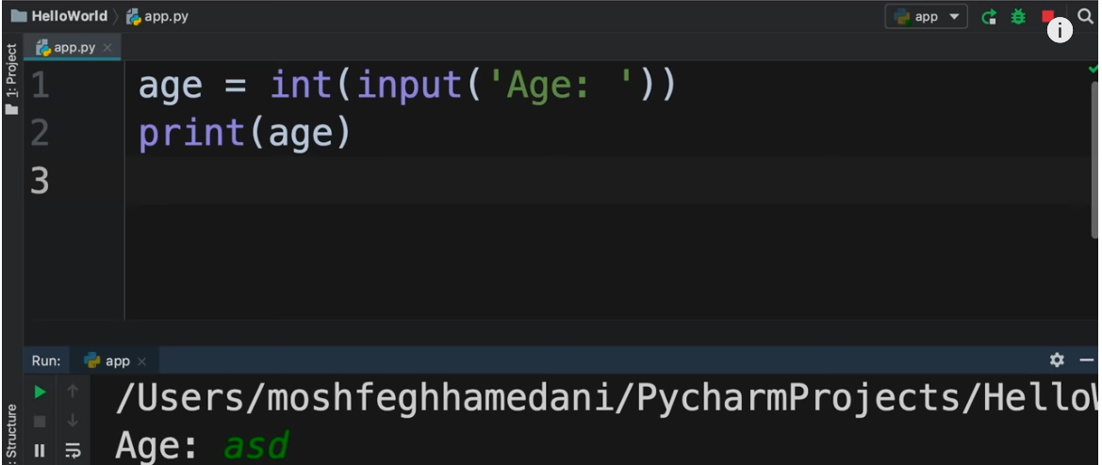

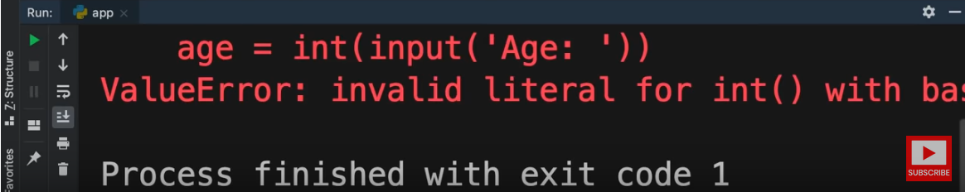

The exit code is 1. This means the program did not terminate normally. The exception is of type **ValueError**

In Python, there is a construct called **try except**. It is used to handle exceptions

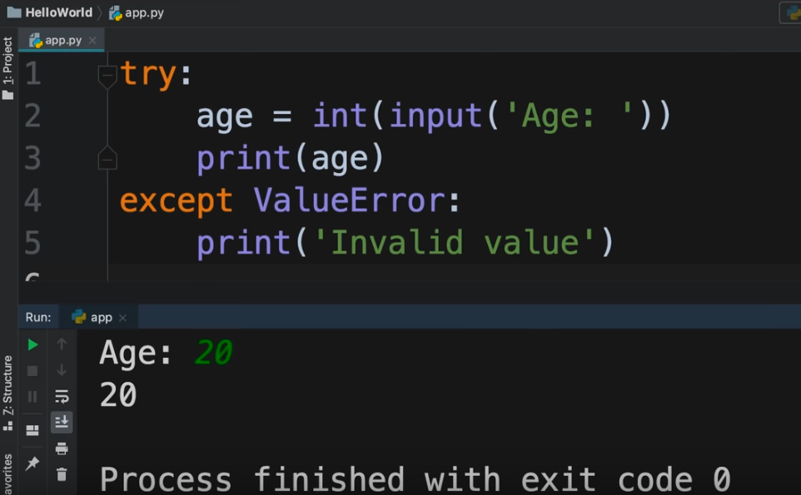

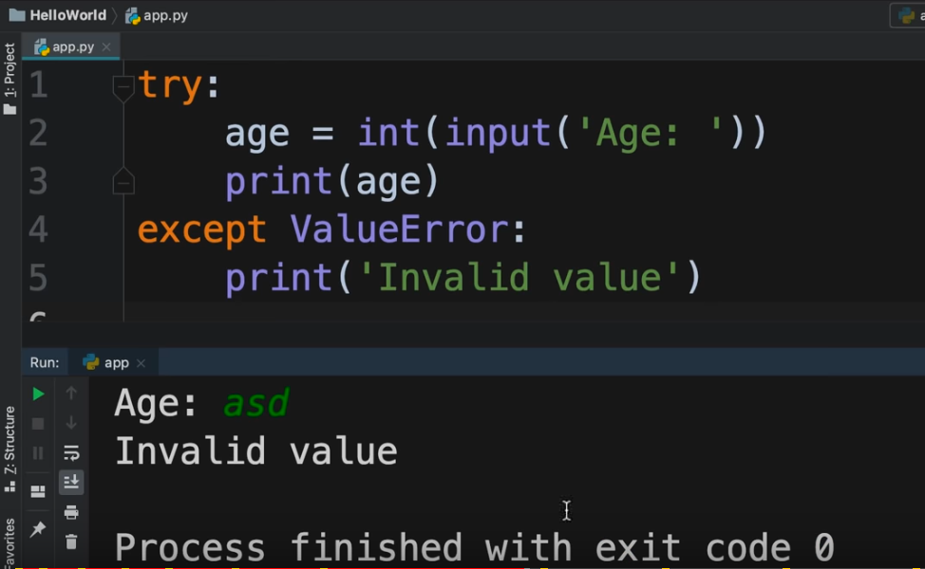

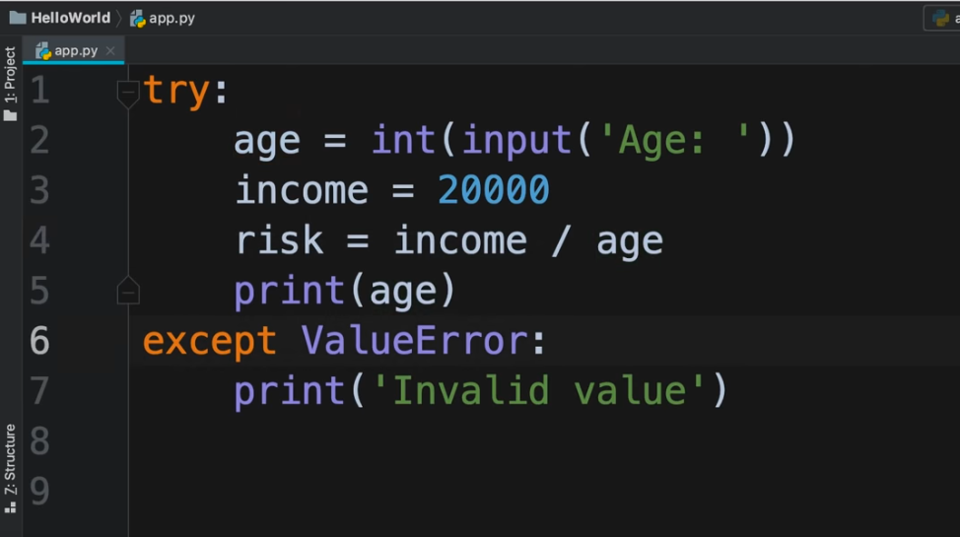

If we provide 0 as input to the above code

<https://youtu.be/_uQrJ0TkZlc?t=10684>

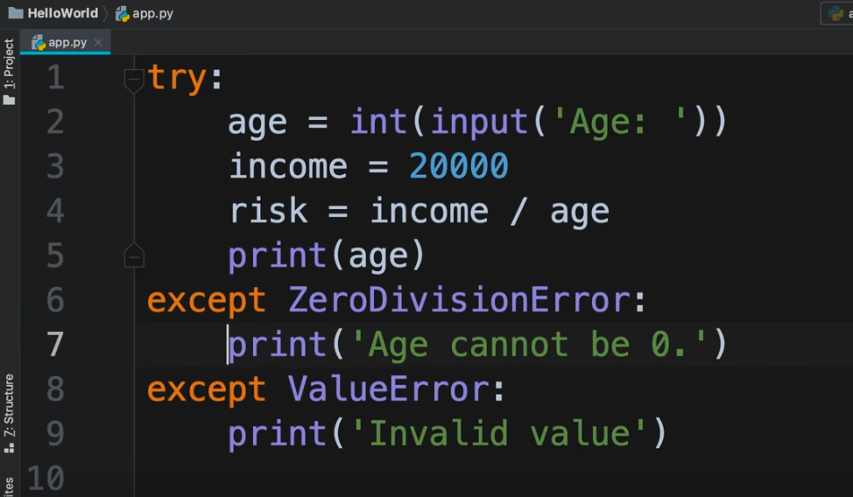

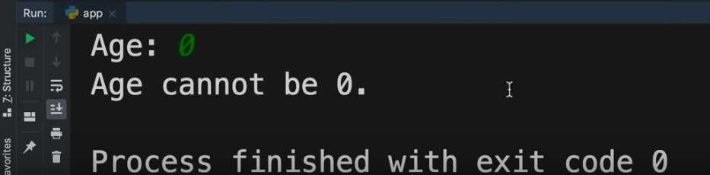

Exception handling by Naveen Reddy

<https://youtu.be/YfO28Ihehbk?t=18053>

There are 3 kinds of errors :

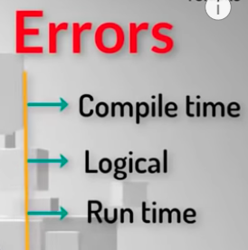

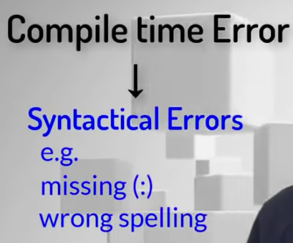

In Logical error, the code does get compiled but the output is not correct

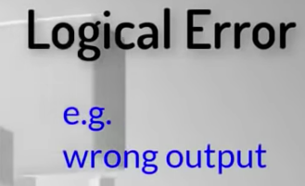

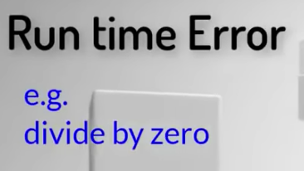

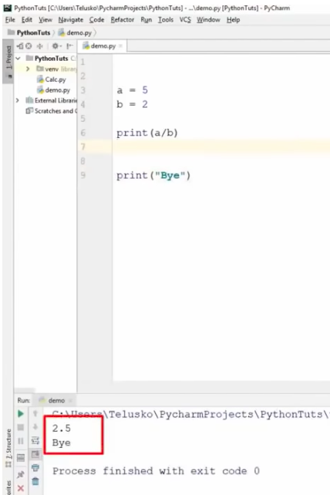

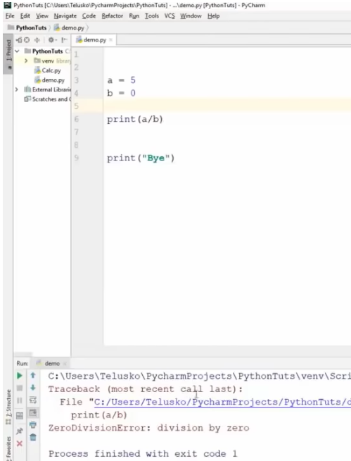

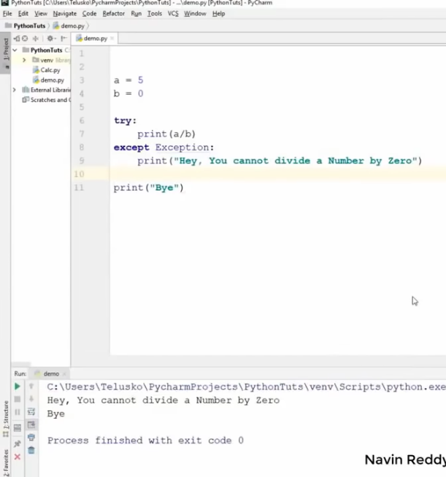

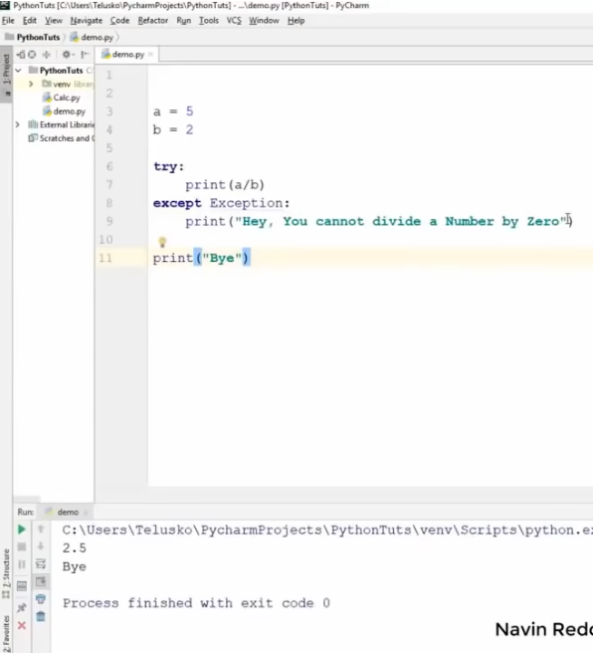

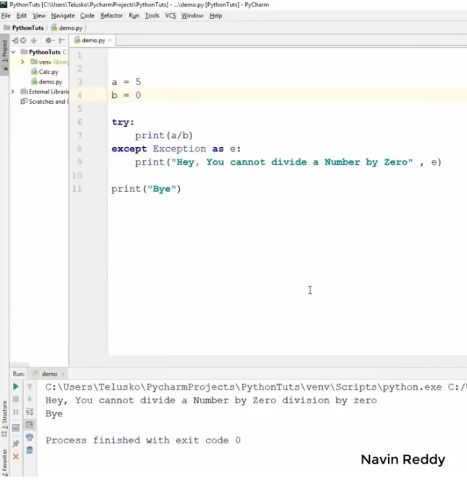

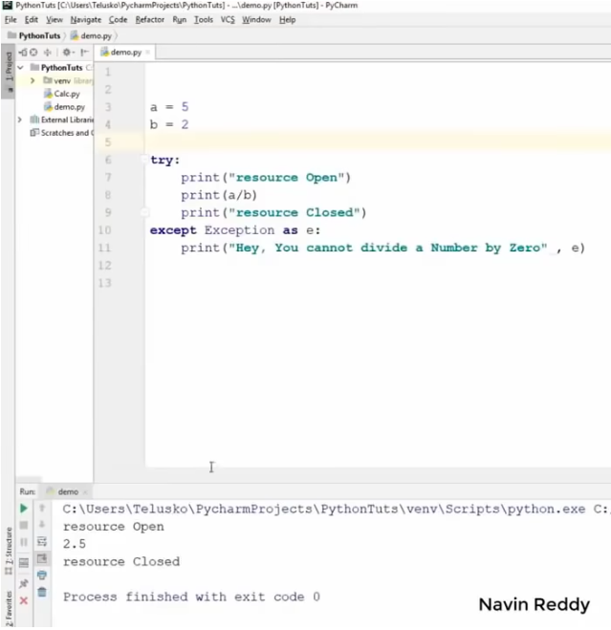

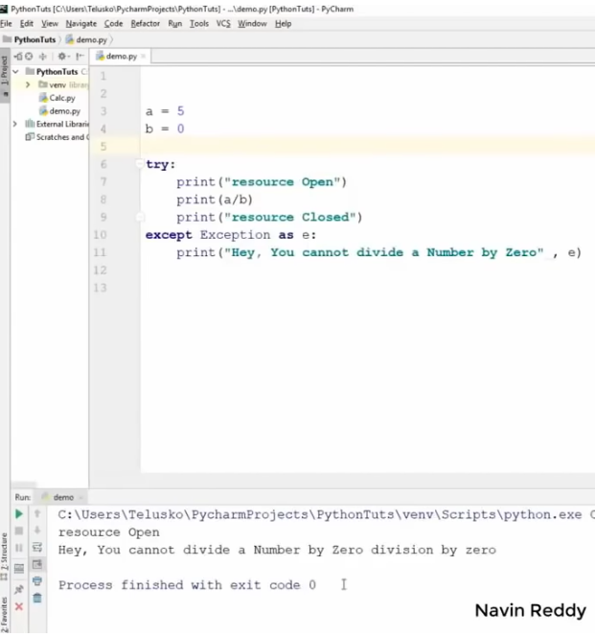

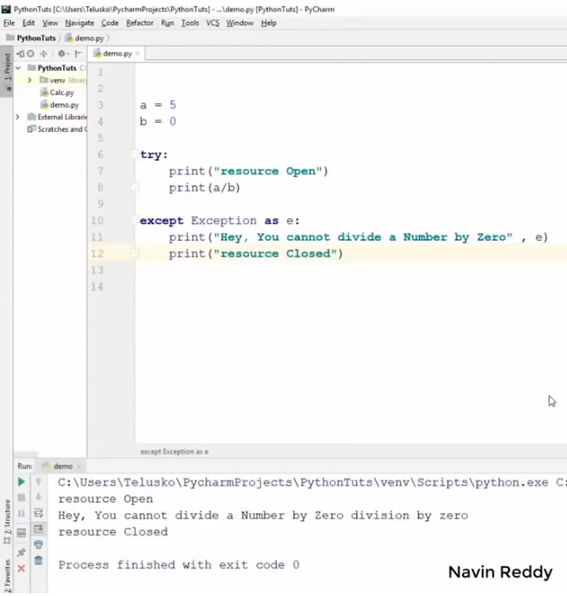

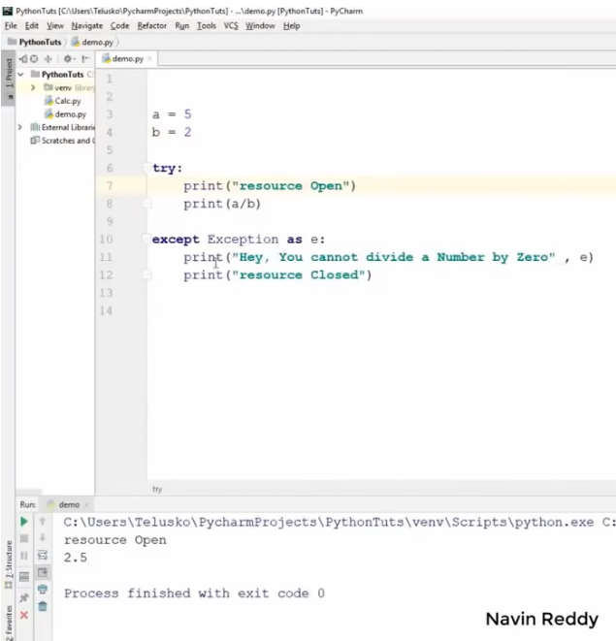

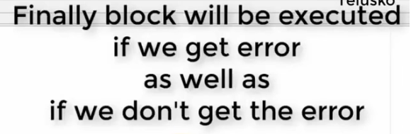

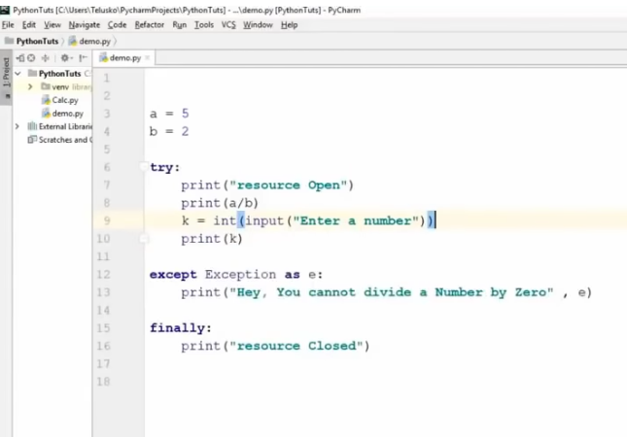

Execution

<https://youtu.be/YfO28Ihehbk?t=18796>

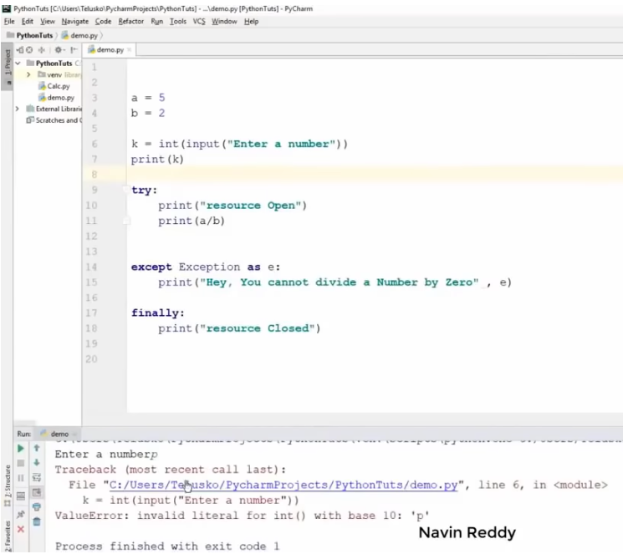

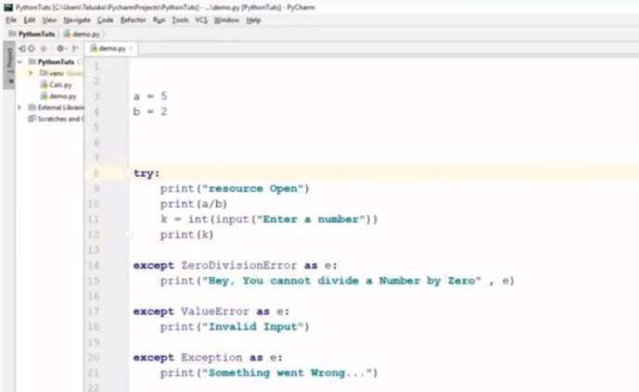

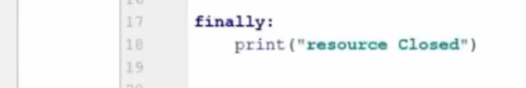

Execution

<https://youtu.be/YfO28Ihehbk?t=18971>

Comments

<https://youtu.be/_uQrJ0TkZlc?t=10766>

We use comments to add notes or comments to the program

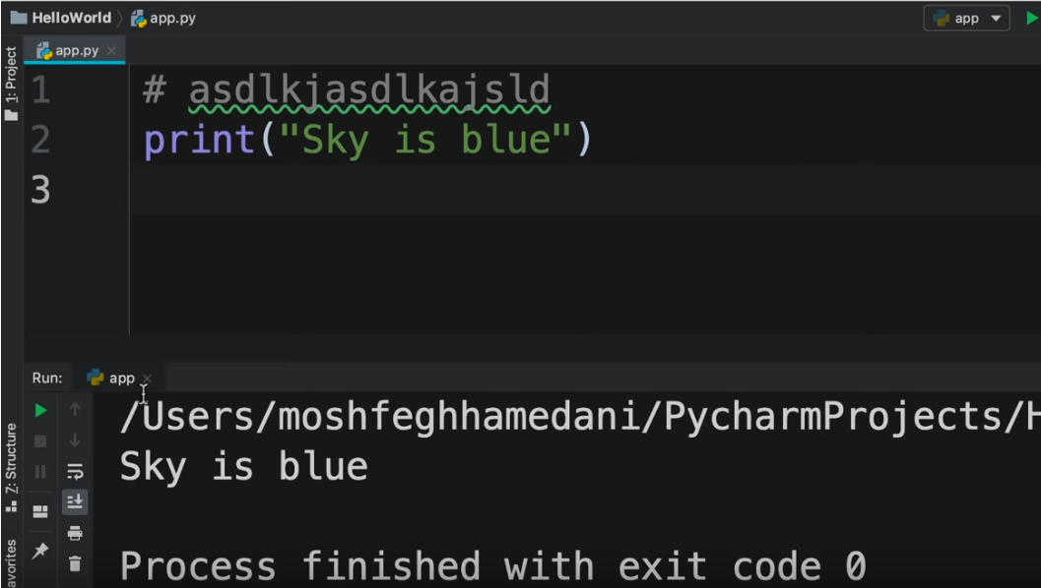

Comments by Naveen Reddy

<https://youtu.be/YfO28Ihehbk?t=20584>

**Creating class in Python**

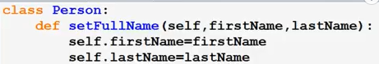

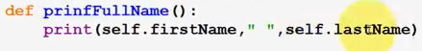

Whenever we declare a function inside a class, the first argument that we give to the function is a keyword called **self**. **self** is basically a pointer that points to the current instance of the class itself. Whenever we create instance/object of the class, then **self** points to the instance of the class

To set values of the variables, we can use self to call the variables of the class

To create an instance of a class :

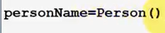

**personName** is the desired name of the instance of the class

This will create object of Person class with the name personName

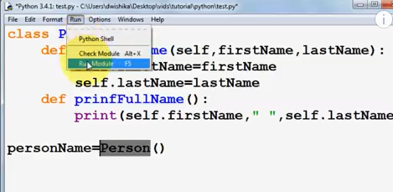

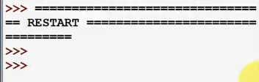

To use member function of the class :

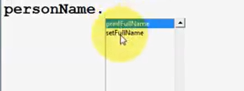



To print :



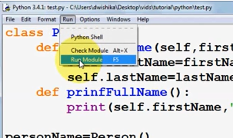

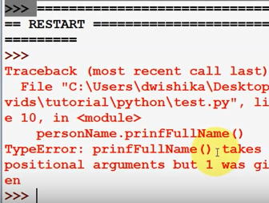

We get an error because the member function **prinfFullName()** does not take any argument

To correct the above error

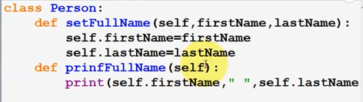

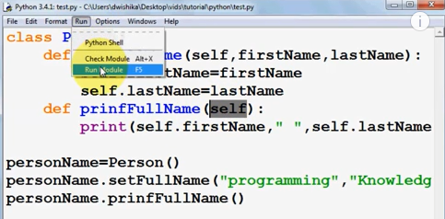

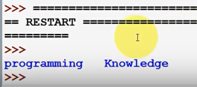

NOTE : whenever we define a member function in a class, we should always give **self** as the argument at the first place

Classes

<https://youtu.be/_uQrJ0TkZlc?t=10919>

We can use classes to define new types.

Here, we have defined a new type and named it as **Point** and there are methods to work with the point.

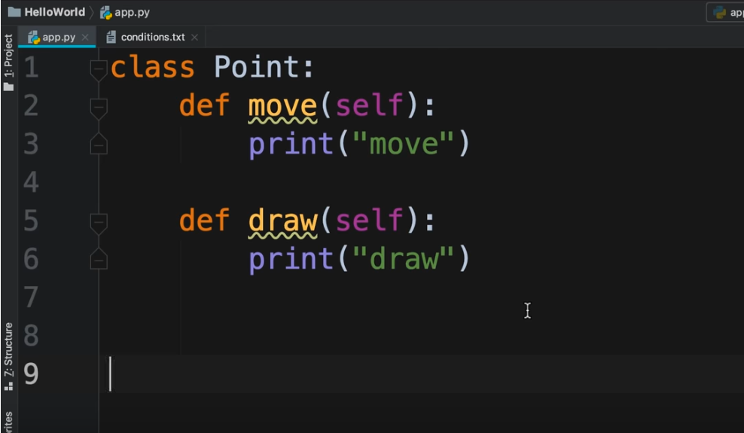

With this new class, we can create an object. An object is an instance of a class.

To create an object :

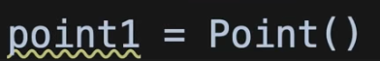

When we use dot operator :

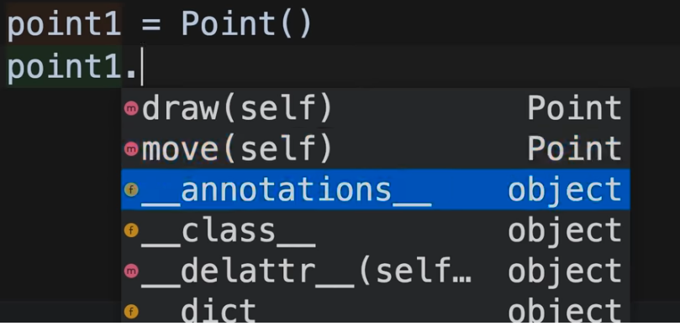

We can see the methods **draw** and **move** that were defined in Point class.

We have a few more methods with underscore. Such methods are called magic methods.

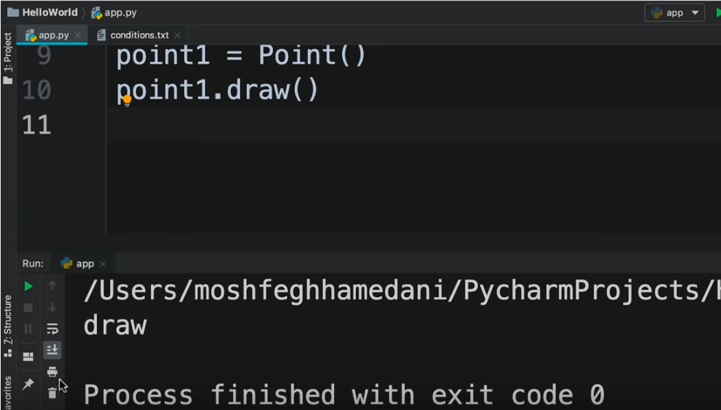

Objects can also have attributes. The attributes are like variables that belong to a particular object.

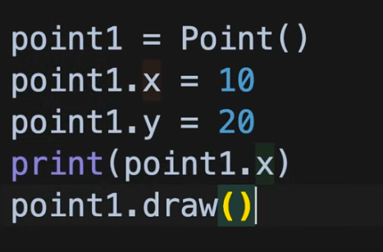

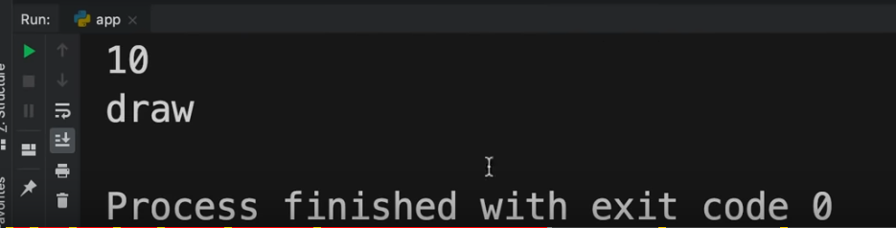

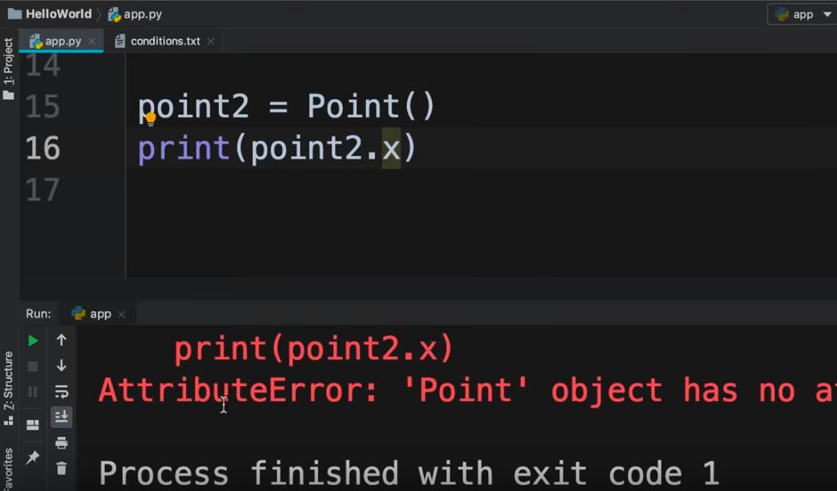

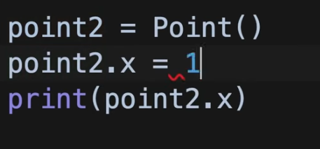

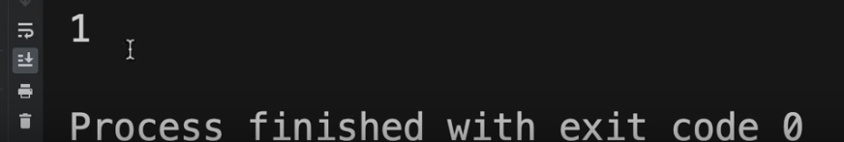

**Constructors and Destructors**

Constructor is used to initialize the value whenever we are creating an instance of the class. As soon as we create an instance of a class, the constructor is called implicitly

Defining constructor

Note : Use double underscore before and after **init**

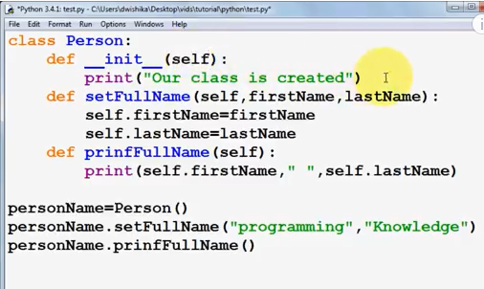

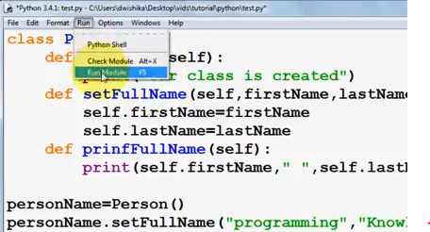

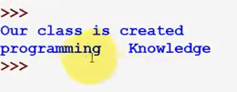

We can use Destructor to destroy an instance of a class. Destructor has to be invoked explicitly whenever the instance of the class has to be destroyed i.e. the instance is not being used further in the code. The Destructor destroys all the resources i.e. member functions and member variables being used by the instance

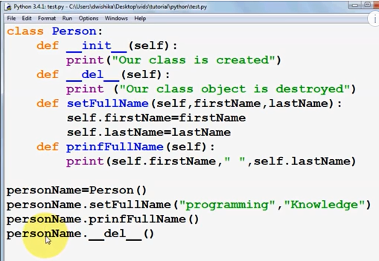

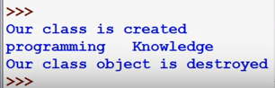

If we are passing a parameter to the constructor, then we will have to pass an argument when creating an instance of the class

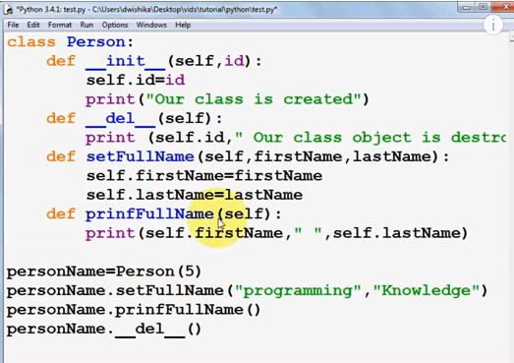

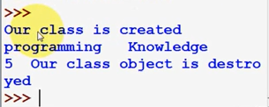

<https://youtu.be/JIVHiXXTUHQ?list=PLS1QulWo1RIaJECMeUT4LFwJ-ghgoSH6n&t=21>

Constructors

<https://youtu.be/_uQrJ0TkZlc?t=11278>

A constructor is a function that gets called at the time of creating an object.

**self** is the reference to the current object. Using the **init** method, we can initialize the object and we refer to this method as a constructor.

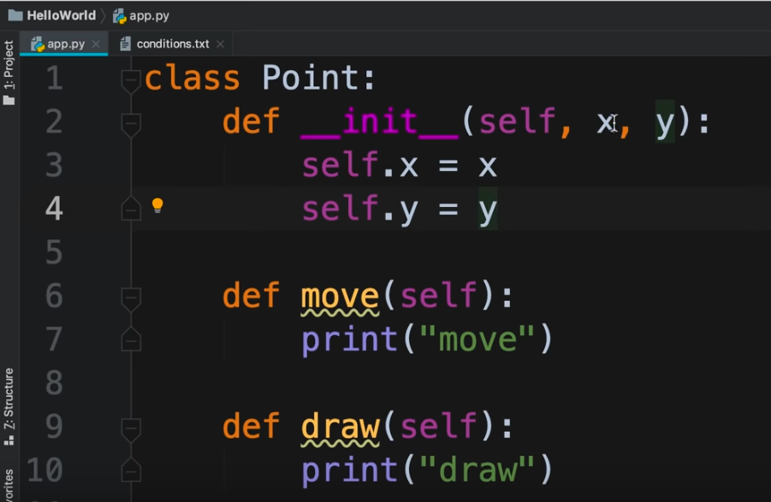

So when we create a new **Point** object, **self** references to that object in memory.

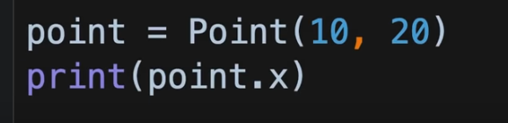

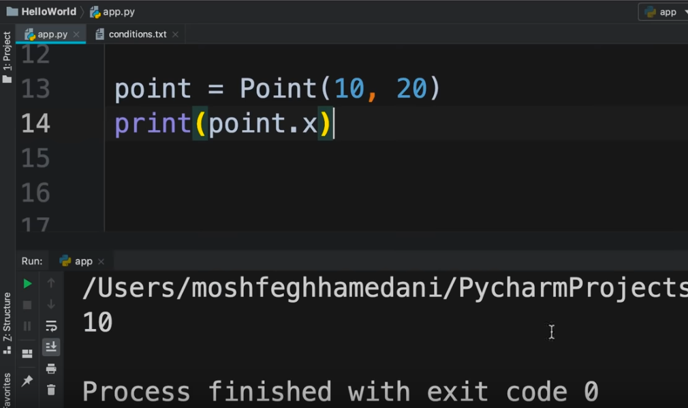

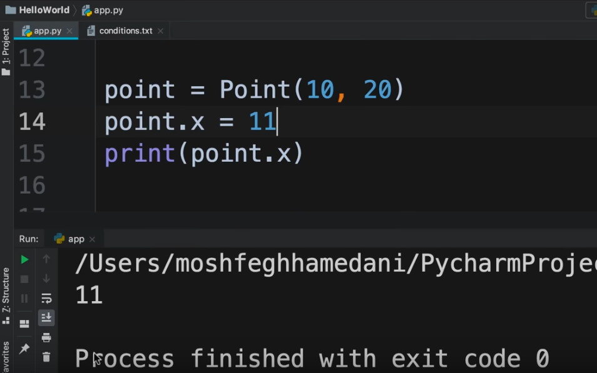

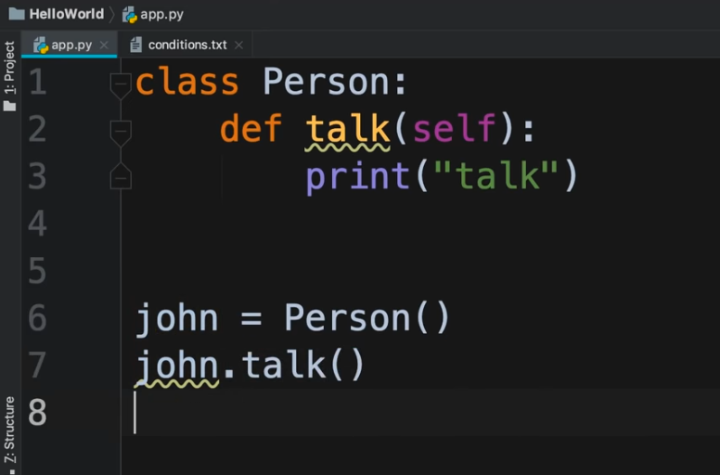

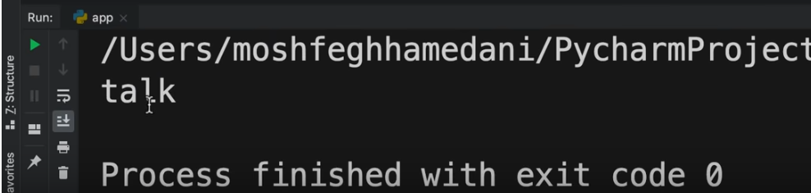

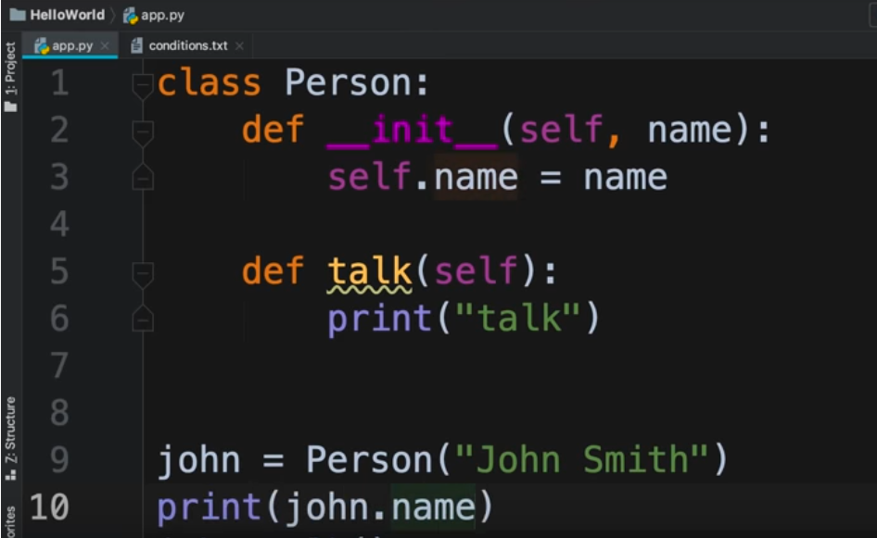

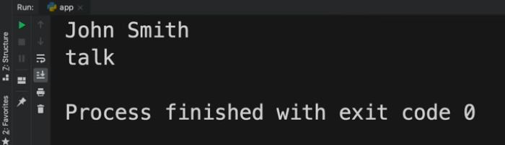

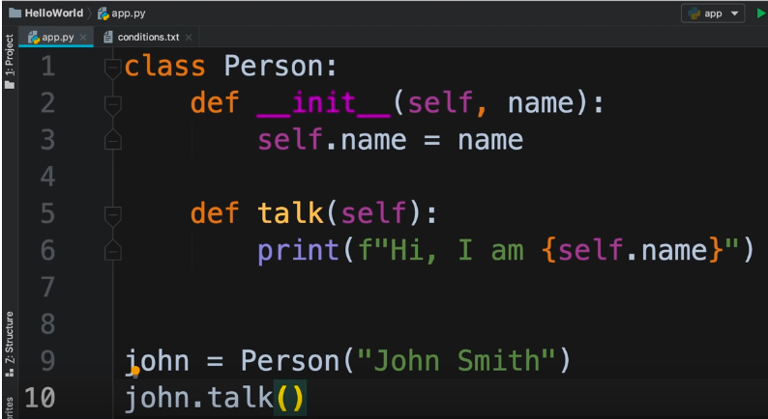

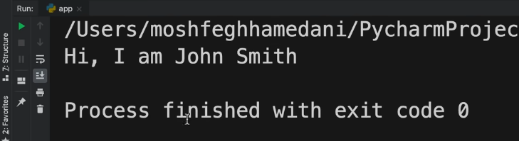

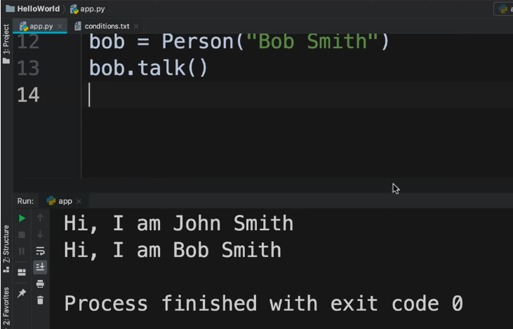

_init_ method and constructor by Naveen Reddy (Watch upto 3:55:11)

<https://youtu.be/YfO28Ihehbk?t=12800>

Suppose we have 2 variables. One defines the type of CPU and the other defines the amount of RAM.

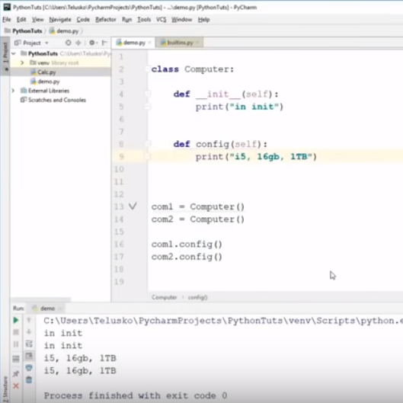

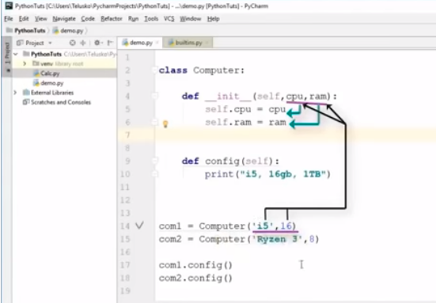

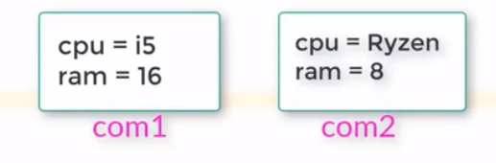

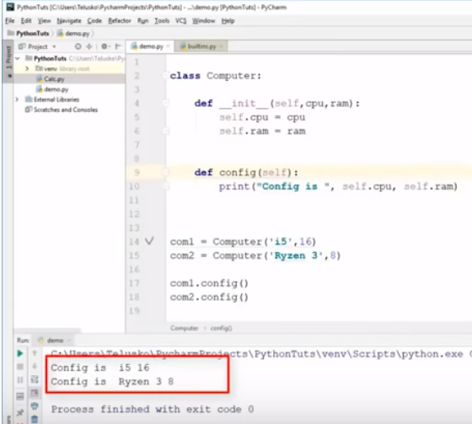

Inheritance

<https://youtu.be/_uQrJ0TkZlc?t=11695>

If we do not want to define any methods in the class, we can use the **pass** keyword

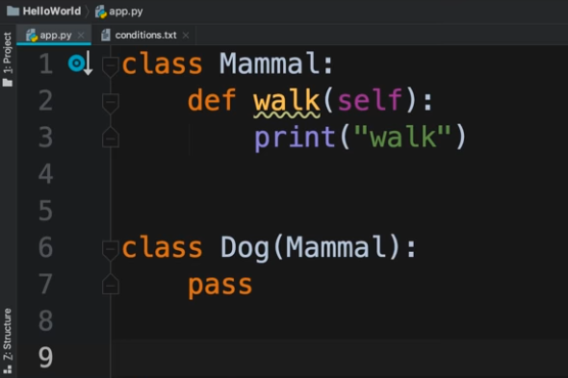

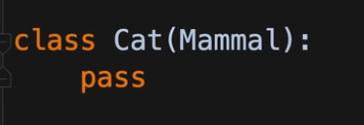

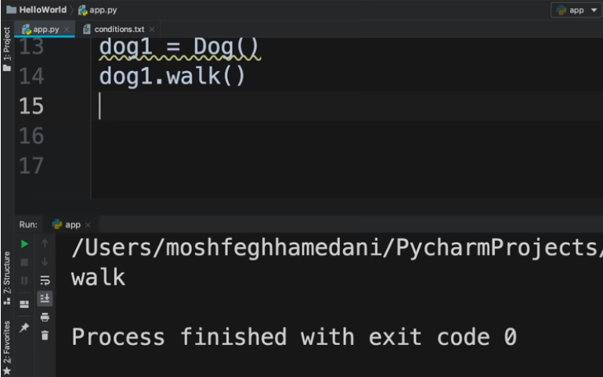

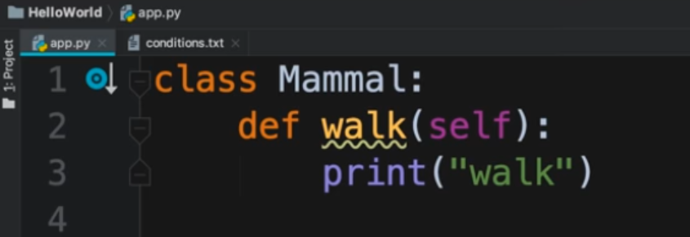

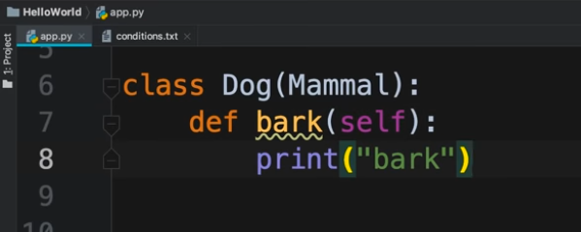

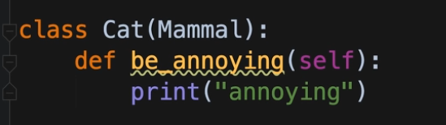

Inheritance by Naveen Reddy (Watch upto 4:20:22)

<https://youtu.be/YfO28Ihehbk?t=15228>

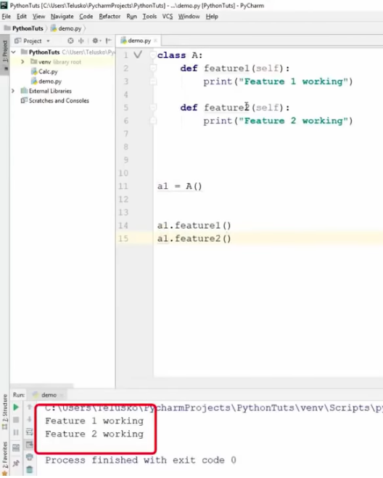

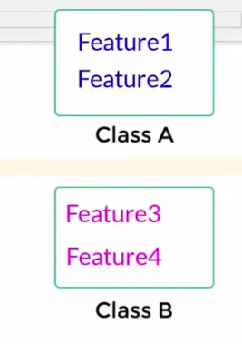

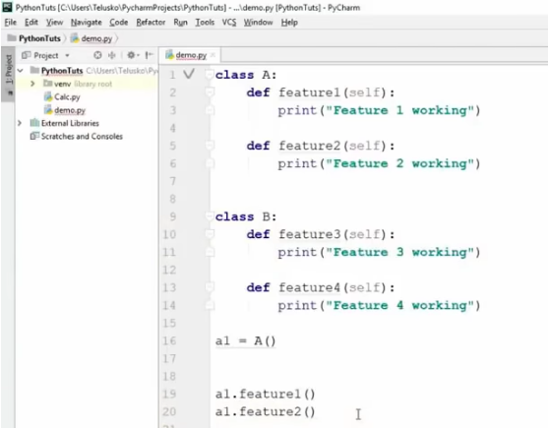

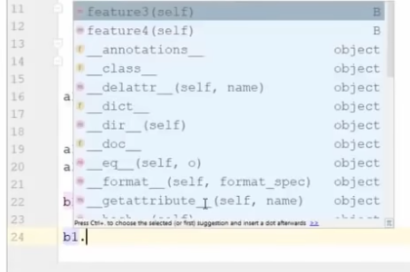

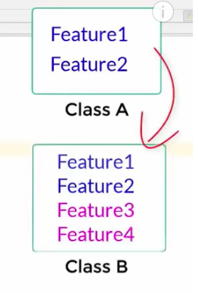

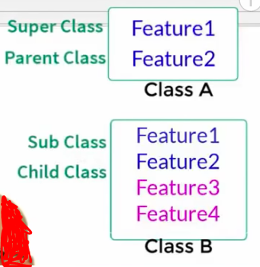

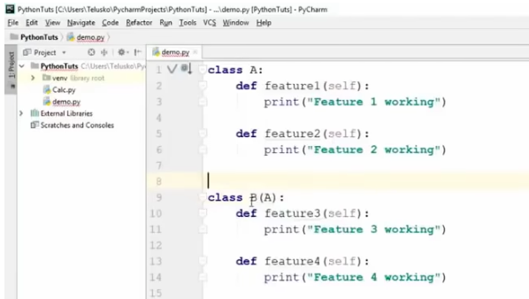

The above is an example of single level inheritance

We also have multi level inheritance



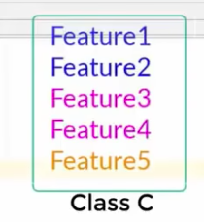



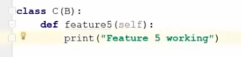

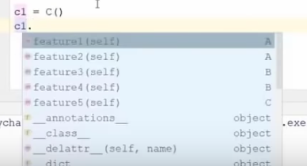

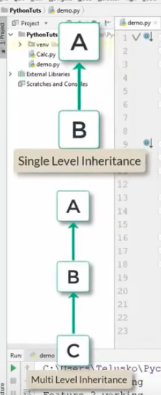

In Python, Multiple inheritance is possible

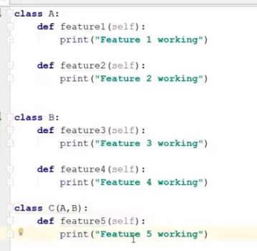

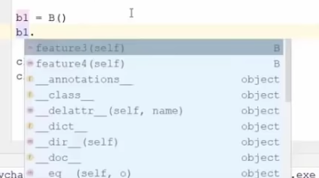

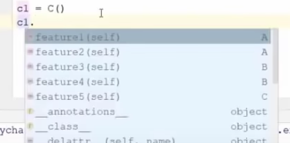

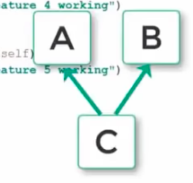

Constructor in Inheritance (Watch upto 4:28:37)

<https://youtu.be/YfO28Ihehbk?t=15625>

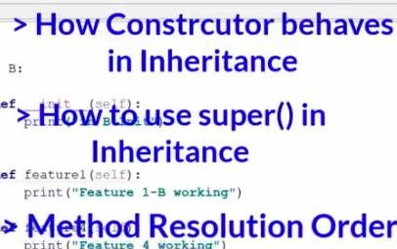

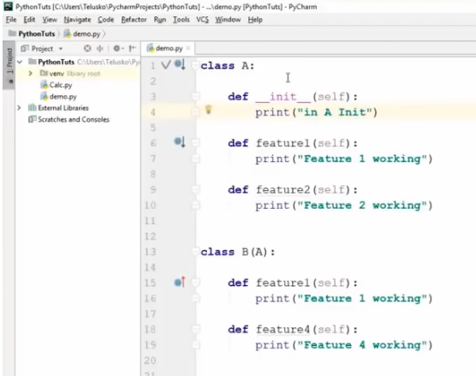

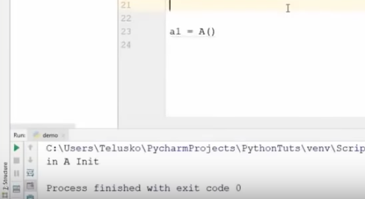

With the object of A, we can access features of only class A

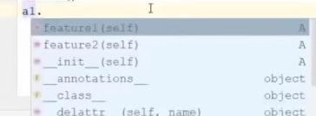

If we create an object of class B, it will call the constructor of class A



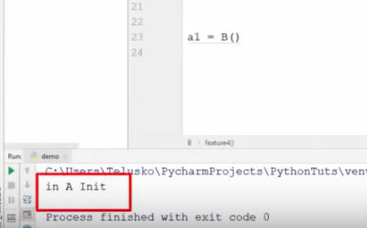

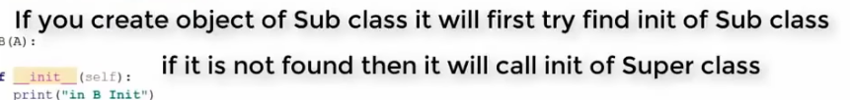

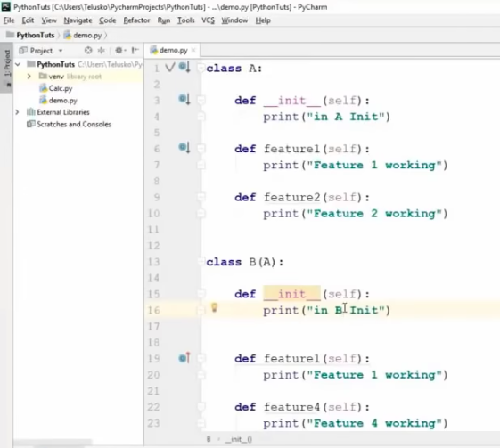

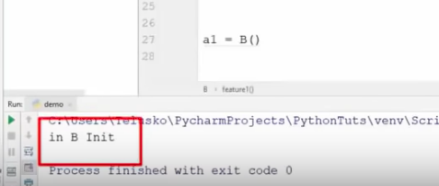

But if we want to call init of both subclass and superclass, we can use **super** keyword for this

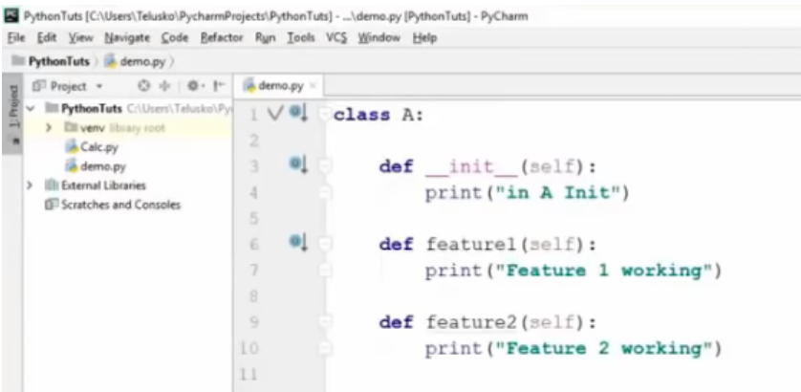

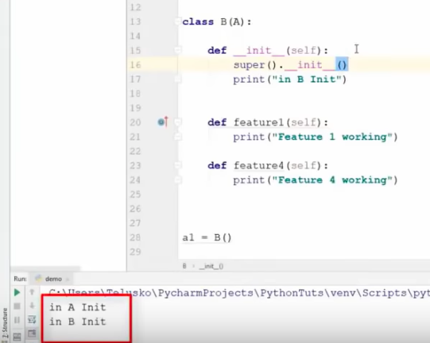



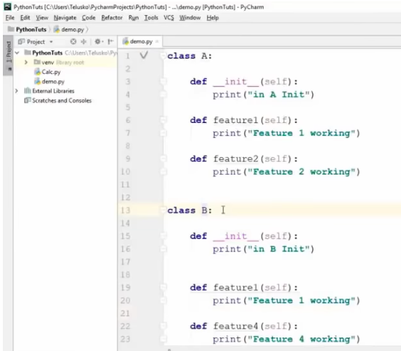

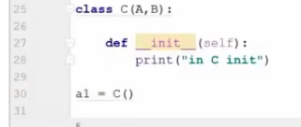

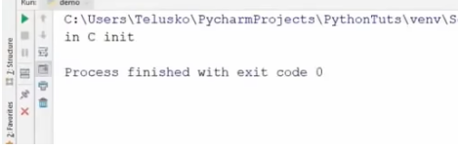

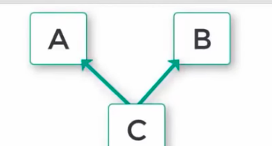



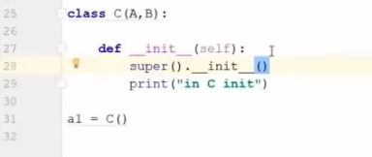

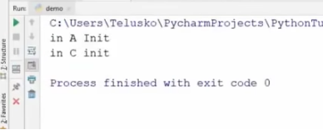

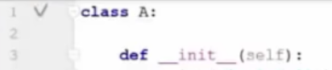

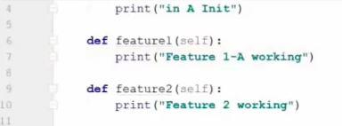

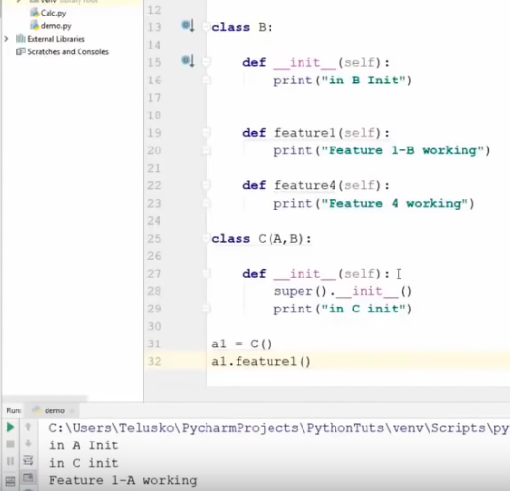

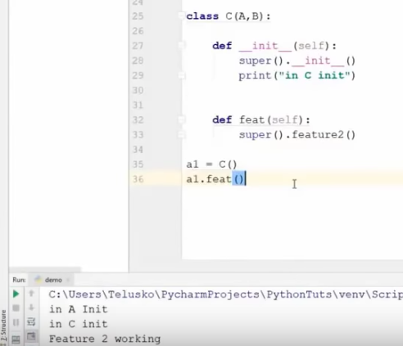

Set Path in Windows and Help by Naveen Reddy (Watch upto 58:41)

<https://youtu.be/YfO28Ihehbk?t=3194>

Types of Methods by Naveen Reddy (Watch upto 4:06:38) (Very important)

<https://youtu.be/YfO28Ihehbk?t=14112>

There are 3 kinds of methods :

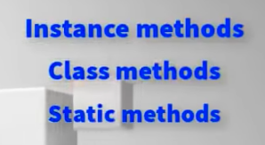

Here, **avg** is an instance method

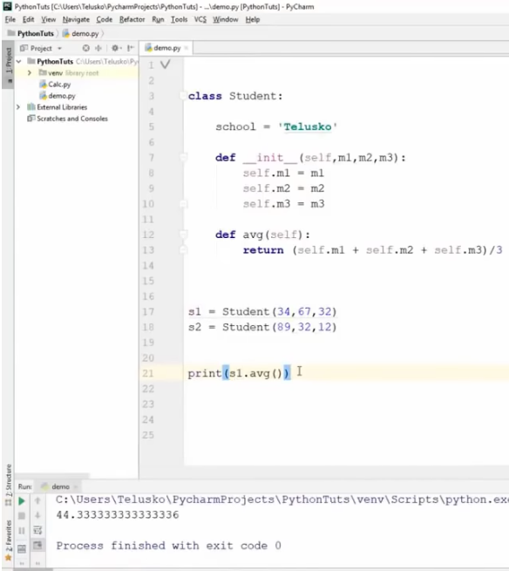

To create a class variable, we need to declare the variable outside the constructor. In the above class, **school** is a class variable.

There are 2 types of instance methods :

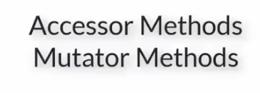

If we just want to fetch the value of an instance variable, we will use Accessor method

If we want to modify the value of an instance variable, we will use Mutator method

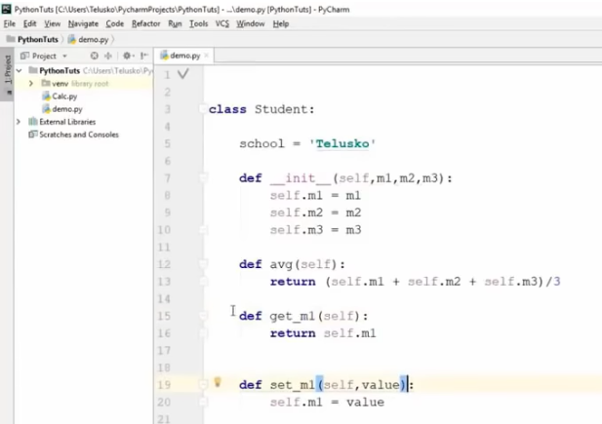

Class method

<https://youtu.be/YfO28Ihehbk?t=14525>

An instance variable can be used with instance methods. **school** is a class variable. To work with class variables, we need to use a class method.

When we are working with an instance, we will use the **self** whereas when we are working with class, we will use the **cls** keyword.

NOTE: self is not a keyword in Python.

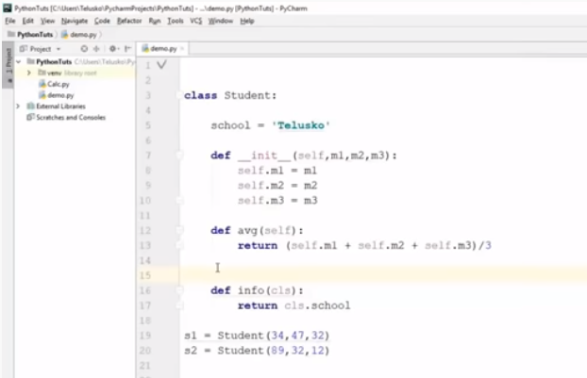

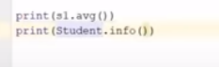

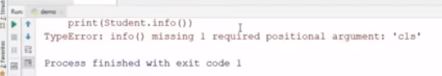

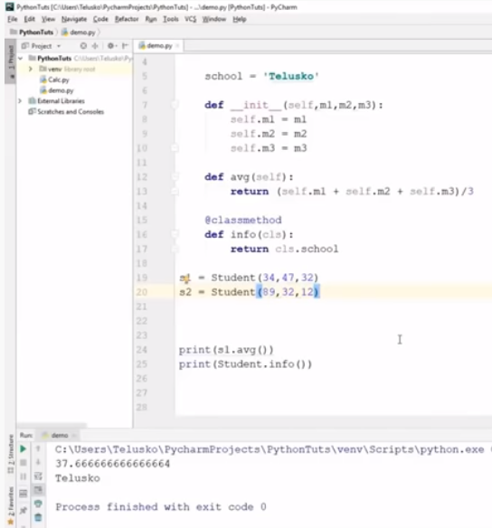

NOTE: To know the list of keywords in Python.

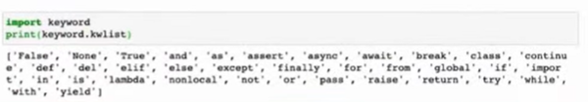

The keywords in Python will differ from version to version.

Static method

<https://youtu.be/YfO28Ihehbk?t=14665>

Suppose we want a method which has nothing to do with the instance variable nor with the class variable. In this case, we will use a static method.

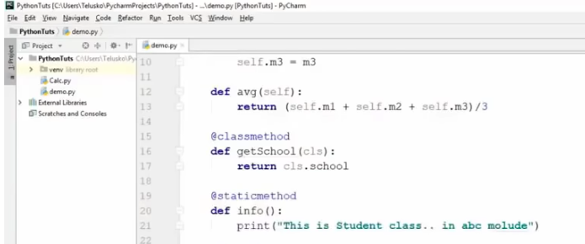

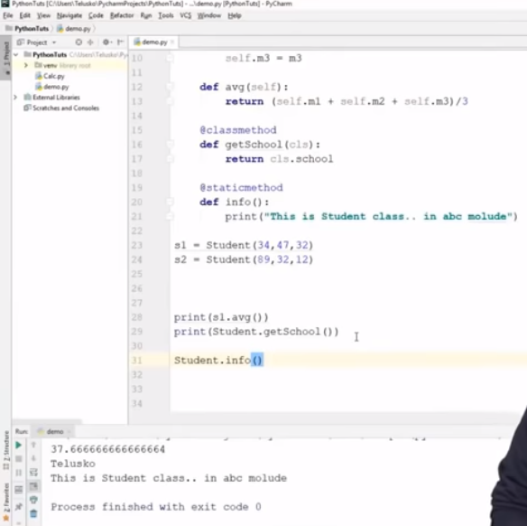

Class and variables in Python

<https://www.youtube.com/watch?v=ZDa-Z5JzLYM>

Classes allow us to logically group our data and functions in a way that is easy to reuse and also easy to build upon if need be. The data and functions in the context of class are called attributes and methods.

Suppose we have an application for a company and we want to represent employees using Python code. Each individual employee will have specific attributes and methods. So a class can be used as a blueprint to create each employee.

Class is basically a blueprint to create instances. Each unique employee that we create using the class will be an instance of the class.

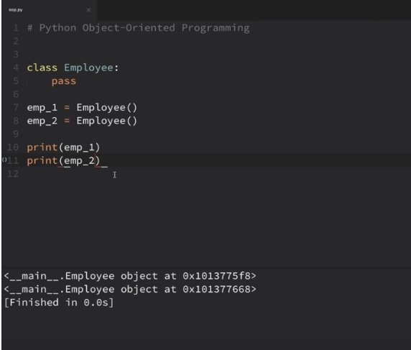

These are 2 unique instances of the Employee class

We can manually create instance variable for each employee. Suppose we want emp_1 to have first name and last name.

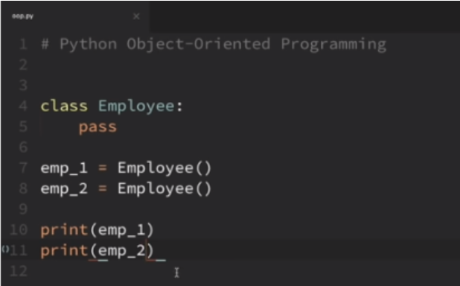

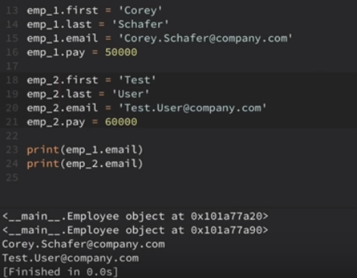

Suppose we want to perform the above task at the time of creating the instance itself rather than doing it manually. For this purpose, we will use the constructor.

<https://youtu.be/ZDa-Z5JzLYM?t=375>

Inner class by Naveen Reddy (Watch upto 4:13:46) (V.Imp)

<https://youtu.be/YfO28Ihehbk?t=14801>

We can print the instance variables as done below :

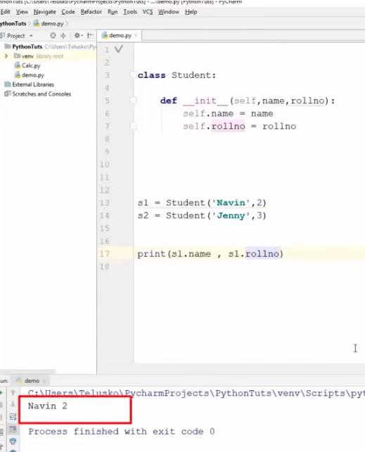

But we may want to print it in a different way

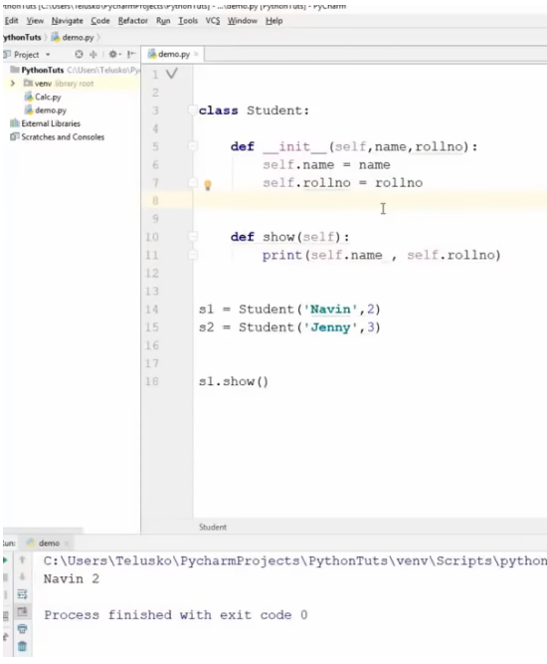

Suppose Students have laptops. A laptop will have configuration specifications. One way of mentioning these specifications is passing them in the constructor. The other way is to create a separate class which is inside the Student class.

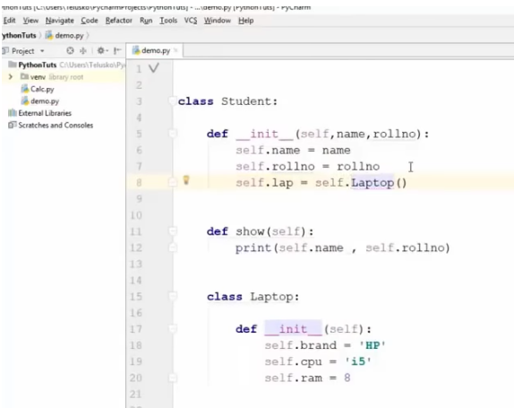

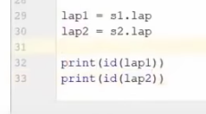

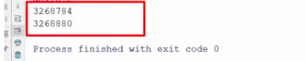

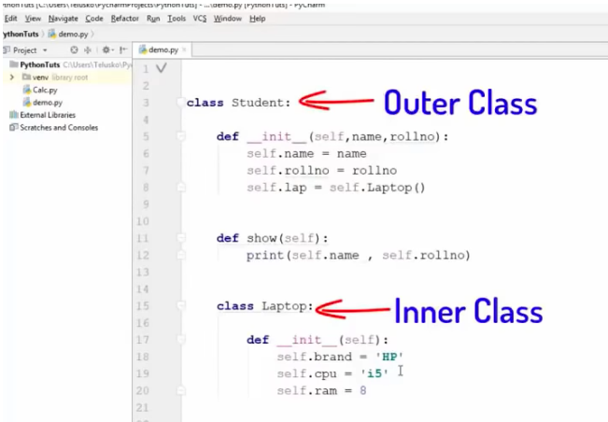

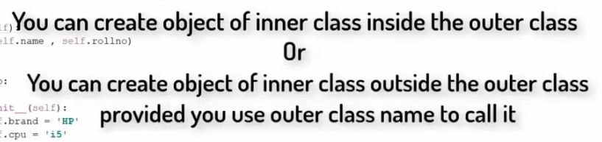

These are 2 different show methods

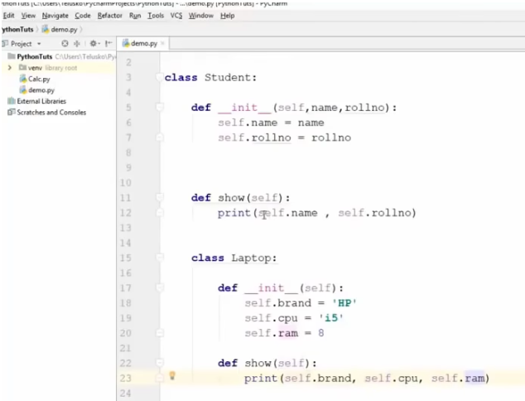

Polymorphism by Naveen Reddy (Watch upto)

<https://youtu.be/YfO28Ihehbk?t=16120>

Poly means many and morph means form. So Polymorphism means multiple forms

There are 4 ways of implementing Polymorphism :

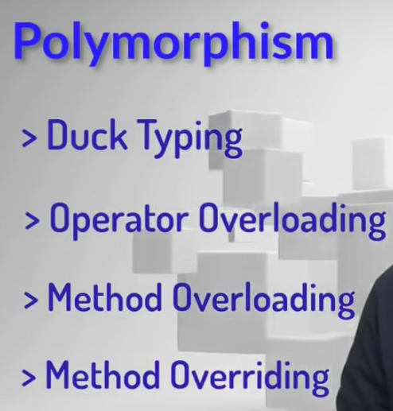

Duck Typing

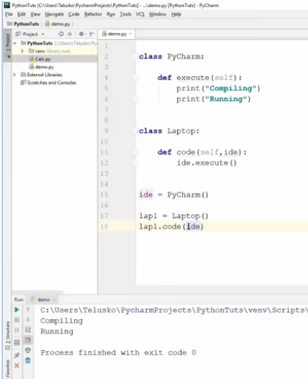

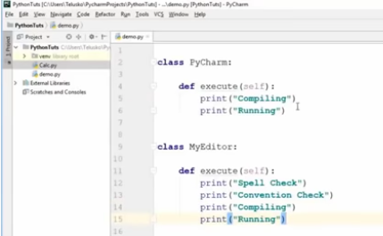

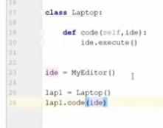

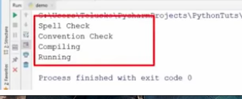

Operator overloading

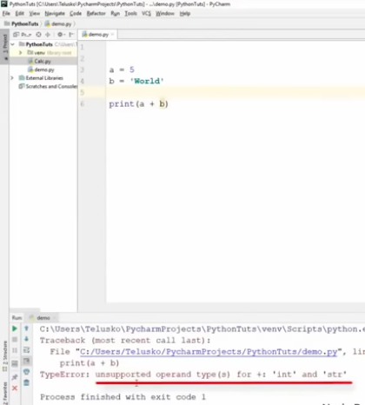

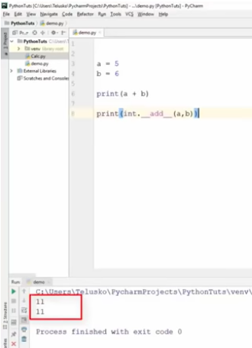

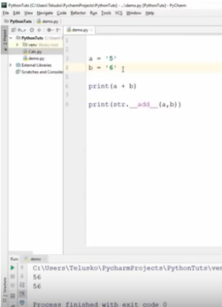

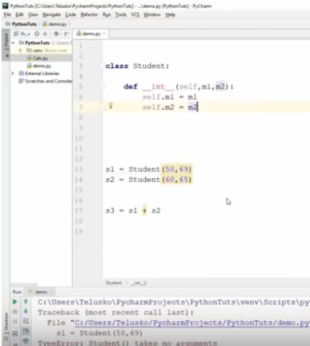

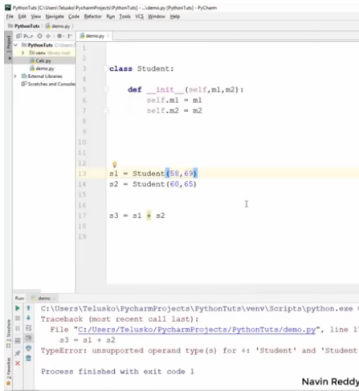

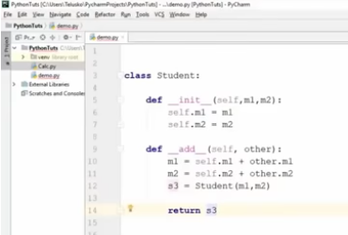

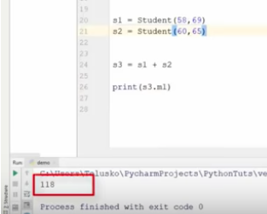

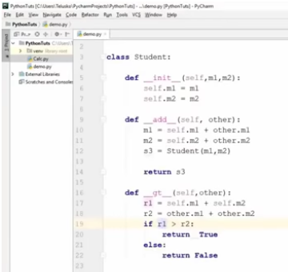

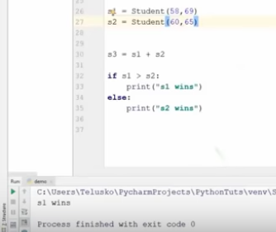

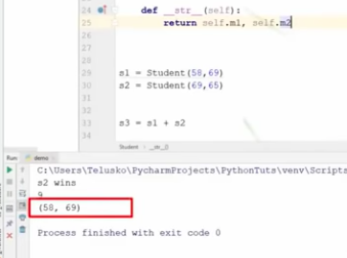

Method overloading and Method overriding in Python

<https://youtu.be/YfO28Ihehbk?t=17436>

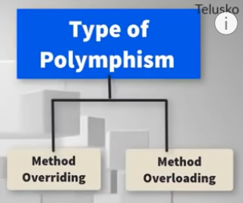

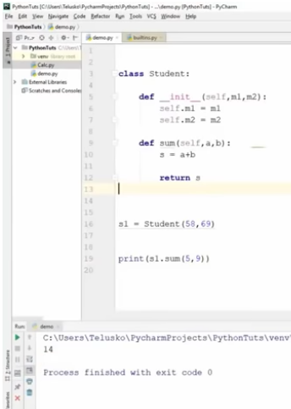

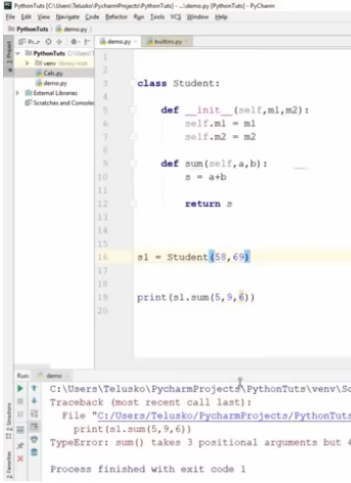

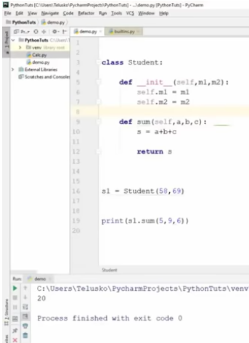

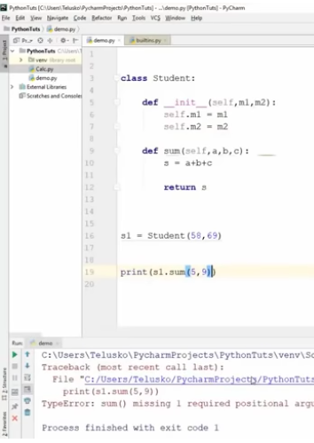

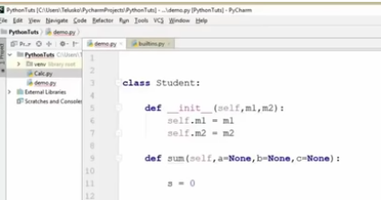

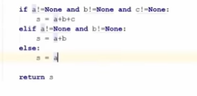

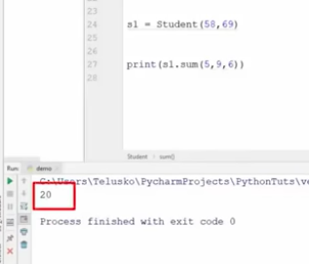

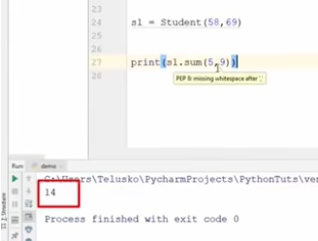

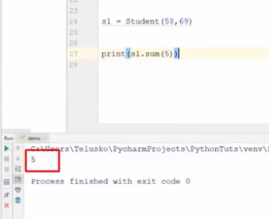

Method overriding

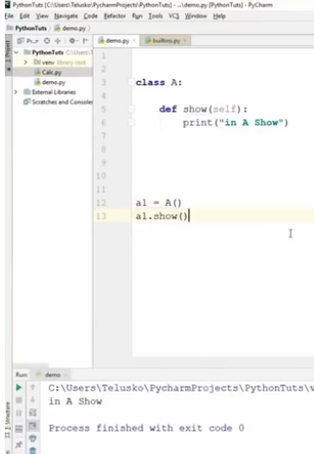

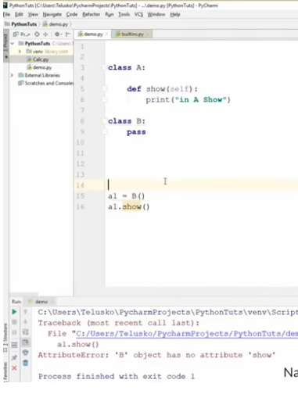

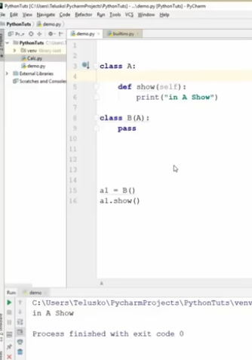

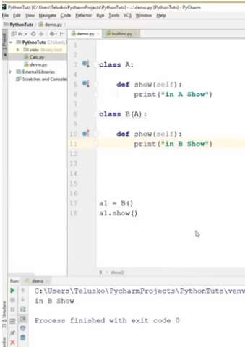

**Advanced Python || Method Overloading & Overriding || by Durga On 27-07-2018**

<https://www.youtube.com/watch?v=SJeflaUipWk>

Modules

<https://youtu.be/_uQrJ0TkZlc?t=11987>

A module is a file with Python code. We use modules to organize the code into multiple files.

This will improve the structuring and reusability of the code.

Suppose we have the below 2 functions :

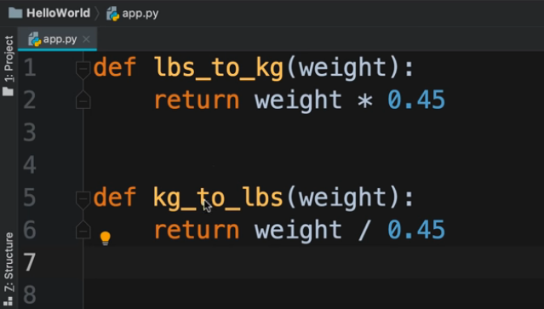

Create a new file

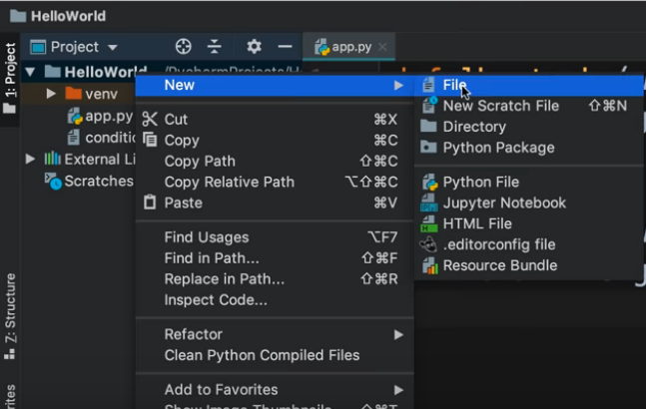

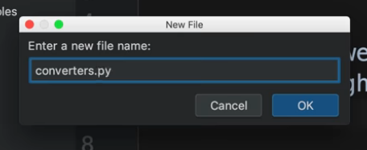

Cut and paste the code from previous file to this new file

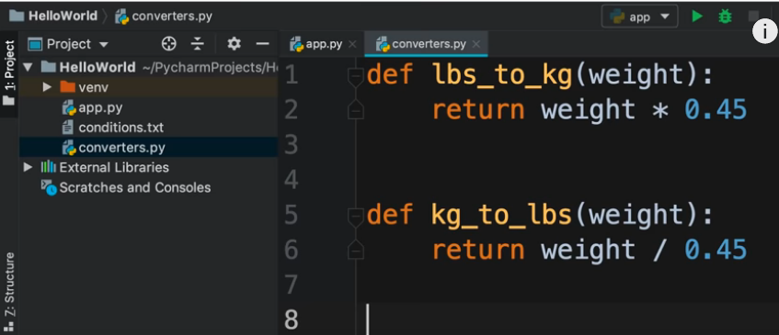

Now we want to import **converter** module into **app** module

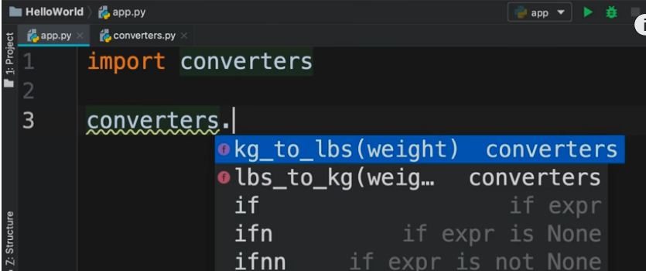

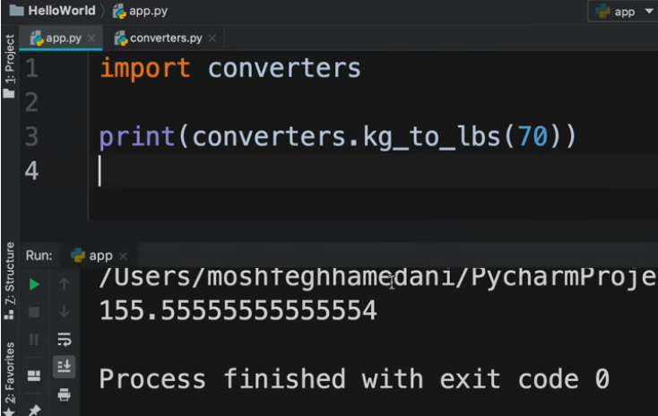

There is another syntax for importing modules

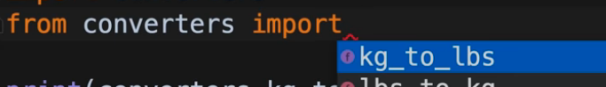

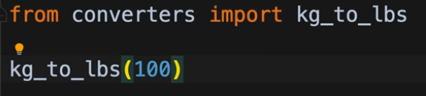

NOTE : **imp** is deprecated now in Python 3. Instead, we need to use the **importlib** module.

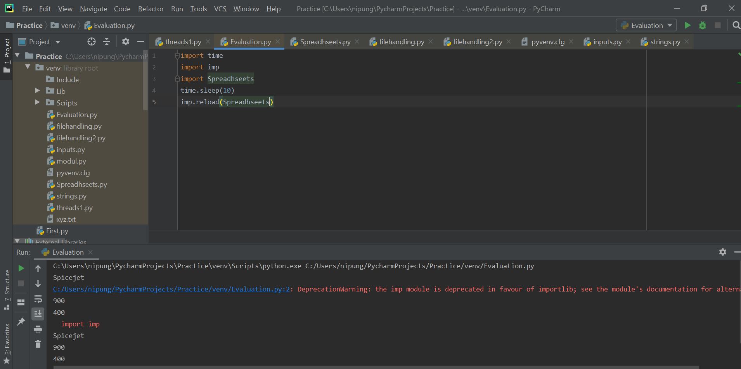

Packages

<https://youtu.be/_uQrJ0TkZlc?t=12626>

A project can contain a large number of modules. We can use packages to organize related modules.

Create a new directory

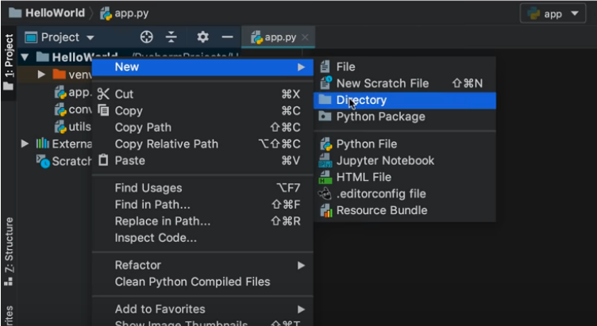

Name the directory

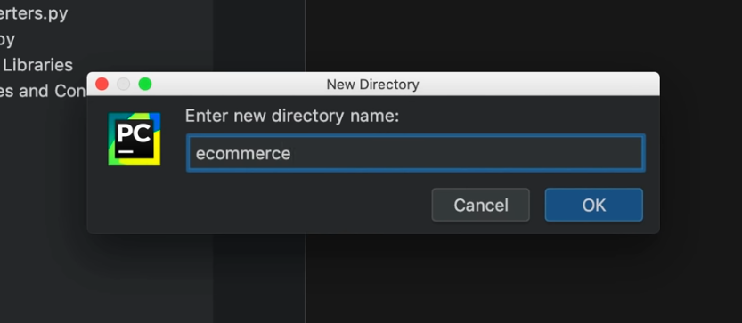

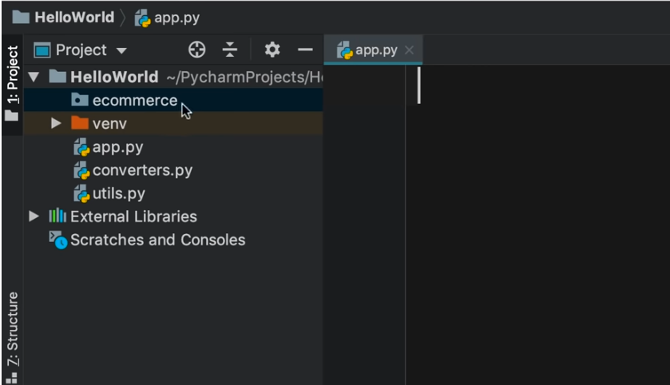

e-commerce is an empty directory at the moment. We want to create a package **ecommerce** and inside this package, we will have modules related for the ecommerce application.

In order to convert this directory into a package, we need to add a special file in it.

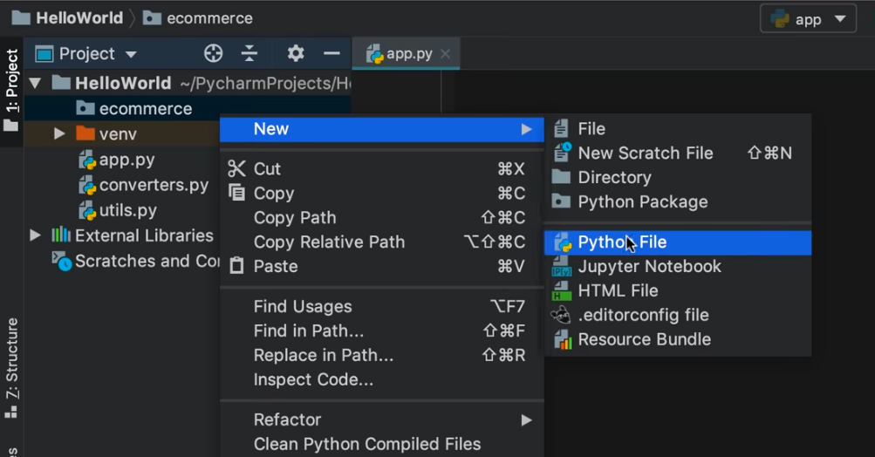

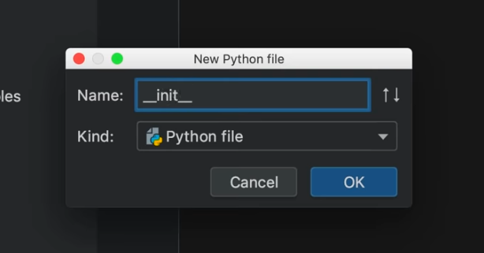

When the Python interpreter encounters a file with such a name i.e. **__init__.py** in a directory, it treats the directory as a package.

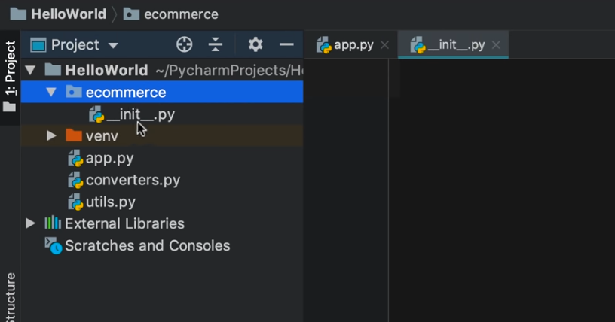

There is a shortcut approach as well

Create a Python Package

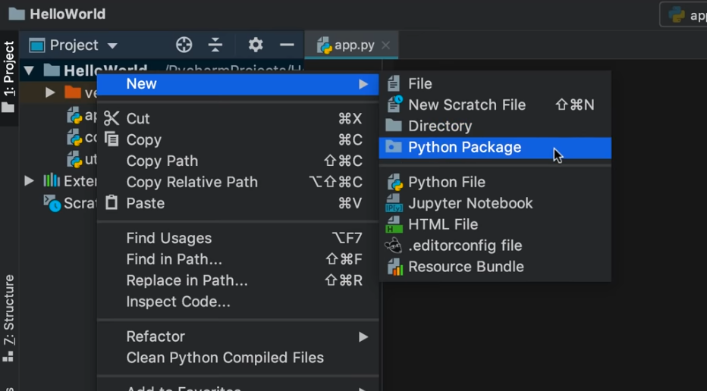

So automatically the file **__init__.py** will be created inside the package.

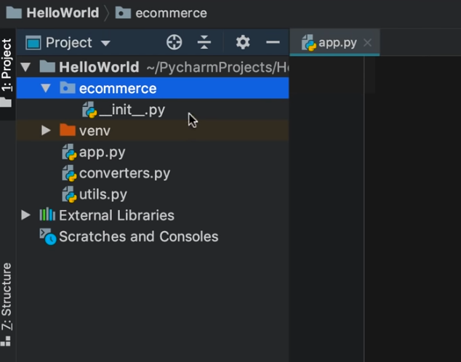

Create a new Python File

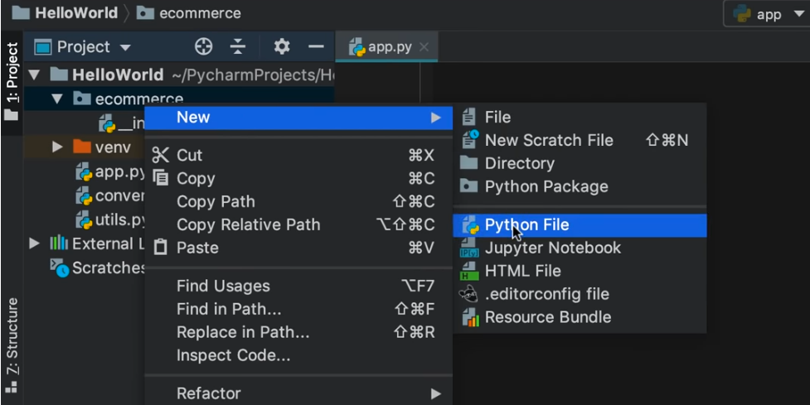

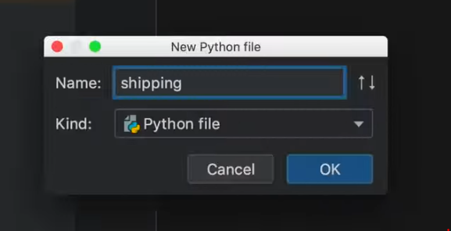

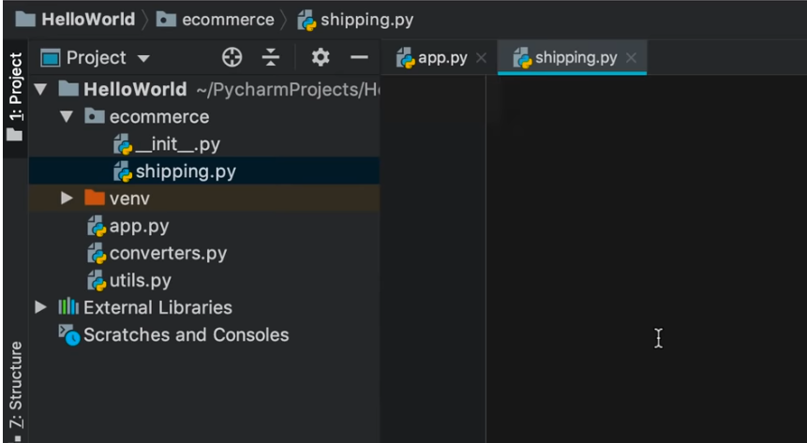

In this file shipping.py, we want to create a function to calculate the shipping cost.

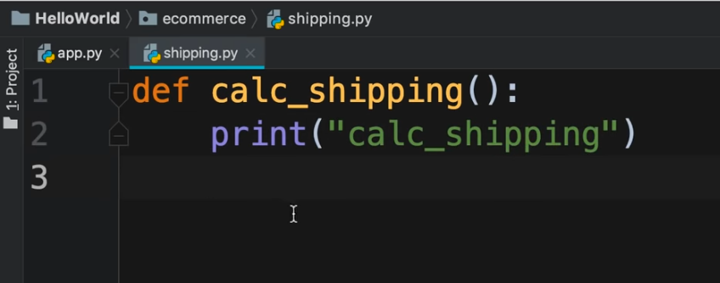

Now suppose we want to import this shipping module into app module

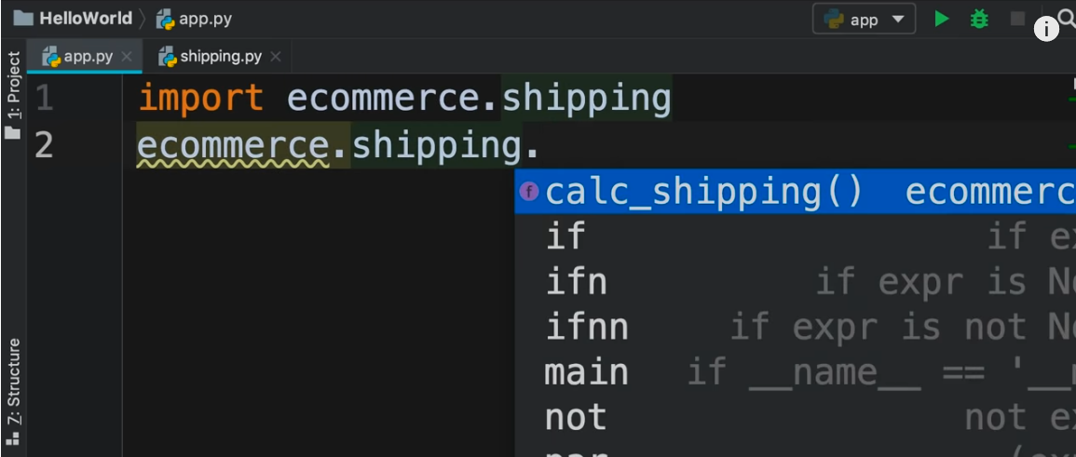

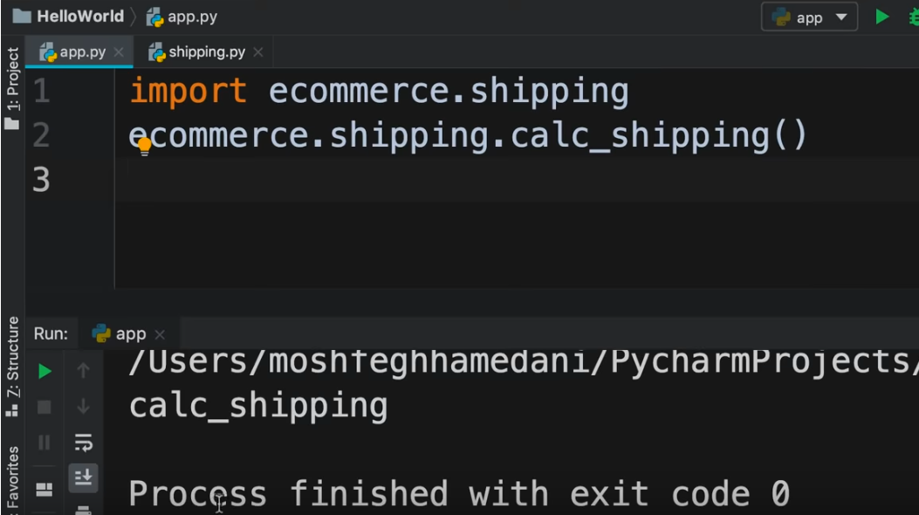

We can import the module as below also :

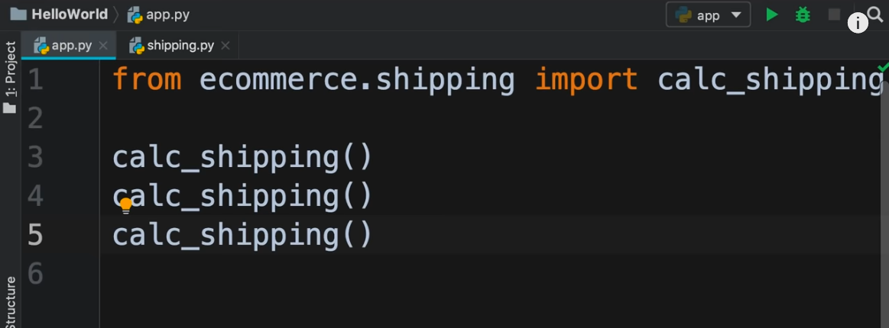

We can import as below :

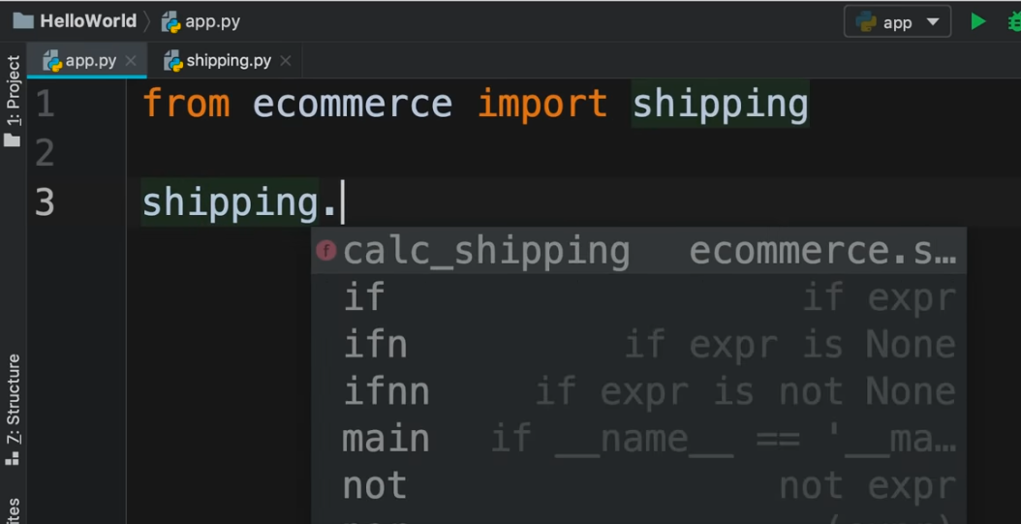

We can also import as well :

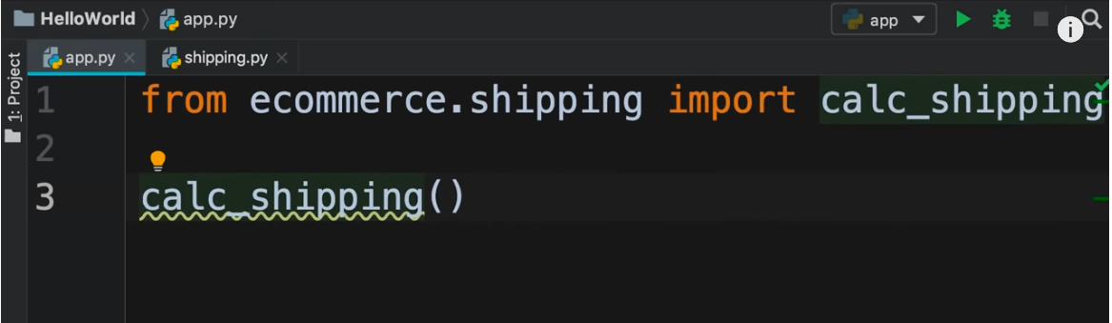

Generating random values

<https://youtu.be/_uQrJ0TkZlc?t=12996>

To find inbuilt modules in Python

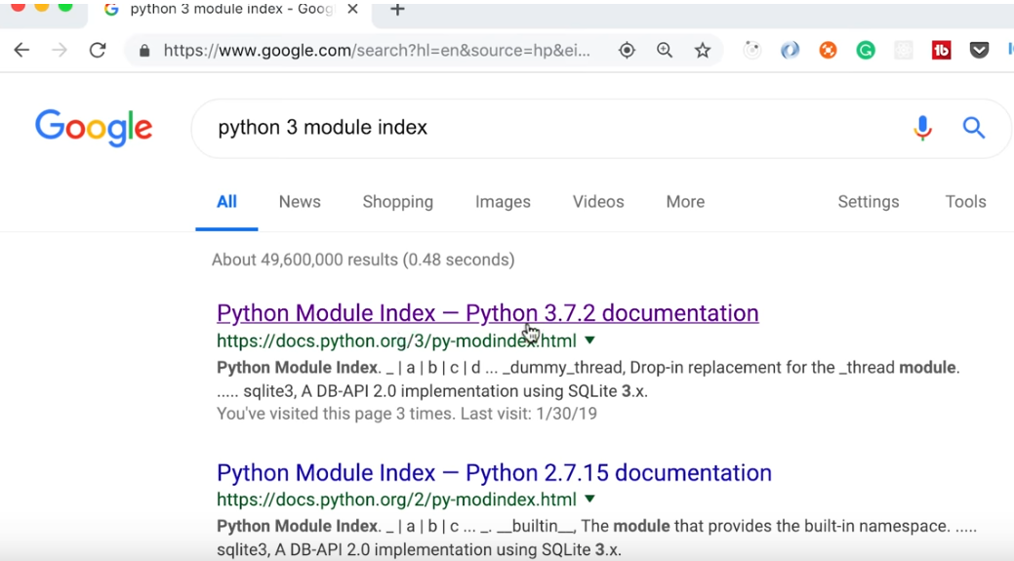

Click on the first link

We are importing an inbuilt module named **random**. Since this is an inbuilt module, there is no need for a file random.py

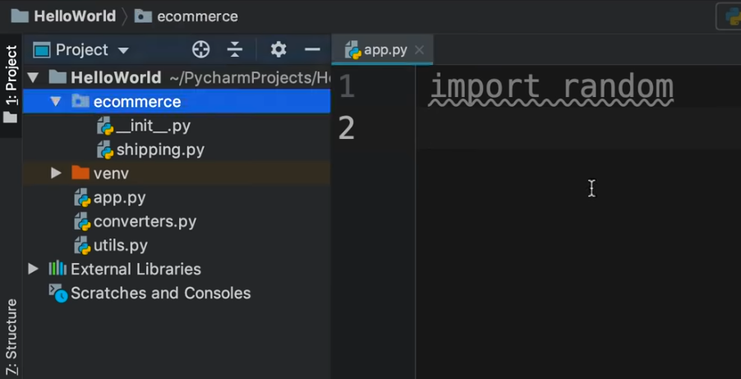

The Python interpreter knows that random is a built-in module and it knows where to find it.

To know where random module is stored on the disk :

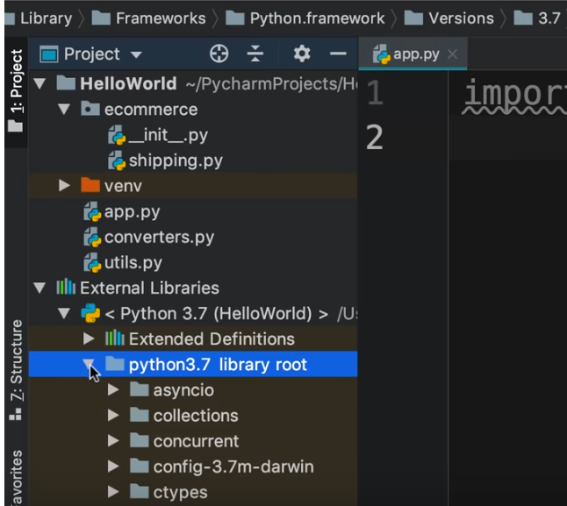

In **python3.7 library root**, there are all inbuilt modules of Python.

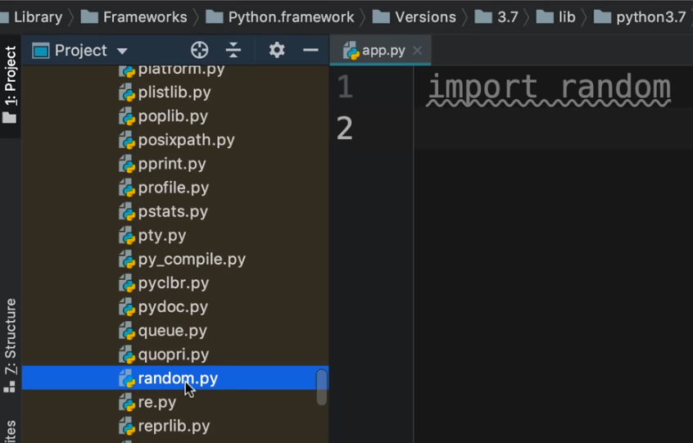

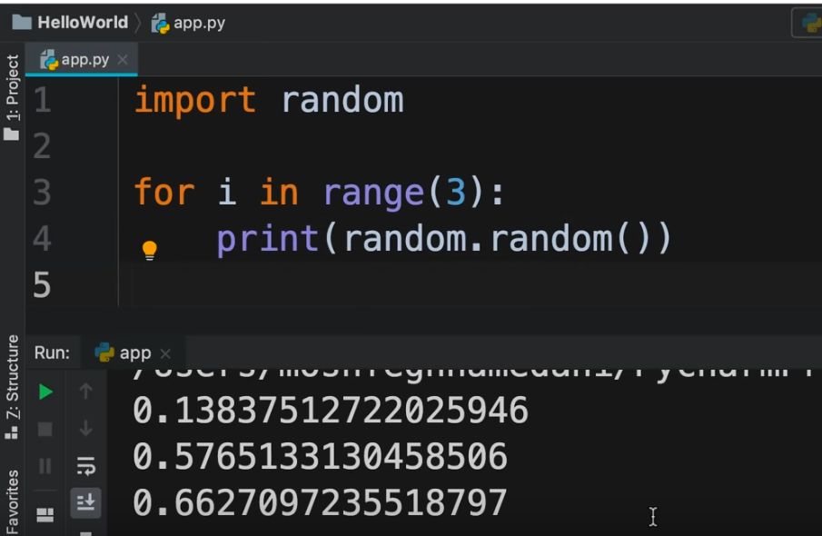

Suppose we want random integral values between a certain range, say 10 to 20.

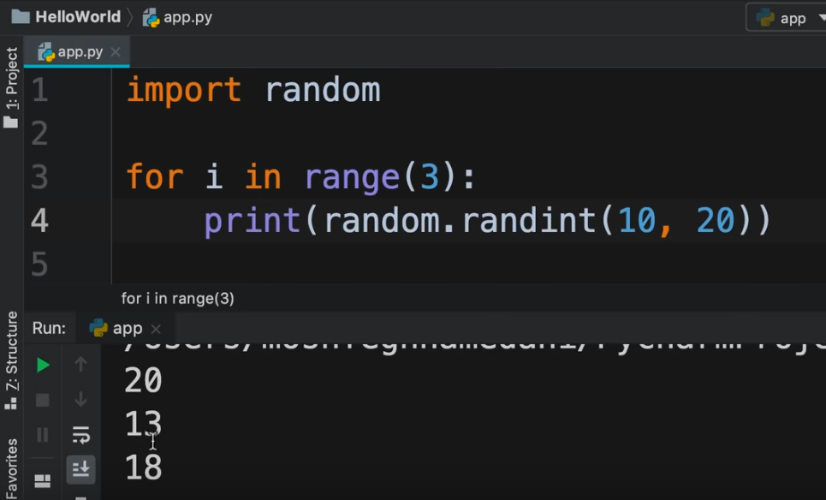

If we run program again

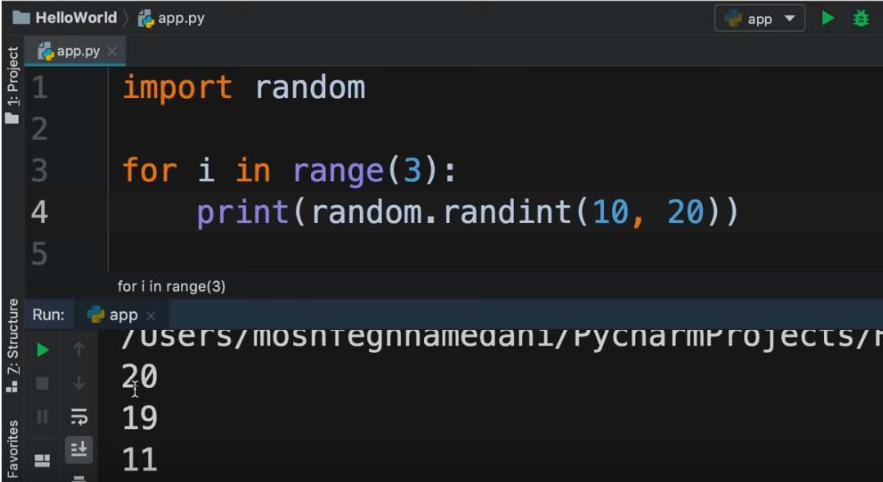

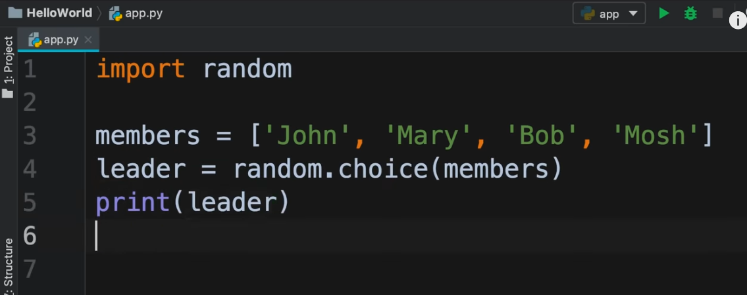

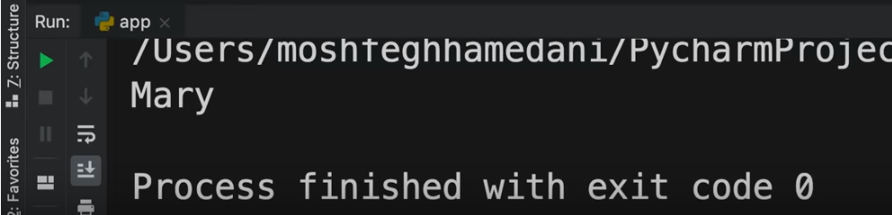

If we run the program again



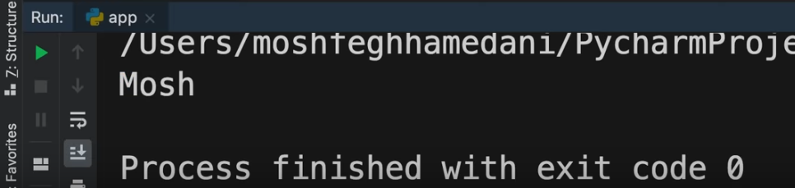

Files and directories

<https://youtu.be/_uQrJ0TkZlc?t=13492>

In Python, there is a module called **pathlib** which provides object oriented file system paths. This means it provides classes to work with files and directories.

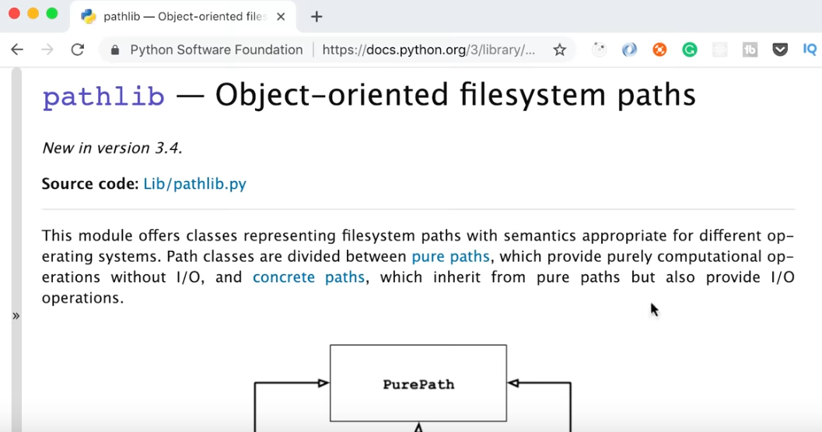

Upon importing pathlib, we need to create a Path object to reference a file or directory.

There are 2 approaches to this :

* Absolute Path
* Relative Path

We need to create a Path object. If we do not pass an argument to the Path() method, then it will reference the current directory.

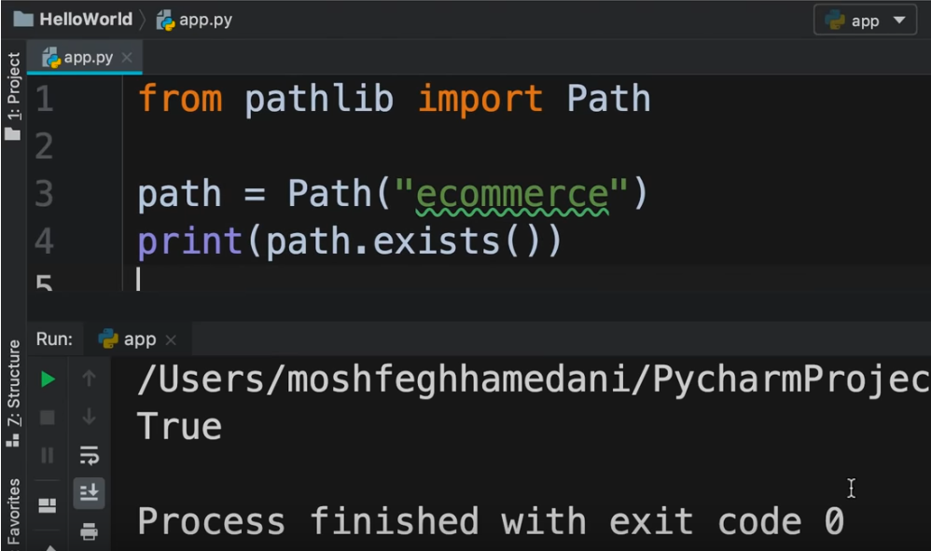

This gives True because the directory **ecommerce** does exist.

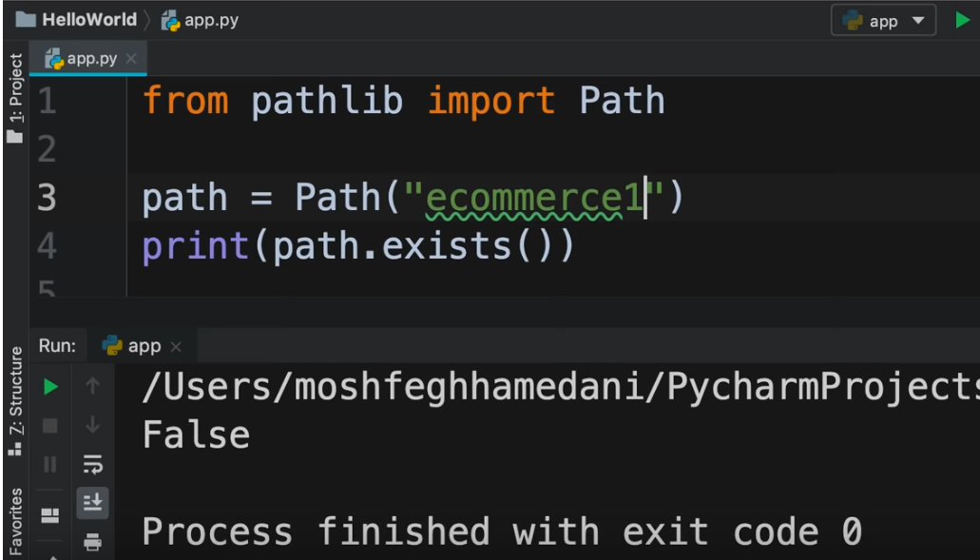

This gives False because the directory **ecommerce1** does not exist.

We can create a new directory as well using **mkdir()** method

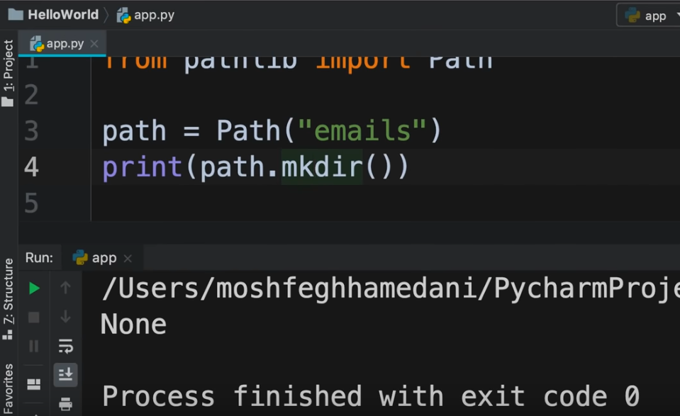

The new directory is created

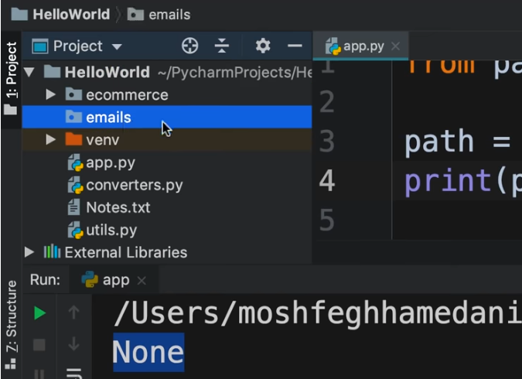

We can also remove a directory

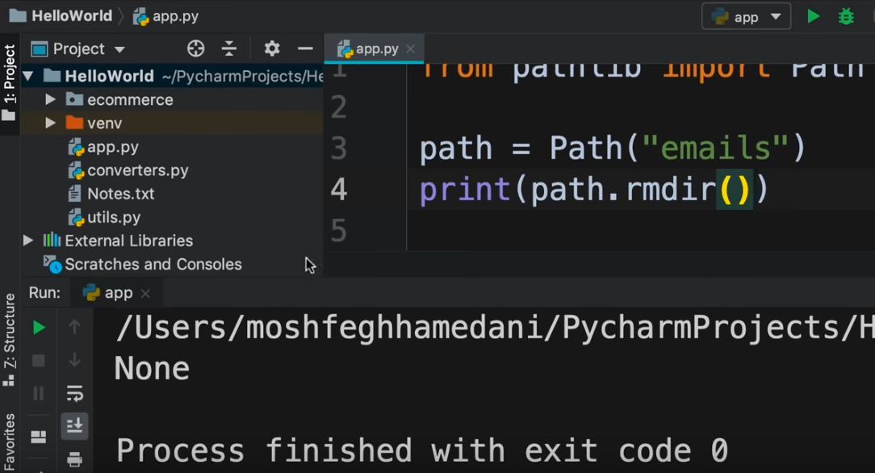

We can search for files and directories using **glob()** method

**\*** means everything. So it can be used for searching files and directories.

So *.* means all files but no directories.

Suppose we want to search for all **.py** files

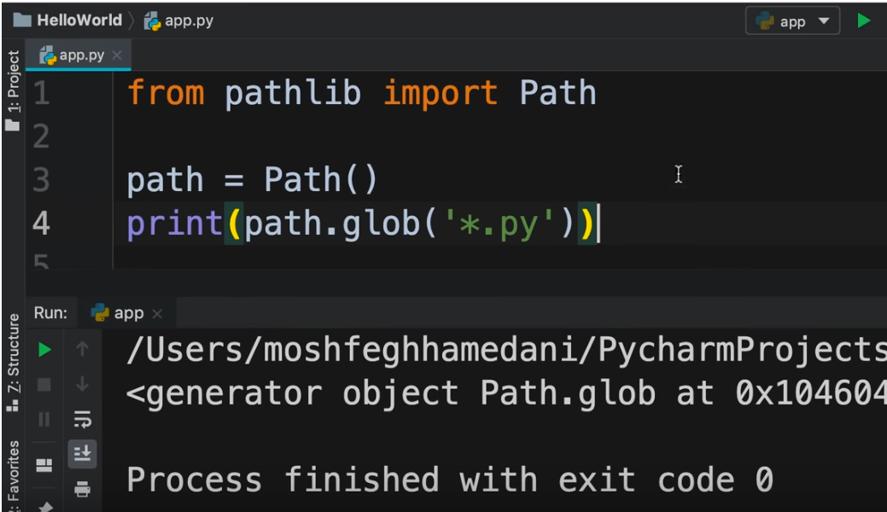

Path.glob() method returns a generator object. We can loop through this generator object

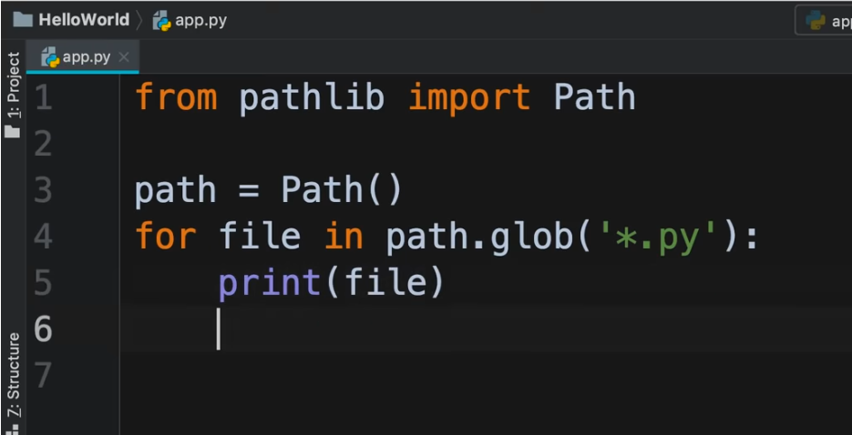

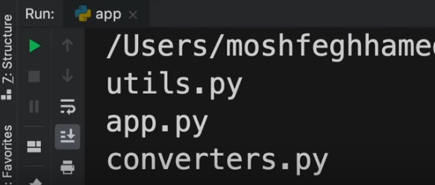

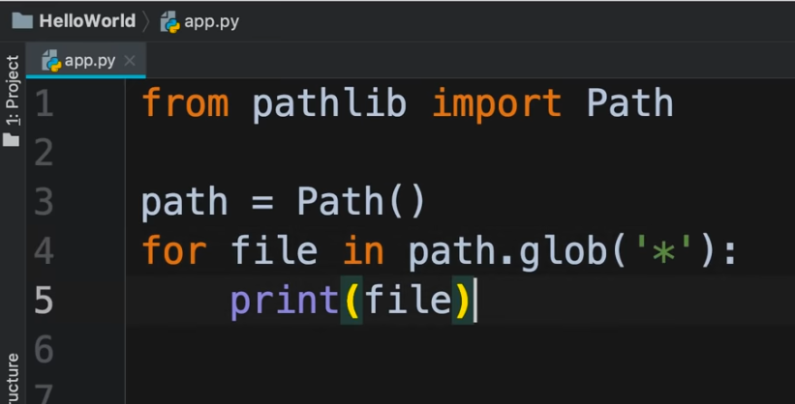

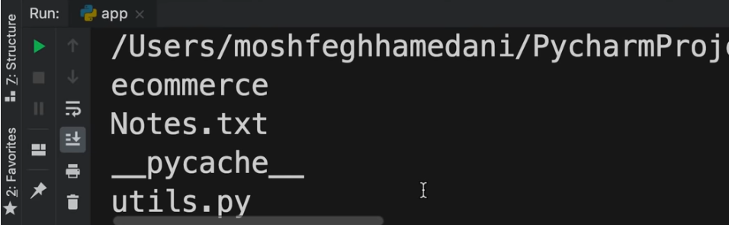

Example of codes :

Initial dataset

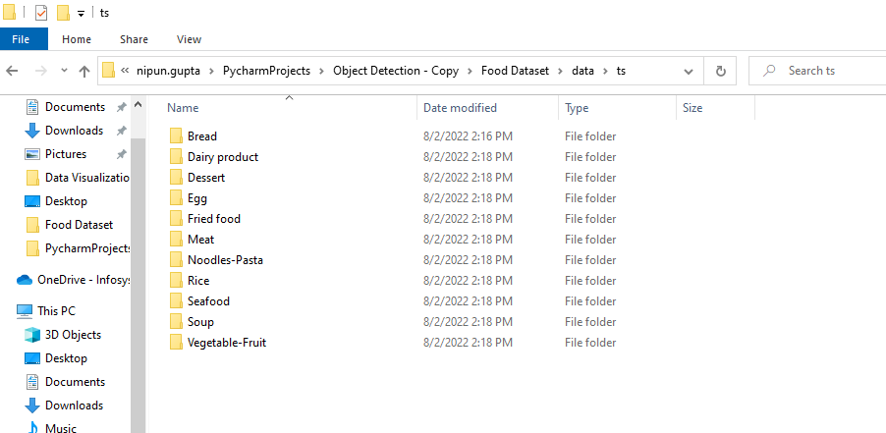

Inside **Bread** folder:

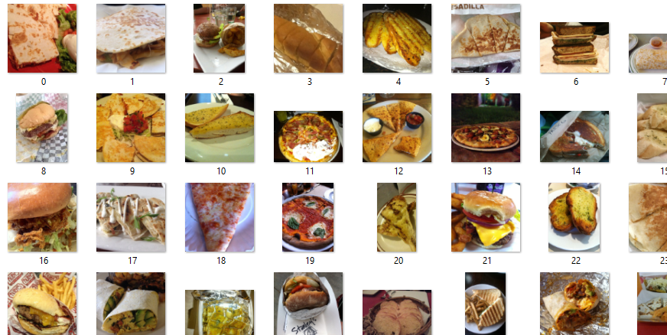

Requirement: To create a .txt file corresponding to each of the image

Code:

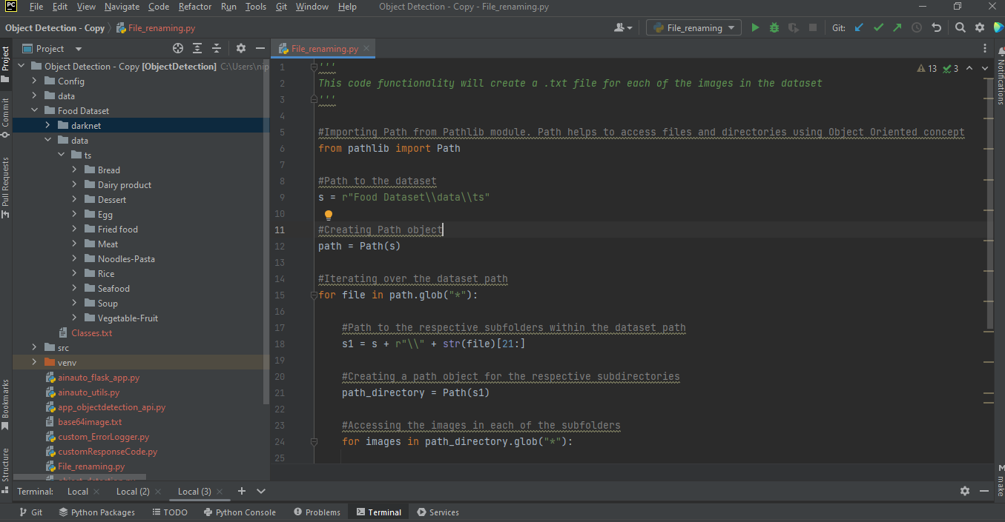

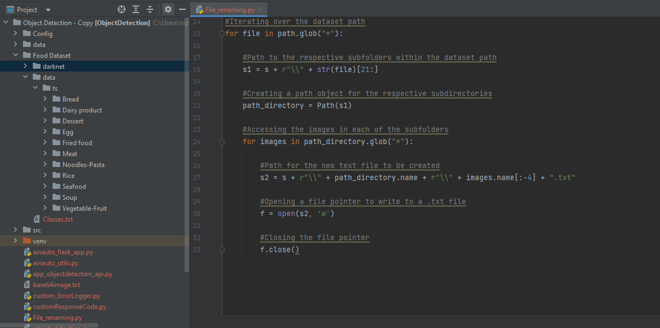

Output:

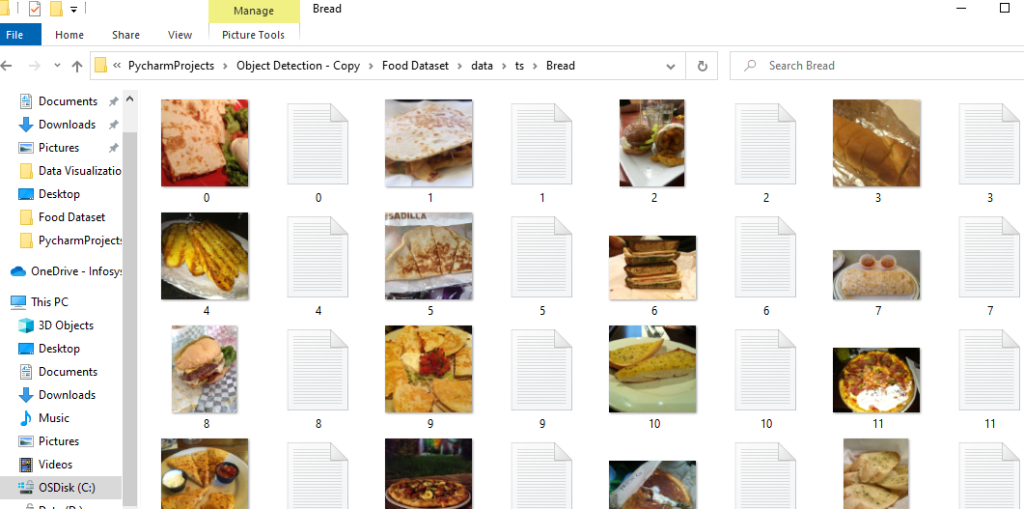

Multithreading by Naveen Reddy

<https://youtu.be/YfO28Ihehbk?t=18994>

Suppose we want to perform multiple tasks, like playing VLC media player, working on MS-word, browsing etc all at the same time. Actually we cannot run multiple tasks at the same time instead the CPU will do time sharing i.e. every task will get some time. But nowadays, we have multi core CPU and on all these multiple cores, we can run multiple processes. Suppose we are running MS-word, so at the same time actions like spellcheck, saving, writing can be performed. Suppose we have a game running where there can be multiple events like actions of multiple players, opponents etc. All the different actions are being performed by different threads and all these threads are getting executed on multiple cores.

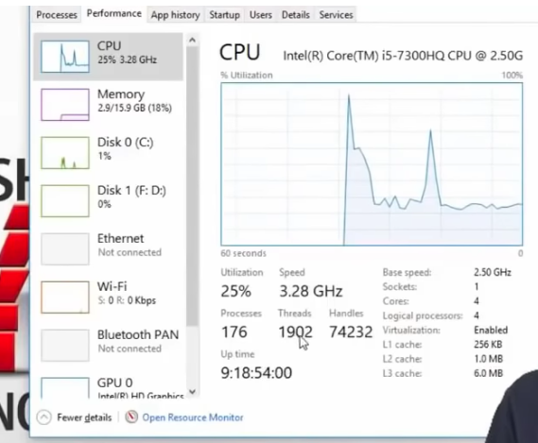

<https://youtu.be/YfO28Ihehbk?t=19207>

Suppose we define multiple functions.

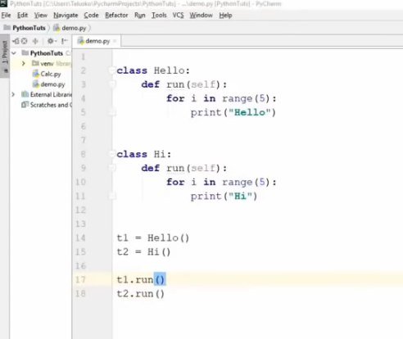

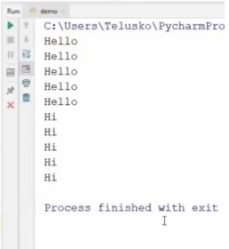

By default, there exists 1 thread for every execution. This thread is Main thread

Suppose we want to run the above code using multiple threads

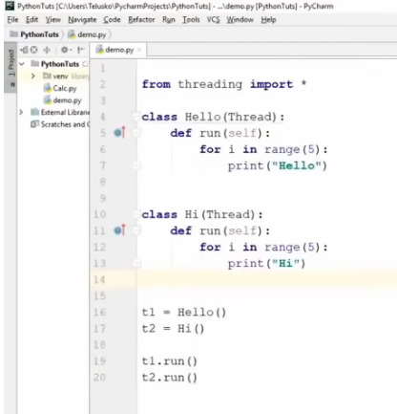

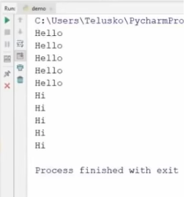

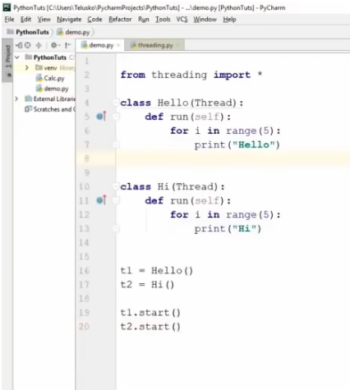

Execution

<https://youtu.be/YfO28Ihehbk?t=19521>

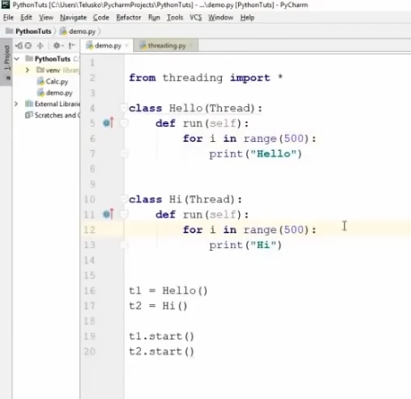

Execution

<https://youtu.be/YfO28Ihehbk?t=19538>

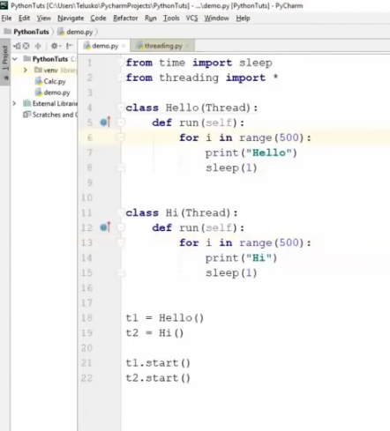

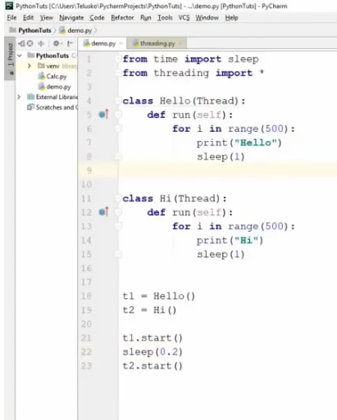

File Handling by Naveen Reddy (Watch upto 5:43:00)

<https://youtu.be/YfO28Ihehbk?t=19863>

Suppose we have a text file as below :

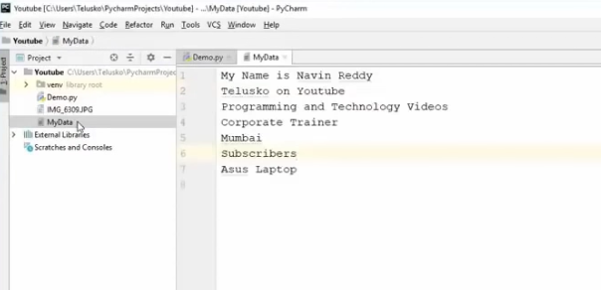

We can use the **open()** function to work with files. As arguments, we need to pass the name of the file and the mode. Mode means the purpose for which the file is being operated on i.e. whether to read or write etc. The keyword **r** can be used to mention the mode for reading the file.

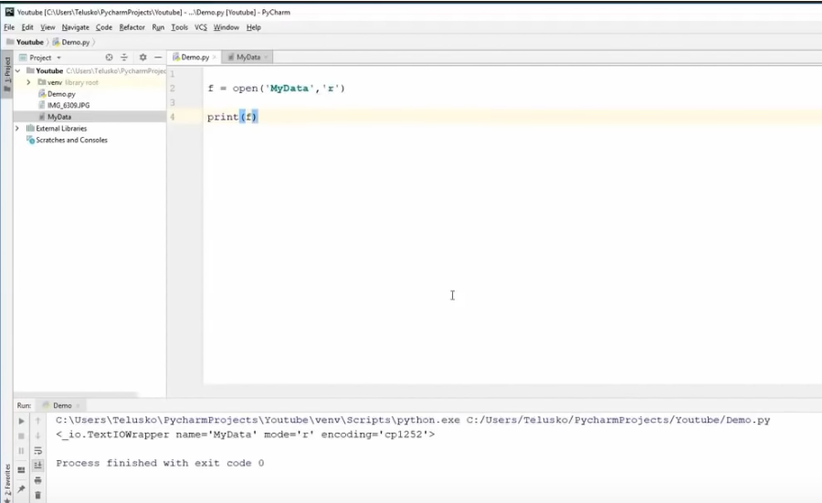

To read the file, we need to use the **read()** function

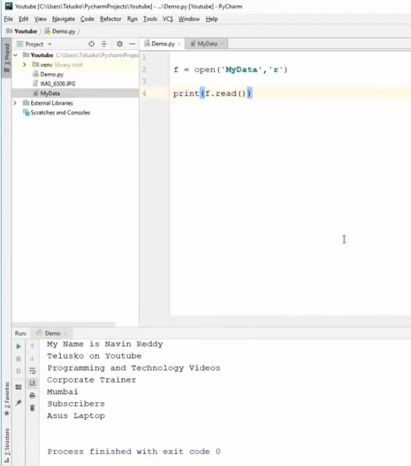

To read a line of the file, we need to use **readline()** function

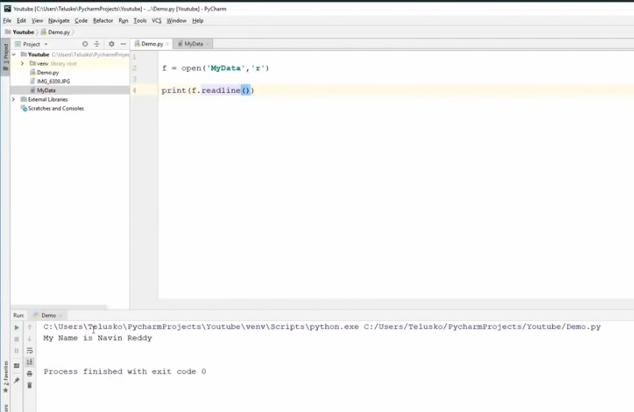

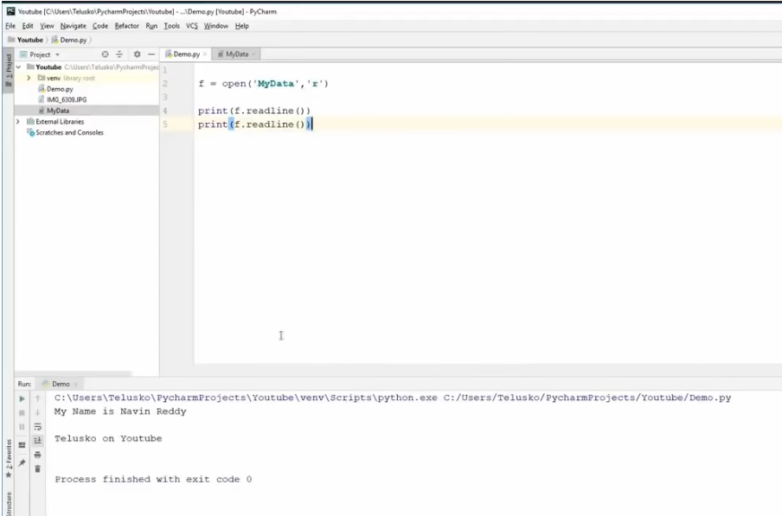

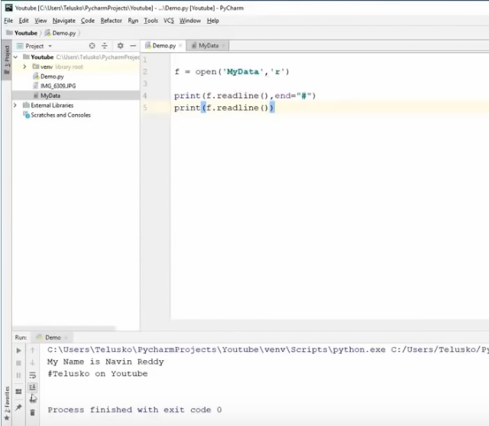

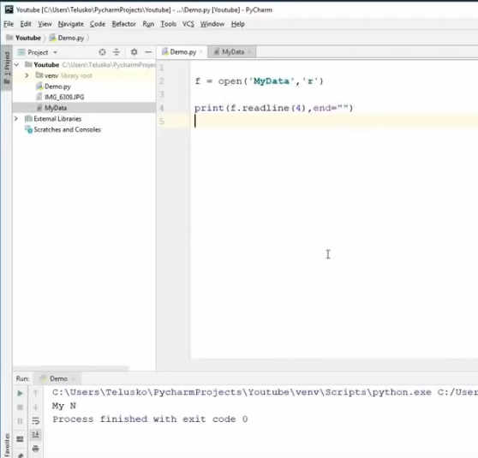

If we want to write to a file, the mode will be **w** for writing. If there is no file with the name specified as argument, a new file with that name will be created

<https://youtu.be/YfO28Ihehbk?t=20220>

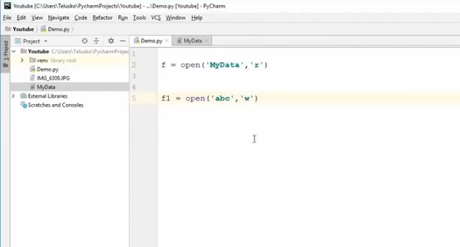

To write to file, we need to use **write()** function and pass argument as whatever we wish to write to the file

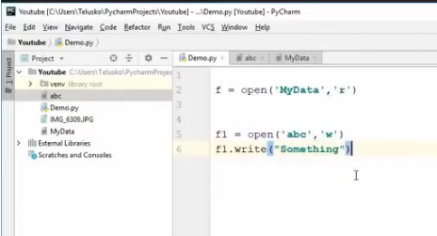

Execution

<https://youtu.be/YfO28Ihehbk?t=20282>

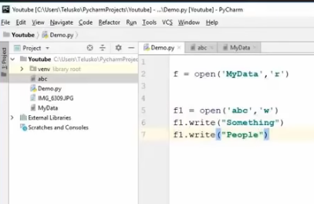

Execution

<https://youtu.be/YfO28Ihehbk?t=20298>

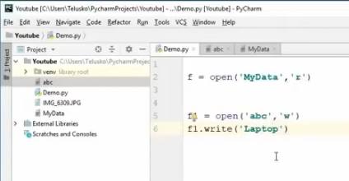

Execution

<https://youtu.be/YfO28Ihehbk?t=20326>

Suppose we want to append to a file. For this, we will use the mode **a**

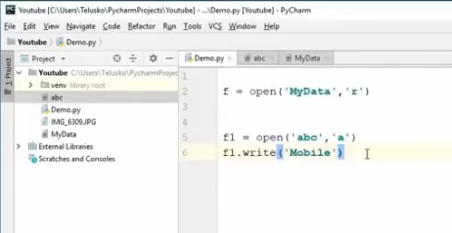

Execution

<https://youtu.be/YfO28Ihehbk?t=20355>

Suppose we want to copy data from 1 file to another

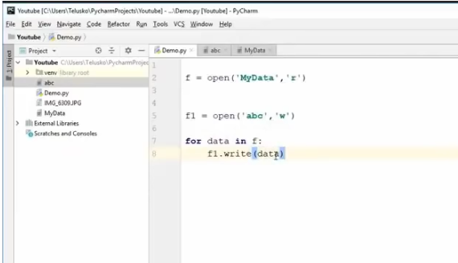

Execution

<https://youtu.be/YfO28Ihehbk?t=20433>

Suppose we want to print data about a file

<https://youtu.be/YfO28Ihehbk?t=20443>

This gives error

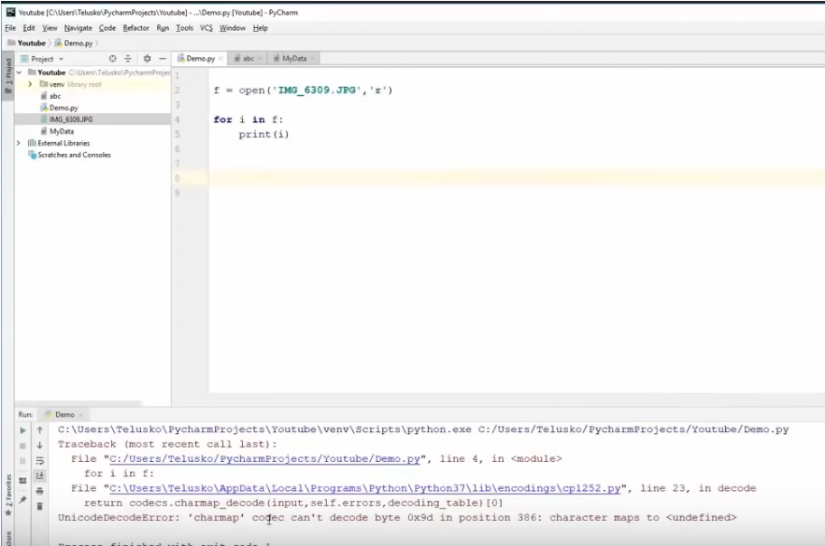

In files, there are 2 modes which are character and binary mode. If the file has text data, we can use character mode. But if the file is an image, then it is binary data and we need to use binary mode.

To read a binary file, the mode should be **rb** which stands for read binary

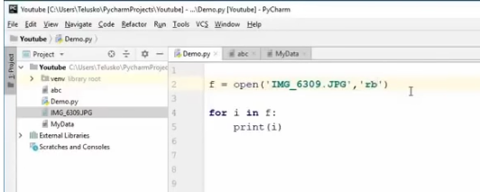

Execution

<https://youtu.be/YfO28Ihehbk?t=20516>

The above prints data which we cannot understand

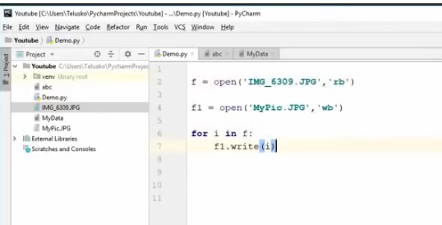

Execution

<https://youtu.be/YfO28Ihehbk?t=20566>

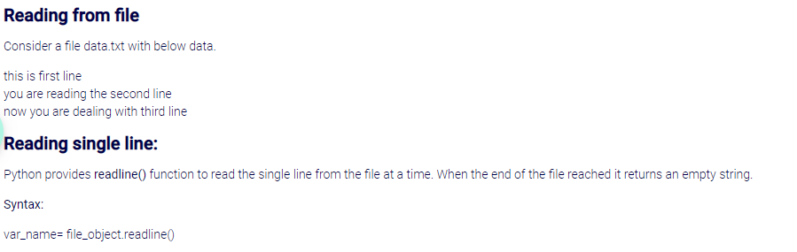

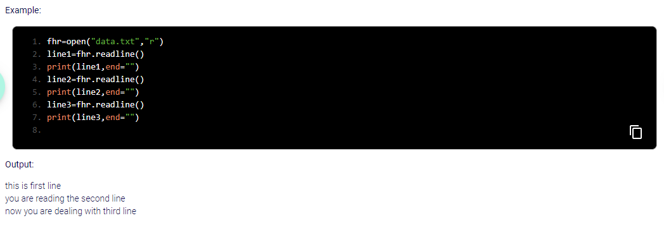

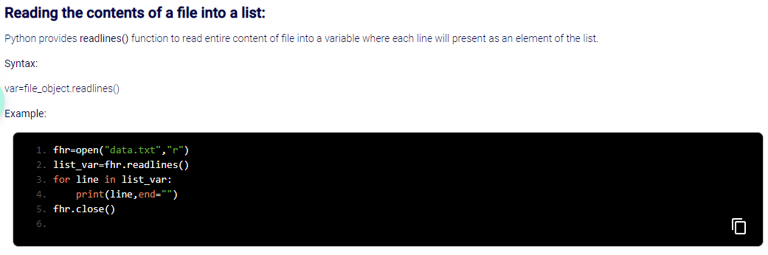

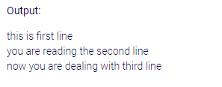

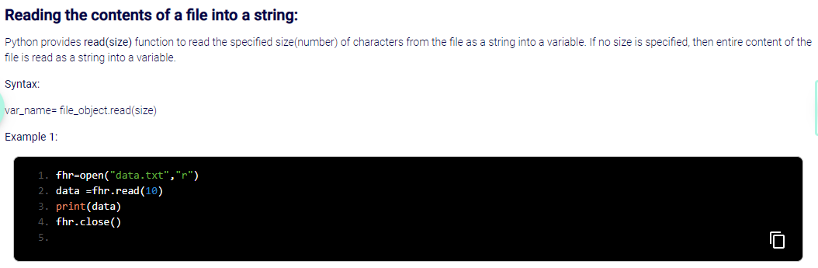

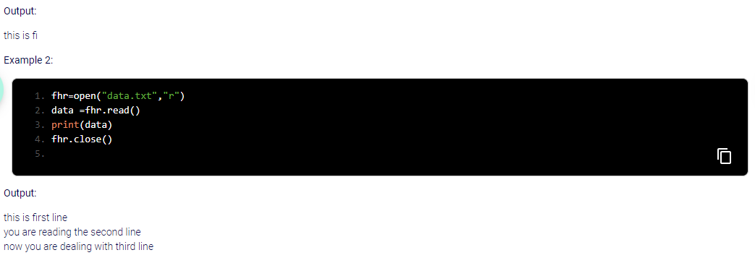

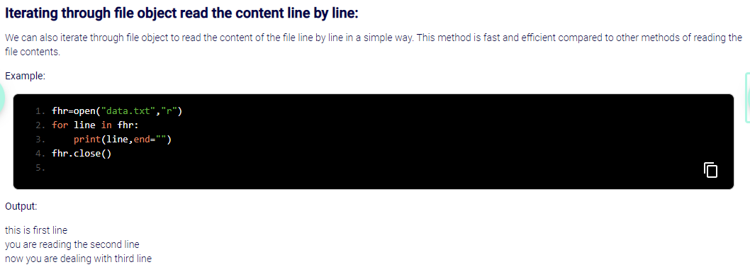

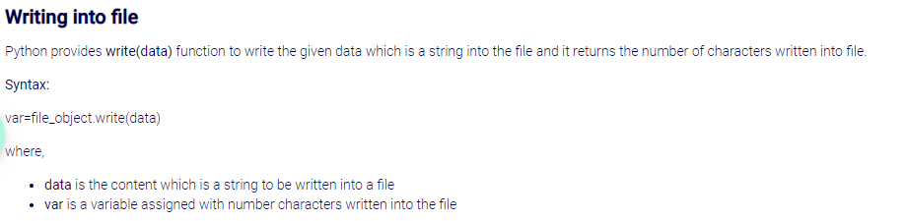

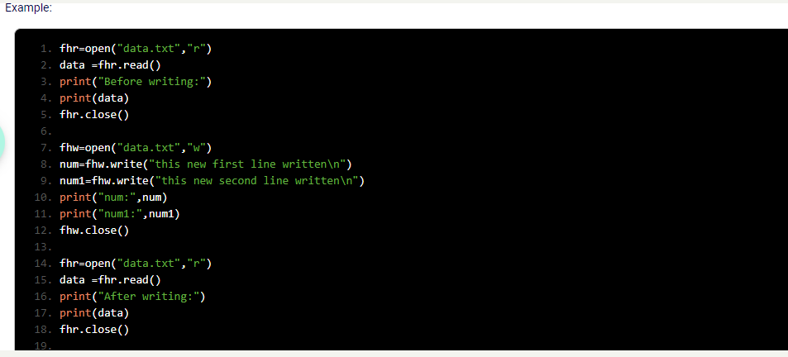

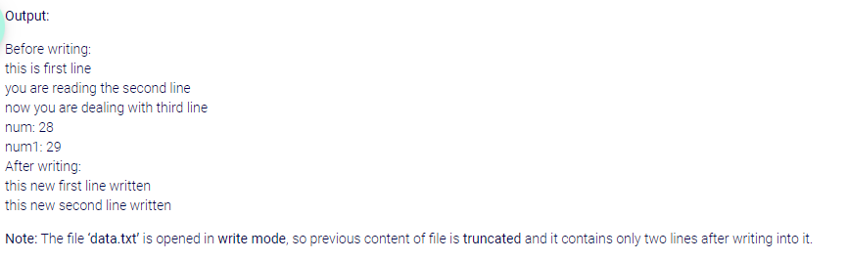

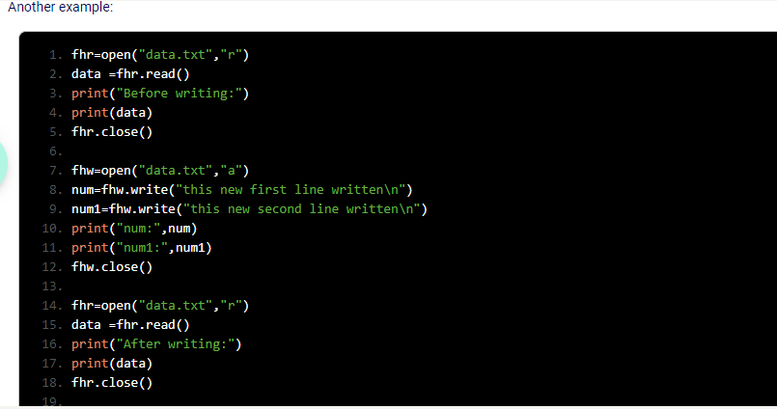

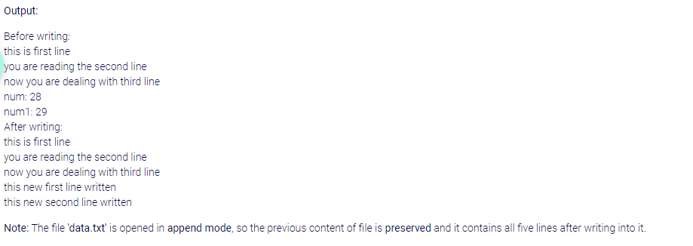

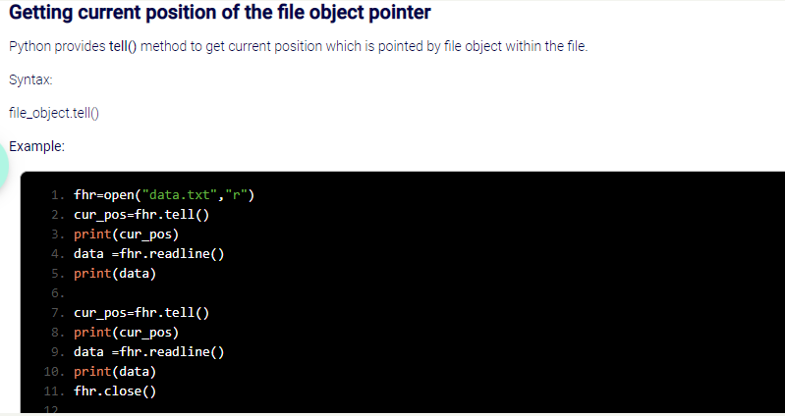

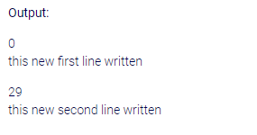

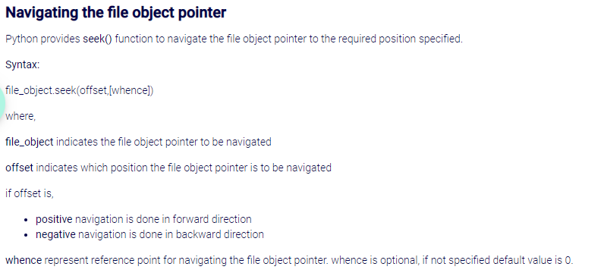

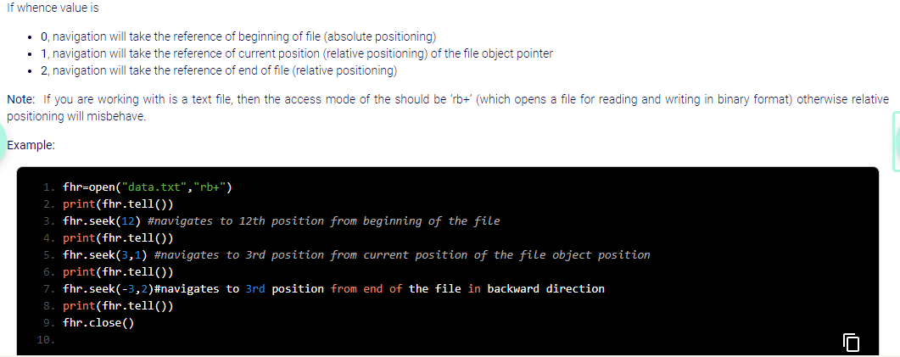

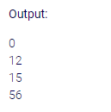

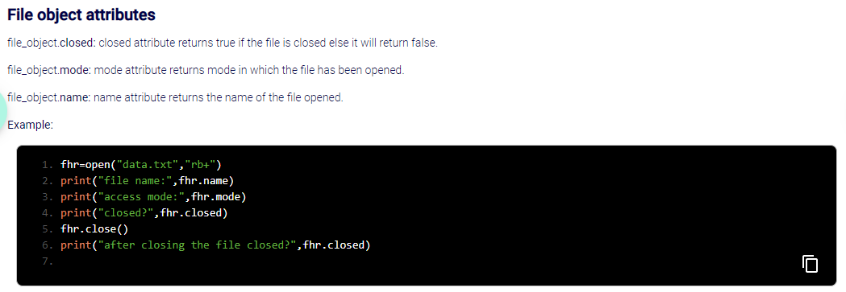

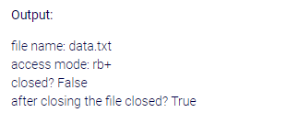

Linear Search using Python by Naveen Reddy (Watch upto 6:00:21)

<https://youtu.be/YfO28Ihehbk?t=21195>

Suppose we want to search for an element from a list

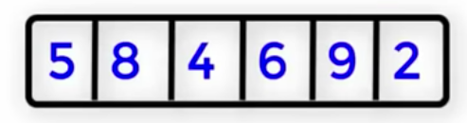

Suppose in the above list, we want to search for 9

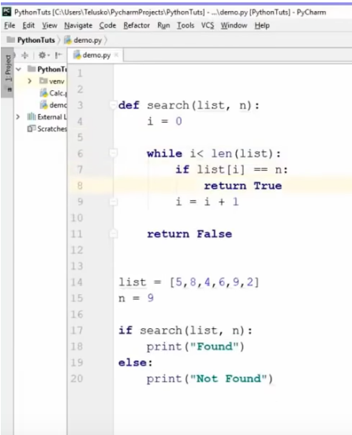

Execution

<https://youtu.be/YfO28Ihehbk?t=21441>

Suppose we also want to find the position of the element

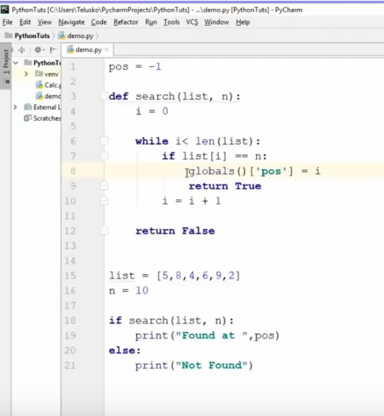

Execution

<https://youtu.be/YfO28Ihehbk?t=21540>

Binary Search using Python by Naveen Reddy

<https://youtu.be/YfO28Ihehbk?t=21624>

Suppose we have a list of 1000 values. We need to search the value which comes after 800 values. In such a scenario, linear search will consume a lot of time.

There is another search technique called Binary search. In this approach, all the values should be sorted.

Suppose this is the list

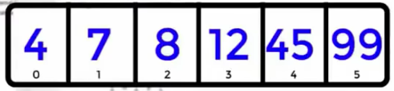

We will first specify the lower bound and upper bound

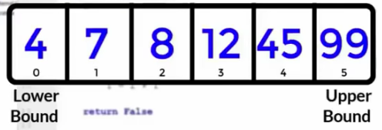

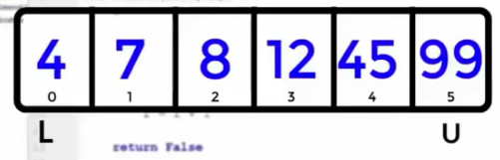

Next, we need to find a mid index

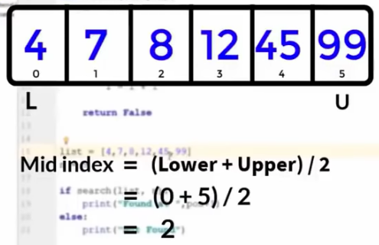

So 8 is the value at mid-index

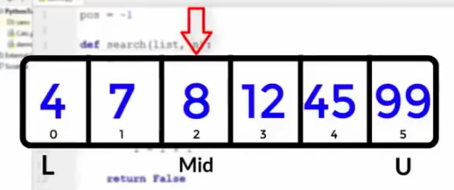

Suppose we want to search for 45

Now we have to check if the value at mid index is the same as the value that we want to search.

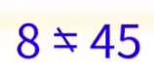

In this case, this does not match

Now we need to change the lower bound or upper bound. To decide which one to change, we need to check if the value to be searched is smaller or bigger than mid value

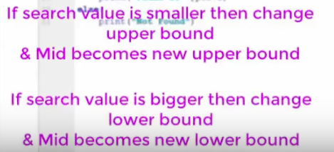

In this case, we will have to change the lower bound

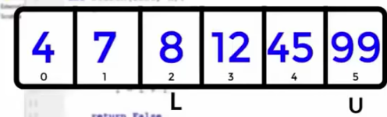

Now again we need to find the mid value

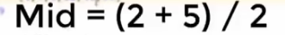

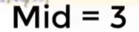

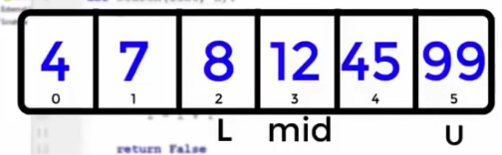

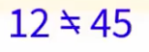

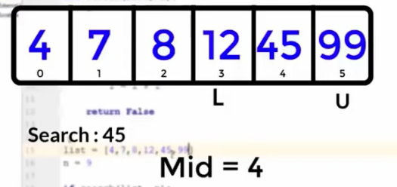

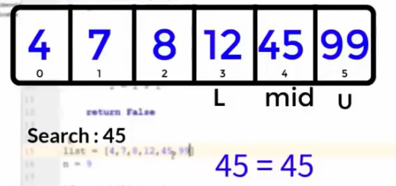

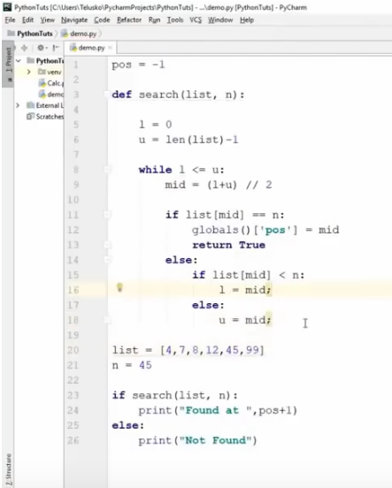

Execution

<https://youtu.be/YfO28Ihehbk?t=22056>

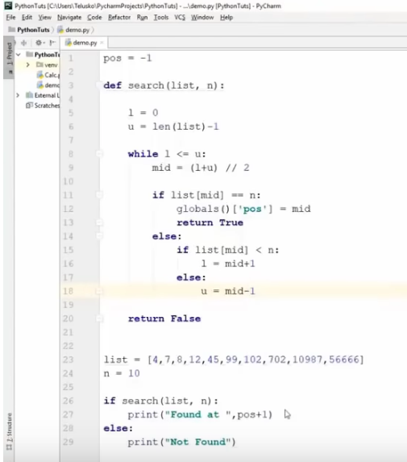

Bubble sort by Naveen Reddy

<https://youtu.be/YfO28Ihehbk?t=22172>

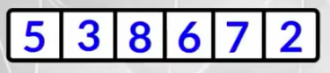

Suppose we want to compare the highlighted values

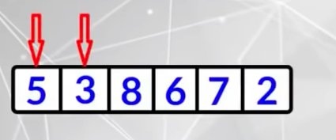

We will perform swapping

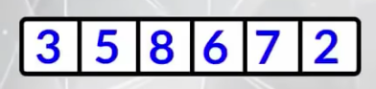

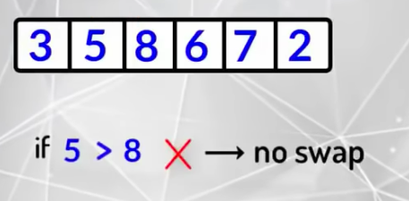

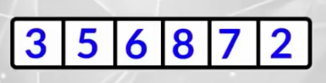

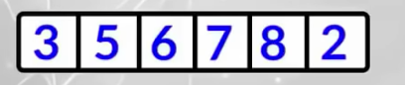



We have now moved the biggest value to the end. But the remaining values are not sorted. So now we will have to reiterate

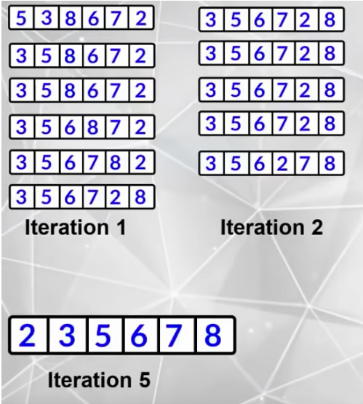

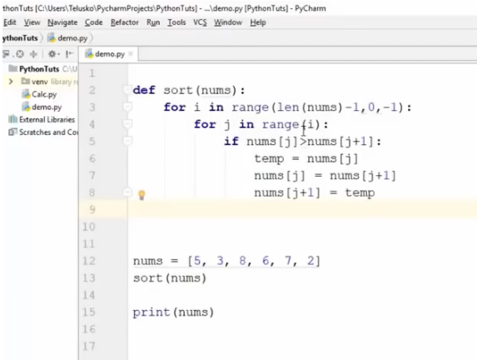

Execute

<https://youtu.be/YfO28Ihehbk?t=22584>

Selection sort by Naveen Reddy (Watch upto 6:24:02)

<https://youtu.be/YfO28Ihehbk?t=22601>

The disadvantage of bubble sort is that in each iteration, we need multiple swappings. Swapping consumes a lot of CPU power and memory.

So to overcome this, we use Selection sort

MySQL workbench Setup and Python database connection

<https://youtu.be/YfO28Ihehbk?t=23045>

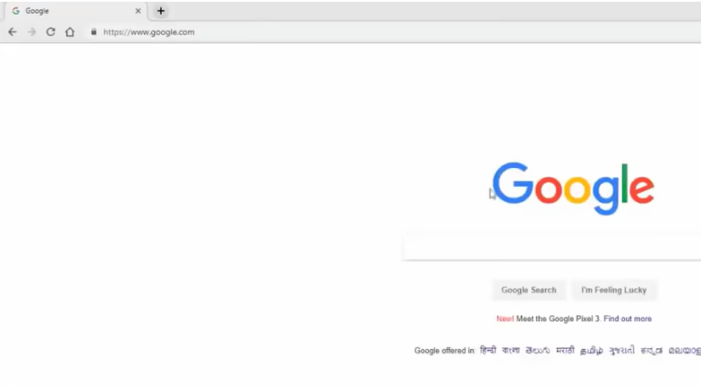

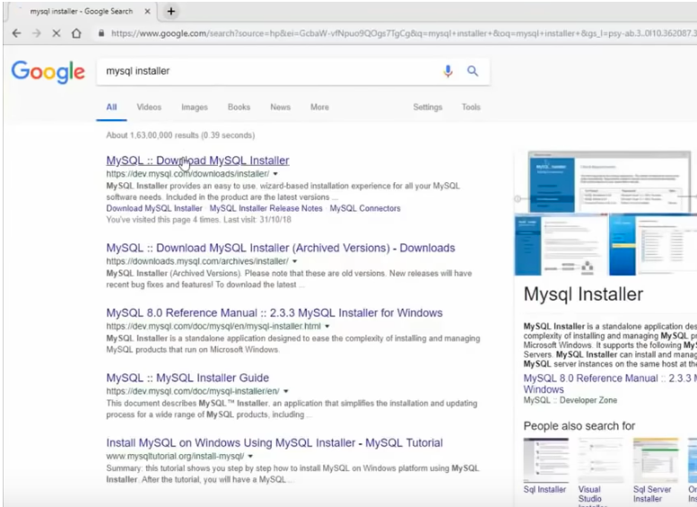

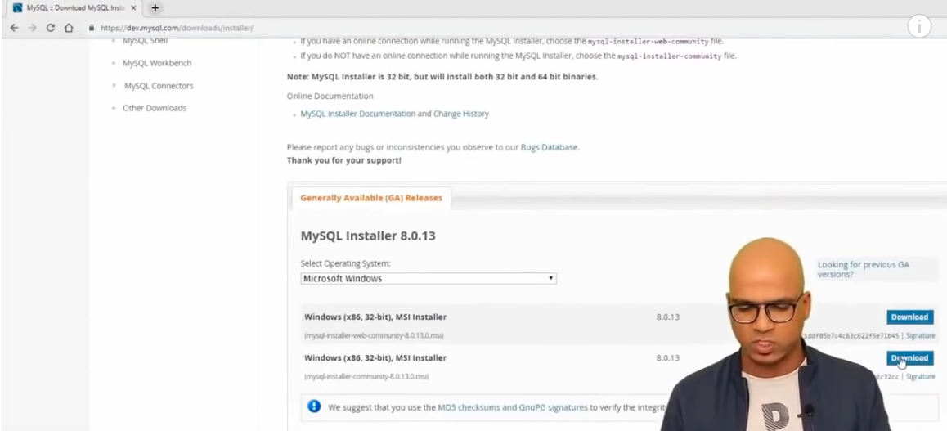

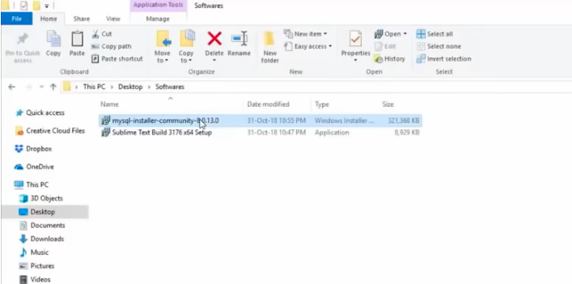

(To watch from)

<https://analyticsindiamag.com/what-are-the-markers-of-a-genuine-data-scientist/>

<https://medium.com/better-programming/5-advanced-operations-using-dictionaries-in-python-5f8edb4719fa>

<https://medium.com/swlh/python-descriptors-a-practical-guide-to-solve-problems-using-reusable-code-fb98c68d1486>

<https://codeburst.io/understanding-the-python-reduce-function-with-examples-4bb07de14816>

Pypi and Pip

<https://youtu.be/_uQrJ0TkZlc?t=13863>

PyPi stands for Python Package Index. This is a package where there are modules which people have developed and published for others to utilise.

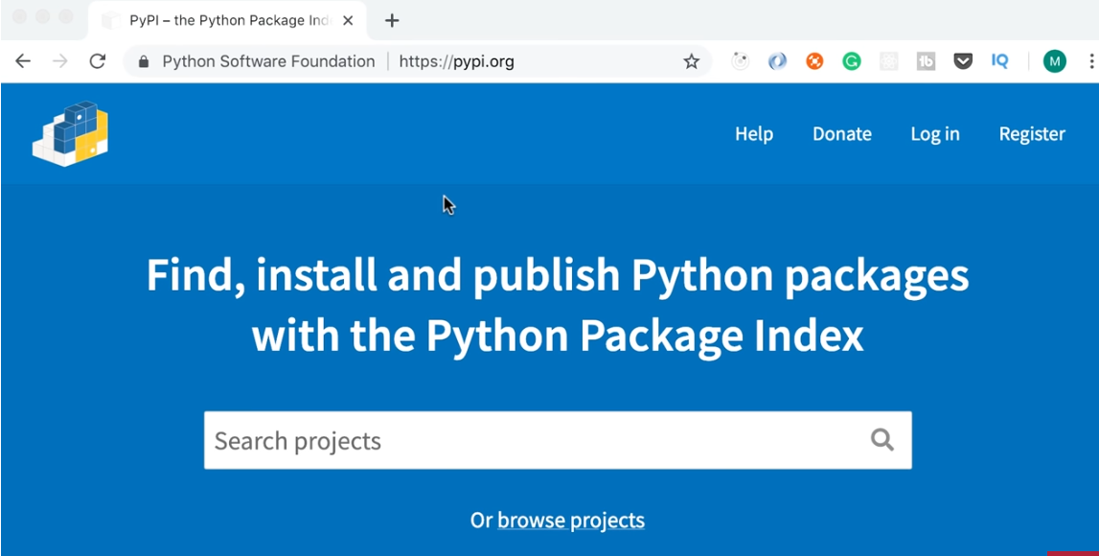

Suppose we want to send text messages in a program. We do not have to build this program from scratch. We can simply come to PyPI.org

<https://pypi.org/>

Search for sms

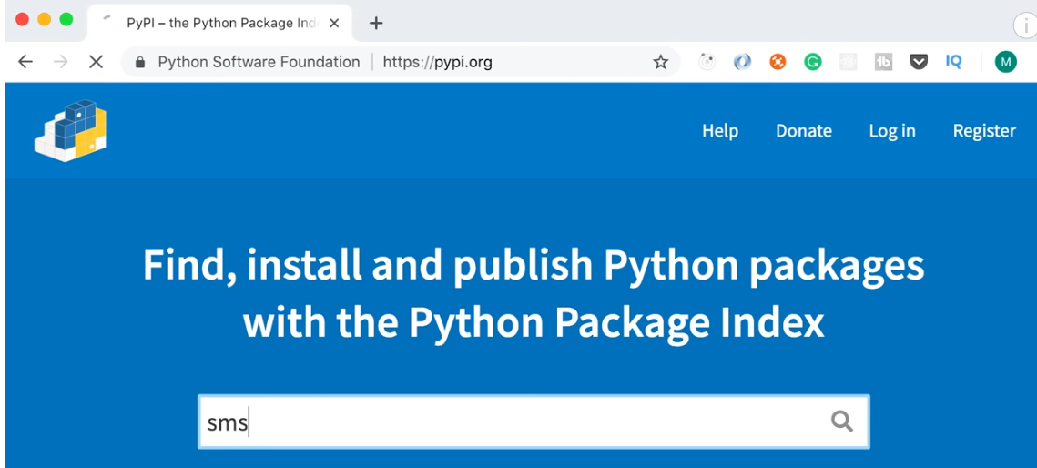

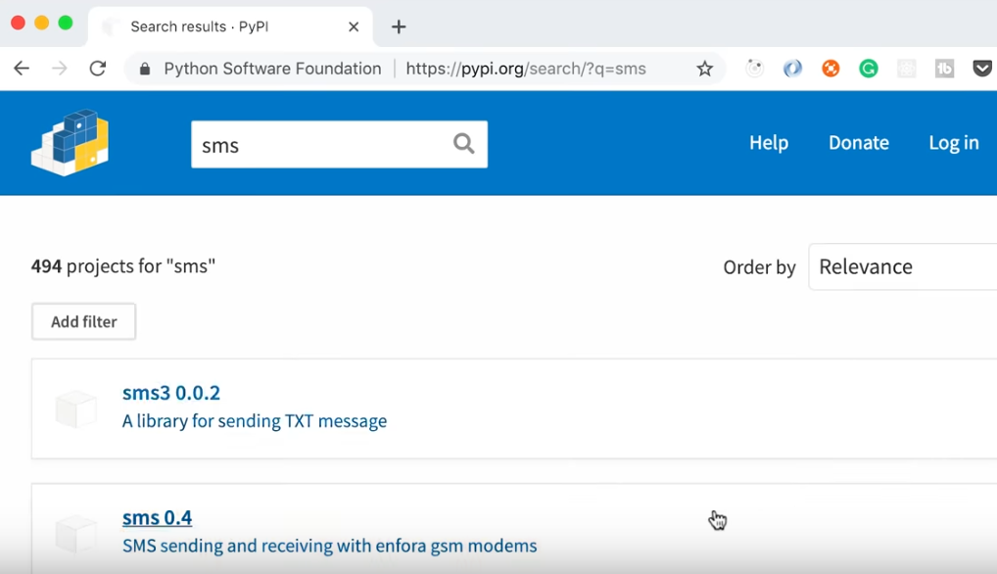

There are so many projects. Some projects might be completed, others might be in development.

Installing packages from PyPI

<https://youtu.be/_uQrJ0TkZlc?t=14005>

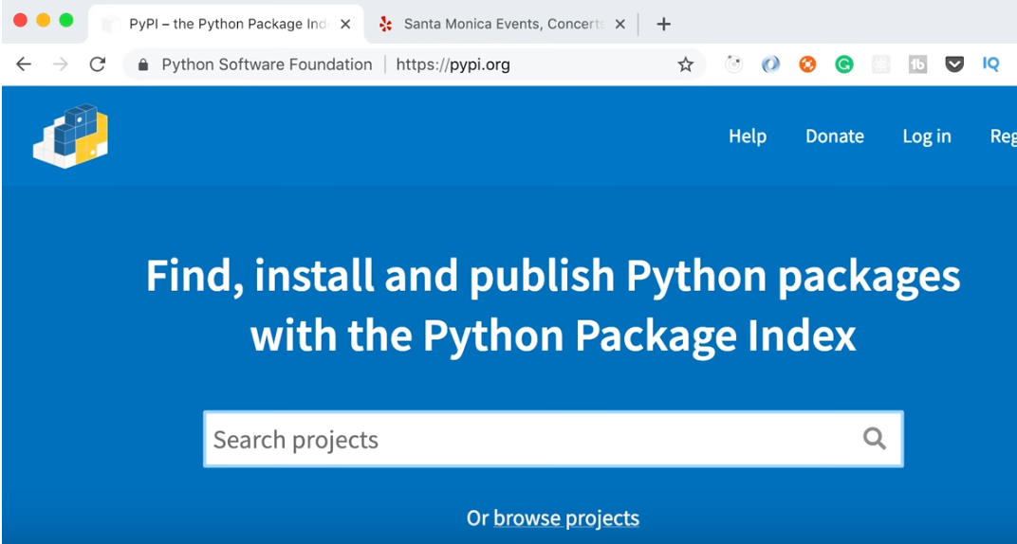

**Openpyxl** is a package that is used for working with Excel spreadsheets

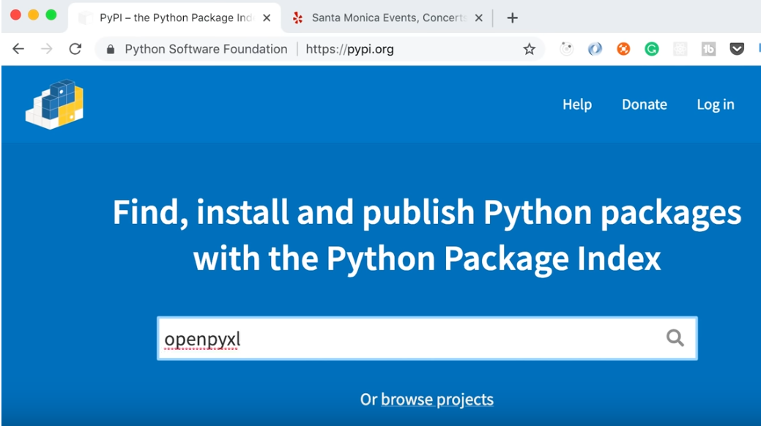

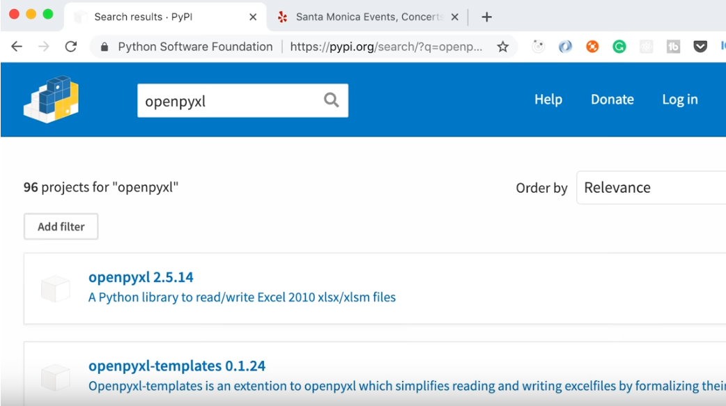

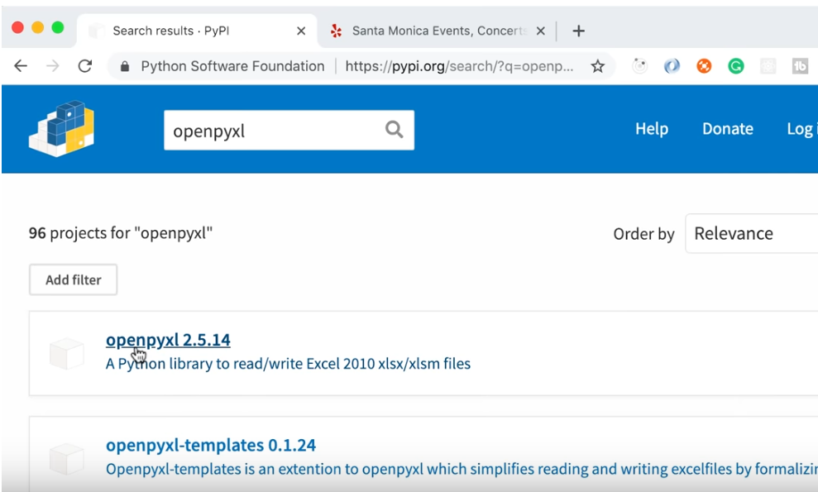

In the below screen, we can see the command **pip install openpyxl**

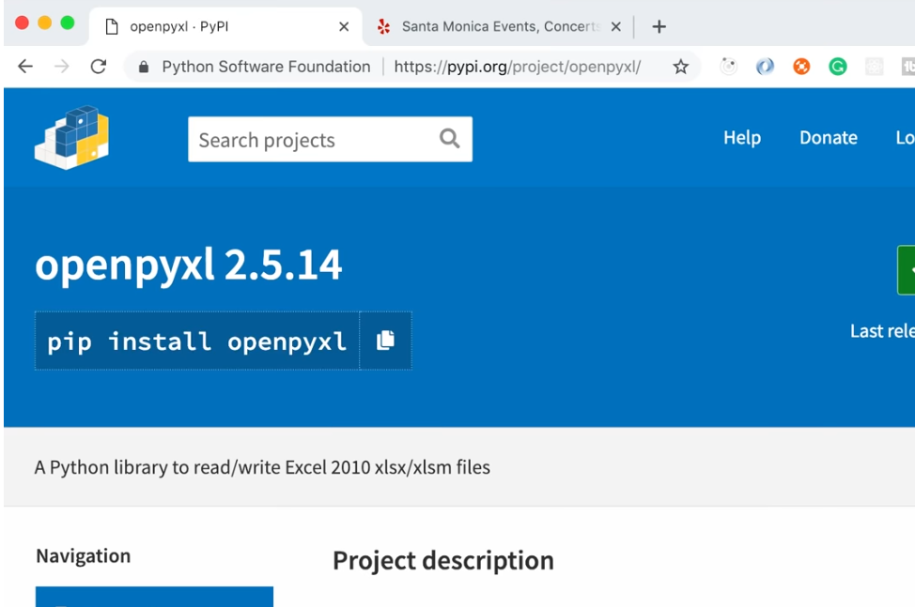

**pip** is the tool that comes with Python installation and it is used to install or uninstall packages registered on PyPI.org

This is the command that we need to type in the terminal window to install this package into our program

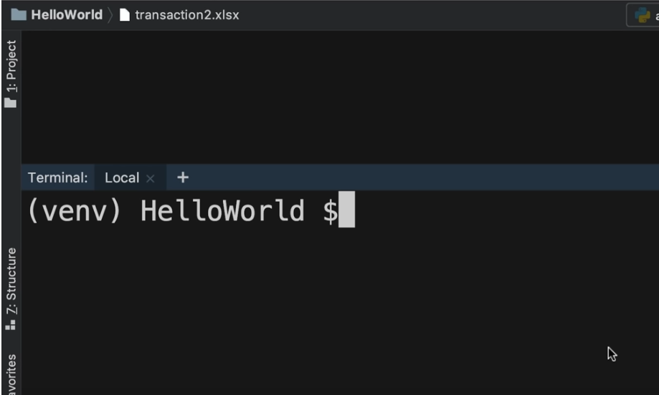

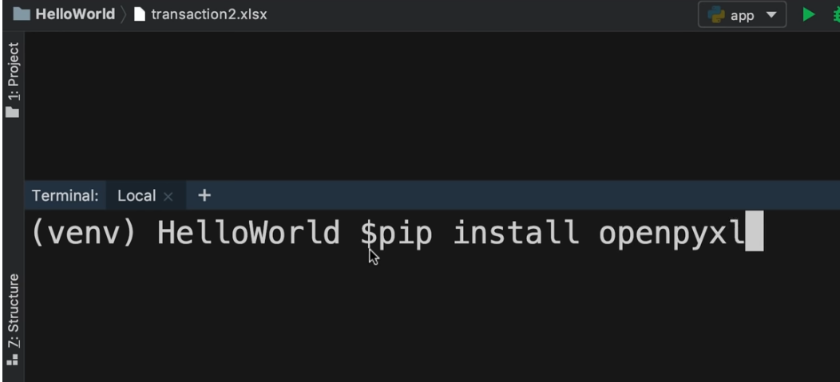

<https://youtu.be/_uQrJ0TkZlc?t=14077>

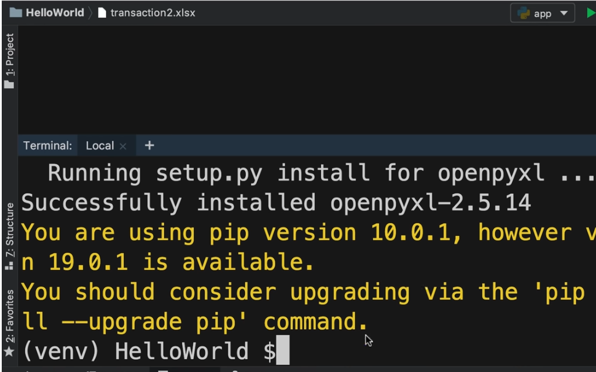

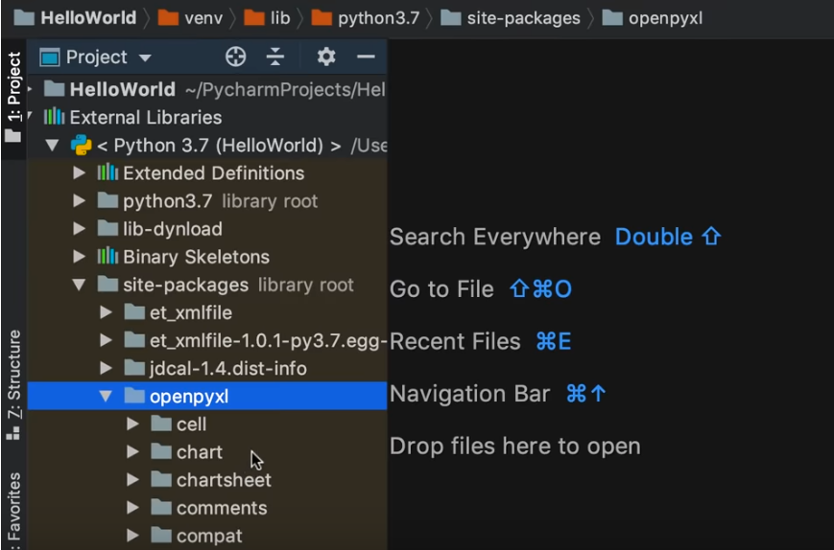

**Python by Durga**

<https://docs.google.com/document/d/1hRU0-CyGYL4E-6OaucDG79xESkDAkYrhIUp-ZGRxEoc/edit>

**Python automation**

<https://docs.google.com/document/d/1tv3BaYsdre3YfdHfcY-G7RESGjo0h75Gsl421jrFf5I/edit>

<https://towardsdatascience.com/notify-with-python-41b77d51657e>

**Advance Python**

<https://www.youtube.com/watch?v=tdn9_MZ0lN4>

**Python Scripting Tutorial for Beginners | Python Tutorial | Python Training | Edureka**

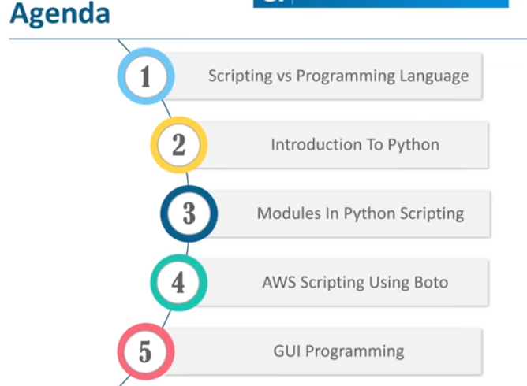

Scripting vs Programming

<https://youtu.be/9F6zAuYtuFw?t=51>

(Watch upto 1:55)

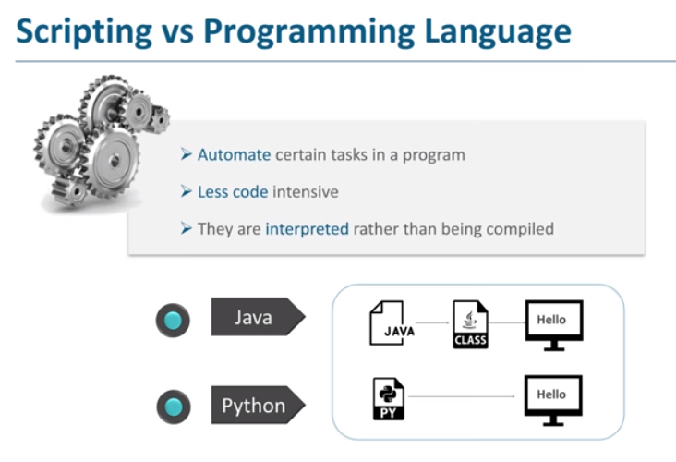

Scripting is used for automating certain tasks.

Intro to Python

<https://youtu.be/9F6zAuYtuFw?t=121>

(Watch upto 3:00)

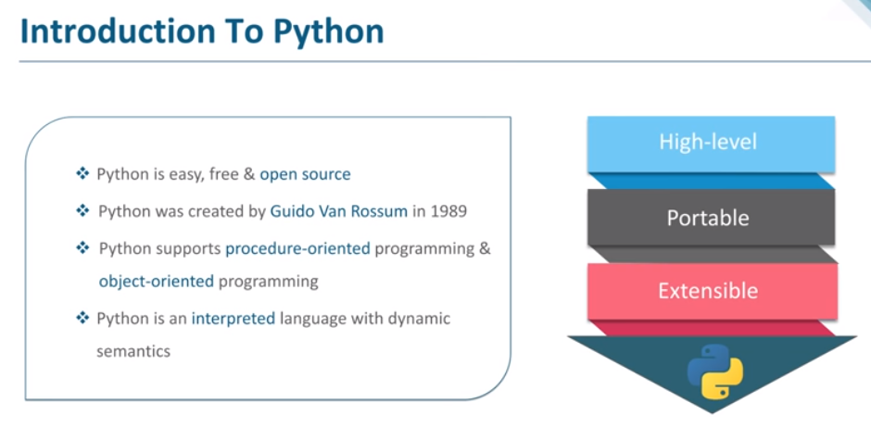

Versions of Python

<https://youtu.be/9F6zAuYtuFw?t=181>

(Watch upto 4:41)

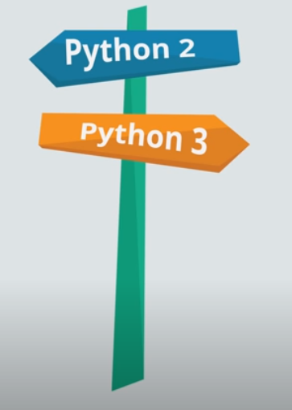

Modules in Python

<https://youtu.be/9F6zAuYtuFw?t=284>

(Watch upto

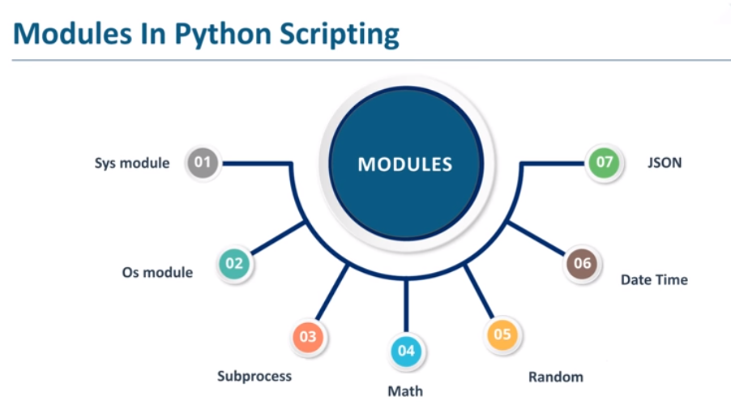

**Sys** module provides information about the constants, functions and the methods of the Python interpreter. It is basically responsible for controlling and interacting with the Python interpreter.

**Os** module stands for operating system. This module is used to interact with the OS. The primary use of this module is to create, move, remove folders.

**Subprocess** module lets us interact with the OS to create new process, pass information into and out of them and fetch the return codes.

**Math** module is used to perform mathematical operations.

**Random** module is used to generate random numbers.

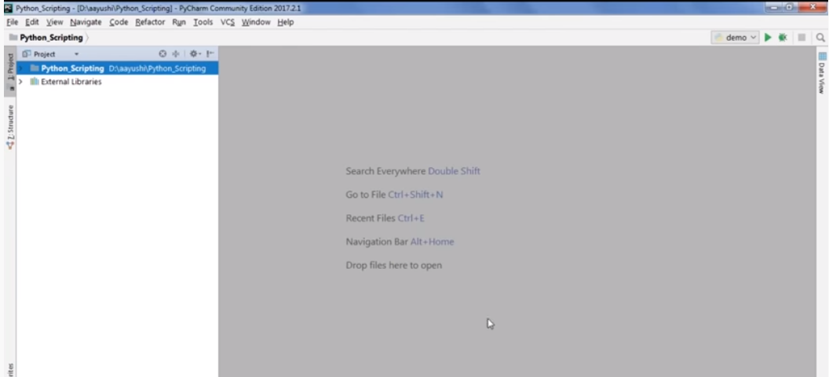

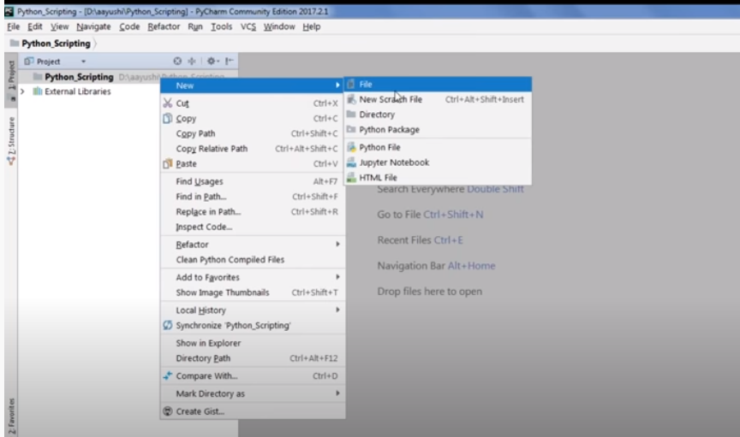

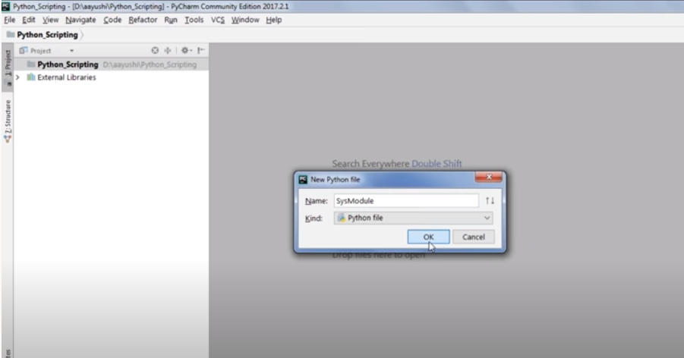

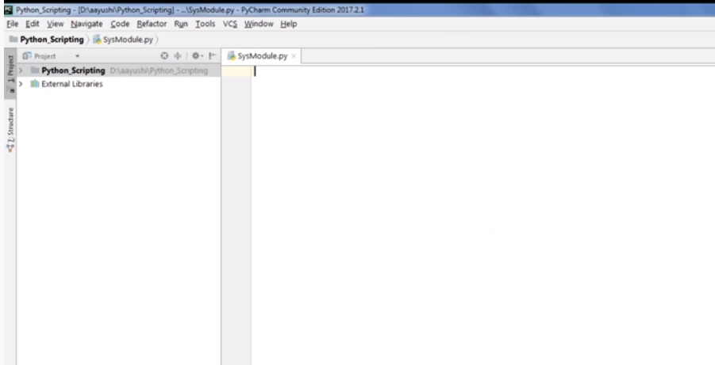

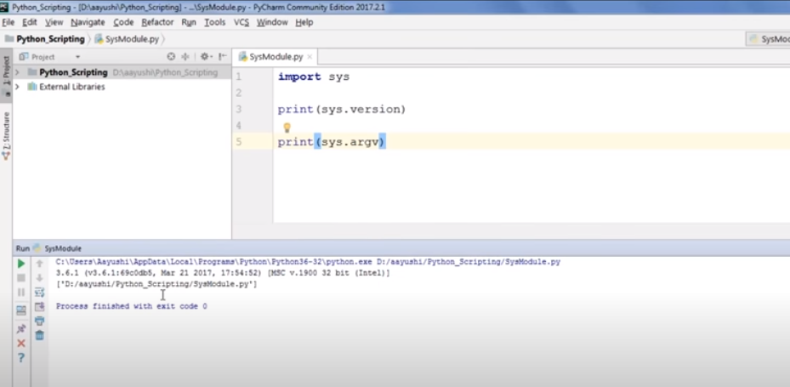

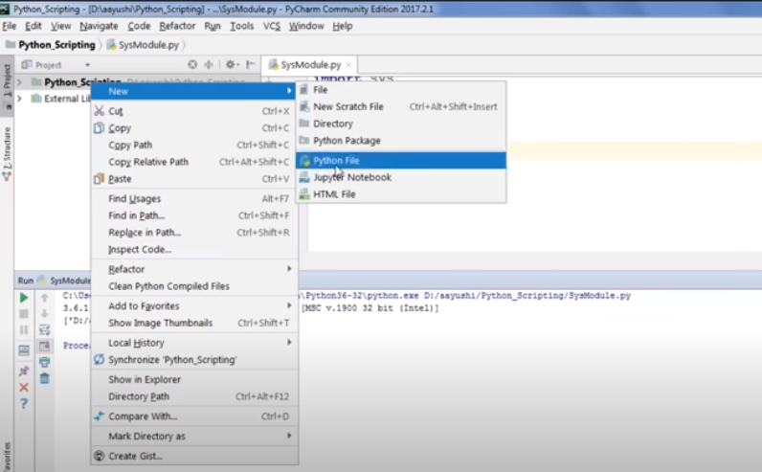

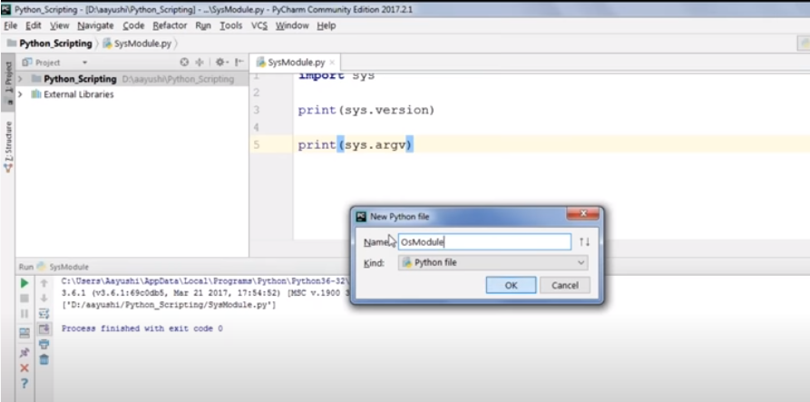

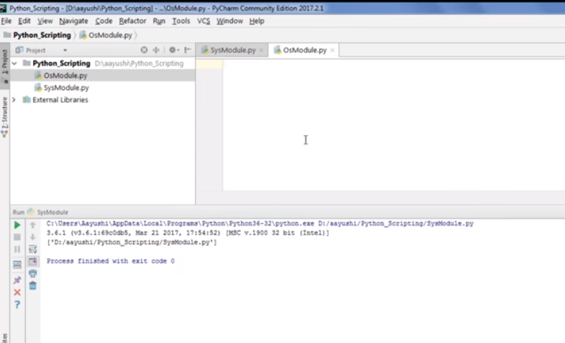

**Python by Geeks lesson**

<https://www.youtube.com/watch?v=PJlAnR3asGQ&t=30967s>

**Ethical Hacking using Python | Password Cracker Using Python | Edureka**

<https://www.youtube.com/watch?v=CV_mMAYzTxw>

**Python Unit Testing With PyTest 1 - Getting started with pytest**

<https://www.youtube.com/watch?v=_QtM7QGuj1A&list=PLS1QulWo1RIaNFUz4zrztWlCJgkpXht-H>

**Test Automation Using Python | Selenium Webdriver Tutorial With Python | Selenium Training | Edureka**

<https://www.youtube.com/watch?v=CwLrdjgsJjU>

**Selenium Python Small Sample Project | Page Object Model POM**

<https://www.youtube.com/watch?v=BURK7wMcCwU>

**Django**

<https://docs.google.com/document/d/1CdfVYJ6bWSIyLQkrtGPh9Y7_DVe3MWGi5y6neShY8wE/edit>

Python Developer skills required

<https://www.merixstudio.com/blog/8-skills-you-need-be-good-python-developer/>

**Code base**

<https://www.youtube.com/watch?v=7xaGRxiN75o>

<https://towardsdatascience.com/new-features-in-python39-2529765429fe>

**21 Python developer skills**

<https://www.upgrad.com/blog/python-developer-skills/>

**Microsoft unveils Pylance, its new Python extension for Visual Studio Code**

<https://www.infoworld.com/article/3564816/microsoft-unveils-pylance-its-new-python-extension-for-visual-studio-code.html>

**Datable package**

<https://towardsdatascience.com/speed-up-your-data-analysis-with-pythons-datatable-package-56e071a909e9>

**Binary Encoding instead of JSON**

<https://medium.com/better-programming/use-binary-encoding-instead-of-json-dec745ec09b6>

**Exploring data with just 1 line of Python code**

<https://towardsdatascience.com/exploring-your-data-with-just-1-line-of-python-4b35ce21a82d>

**Cool Python tricks**

<https://towardsdatascience.com/7-cool-python-tricks-that-you-probably-didnt-know-634ae56112be>

**Manipulating file paths**

<https://medium.com/python-in-plain-english/manipulating-file-paths-with-python-72a76952b832>

**pydecisions — A Python Library of management decision making techniques**

<https://medium.com/@balamurali_m/pydecisions-a-python-library-of-management-decision-making-techniques-f0360adb94a0>

<https://analyticsindiamag.com/a-new-python-language-support-in-visual-studio-code/>

Python : Autoplotter

<https://analyticsindiamag.com/autoplotter-tutorial-open-source-python-library-for-gui-based-eda/>

<https://towardsdatascience.com/how-to-analyse-100s-of-gbs-of-data-on-your-laptop-with-python-f83363dda94>

<https://medium.com/@k3no/organizing-your-python-code-ca5445843368>

<https://medium.com/datadriveninvestor/automating-your-job-with-python-f1952b6b640d>

<https://medium.com/swlh/the-one-and-only-factor-that-will-make-you-a-senior-developer-4fdd9d21b8c4>

<https://medium.com/@gdesantis7/decoding-the-data-scientist-51b353a01443>

<https://towardsdatascience.com/the-trap-of-tutorials-and-online-courses-2b0c22e0388>

<https://towardsdatascience.com/10-cool-python-project-ideas-for-python-developers-7953047e203>

<https://towardsdatascience.com/python-gui-app-in-no-time-ea7282e33024>

**Python Freecodecamp - Imp**

<https://youtu.be/8DvywoWv6fI>

**Python Jupyter Notebooks in Excel**

<https://towardsdatascience.com/python-jupyter-notebooks-in-excel-5ab34fc6439>

**25 Useful Python One-Liners That You Should know**

<https://levelup.gitconnected.com/25-useful-python-one-liners-that-you-should-ec613df18260>

**Stop Using Print to Debug in Python. Use Icecream Instead**

<https://towardsdatascience.com/stop-using-print-to-debug-in-python-use-icecream-instead-79e17b963fcc>

**10 Surprisingly Useful Base Python Functions**

<https://towardsdatascience.com/10-surprisingly-useful-base-python-functions-822d86972a23>

<https://medium.com/pythonland/30-python-language-tricks-that-will-make-you-a-better-coder-f08f811a7b0f>